To capture screenshot with in Vdi to upload the proofs.

Step1: Run below command from cmd
$ sudo apt-get install gnome-screenshot

Step2: Open Screenshot to capture screen details as image
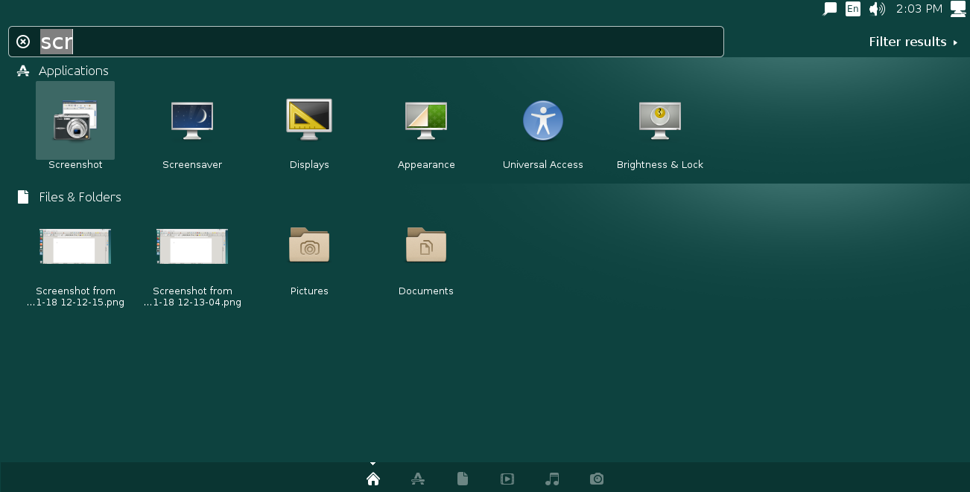

Step3: Select appropriate given option and click “Take Screenshot” button
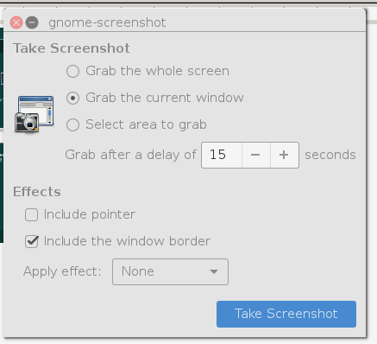

Step4: Post screen capture you have an option to save as .png file alternatively capture as clipboard

Step5: Open Libre Office > Write Document
Paste clipboard content to Libre Offce – Word document along with suitable heading / comments
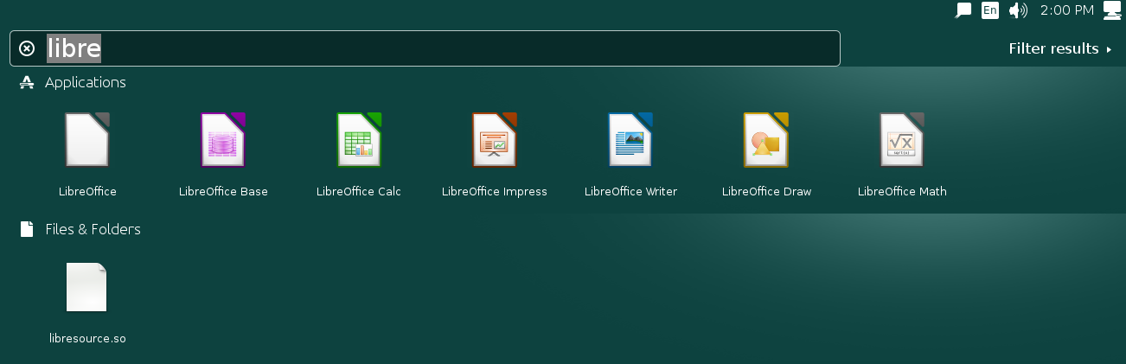

Step6: Save document (extension being either .odt or .docx) and push to gitlab

