**Automation Framework**

[](http://www.seleniumhq.org/)

This is a Selenium Hybrid Framework.

* Written in **JAVA**
* Build Tool - Maven
* Implemented Page Object Model Design Pattern

**Browsers Supported**

* Google Chrome

**Platform Support**

* Windows

**Reporting**

* [Extent Reporting](http://extentreports.com/)
* Report Screenshots:
* Result Summary:

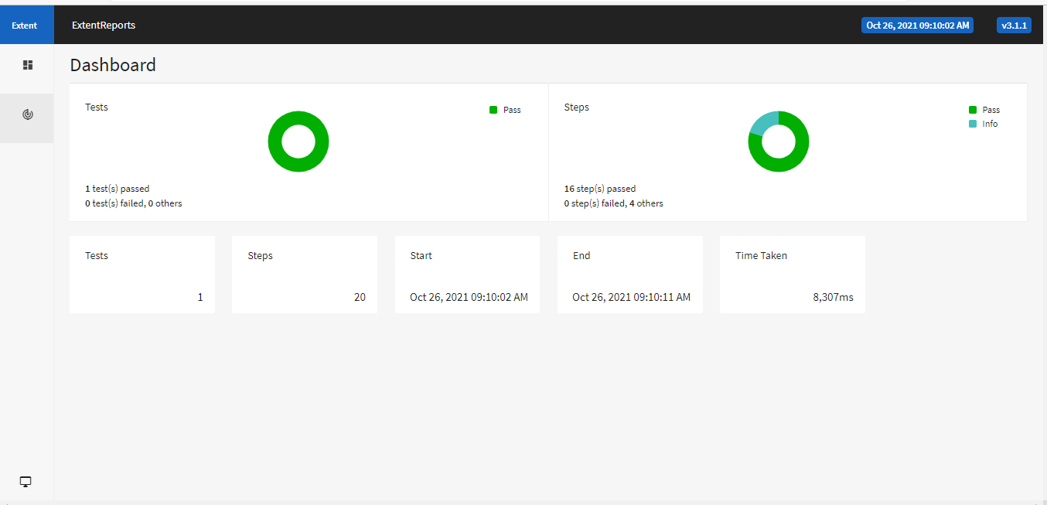

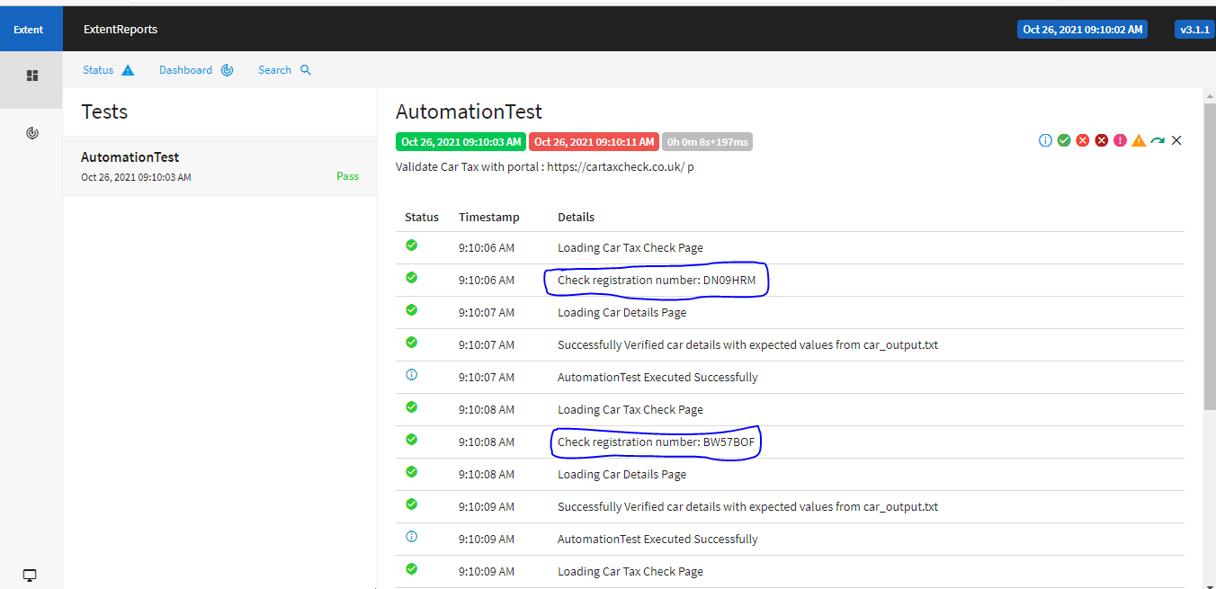

* 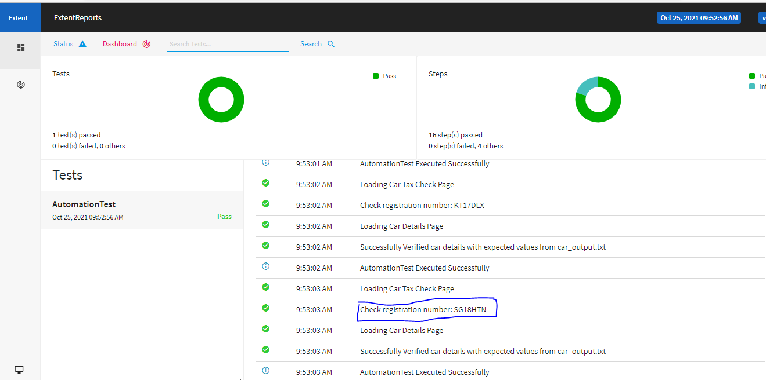

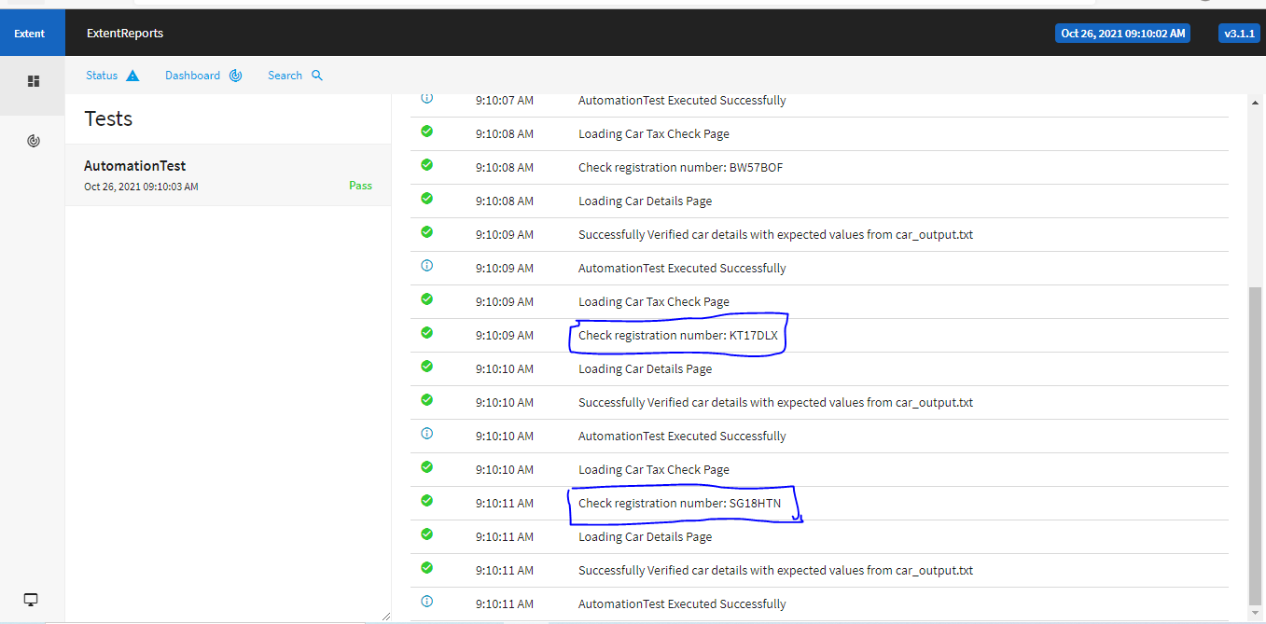

**Usage**

$ git clone:

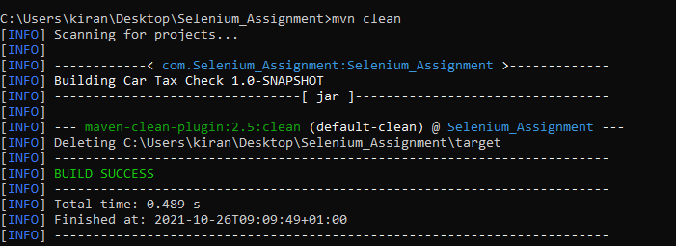

$ mvn clean test:

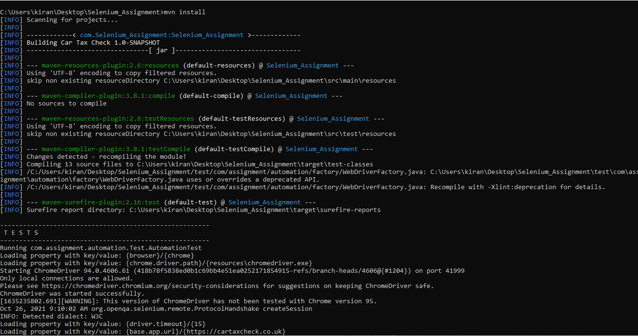

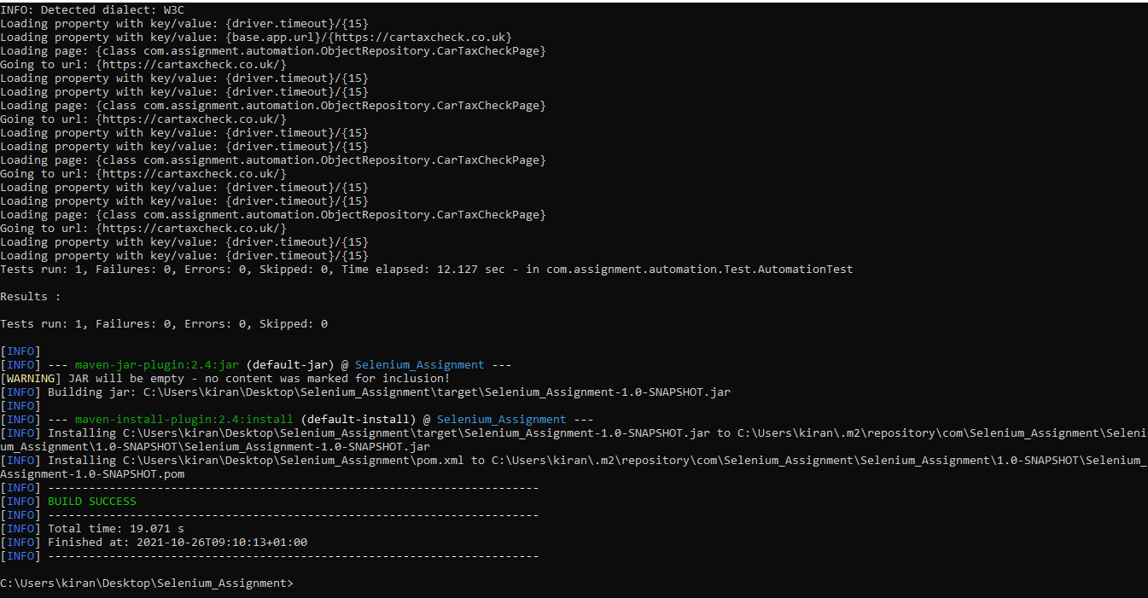

**Report Details**

**Report Location** Selenium_Assignment\target\extent.html