Victor Yuan

Lab 1

Introduction:

The goal of this lab was to set up a Raspberry Pi and type a message and save it into a file.

Procedure:

The Raspberry out of the box and put it in the plastic cover. The microSD card and the heat sinks were attached. The Raspberry was then to the monitor and keyboard. Installation of the needed and recommended software was started. After installation Vi, an editor was open my name lab number and a message was typed in and saved.

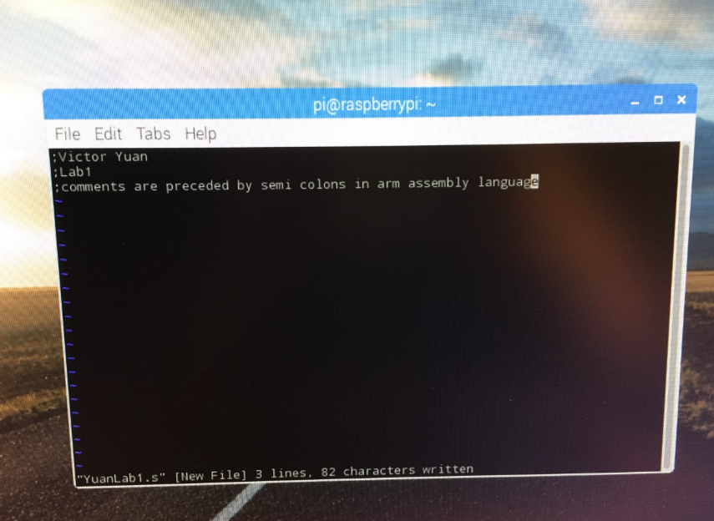Conclusion: Vi is an editor on the Raspberry pi.