Lab 6: How colorful is Your Name

Victor Yuan

Microcontrollers and Embedded Systems

March 9, 2017

Introduction:

The Goal of this lab was to write a program in assembly implementing division and multiplication.

Procedure:

First write a loop that will loop four times to collect all data needed, the total number of coins of pennies, nickels, dimes and quarters. Store the total number of coins into variables p, n, d, q.

Calculate the total value in cents. Be sure to make a copy of the original total. Divide the total by 100. To do this multiple the number stored in a register by the constant 82 then right shift it 13 for the approximation. Once you have this number multiply it by 100 and subtract the original with the dollar number \* 100 this gave the cents. Then print the dollar and cents.

To get the weekly average divide the four week total by 4 by right shifting by 2.

Convert to dollar and cents using the same method with four week total.

To get the yearly total multiply weekly total by 52.

Convert to dollar and cents using the same method with four week total.

Code:

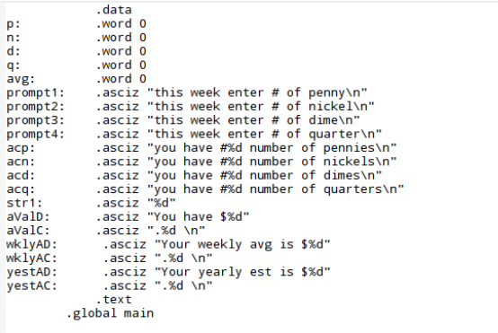

Set variables/prompts/messages

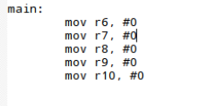

I set these registers to 0 to use in the loop

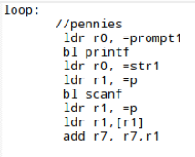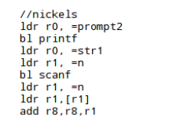

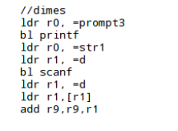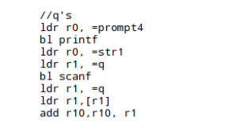

In each one of these a prompt for pennies, nickels, dimes and quarters are loaded to r0 and printed, scanf is used to read the value into variables p, n, d and q. The total number of each coin is stored in r7, r8, r9, r10.



Every time a loop is complete 1 is added to r6. R6 is compared to the constant 4 if r6 is less than 4 then it means 4 weeks have not been answered and the loop starts over again.

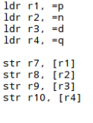

r7-10 holds the total number of coins r1-4 holds the variables. The value in r7-10 is stored into r1-4.

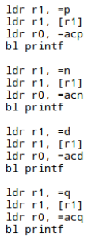

Now each variable is loaded into r1 and printf is called with the appropriate display messages.

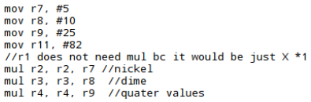

Calculating total value of pennies, nickels, dimes and quarters.

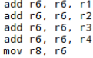

Adding the total value in cents and makes a copy in r8

previously stored

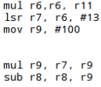

This segment multiplies by 82 then right shifts by 13 this is equal to dividing by 100.

Multiplying by 100 gives the dollar amount only subtracting the original dollar + cents with the dollar leaves the answer in cents only.

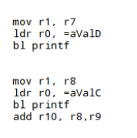

Prints the total value in dollars and cents and adds back r8, r9 and stored in r10 for the four week total sum in cents.

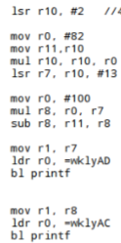

Division by 4 and copied into r11.

Then converted into dollars and cents to be printed.

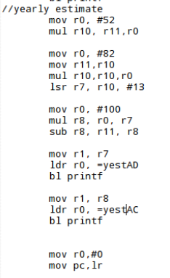

Yearly estimate is the weekly avg \* 52(weeks).

I multiplied by 52 and converted into dollars and cents to be printed.

Results:

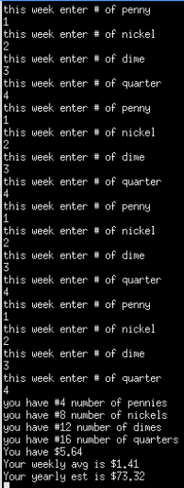 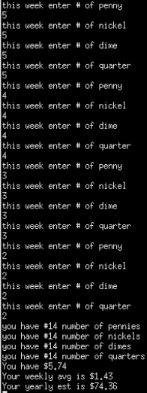 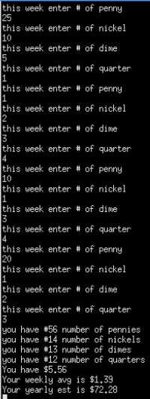

The program was successful.

Conclusion:

To divide by any constant you will need to divide a decently large number 2^11+ divide this by the constant then right shift the result by the power of 2 you first divided by. If your number was 2^13 then you right shift by 13 if it was 2^11 then you right shift by 11.