Lab 8: Fixed point Conversion

Victor Yuan

Microcontrollers and Embedded Systems

March 30, 2017

Introduction:

The goal of this lab was to learn how GPIO pinouts on a Raspberry Pi works.

Procedure:

Access SMU canvas on the Raspberry PI download the GPIO.TGZ file. Go to CMD prompt and locate the file. Use $ tar xfz GPIO.tgz to extract the file. Then open up codeblocks in developers mode with the command sudo codeblock. Import the files extracted from GPIO then wire the breadboard, LEDs and switches according to circuit diagram. GPIO 23-24 for the first 3 switches all connected to the ground. With GPIO 21, 18, 17 connected to the LEDs thru a 560 ohm resistor with a 3.3v voltage source.

Code:

The Code below was given in the GPIO.tgz file

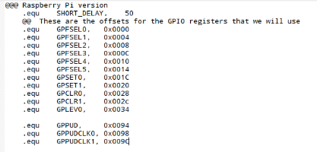

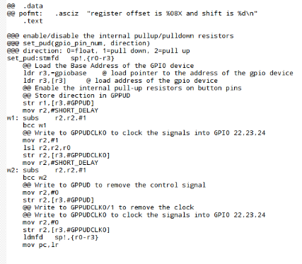

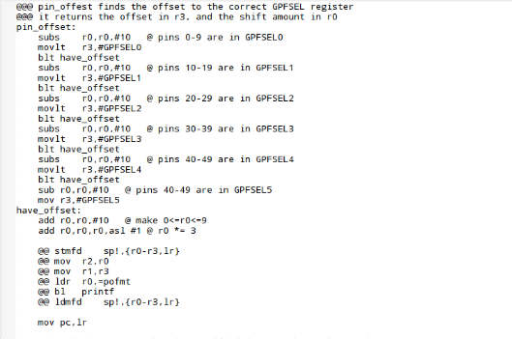

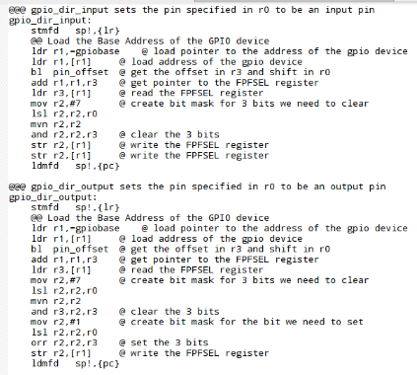

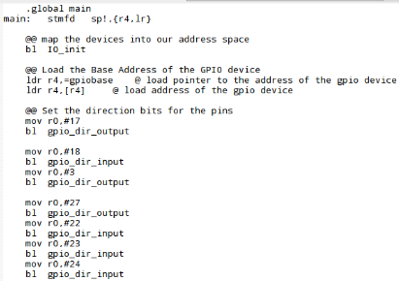

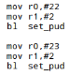



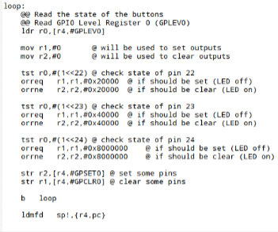

Results:

When no buttons are pressed

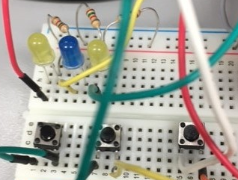

1st light on

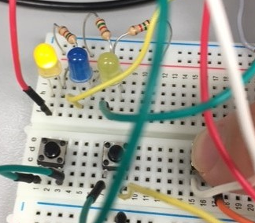

2nd light on

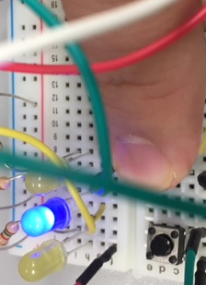

3rd light on

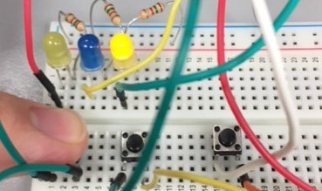

All lights Turning on

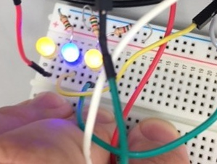

Conclusion:

The code worked as intended, the light turns on only when the switch is pressed, and turns off when the switch isn’t pressed.