Lab 9: Pulse Modulation

Victor Yuan

Microcontrollers and Embedded Systems

April 20, 2017

Introduction:

The goal of this lab was to configure the clock, PWM so that input from pinouts changes the brightness of a lightbulb .

Procedure:

Download the base code from Canvas. Then configure GPIO 12 for alternate function 0. Then configure the PWM. Configure PWM0 from 0 to 100% duty cycle. Wire the pinouts to the breadboard, switches, and led.

Code:

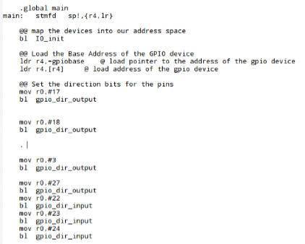

pins 22,23,24 set to input for the switches

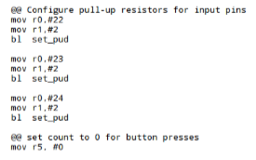

Given Base code

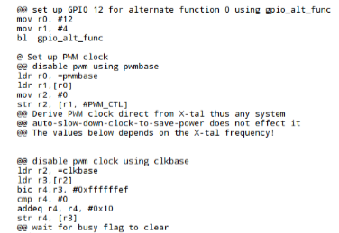

Setting up GPIO 12 for output and alternate function 0, setting up PWM

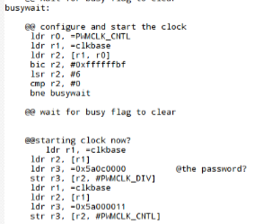

First Busy wait,

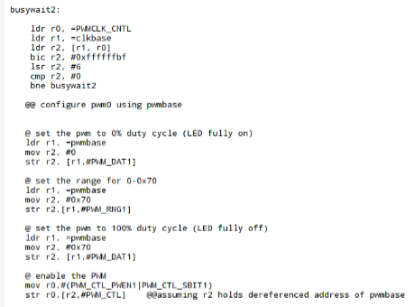

Second Busy wait

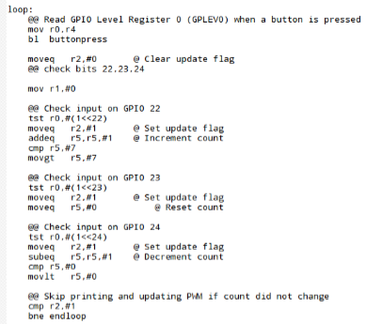

Setting up PWM0

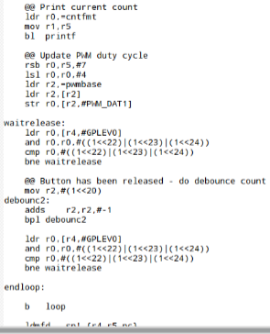

Setting up the duty cycle 0x0 = 0%, up to 0x70 = 100%

Range from 0x0-0x70

Results:

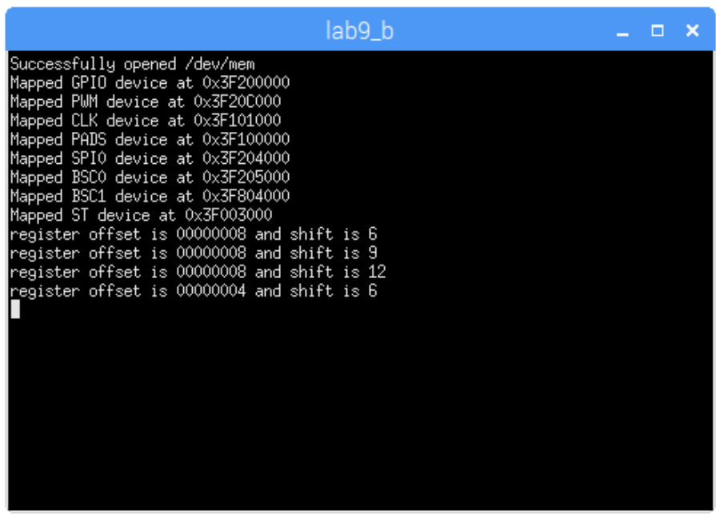

Conclusion:

The code did not work in the end, this was due to an infinite loop in busy wait.