**Lab 02 Report**

**Sensor Data Collection:**

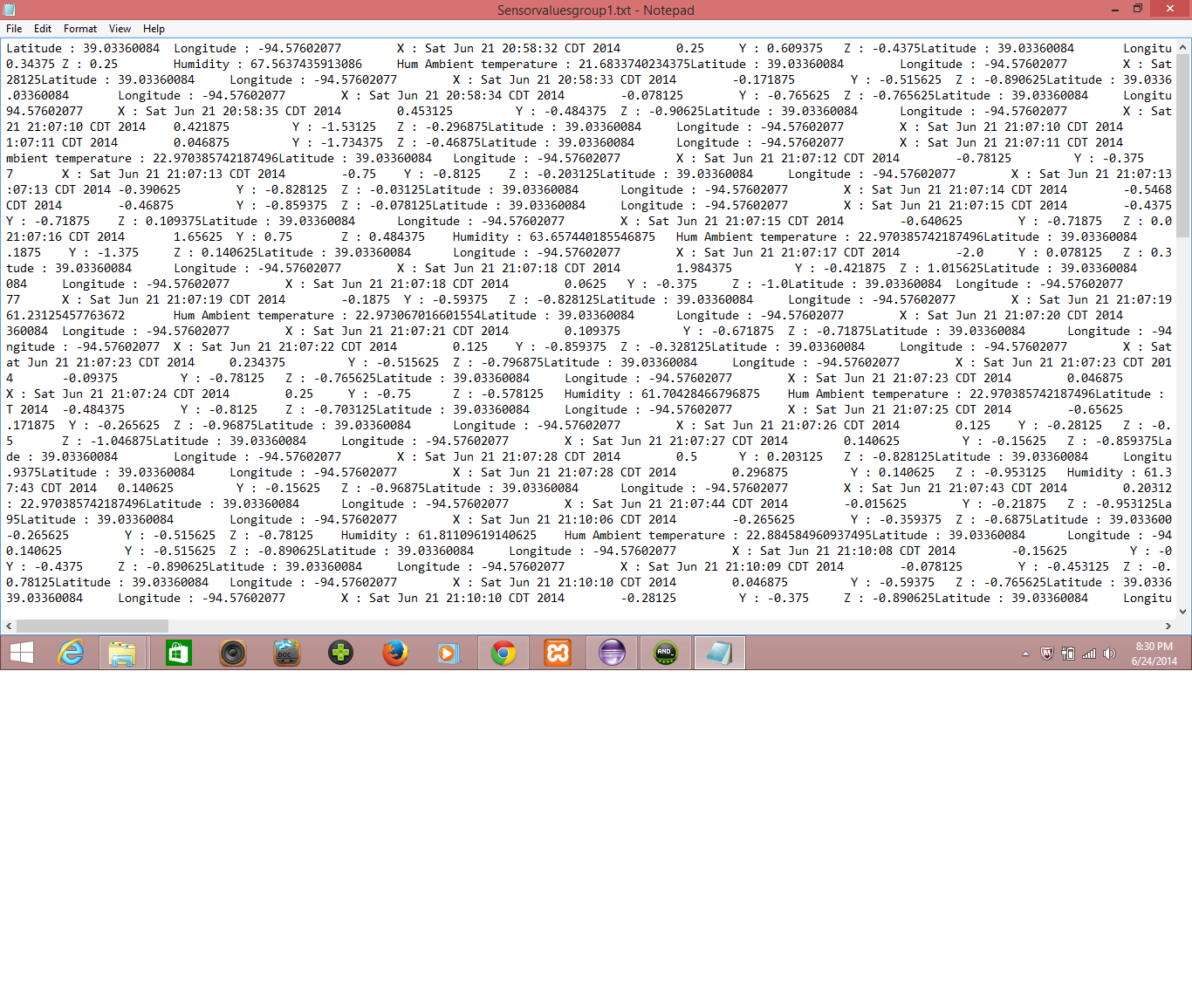

**HBase Program Code:**

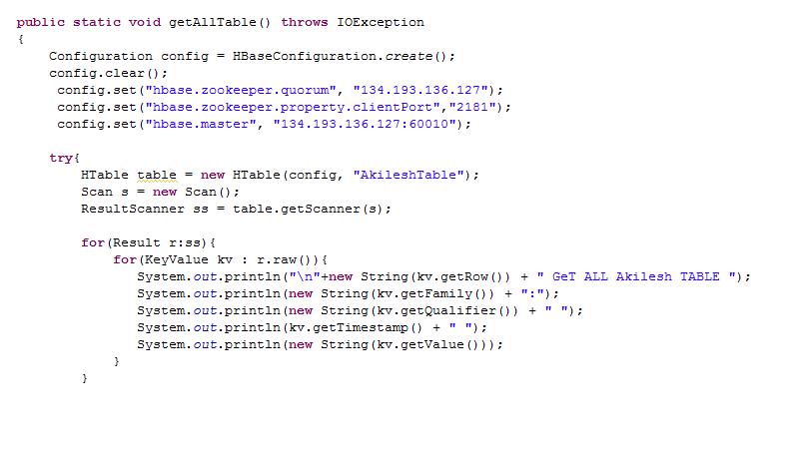

**HBase Table Creation and Data Insertion:**

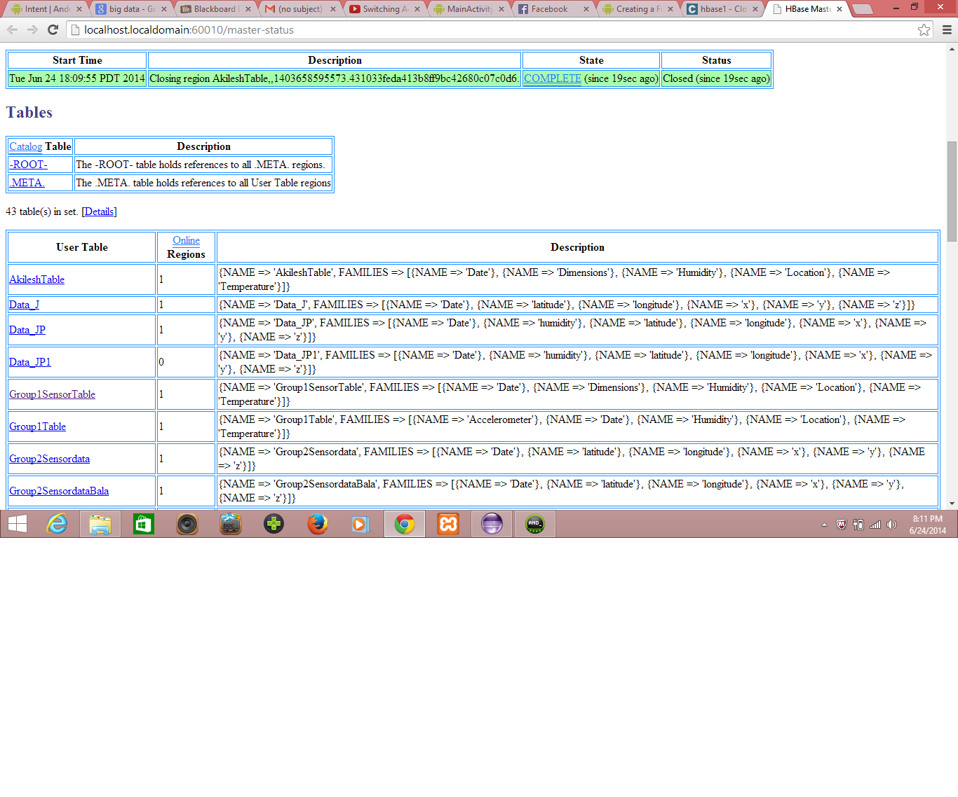

**HBase Data Retrieval:**

