ASSIGNMENT 1

MY GIT HUB ACCOUNT

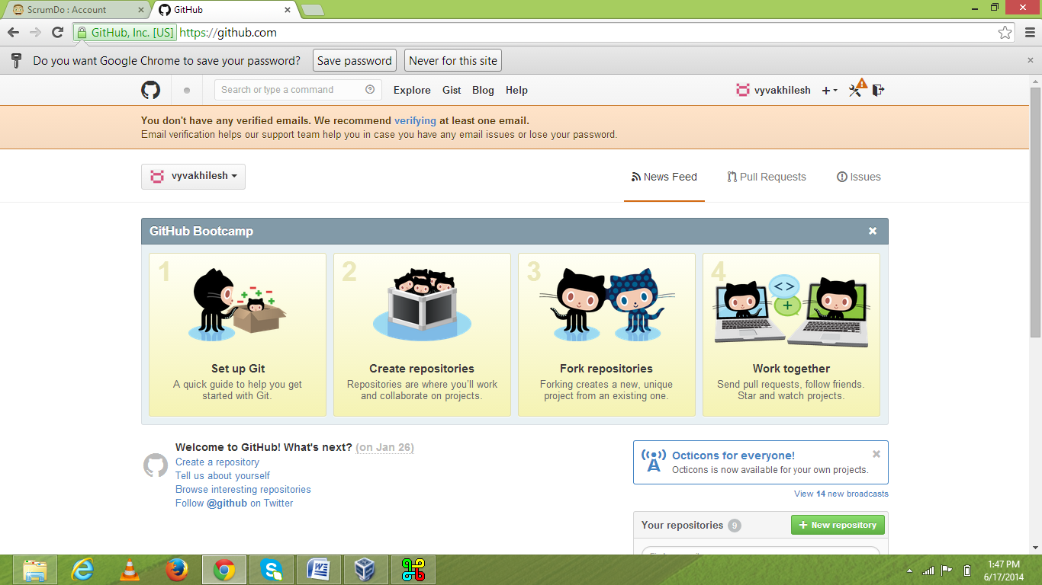

MY CLOUDERA

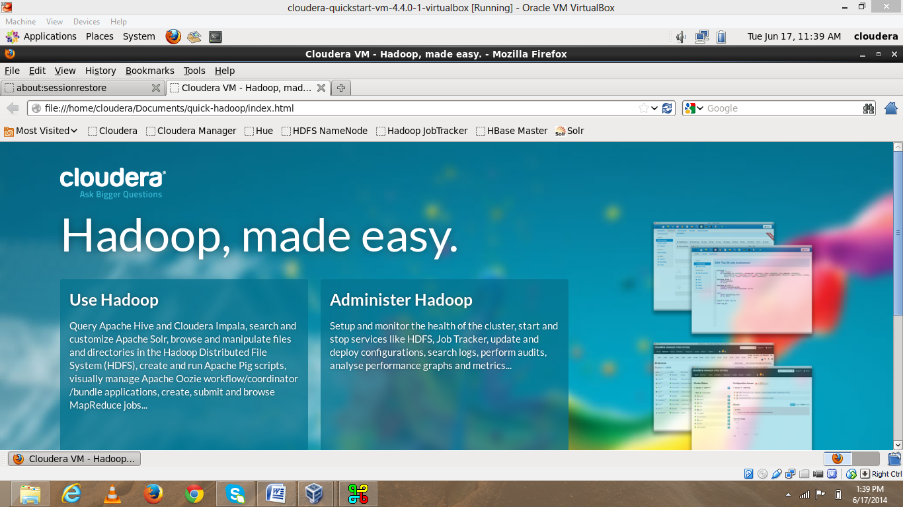

MY SCRUM DO

