creating maven project:

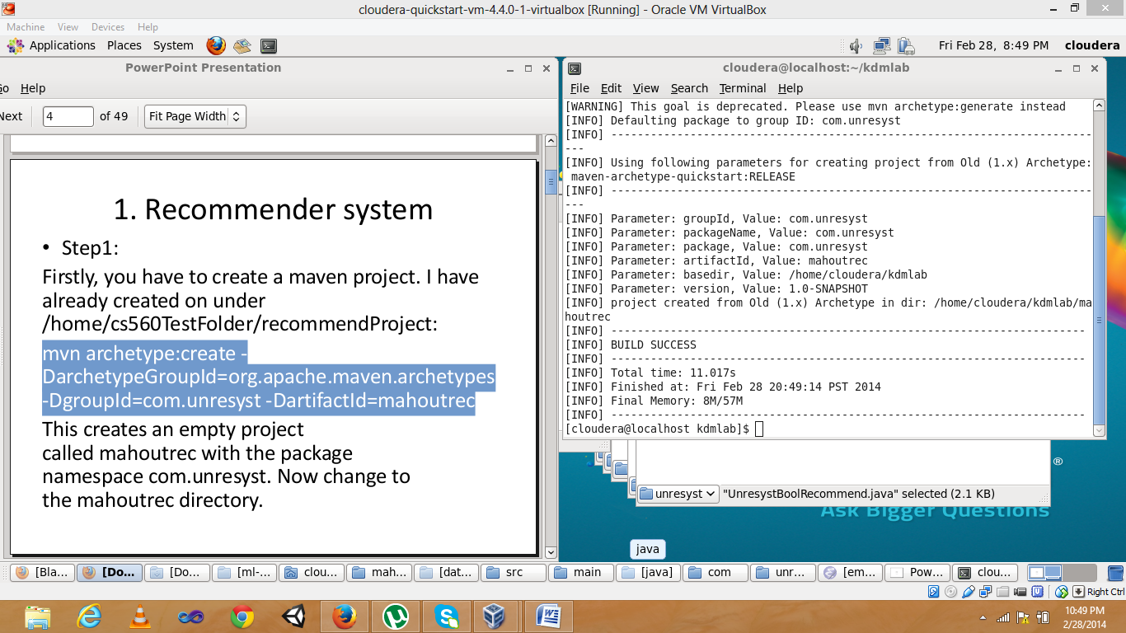

compiling mahoutrec:

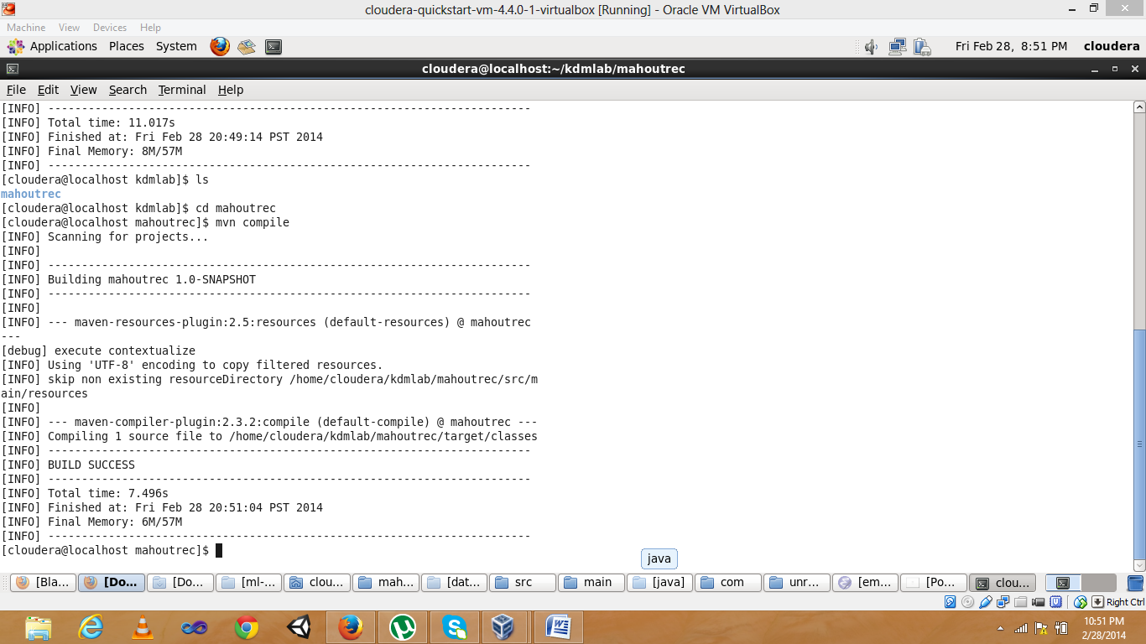

executing mainclass for printing hello world!

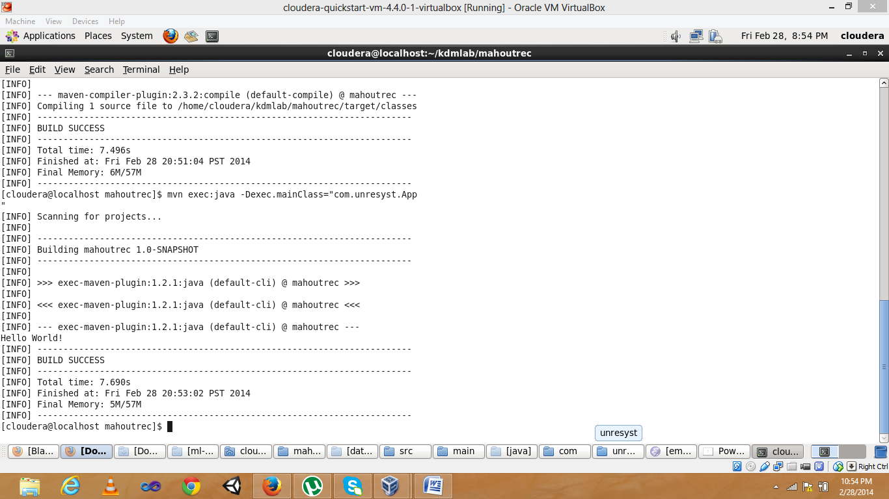

adding dependencies and parent code to the pom.xml file and compile

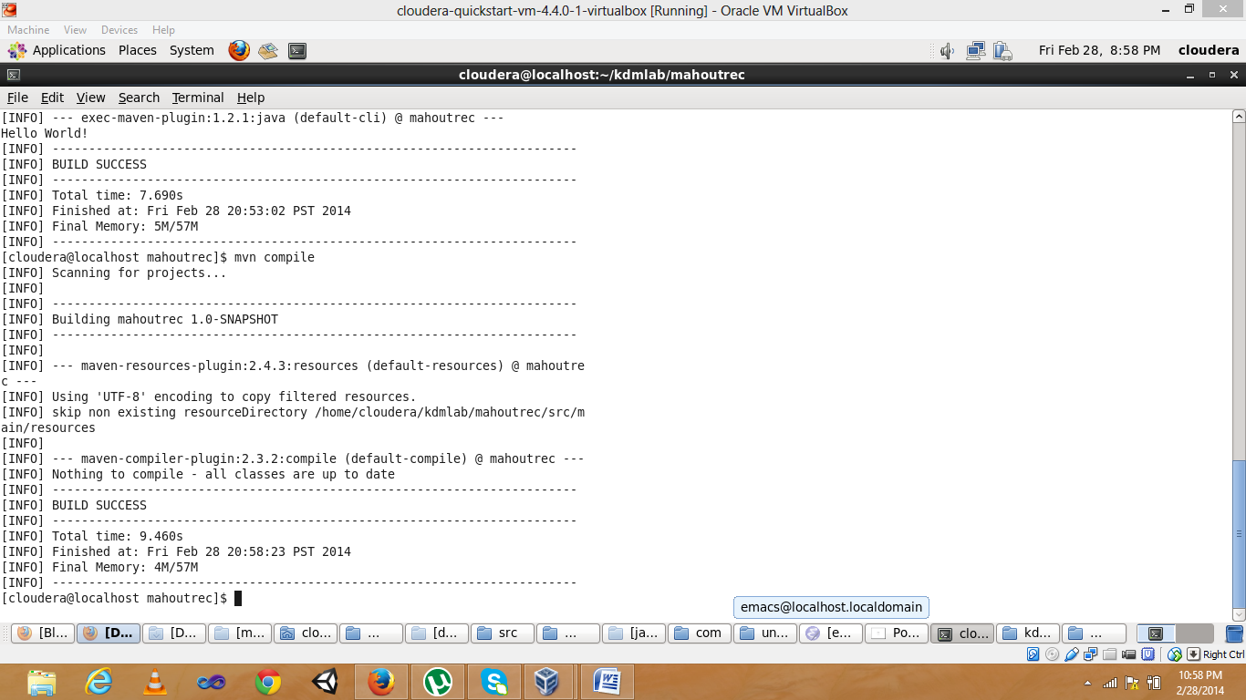

creating UnresystBoolRecommend.java

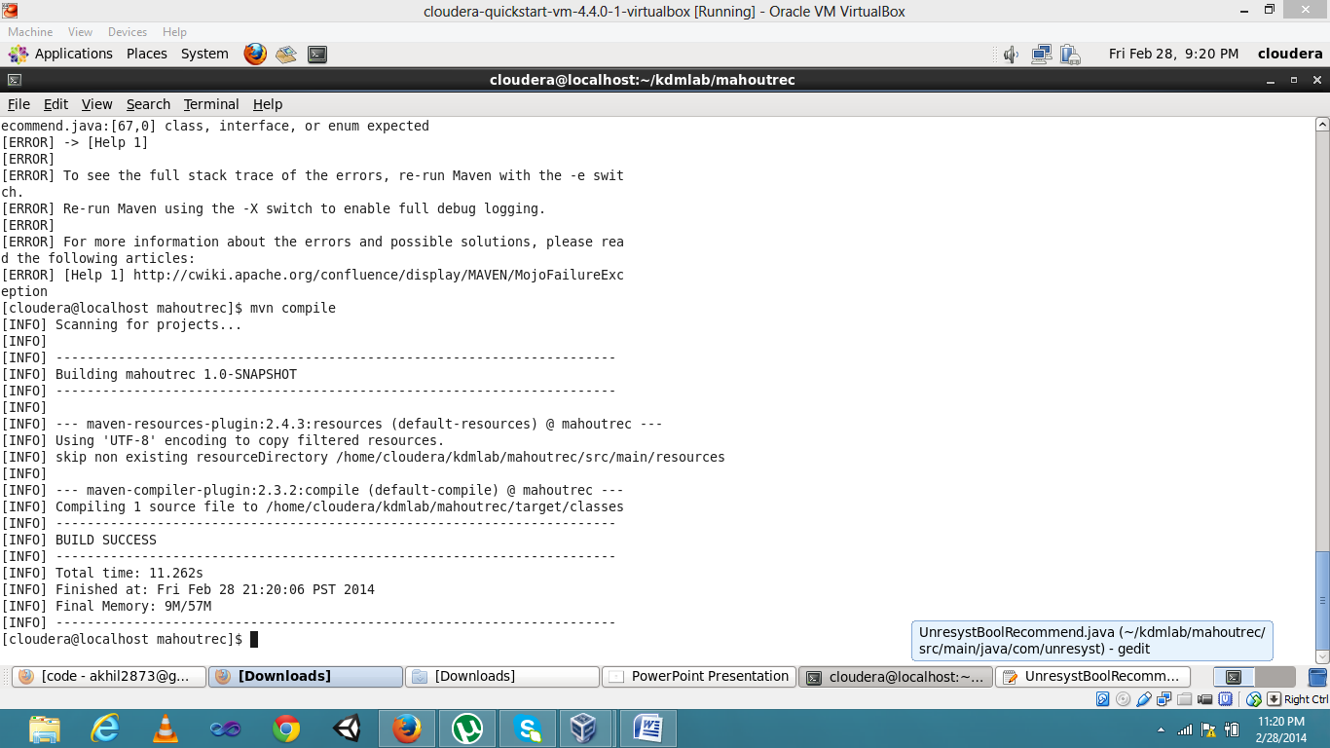

and run the main function we get the recommender output:

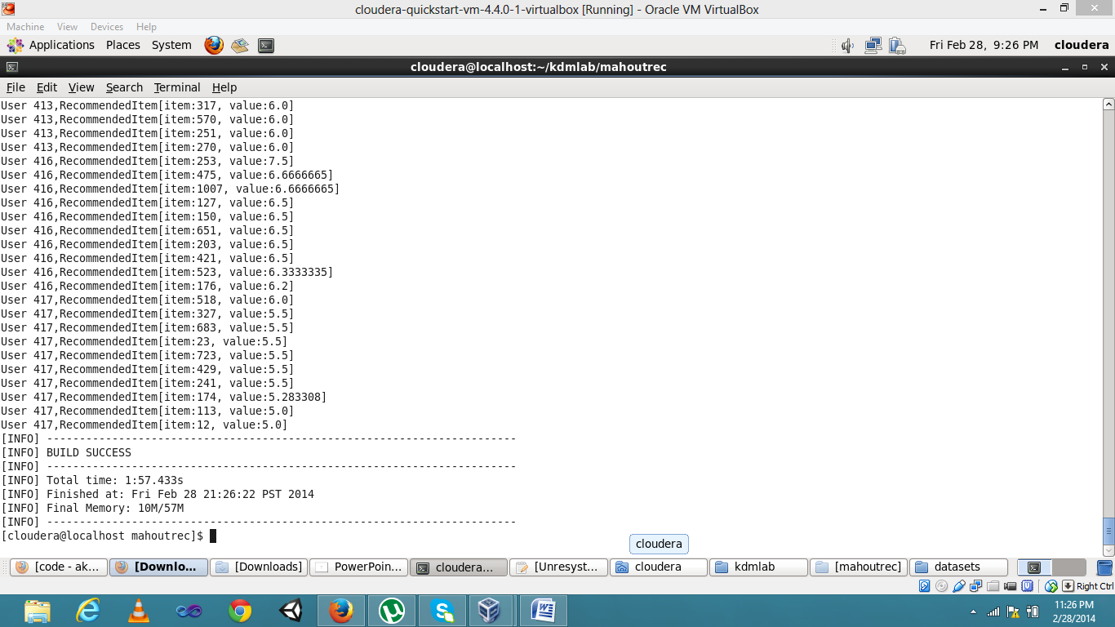

the recommended out put is

User 416,RecommendedItem[item:651, value:6.5]  
User 416,RecommendedItem[item:203, value:6.5]  
User 416,RecommendedItem[item:421, value:6.5]  
User 416,RecommendedItem[item:523, value:6.3333335]  
User 416,RecommendedItem[item:176, value:6.2]  
User 417,RecommendedItem[item:518, value:6.0]  
User 417,RecommendedItem[item:327, value:5.5]  
User 417,RecommendedItem[item:683, value:5.5]  
User 417,RecommendedItem[item:23, value:5.5]  
User 417,RecommendedItem[item:723, value:5.5]  
User 417,RecommendedItem[item:429, value:5.5]  
User 417,RecommendedItem[item:241, value:5.5]  
User 417,RecommendedItem[item:174, value:5.283308]  
User 417,RecommendedItem[item:113, value:5.0]  
User 417,RecommendedItem[item:12, value:5.0]

to login the solr interface

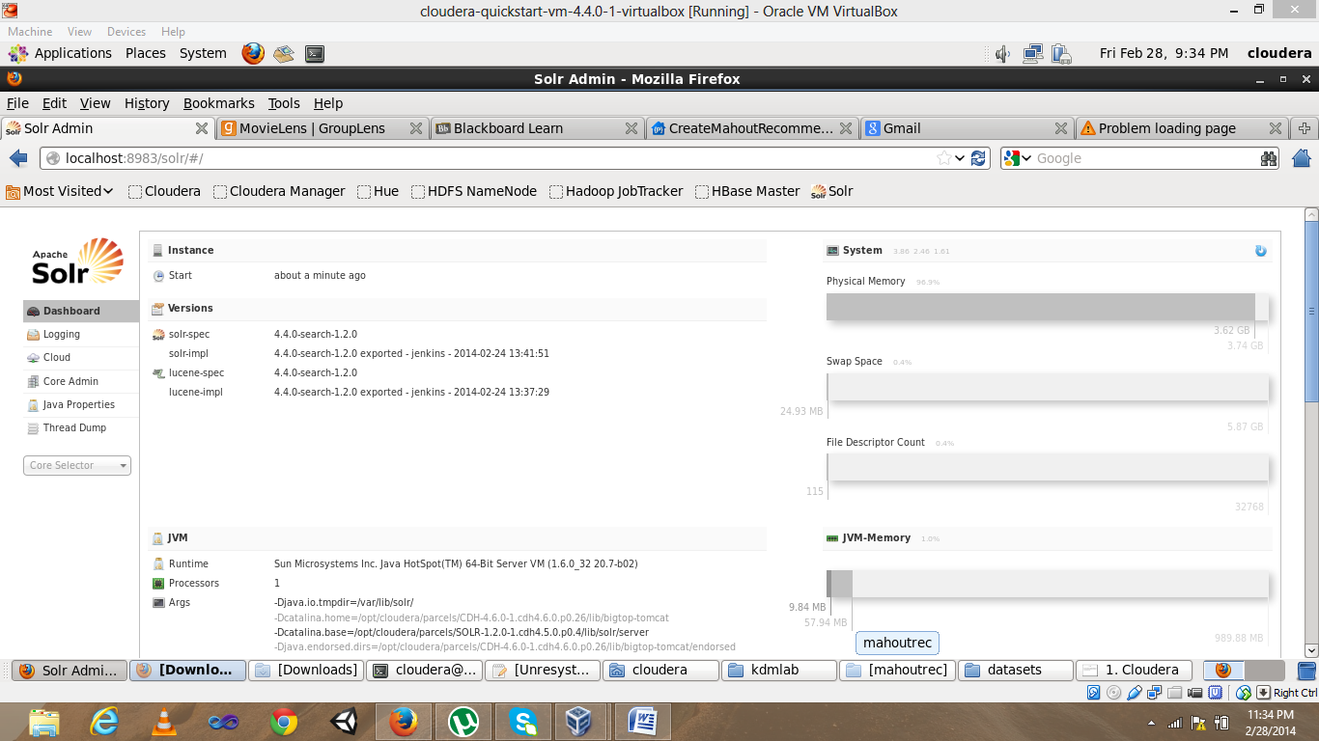

to create a skeleton for instance and uploading the content to zookeeper

[cloudera@localhost mahoutrec]$ solrctl instancedir --generate $HOME/solr_config  
[cloudera@localhost mahoutrec]$ solrctl instancedir --create collection2 $HOME/solr_config  
Uploading configs from /home/cloudera/solr_config/conf to localhost.localdomain:2181/solr. This may take up to a minute.  
[cloudera@localhost mahoutrec]$

instance directory succesfully uploaded to zookeper

[cloudera@localhost mahoutrec]$ solrctl instancedir --list  
collection1  
collection2

and creating collection 2 in solr using collection 2

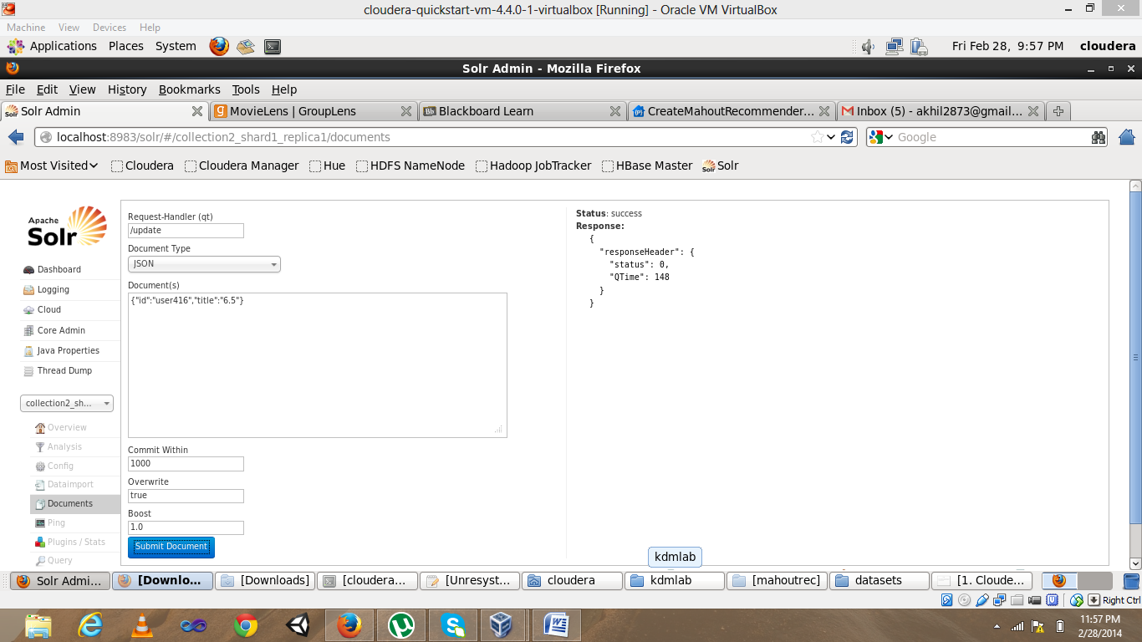

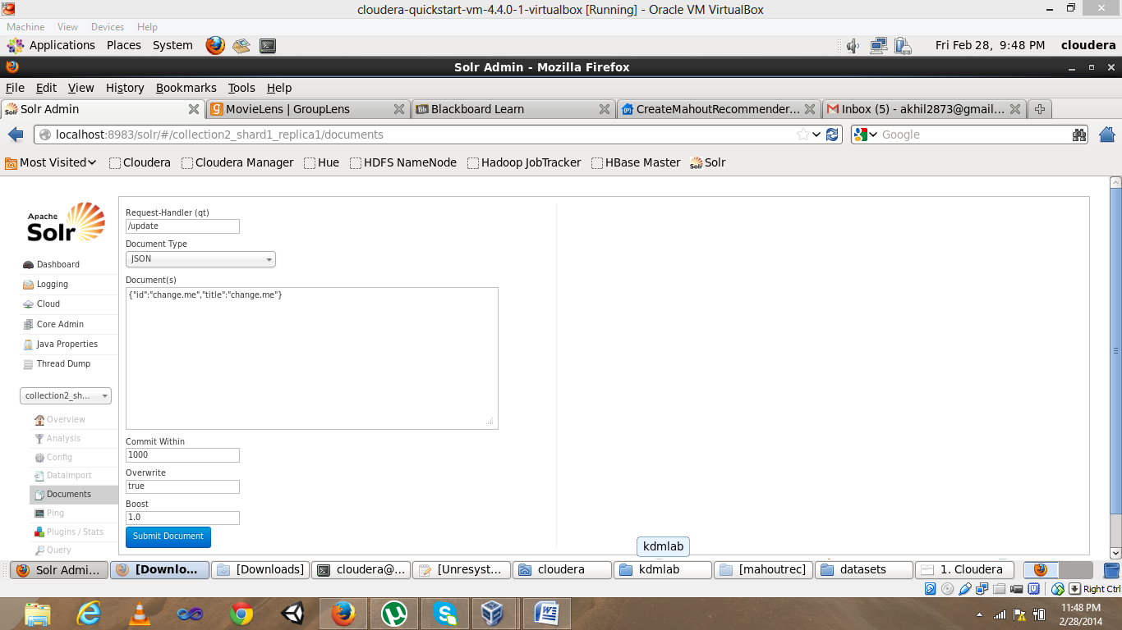

entering data and querying data in to solr:

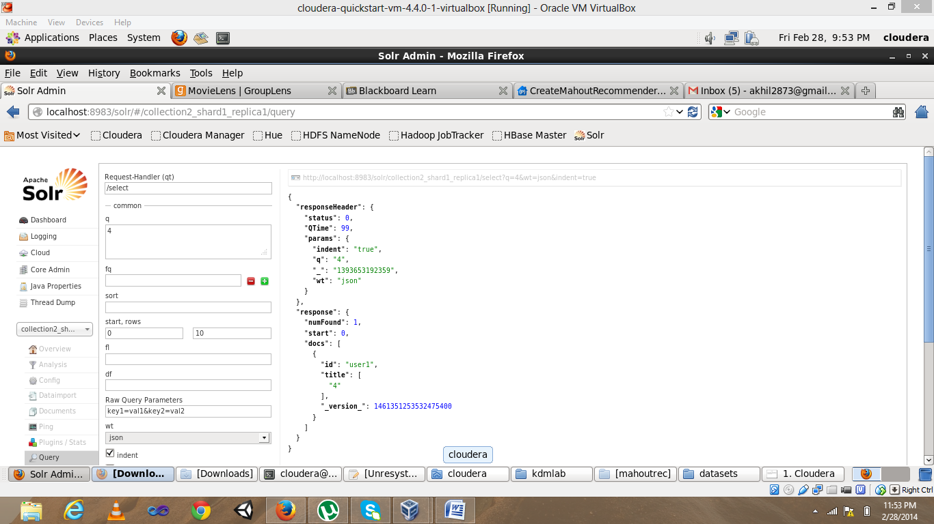

the url is connecting to the solr and displaying the output in the console

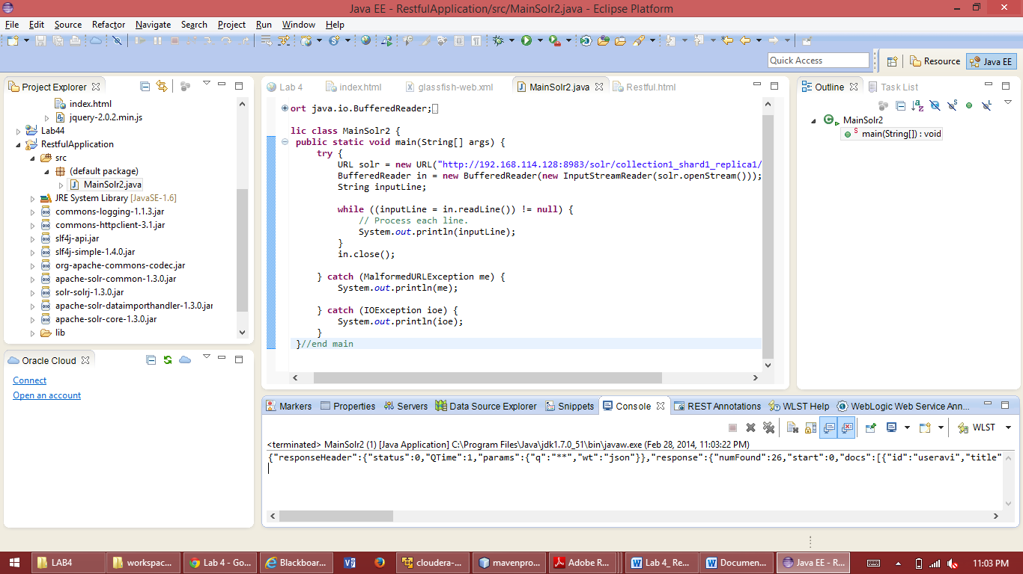

the input given in the text box in recomendation system will access the solr through the url and gives the recommendation in the output

