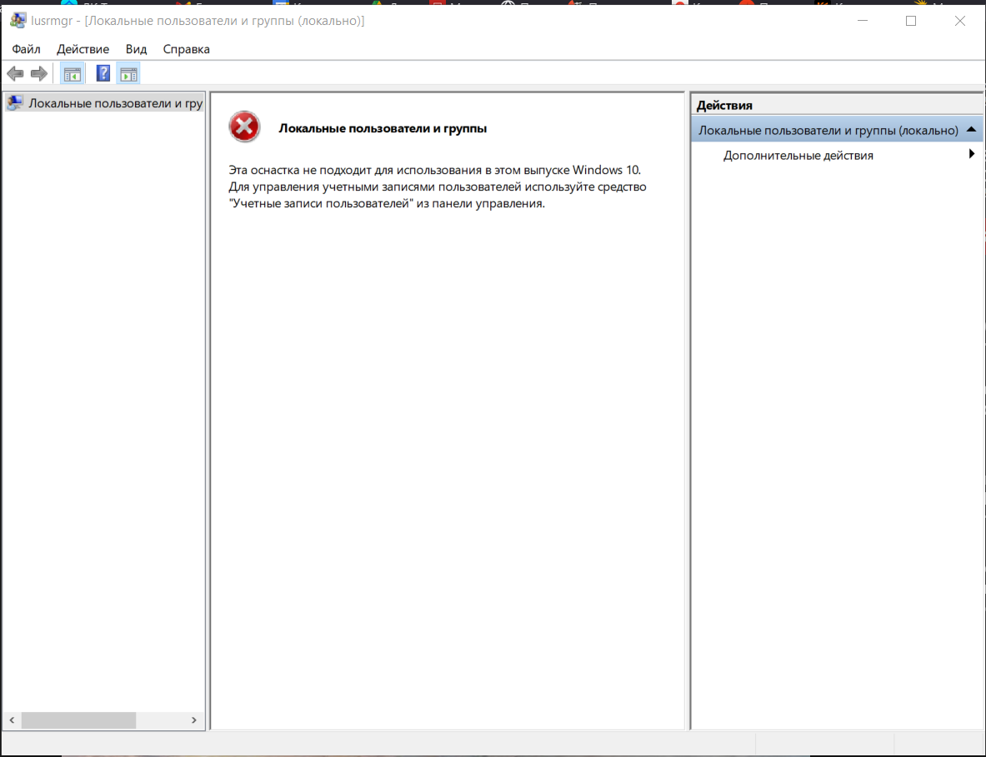

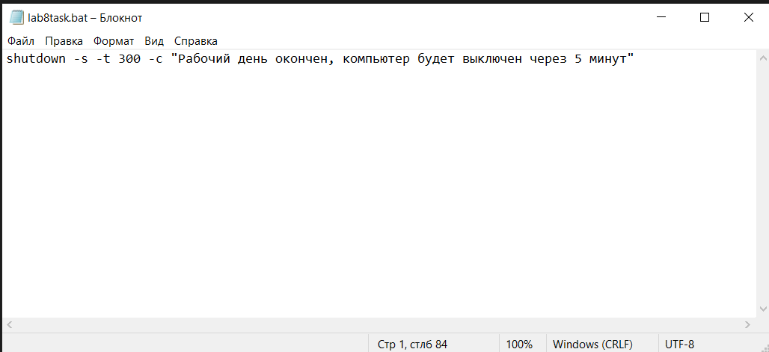

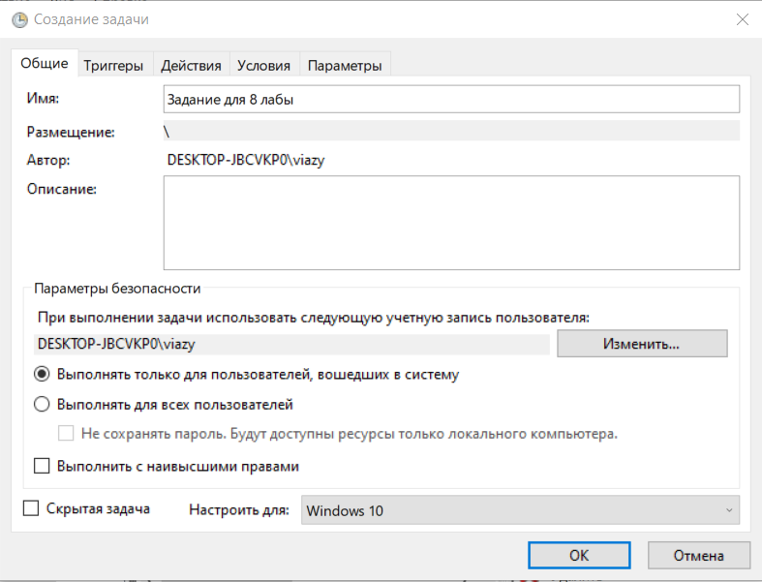

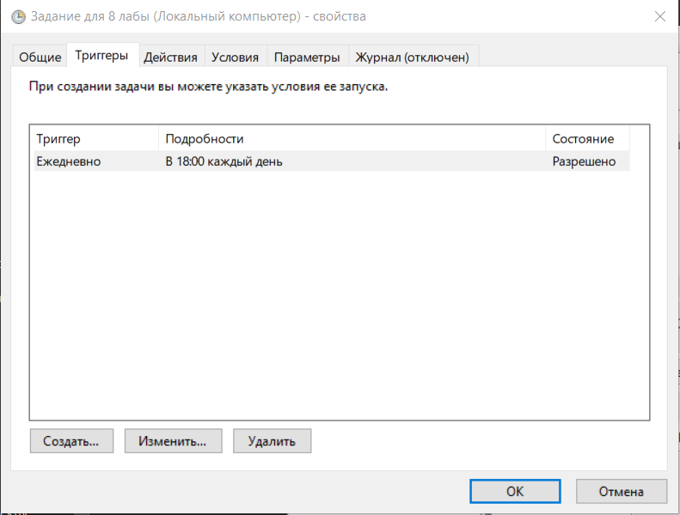

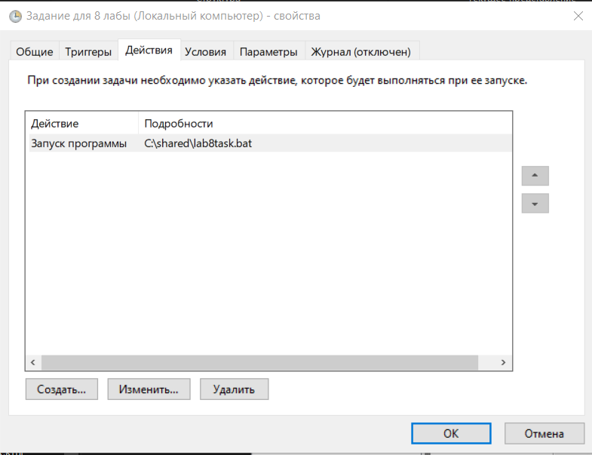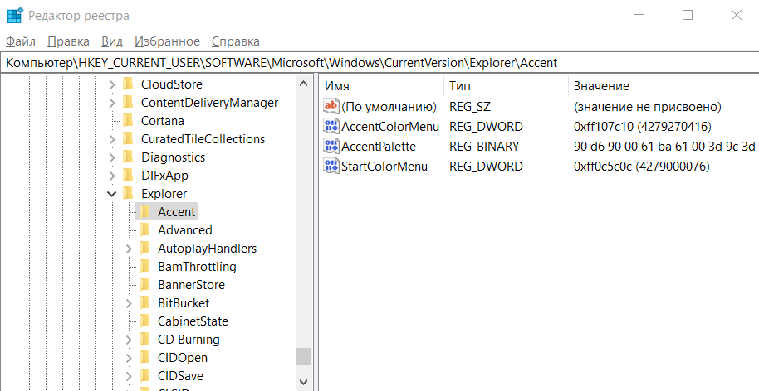

reg.exe add "HKCU\SOFTWARE\Microsoft\Windows\CurrentVersion\Explorer\Accent" /v AccentColorMenu /t REG_DWORD /d 0xfff44336



reg.exe delete "HKCU\SOFTWARE\Microsoft\Windows\CurrentVersion\Explorer\Accent" /f