

**PROJECT USER GUIDE**

**Quiz Project**

November 2018

**Submitted By**

**Sitharaman Deepak Guptha**

Contents

1. Purpose 3

2. Introduction 3

[3. Quiz Project - Operations:   
 3.1 Launching the application 3](#_Toc530784613)

3.2 Launching the Quiz Project 9

3.3 Create – View Page 10

3.4 Search – View Page 13

3.5 Delete – View Page 13

3.6 View All – View Page 15

3.7 Update – View Page 15

# 1. Purpose: The main aim of this user guide is to provide the operations of Quiz Project. The user operations are explained with the screenshots.

# 2. Introduction: The features implemented in this Quiz Project are,

* Create Questions and Choices.
* Search a Question.
* View All Questions and Answers
* Update a Question and MCQs.
* Delete a Question and MCQs.

# 3. Quiz Project - Operations: 3.1 Launching the application (i) Install JAVA 9.0 (JDK and JRE) in your system and Eclipse

(ii) Download the files from the Git repository  
  
[**https://github.com/vzan2012/Quiz-Project**](https://github.com/vzan2012/Quiz-Project)  
  
(iii) Create a new database connection from the Data Source Explorer view by right-click the Database Connections and select “New” (Screenshot provided below).

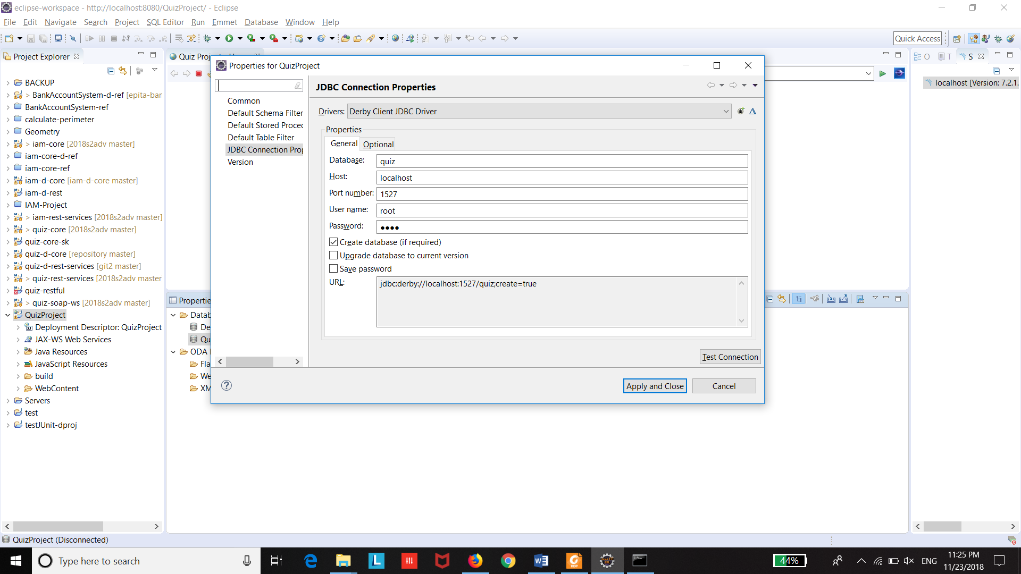

URL: jdbc:derby://localhost:1527/quiz;create=true

**Username:** root  
**Password:** root

(iv) Select the **“quiz-d-core”** project, right click it and select **“Run As”**, select the option **“Maven Install”**

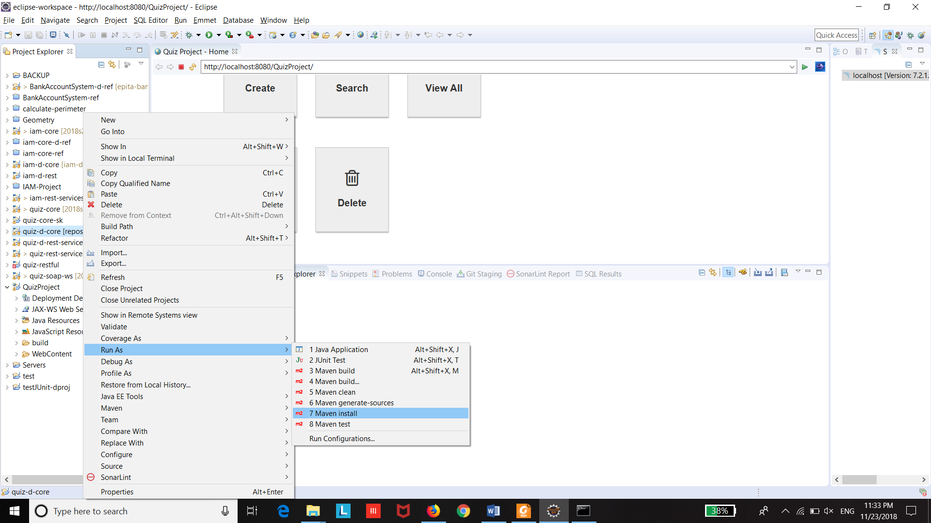

After the Maven Install, **“Build Success”** message will be appeared.

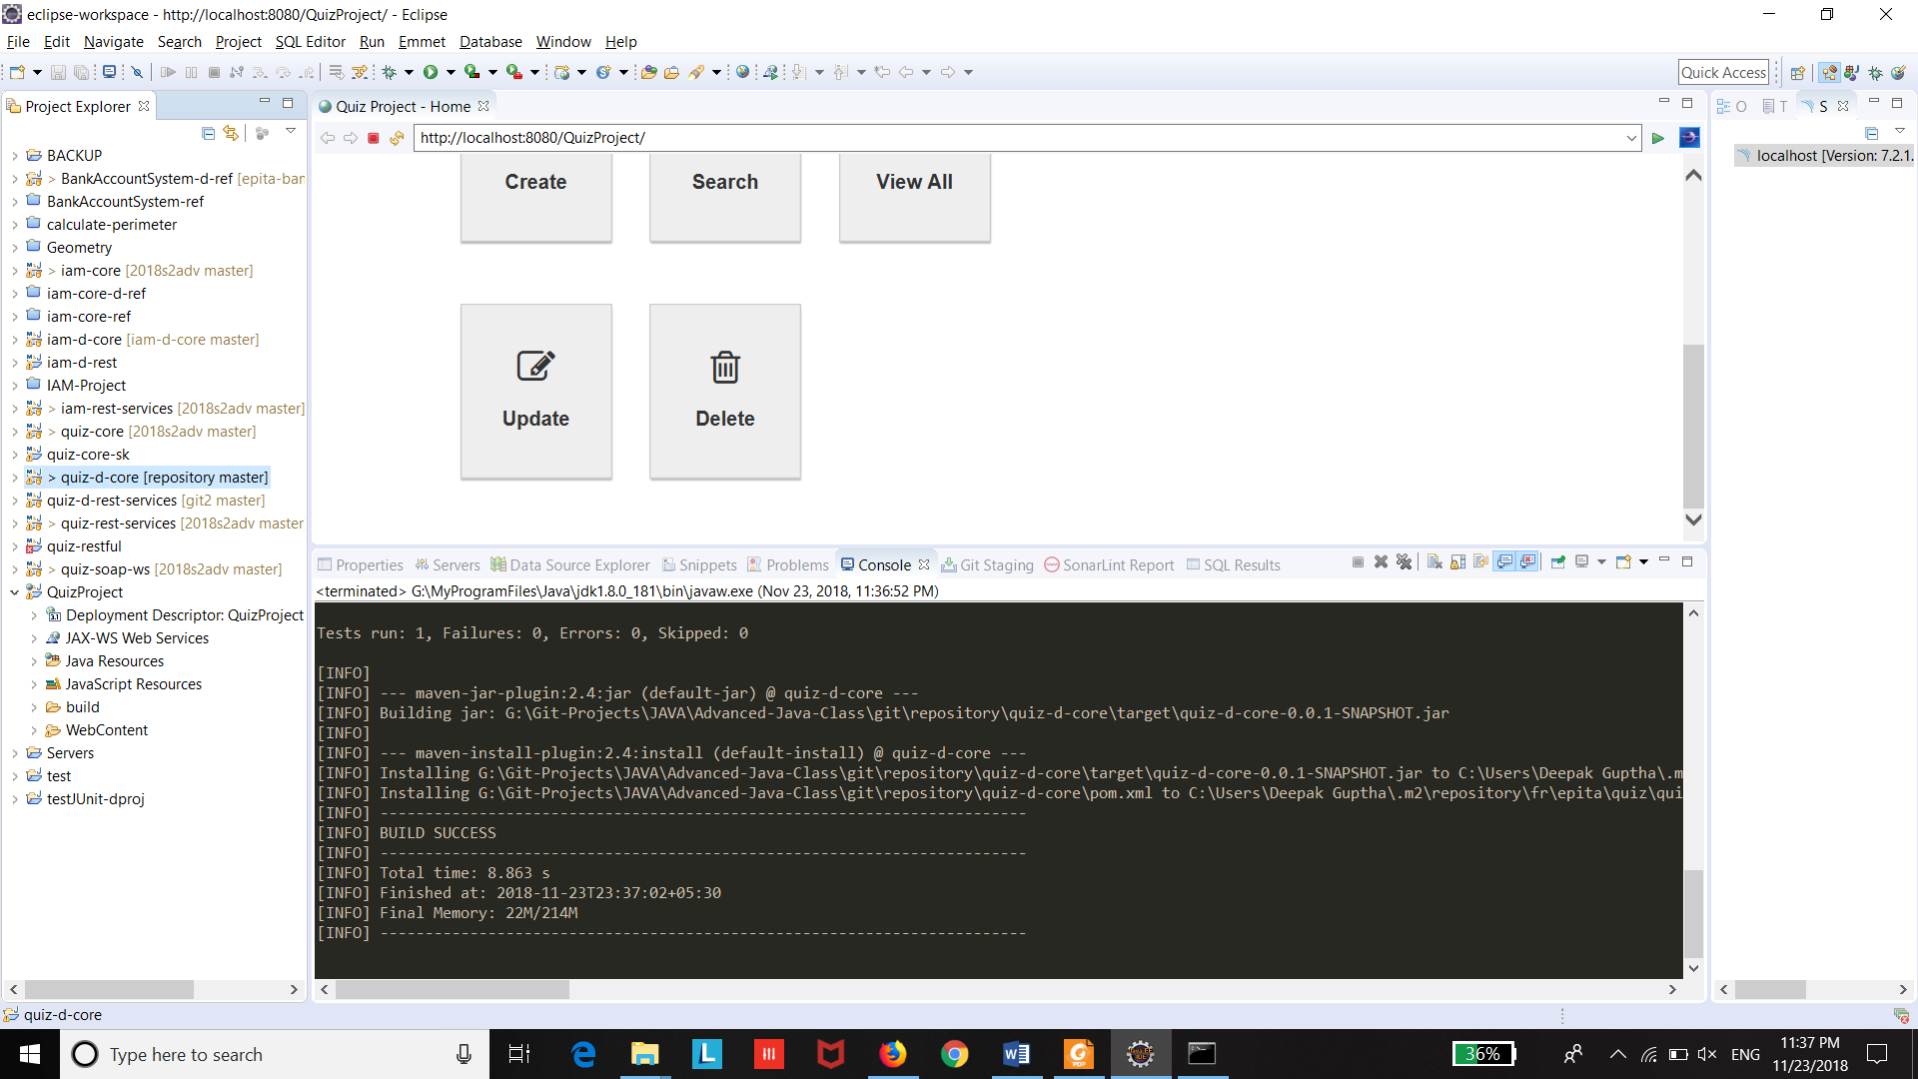

(v) Select the **“quiz-d-rest-services”** project, right click the project and select the option **“Run As”** and select **“Run on Server”**.

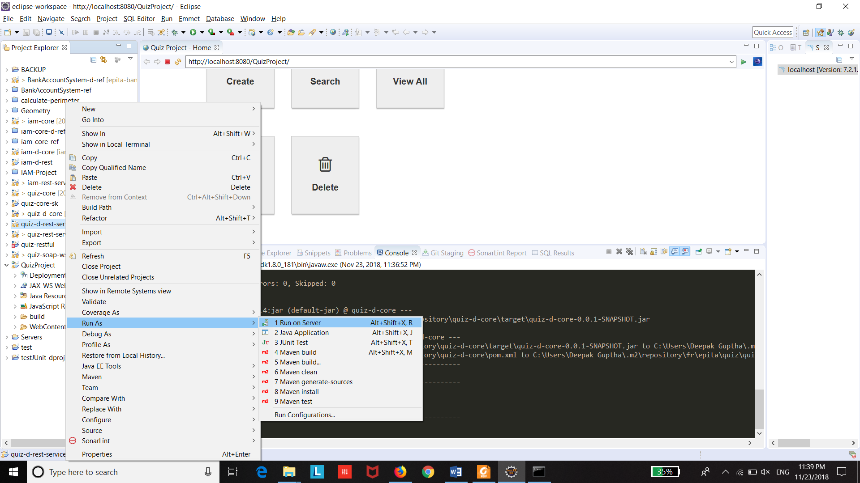

(vi) Select the “Tomcat v9.0 Server at localhost” and click **Next:**

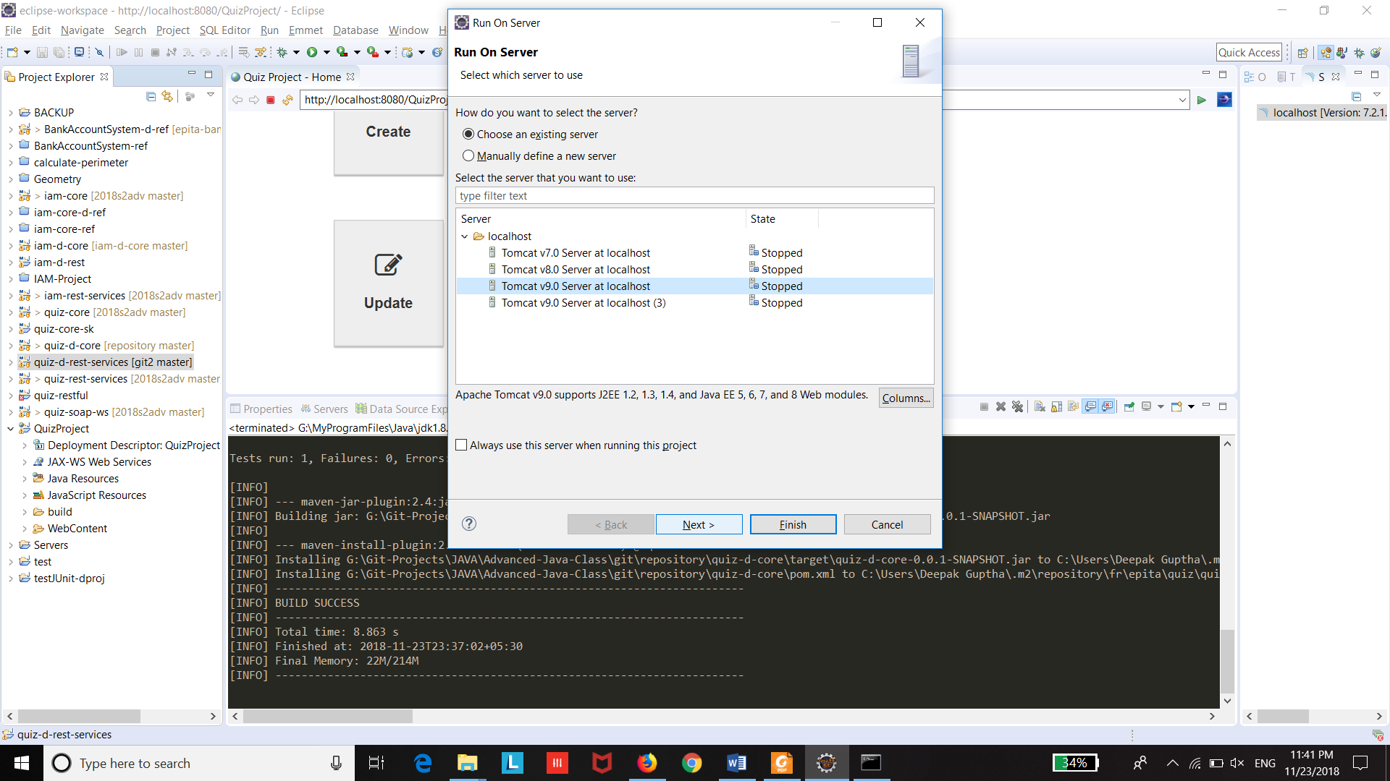

(vii) Add the Project to the Configured section and click “Finish”.

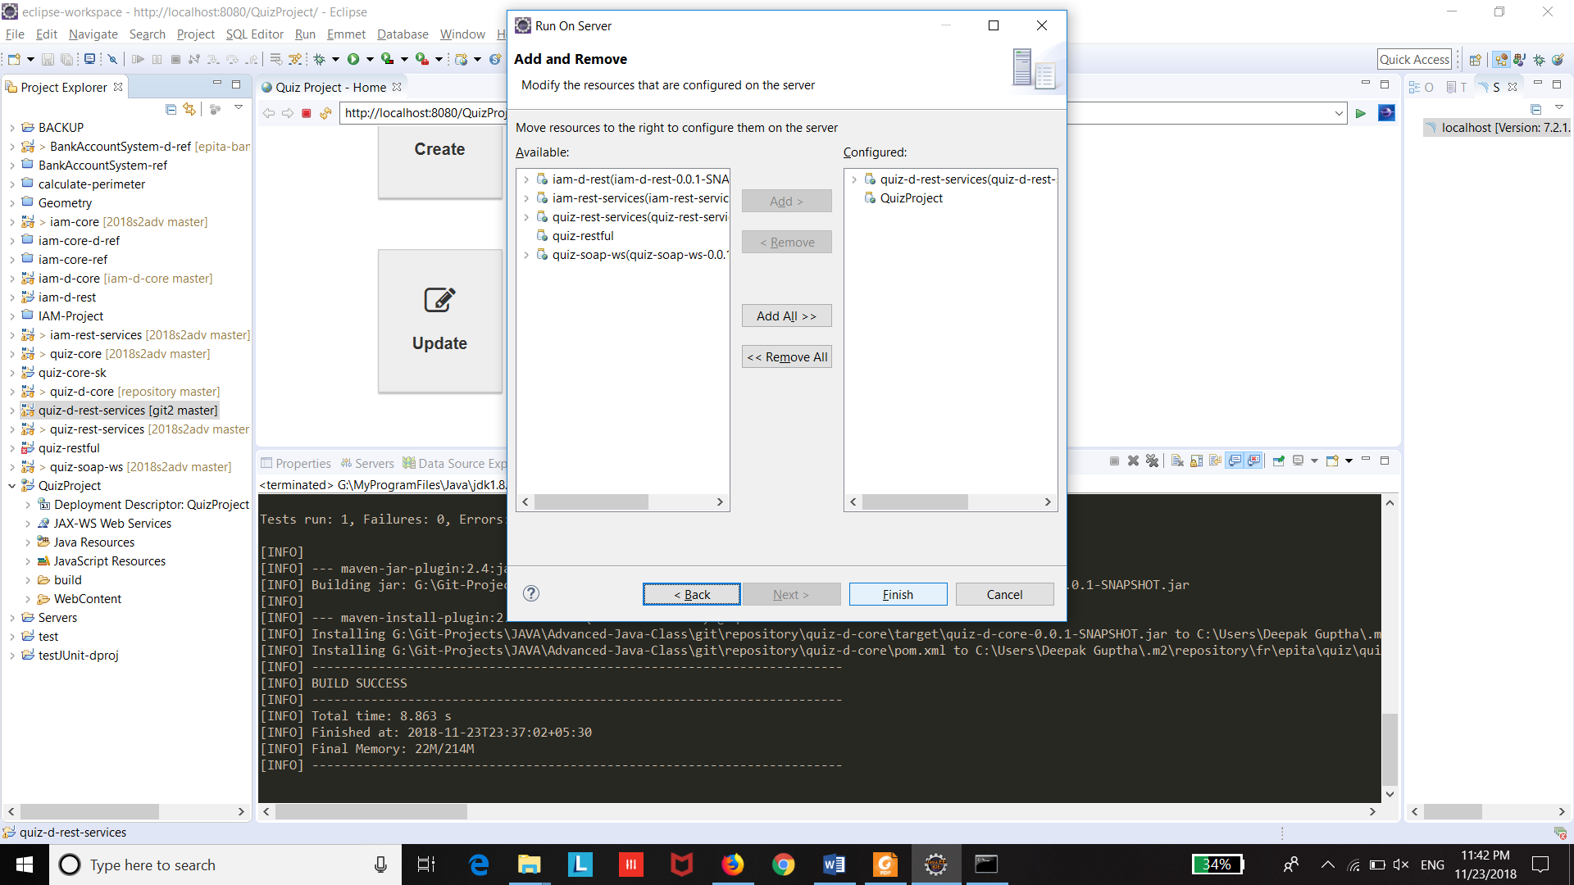

(viii) After that, go to link:  
  
Link: <http://localhost:8080/quiz-d-rest-services/>

Welcome page will be displayed, this ensures that the REST services are running.

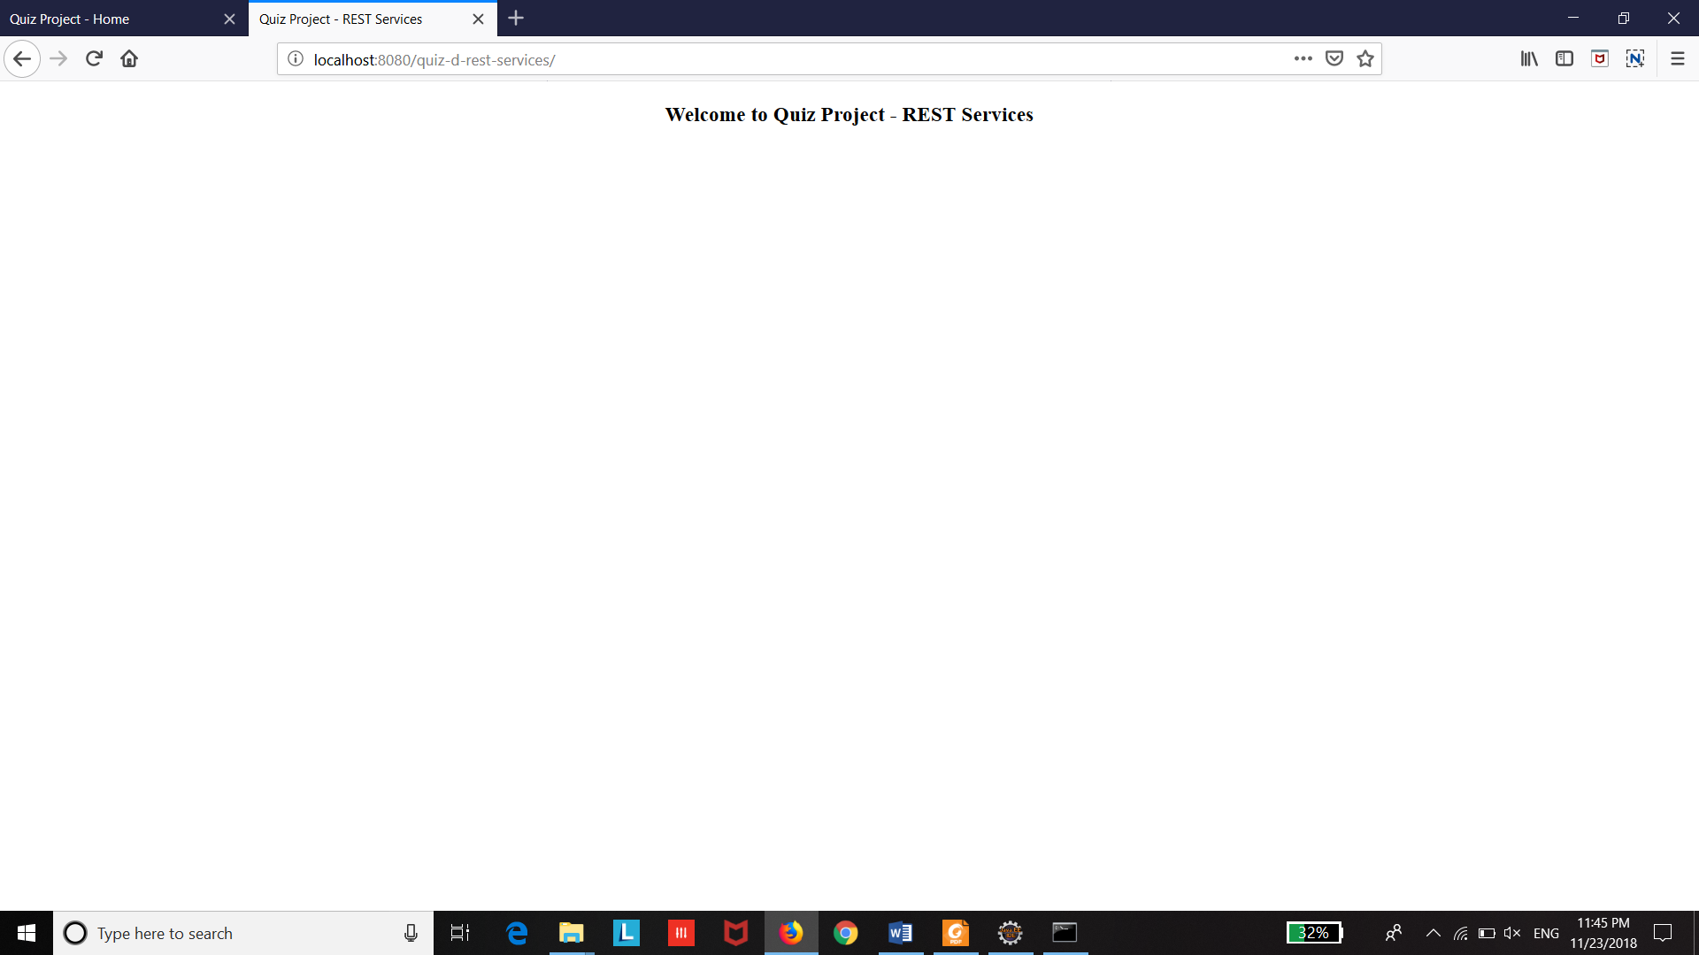

(ix) Select the **“Quiz Project”** project, right click the project and select the option **“Run As”**, select **“Run on Server”**, select the **“Tomcat Server v9.0”**  and add the project to the configured then click **“Finish”.**

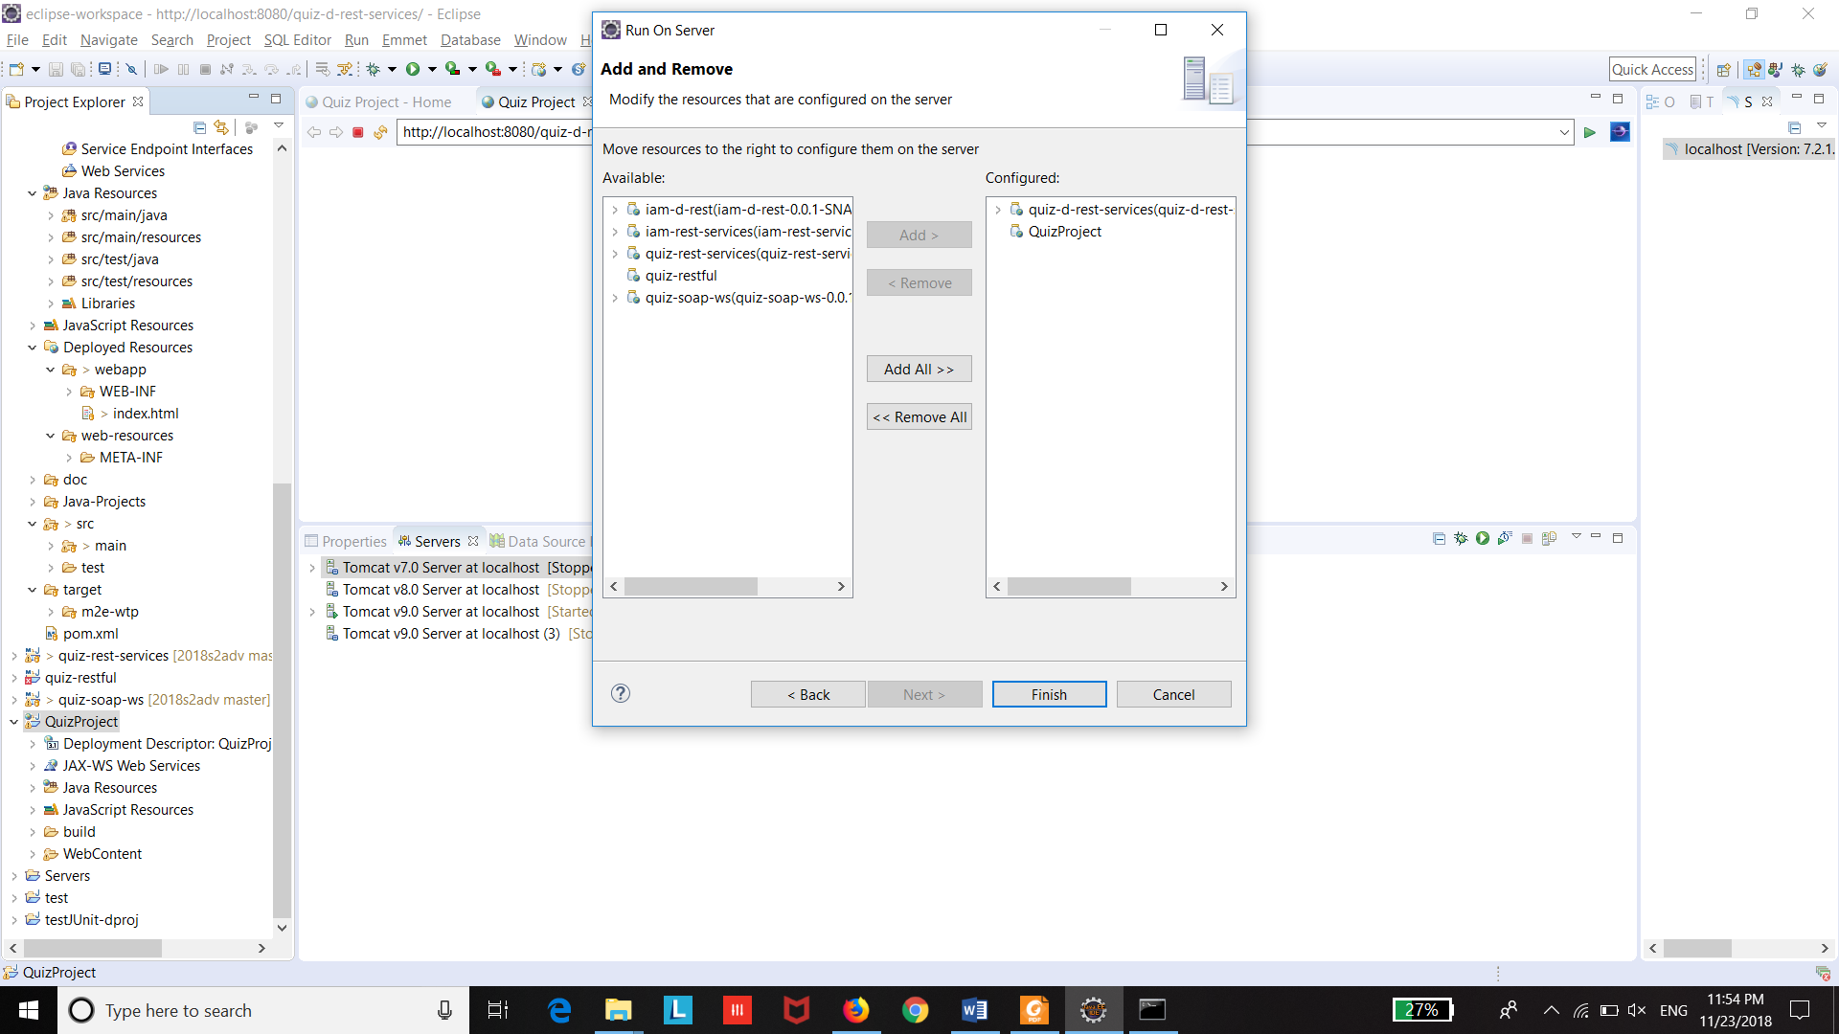

3.2 Launching the Quiz Project

Go to the web page link,

**Link:** <http://localhost:8080/QuizProject/>

A Welcome page (Dashboard) will be opened,

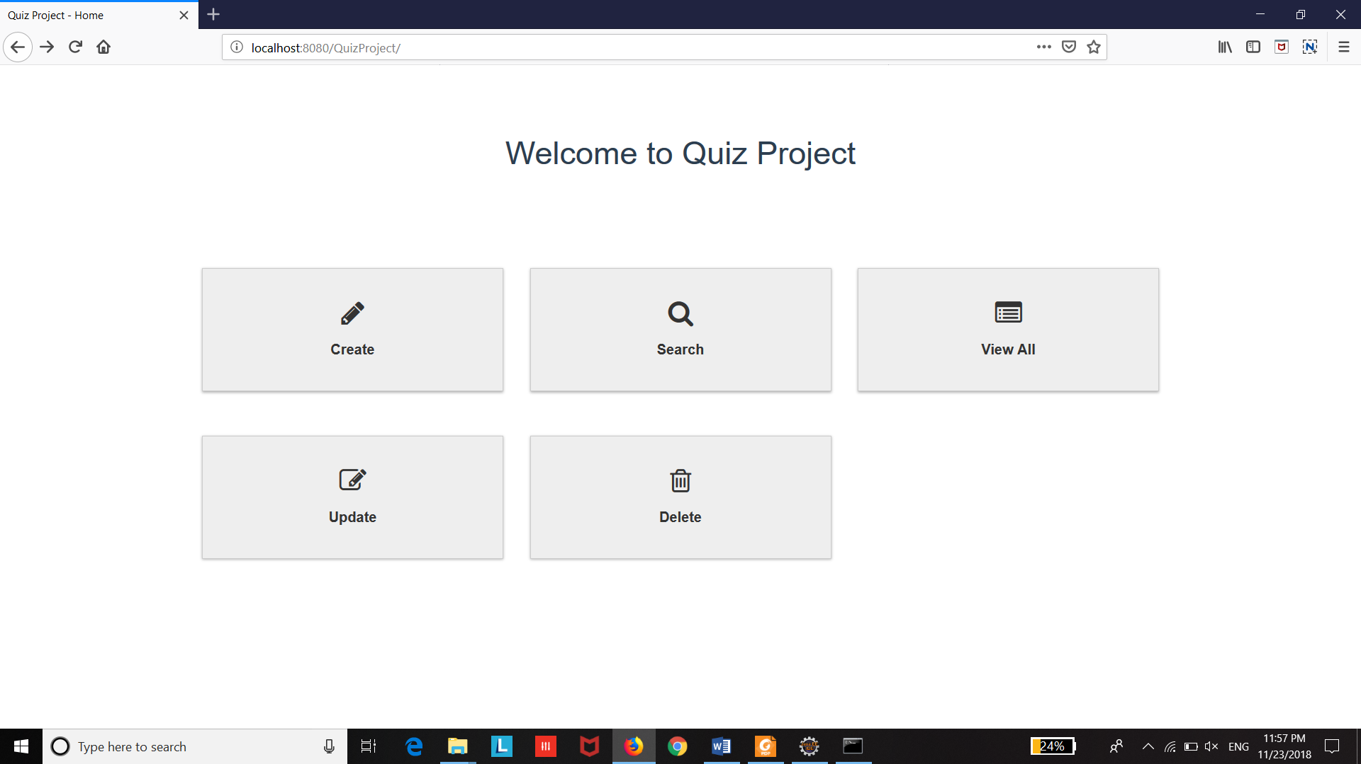

This page has the Create, Search, View All, Update and Delete operations of MCQs can be performed.

3.3 Create – View Page

(xi) Click on the “Create” icon to enter into the “Create Questions and MCQs”

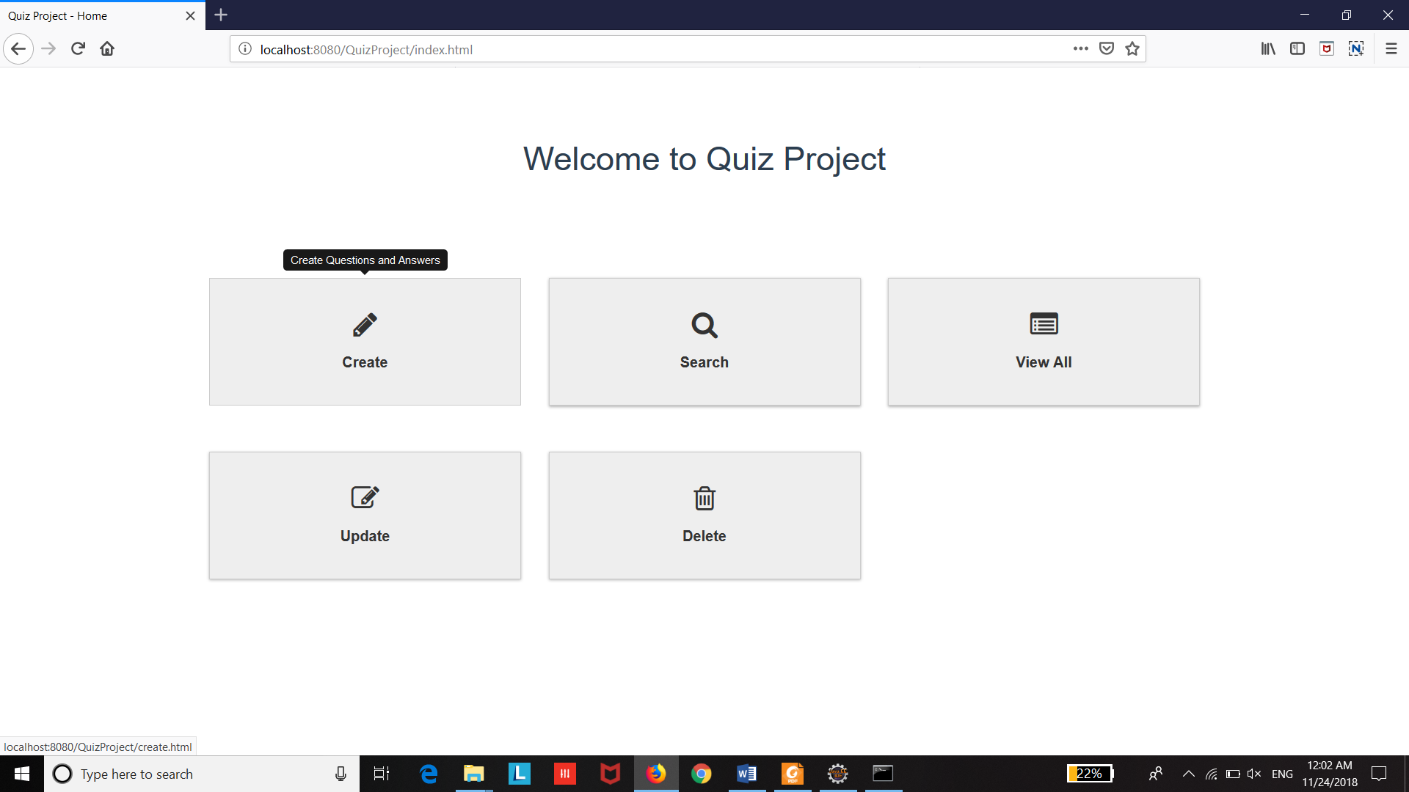

Create Page will be opened.

Give the Question and choices, select the valid status (correct answer: true or false) for each option.

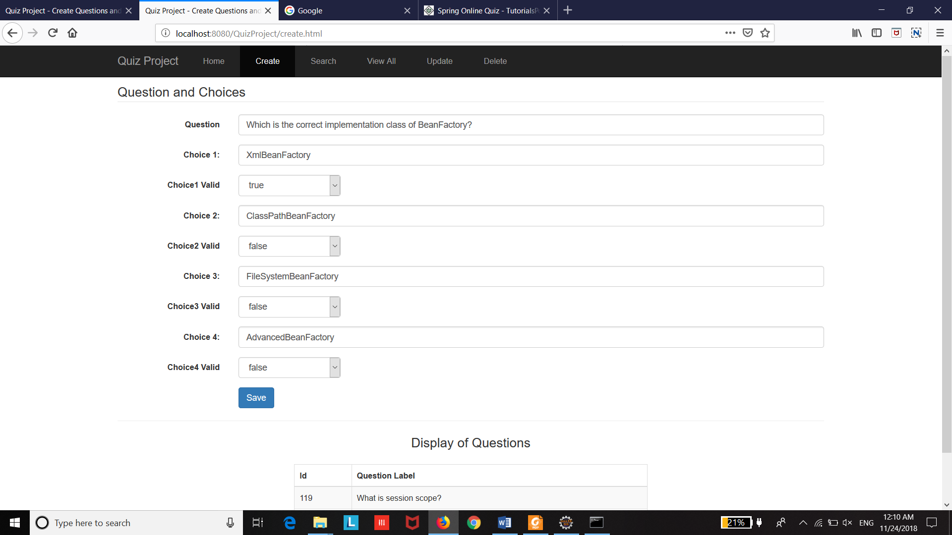

Click **“Save”** button to save the Question.

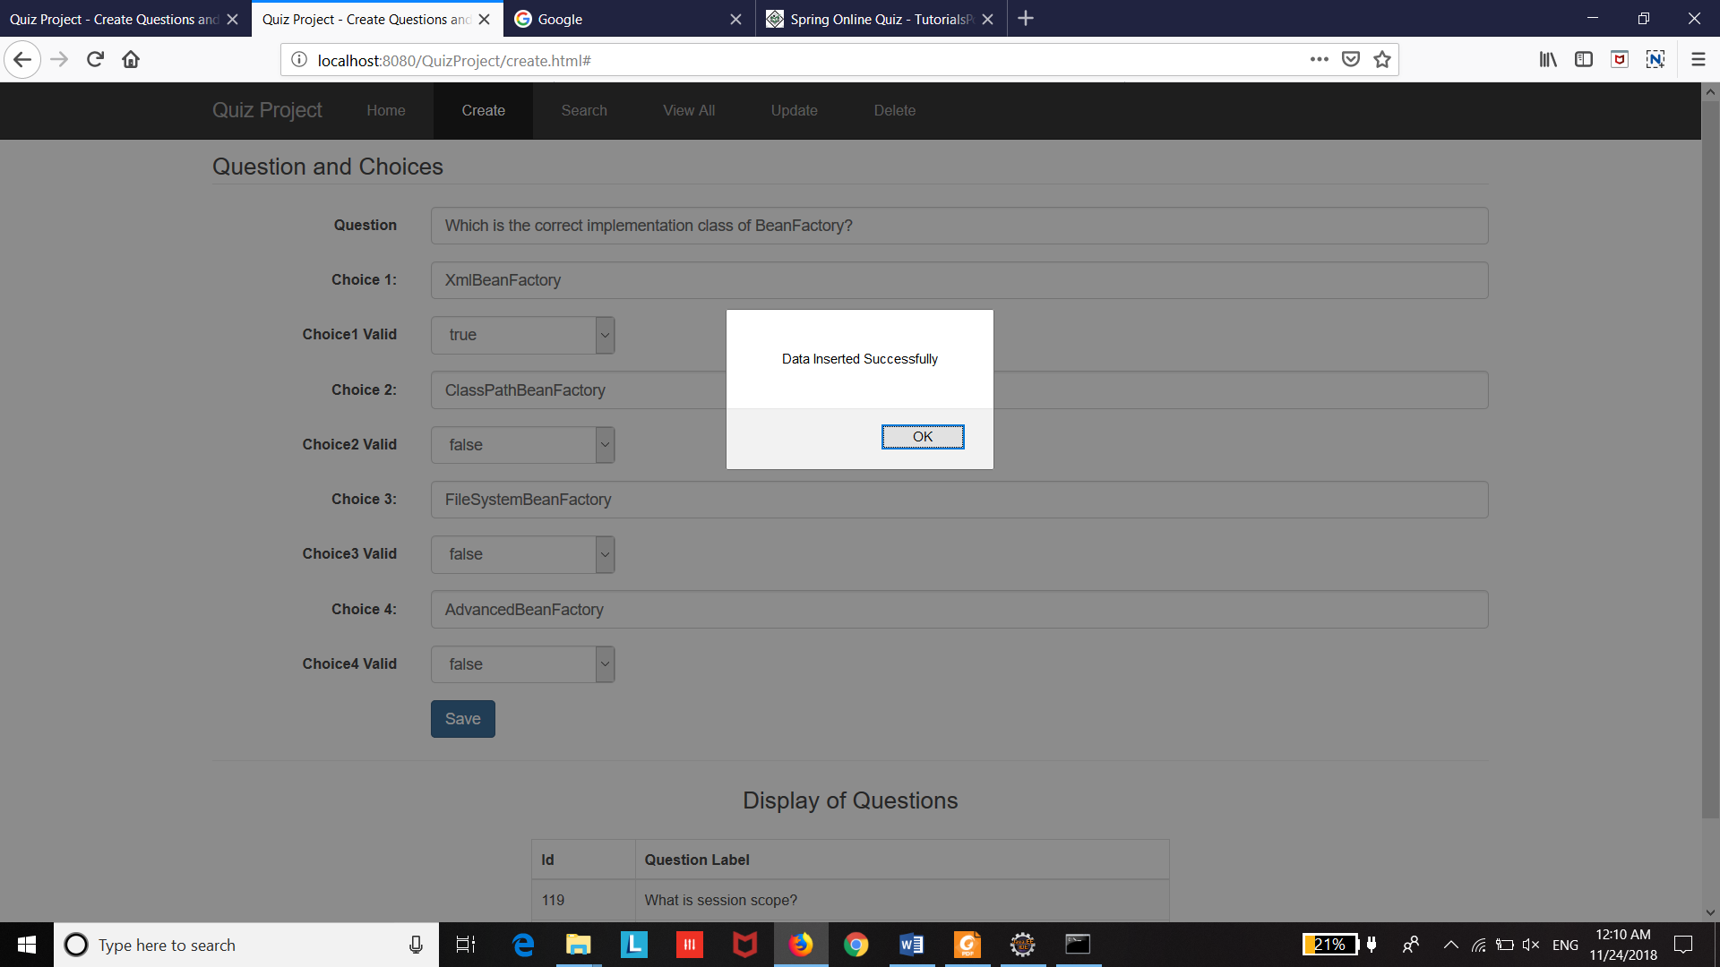

Front End Validations has been implemented displayed in the screenshot.

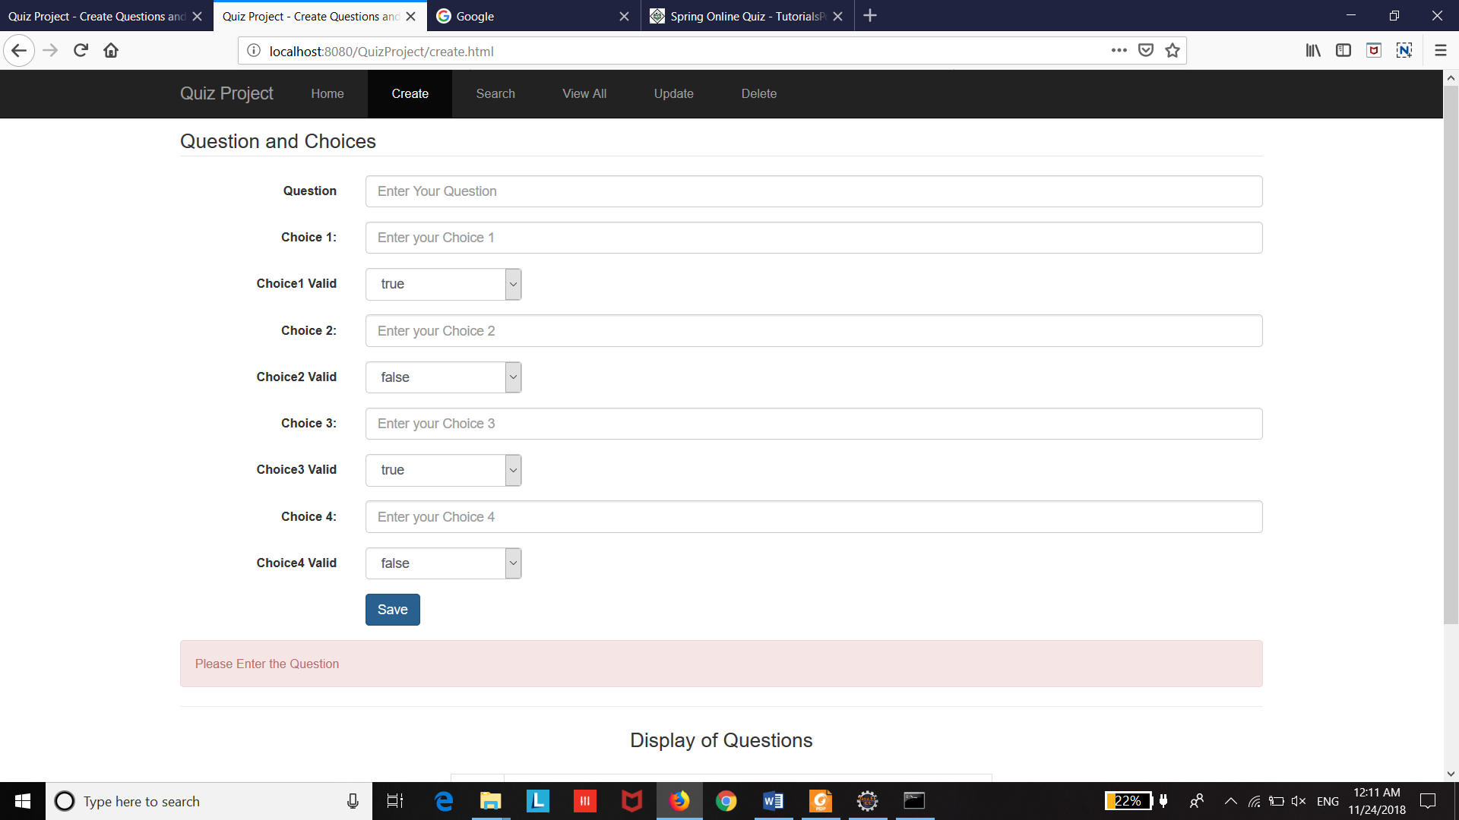

3.4 Search – View Page

In Search page, to search the question, please enter the keyword or part of the Question. (Eg: “correct” in the search field) and “Search” button. The Search Results will be displayed.

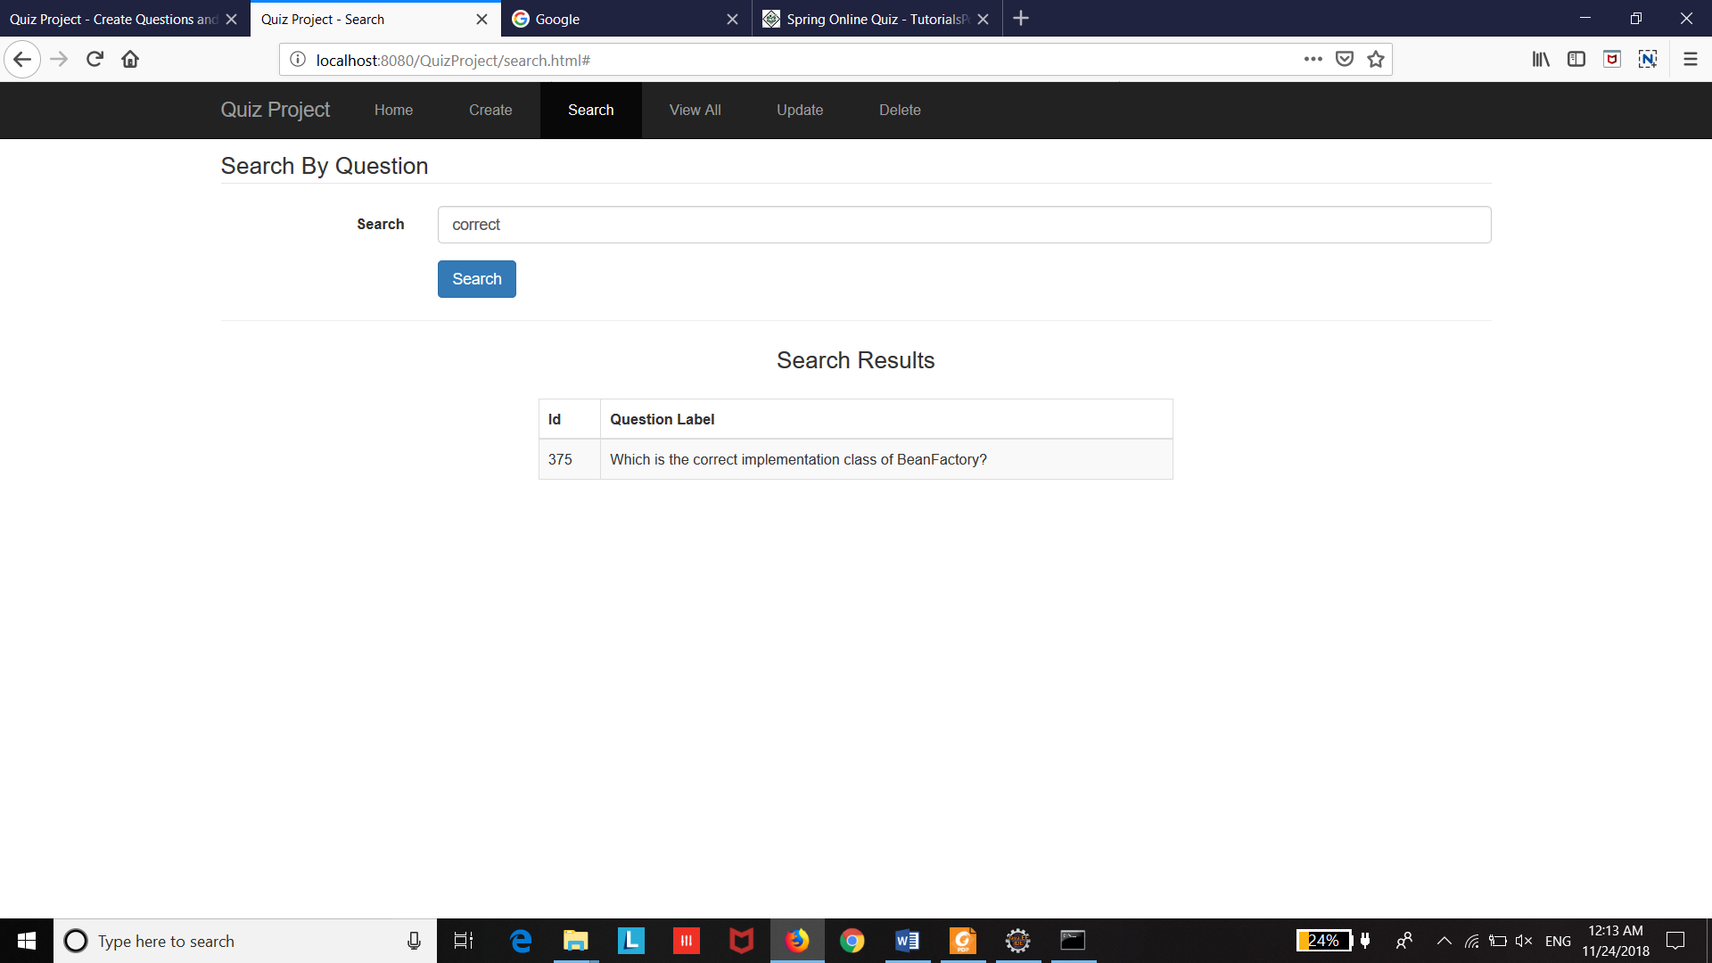

3.5 Delete – View Page

In Delete page, Give the Question ID in the field to delete the Question and the Choices

**Eg:** 119 (Question ID)

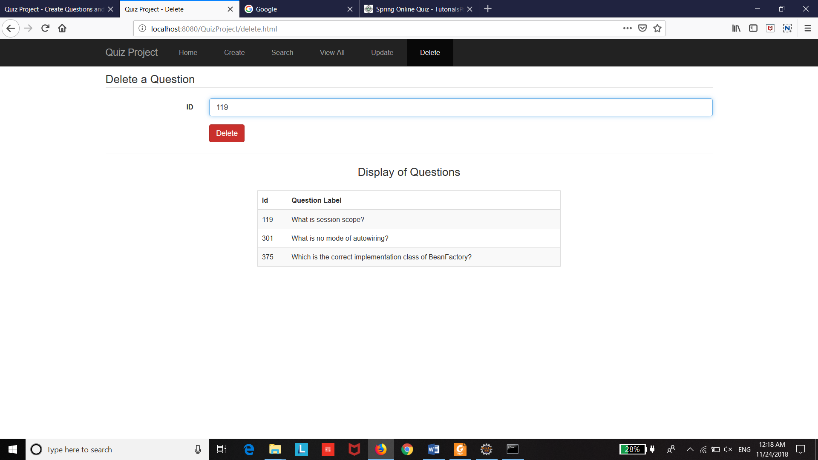

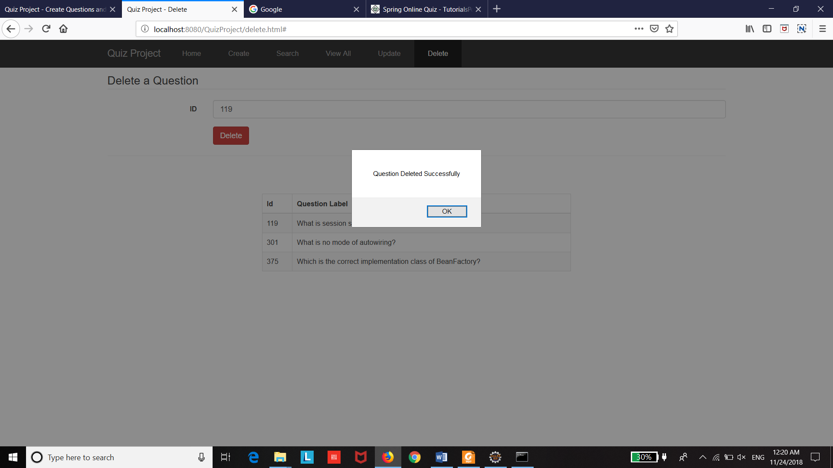

3.6 View All – View Page

In View All page, Displays all the “Questions and Answers” with the Question ID, Question Label, Choice ID and the list of choices.

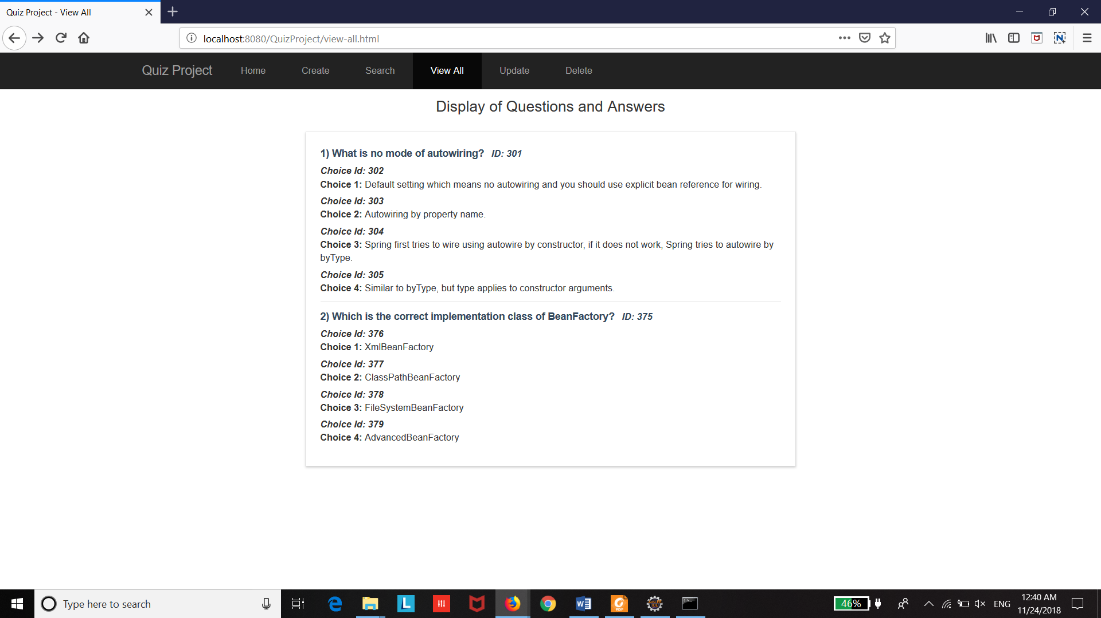

3.7 Update – View Page

(xv) In Update page, Give the Question ID, Question Label, Choice ID, Choice Label to be updated.

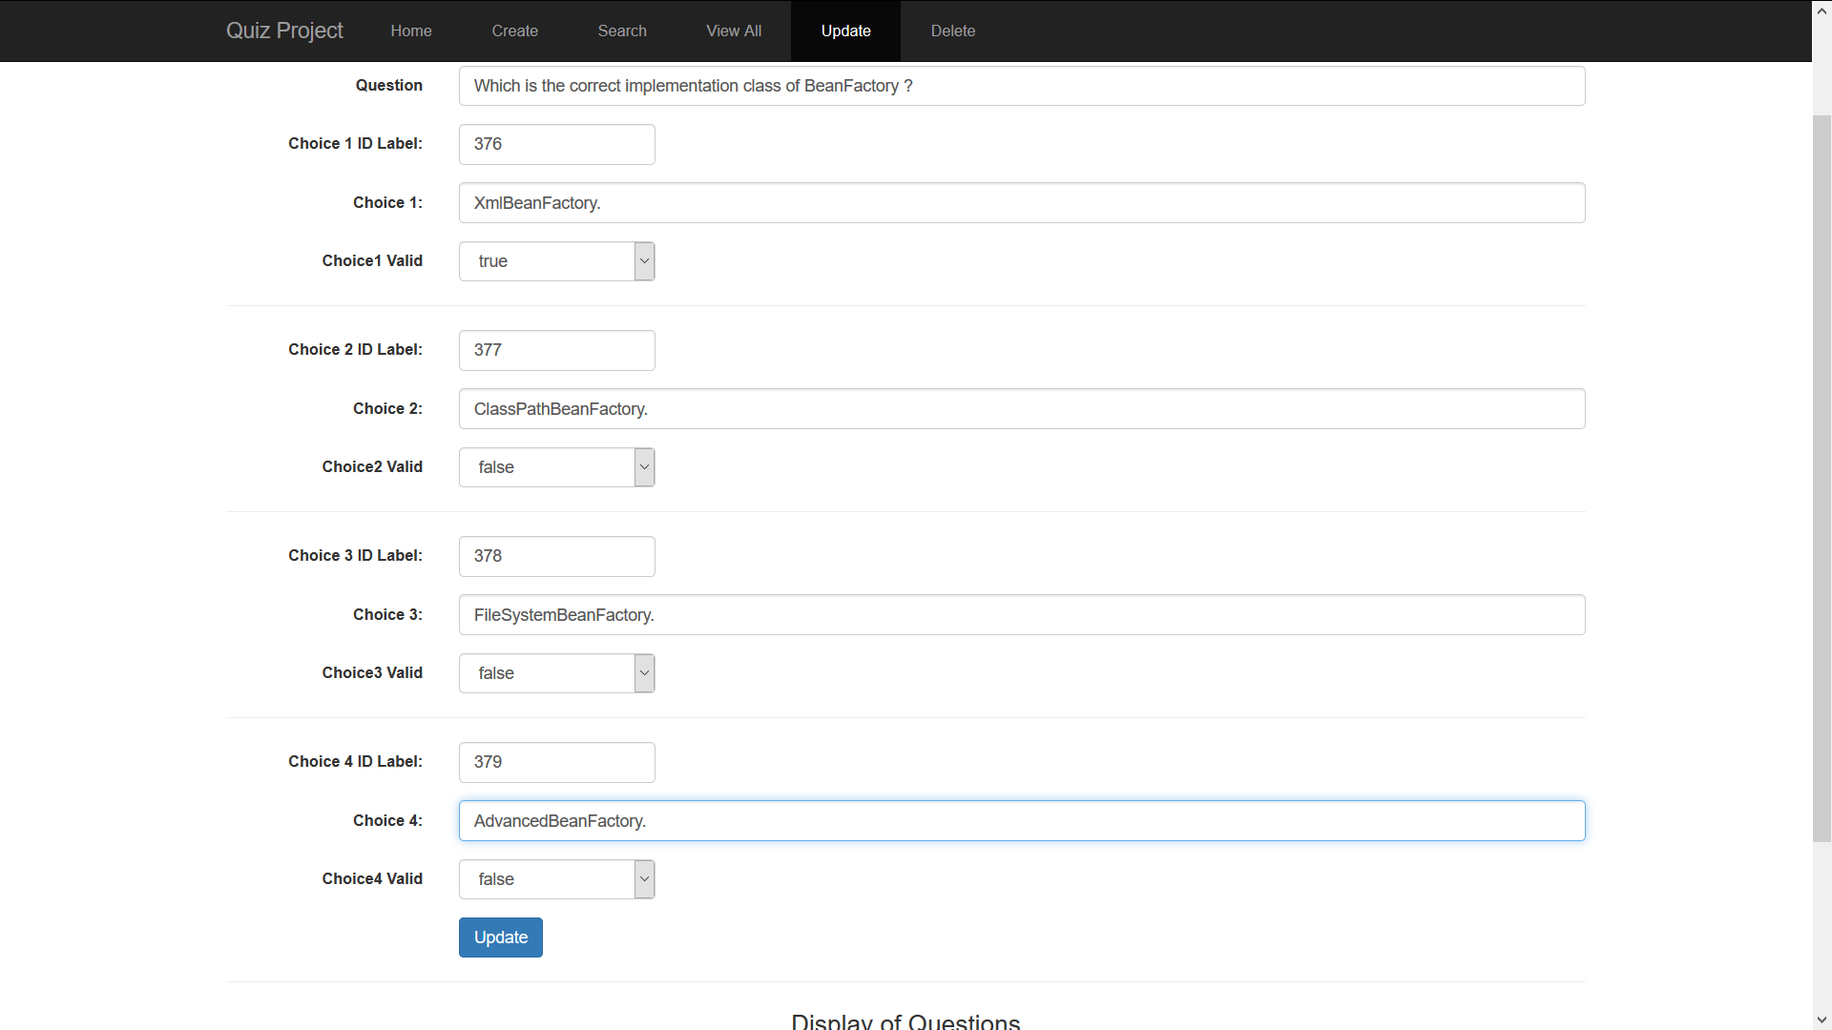

Click the **“Update”** button and alert the message will be displayed **(“Question and Choices – Updated Successfully”).**

