Email Receipt

On Self-Checkout Stations

This new feature will allow our patrons the option to email a digital version of the due date slip instead of a printed version. In addition to the digital version, patrons can chose not to print a receipt at all.

How does this work?

The process to check out items remains the same. When the patron is ready to finish their session (When they click “Finish & Print”), they’ll be presented with two additional options.

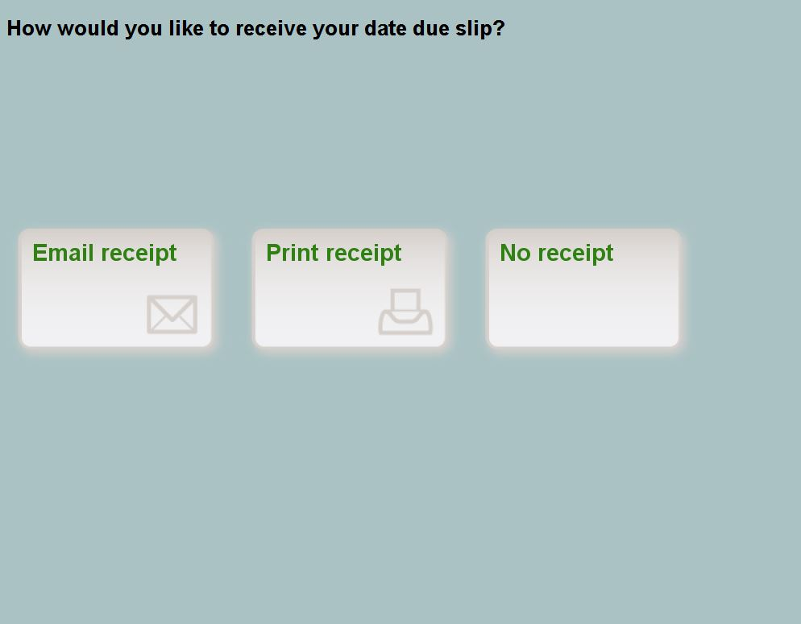

Patron will also have the option **NOT** to print a receipt at all.

If the email receipt option is clicked, the system will send the due date slip receipt to the email address stored on the patron account on Sierra.

When processing an Ecommerce transaction, the screen will display the amount paid and same delivery options.

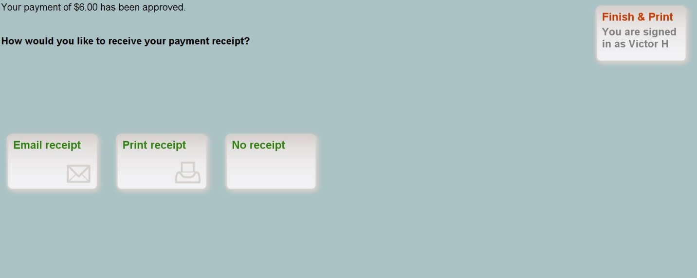

Once emailed by our system, patrons will receive a digital receipt.

Due Date Slip:

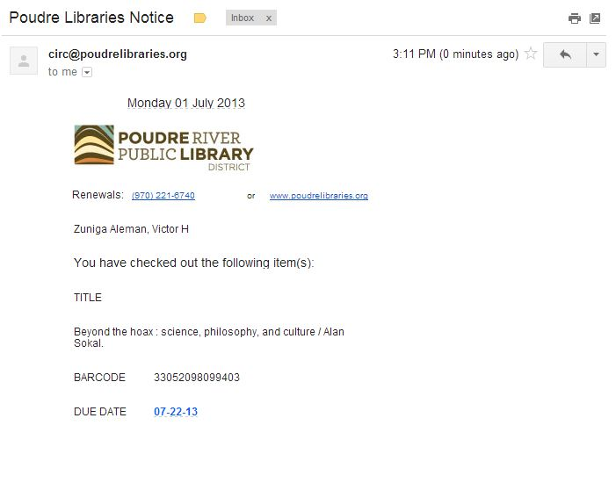

Ecommerce receipt:

