Albert Wang

HW#1 ME480

STL of cube by hand, no errors:

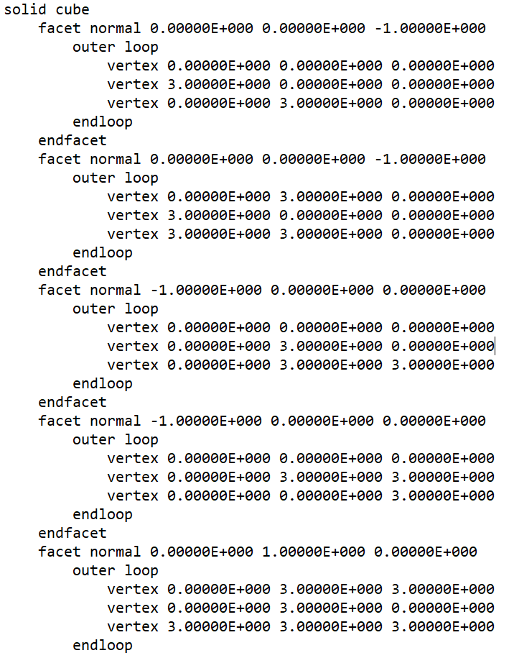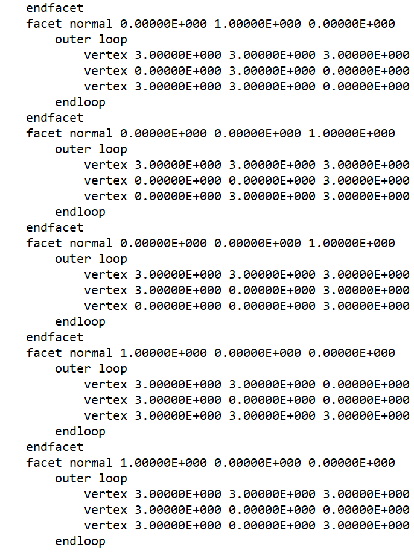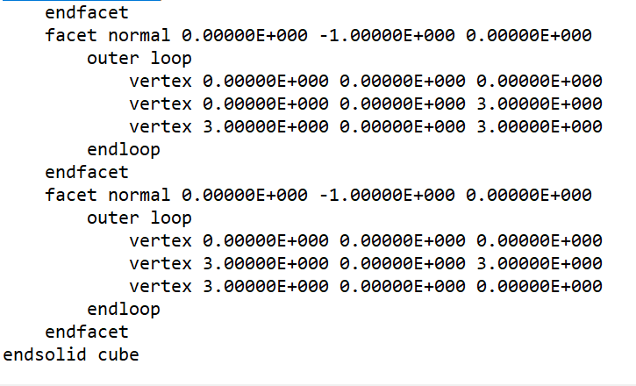

Screenshot of cura rendition – cube STL with no errors

STL of cube by hand, errors (missing triangles):

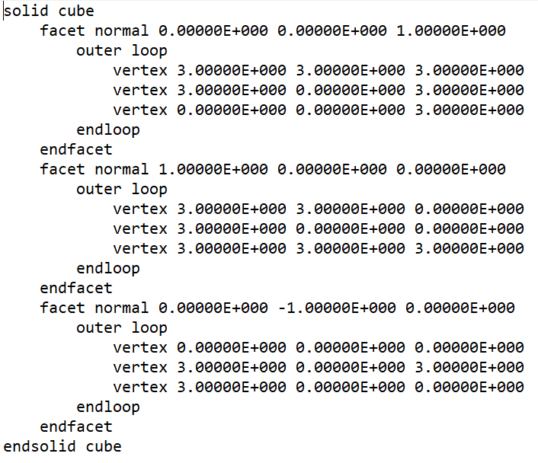

Screenshot of cura rendition – “cube” STL with errors

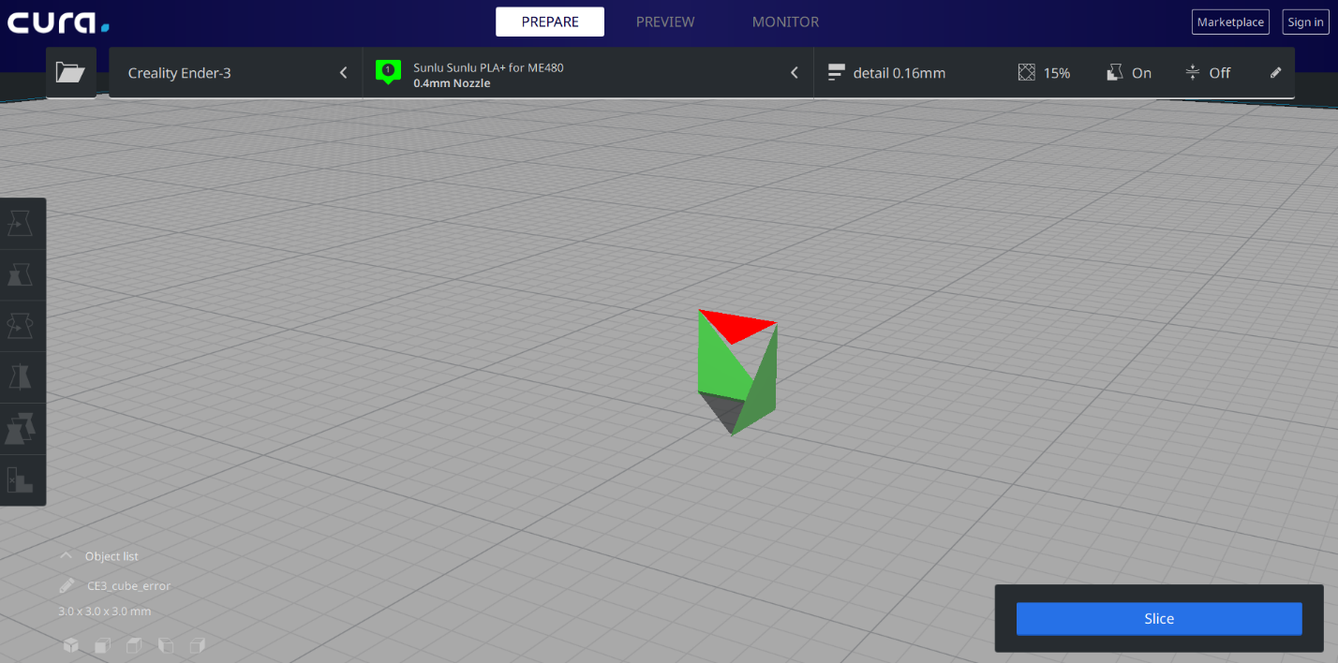

Gcode of unit cube by hand: absolute positioning with start and stop code for ender 3 machine:

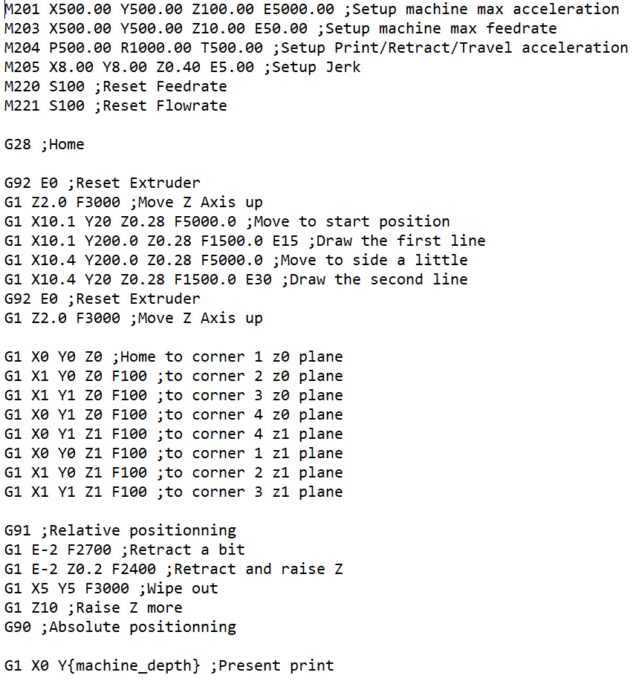 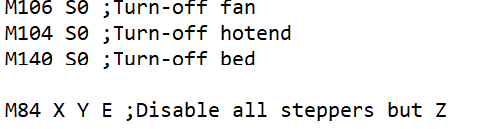

Visualization of g-code file (absolute):

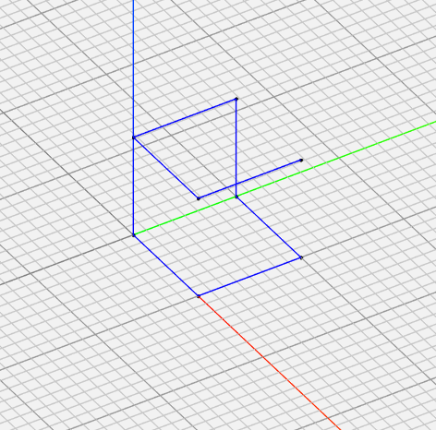

Gcode manually of unit cube using relative positioning:

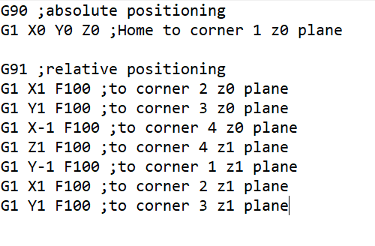

Visualization of g-code file (relative):

Infills:

Using an xyz 20mm calibration cube, the model was sliced in cura using gyroid, line, and trihex infills.

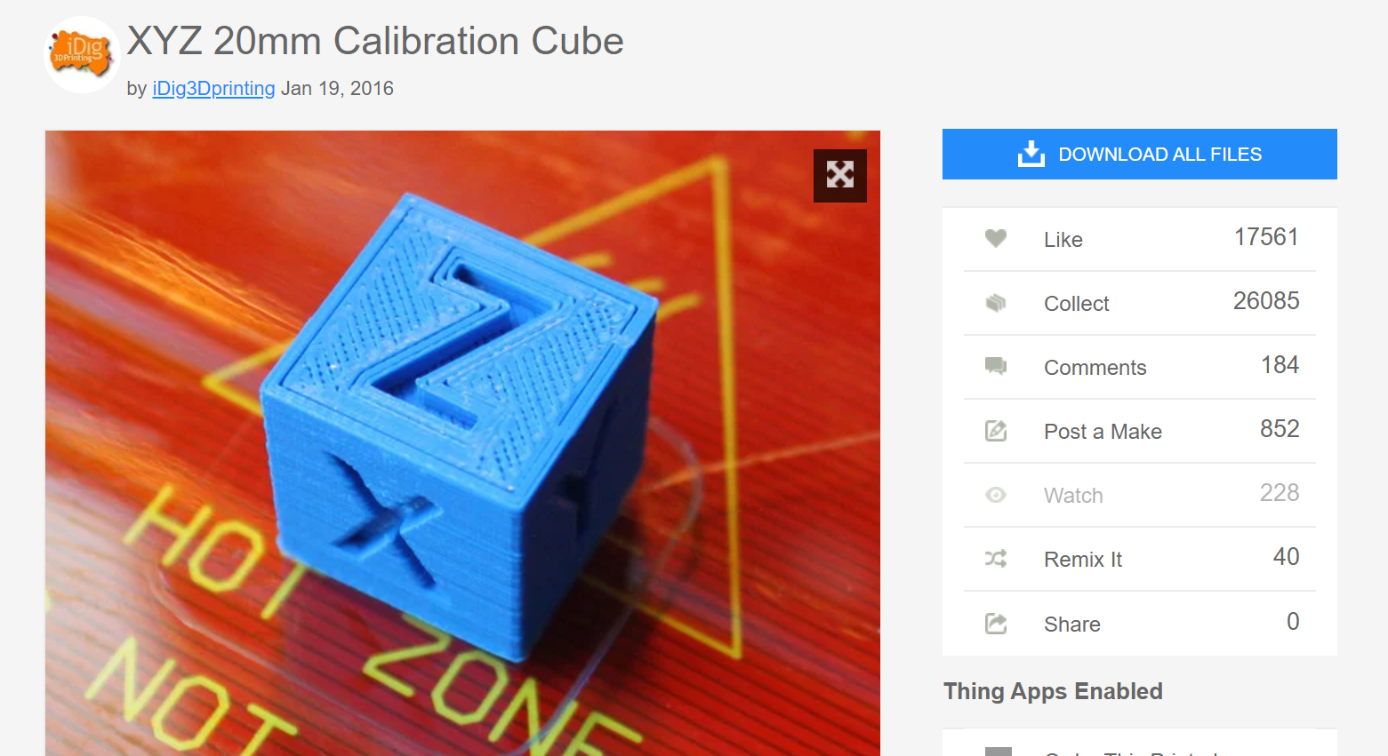

Gyroid: looks cool, prints on every later and fills 3d space allowing better strength distribution throughout the model in all directions. Takes longer to print + more material, more memory in file storage, and has overhangs which could lead to print failures.

Line: quick to print, doesn’t use much material and is easy to calculate paths for. Doesn’t print on all directions every layer, so infill is weaker, and “draping” lines at different heights can lead to uneven surfaces along z height.

Trihex: A good middle ground between gyroid and line. Prints every layer and in multiple directions per layer so strength is better distributed in 3d space, but without overhangs. Makes straight line moves so computational space and time spent is lesser than gyroid. Downside is you don’t get the full benefits of a simple (line) or a complex (gyroid) infill by compromising on certain features.