**User Manual for TransformerApp v0.1.1**

This is the user manual for TransformerApp v0.1.1. This document only covers how to use the app. For theory background, formulae and more development details, please refer to Developer Note.

**I. Circuit Compiler**

In this tab, the user can compile the circuit and get several useful parameters for the following design procedure.

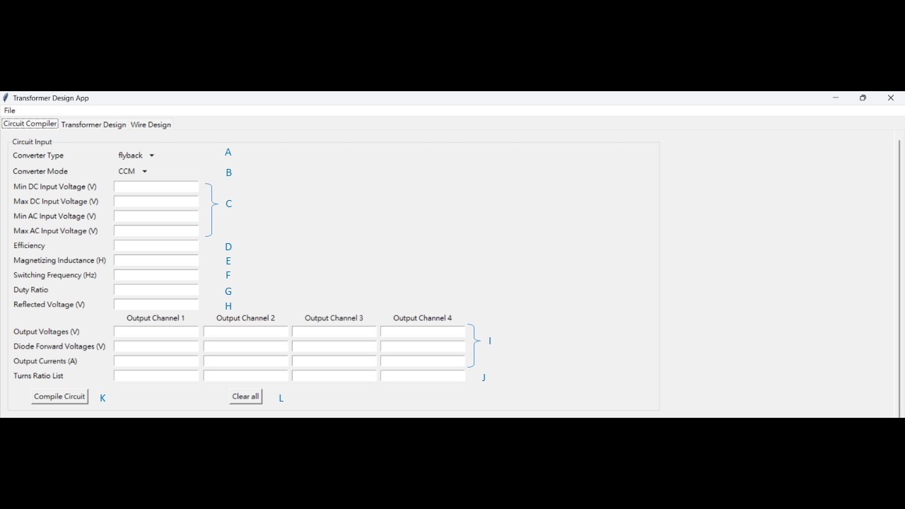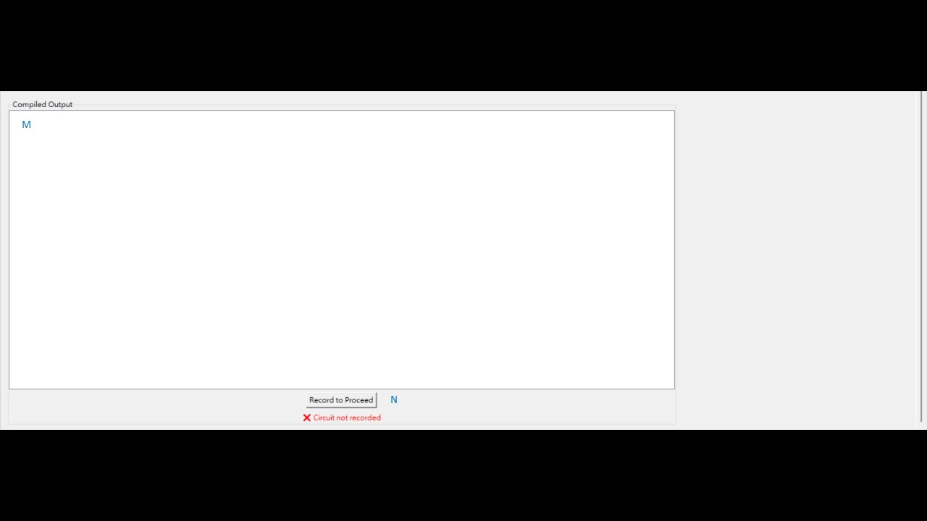

1. Converter Type

This is where the user selects the circuit topology. The formulae used in the following steps are based on the selection. The current version only supports flyback and forward topologies.

1. Converter Mode

The operation mode of your circuit. The current version supports CCM and BCM.

1. CCM (continuous conduction mode)

Under CCM, magnetizing inductance **must** be specified.

1. BCM (boundary conduction mode)

For flyback converter, the magnetizing inductance is a derived value under BCM. Please note that the value you inserted in magnetizing inductance will **not** be used when flyback converter and BCM are selected at the same time. A warning message will emerge in the console.

For forward converter, the compiler outputs an additional parameter “critical output inductance” under BCM. Please note that the magnetizing inductance **should still** be specified, and the calculation is **based on the assumption that the output current never falls under the specified output current value. This is just a rough calculation.**

1. Voltage Input Range

The input range of your converter in volts. Please note that at least one of minimum DC voltage or minimum AC voltage should be specified. Although the user can specify both, only the one that generates the minimum input voltage will be effective. In AC fields, the program expects an **RMS value** instead of peak value.

1. Efficiency

The assumed efficiency of your converter. Only values between 0 and 1 are accepted.

1. Magnetizing Inductance

The user should enter the magnetizing inductance (in Henry) under all circumstances except flyback topology under BCM. There will only be a warning message at the console but no error if entered. Under this configuration, the magnetizing inductance is a derived value. If the user selects a value higher than the compiled result, the circuit operates in CCM. If the user selects a value lower than the compiled result, the circuit works operates in DCM.

1. Switching Frequency

The switching frequency of the circuit.

1. Duty Ratio

The maximum allowed duty ratio for the circuit. The entered value should be between 0 and 1. At least one of duty ratio, reflected voltage and turns ratio should be specified. If multiple parameters are specified, the result will be based on the first available in the following order: duty ratio, turns ratio, reflected voltage.

1. Reflected Voltage

The voltage reflected to the primary side from secondary side in volts. At least one of duty ratio, reflected voltage and turns ratio should be specified. If multiple parameters are specified, the result will be based on the first available in the following order: duty ratio, turns ratio, reflected voltage. This field can be useful when maximum voltage across the MOSFET is specified.

1. Output spec

The user should enter all output specs here. Please note that **auxiliary outputs are treated as a normal output channel**.

1. Turns Ratio

Enter turns ratio here for each channel if the user has desired turns ratio in mind. Please note that **the primary winding is defined as 1.** For example, if some secondary turn has 15 turns while the primary has 10, the user should enter 1.5 for this channel. At least one of duty ratio, reflected voltage and turns ratio should be specified. If multiple parameters are specified, the result will be based on the first available in the following order: duty ratio, turns ratio, reflected voltage.

1. Compile Circuit

This button compiles the circuit for you. Remember to recompile if any of the above fields are modified.

1. Clear All

This button clears all entry in the fields above.

1. Output Field

If the compilation is successful, the results will be shown here.

1. Record to Proceed

This button records the latest compilation and can later be imported directly in transformer design tab. However, the user should still review the parameters in the next tab and make adjustments if necessary.

**II. Transformer Design**

This tab assists the user with transformer turns design. Several fields can be directly imported from the Circuit Compiler tab; however, users should not apply these values blindly. It is important to understand the difference between the output parameters from the previous tab and the required input for this design step. Additional parameters are necessary, and adjustments should be made to ensure a feasible and accurate turns configuration.

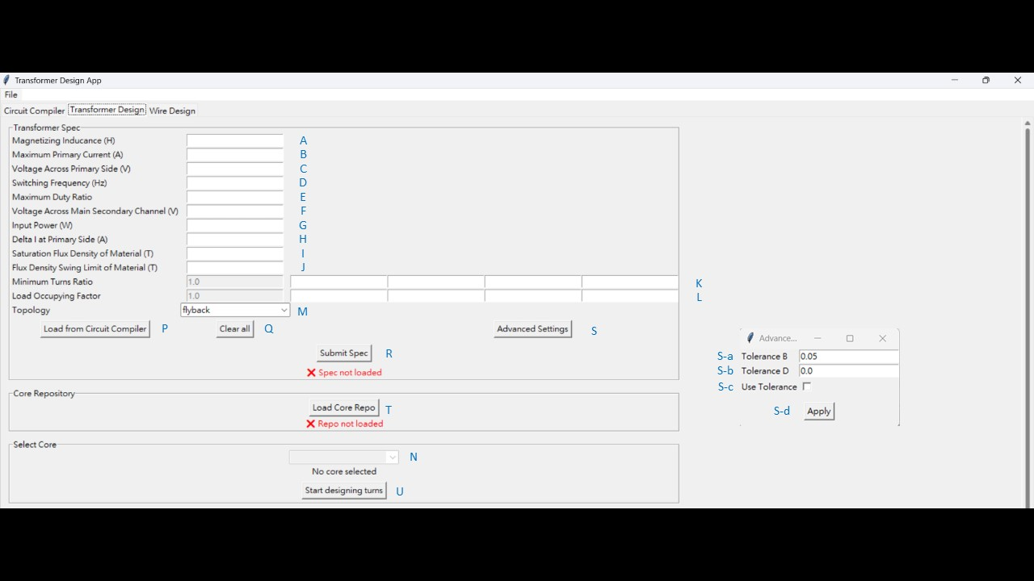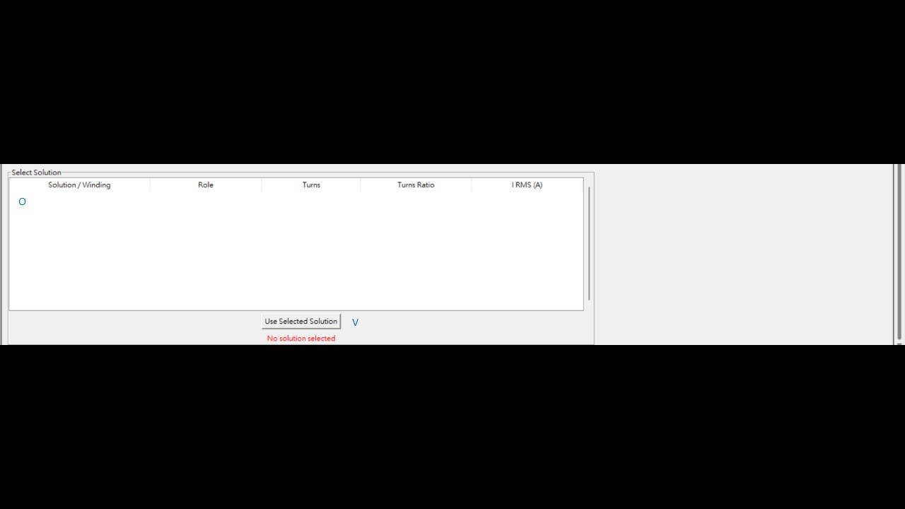

1. Magnetizing Inductance

The user should specify the magnetizing inductance of the transformer in Henry.

1. Maximum Primary Current

This field takes the maximum primary current (peak current) at primary side in Ampere. This field is only active when saturation flux density is also specified. Hence, at least one of the following pair should both be specified: Maximum primary current and saturation flux density; delta I at primary side and flux density swing limit. Although this field is optional as it checks for saturation of magnetic flux density for the material, the user should omit this field only if he or she is certain that the saturation of the flux density is not one of the design consideration.

1. Voltage across the Primary Side

This field takes in the voltage across primary side in volts.

1. Switching Frequency

The switching frequency of the circuit.

1. Maximum Duty Ratio

The maximum allowed duty ratio for the circuit. The entered value must be between 0 and 1. **Warning: This field takes in the maximum allowed duty ratio, which is not necessarily and often not the value the user obtained from circuit compiler. Although the import button directly imports that value, please do not apply it blindly and make sure to check it before using it safely.**

1. Voltage across Main Secondary Channel

This field accepts the voltage across the main secondary channel (the one from which the control scheme takes feedback). Please note that this is the voltage across the channel, not the output voltage. Therefore, the voltage drop caused by diodes or other components should also be considered. If imported from circuit compiler tab, the default value imported is from the first output channel, and the forward voltage of the diode is added automatically for the user.

1. Input Power

This field takes in the input power in watts.

1. Delta I at Primary Side

This field takes the maximum current swing (delta I) at primary side in Ampere. This field is only active when flux density swing limit is also specified. Hence, at least one of the following pair should both be specified: Maximum primary current and saturation flux density; delta I at primary side and flux density swing limit. Although this field is optional as it checks for the limit to magnetic flux density swing for the material (often seen in high frequency, core loss bound cases), the user should omit this field only if he or she is certain that the swing of the flux density is not one of the design considerations.

1. Saturation Flux Density of the Material

This field takes in the saturation flux density of the material in Tesla. This field is only active when maximum current at primary side is also specified. Hence, at least one of the following pair should both be specified: Maximum primary current and saturation flux density; delta I at primary side and flux density swing limit. Although this field is optional as it checks for saturation of magnetic flux density for the material, the user should omit this field only if he or she is certain that the saturation of the flux density is not one of the design consideration.

1. Flux Density Swing Limit of the Material

This field takes in the flux density swing limit of the material in Tesla. This field is only active when delta I at primary side is also specified. Hence, at least one of the following pair should both be specified: Maximum primary current and saturation flux density; delta I at primary side and flux density swing limit. Although this field is optional as it checks for the limit to magnetic flux density swing for the material (often seen in high frequency, core loss bound cases), the user should omit this field only if he or she is certain that the swing of the flux density is not one of the design consideration.

1. Minimum Turns Ratio

The field takes in the **minimum** turns ratio for each corresponding channels. The values are used as a starting point for finding turns solution. Please note that **the primary winding is defined as 1**. For example, if some secondary turn has 15 turns while the primary has 10, then the user should enter 1.5 for this channel. There is a disabled entry with value 1 at the beginning of the list which stands for the primary winding; hence, the user **should not** enter the turns ratio of the primary winding manually.

1. Load Occupying Factor

This field takes in the load occupying factor for each corresponding channels. It is calculated by the power of the specific channel over total output power. There is a disabled entry with value 1 at the beginning of the list which stands for the primary winding; hence, the user **should not** enter the load occupying factor for the primary winding manually.

1. Topology

The circuit topology of the design.

1. Select Core

The user can select his or her desired core from the drop down list. The user can create a custom core and be selected from here. More details will be gone through later.

1. Solution Field

This field displays the turns solution found with the spec submitted and the core selected.

1. Load from Circuit Compiler

This button auto-fills the fields whose information is available in the circuit compiler tab. To avoid unwanted data, uncleaned data, it is strongly recommended that the user **click clear all before loading** from circuit compiler. **Warning: The user should be aware of the difference between the output of the previous tab and the input of the current tab. The user should never apply the imported values blindly. Adjustments may be necessary for some of the fields. Figures are rounded upon import.**

1. Clear all

This button clears all fields in this tab excluding the core repo and selected core.

1. Submit Spec

This button captures all the fields in the Transformer Spec frame and take it as input to proceed solution finding. The user must submit spec before finding solution, and the user should always submit spec after modifying the entries.

1. Advanced Settings

This button opens up a window where the user can configure advanced settings.

1. Tolerance B

This is the ratio which the magnetic flux can exceed the limit by. Only values between 0 and 1 are accepted.

1. Tolerance D

This is the ratio which the duty ratio can exceed the limit by. Only values between 0 and 1 are accepted.

1. Use Tolerance

By checking the box, the tolerance is applied to the solution finding procedure. This allows the user to get multiple solutions to select. Only enable this if the user knows what he or she is doing.

1. Apply

The user should always remember to click apply after any changes in this window is made.

1. Load Core Repo  
   This button opens up a file dialog window where the user browse his or her own file system to fetch the core data. Upon choosing the file, the user will also have to choose the sheet where the formatted data is located. The format of the data is shown below; the user can always add custom cores as long as the format is complied. Basically, the core can fully function in the program as long as Ae, Aw, width, and height are specified. Please enter the winding width under “width” instead of “幅寬.”
2. Start Designing Turns

This button starts the designing process with the latest submitted spec, latest applied advanced option and the core selected. If unreasonable result appeared, please first confirm that every change in fields is submitted or applied.

1. Use Selected Solution

Once a solution is selected, this button records it. To select a solution, simply click on any line, which highlights it, that belongs to the solution.

**III. Wire Design**

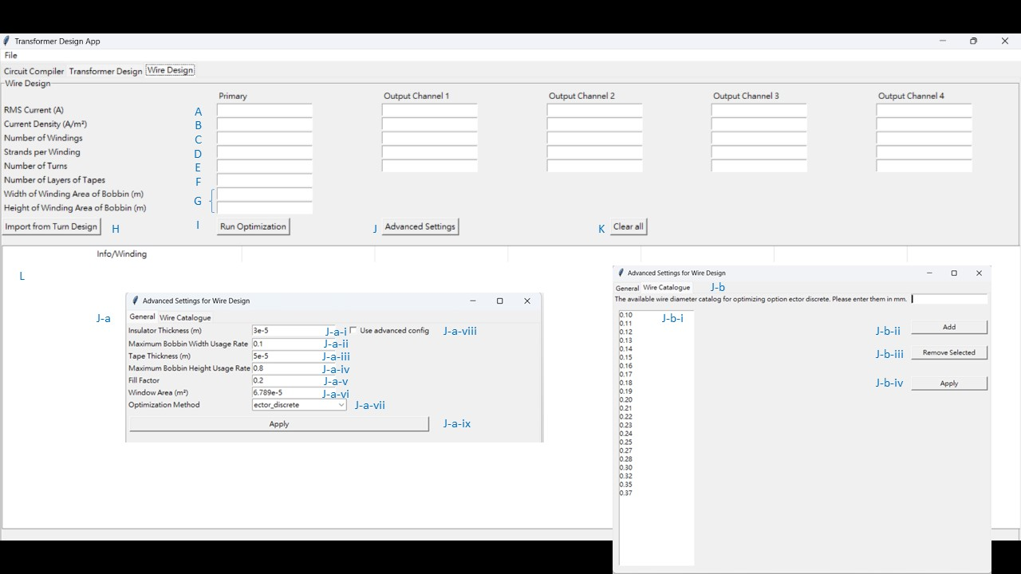This tab tries to find an optimized wire diameter for the transformer design.

1. RMS Current

These entries accept RMS current for each channel in Ampere. Please note that in this tab, primary, secondary and auxiliary windings are all treated in the same way.

1. Current Density

These entries take in the maximum current density allowed for each channel in Ampere per millimeter squared. This serves as a strict constraint in the following optimization steps. In kf_method, these entries serve as the current density used to calculate the required winding window area.

1. Number of Windings

These entries take in the number of windings for each channel. Here, we define a winding as a full set of strands that occupies a whole layer on its own, no matter it is connected in parallel on the same pin or not. Examples are provided below for reference.

1. Strands per Winding

These entries take in the number of strands for each winding. Examples are provided below for reference.

1. Number of Turns

These entries take in the number of turns for each channel. Please note that in this tab, primary, secondary and auxiliary windings are all treated in the same way.

1. Number of Layers of Tape

This entry takes in the number of layers of Mylar tape wrapped in the whole winding window. Please note that it refers to the layers of tape used, not how many interlayers there are in the transformer (an interlayer can contain more than one layer of tape).

1. Geometry of the Winding Area in Bobbins

These two entries take in the width and height of the winding area of the bobbin respectively. The values will automatically be imported from the transformer design tab if the import is success and the core database includes this information. The user can also fill in the values on their own.

1. Import from Turns Design

This button imports the solution selected from the transformer design tab. Please note that the user should select a solution first in the previous tab, even if there is only a single solution. It is recommended that the user click clear all button before importing solution. **Warning: Figures are rounded upon import.**

1. Run Optimization

This button runs the optimization process and present the result in the result field. The user should always rerun optimization if a field above is modified.

1. Advanced Settings

This button opens up a window that allows the user to make some advanced configurations.

1. General

i. Insulator Thickness

This determines the thickness of the insulator coated around the wire. The default value is 3e-5 (0.03mm).

ii. Maximum bobbin width usage rate

This entry takes in the maximum ratio that the wire can occupy along the width of the winding area of the bobbin. The program will automatically decrease the wire diameter or even add another layer to fit this value. The default value is 0.9.

iii. Tape thickness

This entry takes in the thickness of the tape wrapped between and at the outer most of the windings. The default value is 5e-5 (0.05mm).

iv. Maximum bobbin height usage rate

This entry takes in the maximum ratio that the winding can occupy along the height of the winding area of the bobbin. The default value is 0.8.

v. Fill Factor

This entry takes in the assumed fill factor used to make a primal guess of whether the winding can fit in the window area of the bobbin or not. The default value is 0.2. This field is only active under kf method.

vi. Window Area

This entry takes in the window area of the core. Since the window area data is not available for every core, the user should key them in on their own. This field is only active under kf method.

vii. Optimization method

The current version supports only 3 optimization methods.

vii-i. Ector_discrete

This method uses concrete width and height calculation based on all the aforementioned information excluding fill factor and window area. In this method, the result only includes specific wire diameters, resembling the reality more. Thus, it is also set as the default method. The catalog of the wire diameters can be configured in the Wire Catalog tab which will later be elaborated.

vii-ii. Ector_continuous

This method uses concrete width and height calculation based on all the aforementioned information excluding fill factor and window area. However, the results contain continuous wire diameters. This method has more prospects in optimization target and constraints that has not yet been implemented.

vii-iii. kf_method

This method serves as a primal approach to determine if the current window of the core is enough for the winding or not. The feasible/infeasible result is determined through calculating the window area required by the RMS current and the assumed current density. The assumed current densities use the same entries as other methods.

viii. Use advanced config

Only when the box is checked for this option will the advanced config be used in optimization. If left unchecked, the program automatically runs ector_discrete method with the default wire diameter catalog. Only enable this option if the user knows what he or she is doing.

ix. Apply

This button applies the general configurations in this tab to the optimization. Please note that only when the use advanced config option is checked will the settings be used in the actual optimization, and that this button does not affect the wire catalogue even if unsaved changes are present in both tabs.

1. Wire Catalogue

This tab enables the user to configure the available wire diameters that can be used in optimization method ector_discrete.

i. Catalog field

This field shows all the wire diameters available in optimization in the current state if the use advanced config option is checked.

ii. Add diameter

This entry takes in the wire diameter the user wants to add in the catalogue in mm. Remember to click on Add button to add the entered value to the catalogue. If the diameter is successfully added, the user can immediately observe it in the catalog field.

iii. Remove Selected

By clicking on the undesired diameter in the catalog field, which highlights the entire row, a diameter is selected. To remove it from the catalogue, click remove selected.

iv. Apply

This button applies the wire catalogue showed in the catalog field to the optimization only if the use advanced option is checked in tab General. Please note that only when the use advanced config option is checked will the catalogue be used in the actual optimization, and that this button does not affect the general settings even if unsaved changes are present in both tabs.­­­­

1. Clear All

This button clears all entries in the tab. It is highly recommended to click it before importing from turns solution to prevent confusion.

1. Result Field

This field displays the result of the optimization.

**IV. File System**

1. Import Workspace

It opens up a file dialog that allows the user to choose an existing saved file. After the file is selected, all entries with available data in the imported file will be overridden. It is highly recommended that the user clears all entries before importing.

1. Export Workspace

It opens up a file dialog that allows the user to choose where to save the current progress. All entries will be captured at present state, and the result for wire optimization will be recorded. The file is saved as yaml file for user-editable consideration. However, the naming rules are different from the user interface in the application. Please be careful editing them outside the application.

1. Exit

Exit the application.

**V. Example**

Here is an example showing how this application can cooperate with the designer with provided specification.

Power transformer specification for PMP 22345 Flyback converter

Topology and operation mode: Flyback under CCM

Switching frequency: 250 kHz

Primary voltage: 40VDC to 57VDC

Secondary voltage: 32VDC/2.4A

Bias Voltage: 11VDC/20mA

Maximum duty ratio: 49%

Primary Inductance: 30uH

Layer Stackup: 1/2 PRI_SEC_BIAS_1/2PRI

Core: EFD25

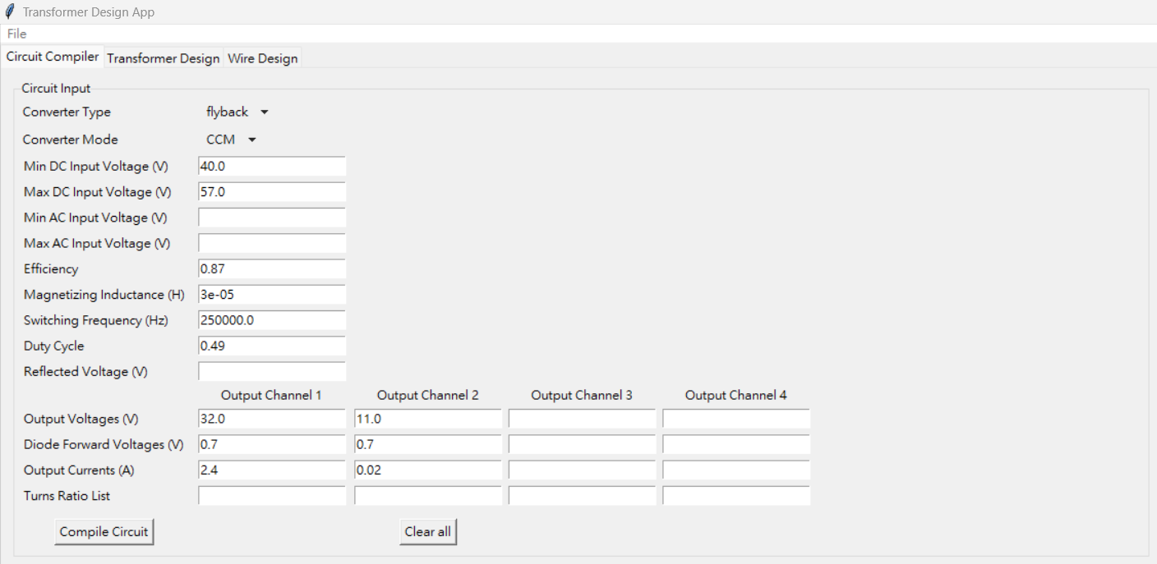The design process starts with entering relevant fields as shown below. We assume that the diode forward voltage is 0.7V and the efficiency is 0.87.

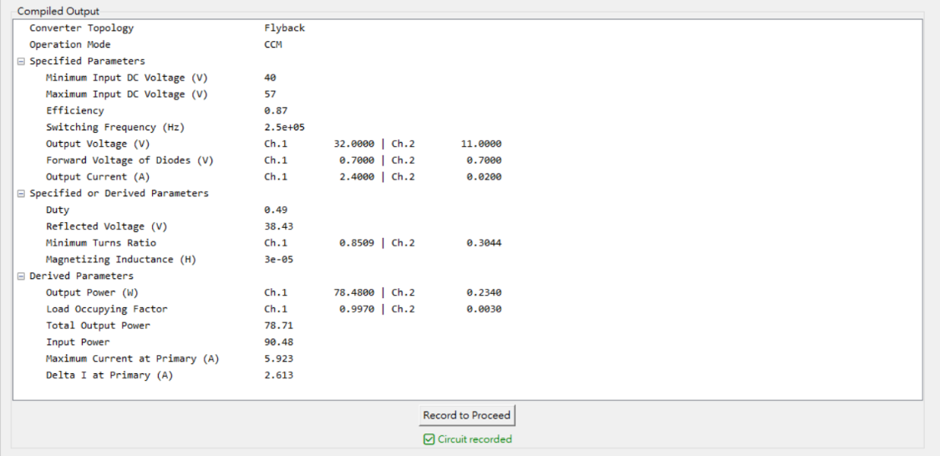Click compile Circuit and click Record to Proceed:

We can now proceed to transformer design tab. First, click on import from circuit compiler and fill in the saturation flux density of material, assuming that the saturation flux density is 0.25T. We then submit the entered spec with the button. Next, we load the core repository from our file system and select sheet1. Upon creating the repository in the application, we select EFD25 from the dropdown list.

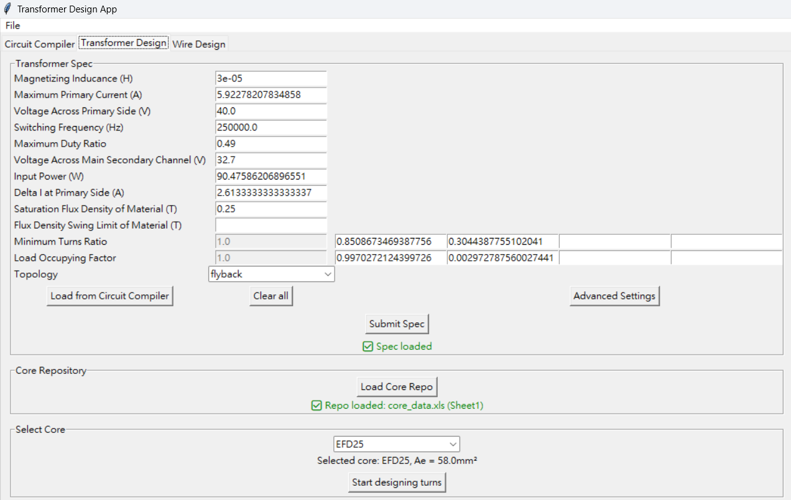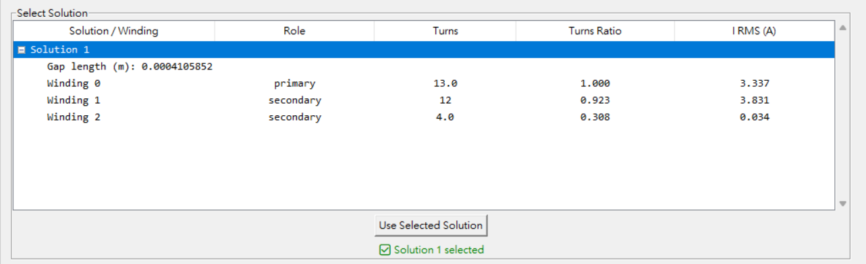After everything is done, we click start designing turns and observe it in the output field. We click on arbitrary row of the desired solution and click use selected solution.

We can now proceed to the final tab.

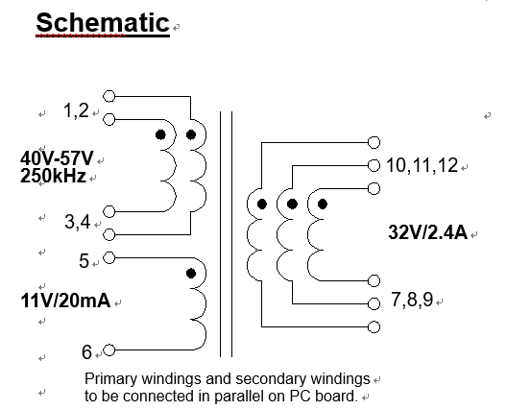Click on import from turn design and enter relevant parameters in the corresponding entries. The following figure shows the designed schematic:

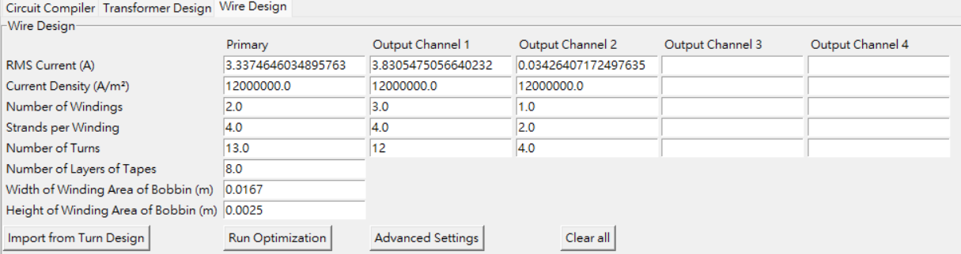According to the schematic, the primary contains two windings, the secondary contains three windings, and the auxiliary contains only one winding. We choose the number of strands for the primary, secondary and auxiliary to be 4, 4, 2 respectively, and the maximum current density allowed to be 12e6 A/mm^2. We wrap Mylar tape between the primary and secondary, the secondary and auxiliary, the auxiliary and primary, and the outermost part; hence, there are 4 intervals with tape with 2 layers each, yielding a total of 8 layers.

After everything is set, we click run optimization and observe the result.

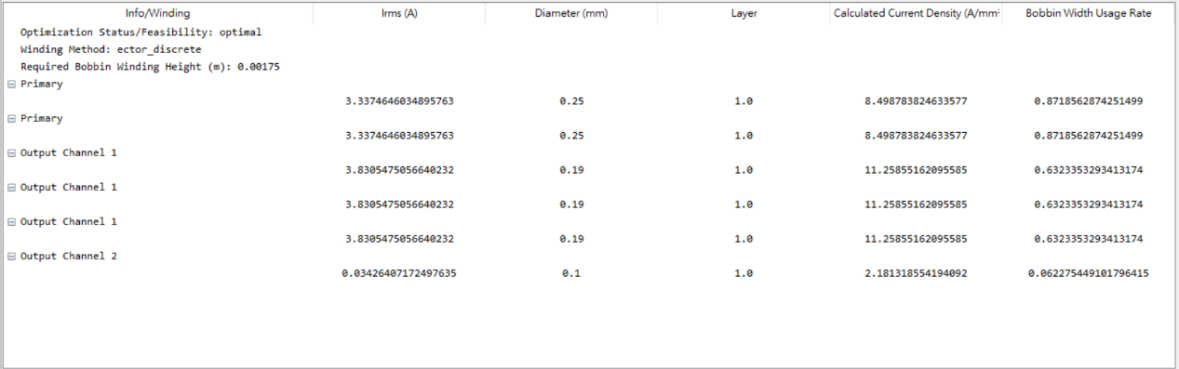Please note that the result may differ due to some properties of the solver, but the solution is always valid for the configuration the user set if the optimization status is optimal. To get a unique solution, we should come up with a reasonable optimization target for the solver.

**VI. Miscellaneous**

Contact Daniel Wang if you encounter any question. Email: wcpwcpd@gmail.com

Changelog:

2025.08.05 Draft for v0.1.0

2025.08.06 Figures added

2025.08.07 Several mistakes corrected. Warnings about importing added. Upgraded to v0.1.1