Ian Mackie

William Duong

**CECS 311 – Final Project: Analog Line Following Robot**

**OBJECTIVE:** This group will design a basic line following robot guided by using a light dependent resistor (LDR) in conjunction with pulse width modulated (PWM) final drive system. This robot will traverse a preset route defined by black, non-reflective electric tape set on a reflective, white poster board background. We propose that a combination of the aforementioned systems will provide a smoother and more accurate locomotive drive than a traditional ‘stop-go’ line following robot based on the same LDR sensor.

**Design Part I: Photosensitive Control System**

The main design of this robot is dependent on two modules: a sensor system based on a photodiode emitter and receiver pair, and the PWM-motor system as the final drive output. To consider the first module, we must start with the sensors. Using a cadmium sulfide (CdS) photocell and an infrared LED, we can ‘measure’ the light reflected off our travel path and convert it to an analog voltage through the use of an op-amp (see ‘OUTPUT’ of figure 1). In short, we can take advantage of the LDR’s mechanism of increasing resistance in the presence of low light (i.e. black electric tape) versus its decreased resistance when encountering a clear path (i.e. white background) to keep our motors moving straight.

**FIGURE 1:**

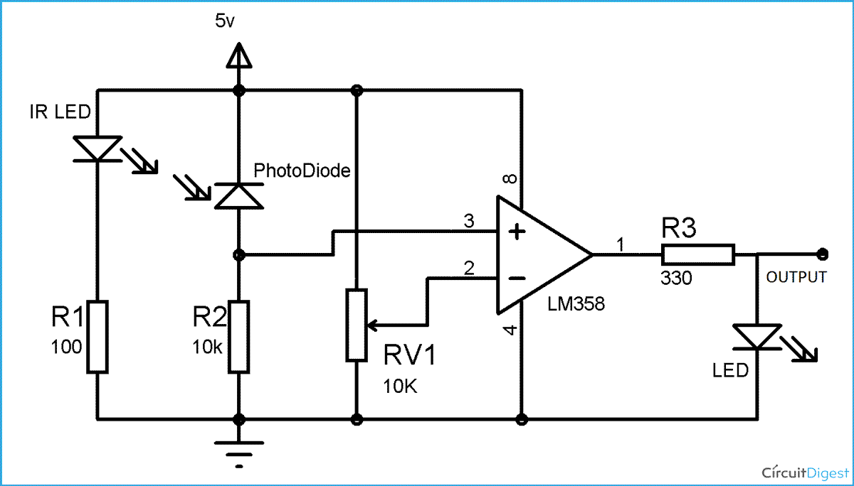

We can also see in Figure 1 the use of a potentiometer at the (V-) terminal of the op-amp, which will serve to set our reference voltage and, correspondingly, the sensitivity of what our LDR detects as an ‘obstacle’.

**FIGURE 2:**

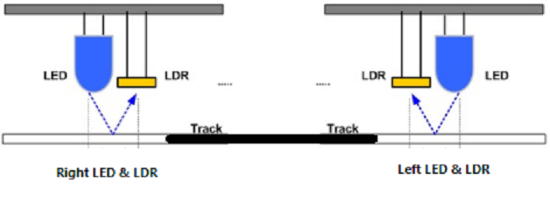

By using a pair of these sensor/LED pairs in tandem, we have set up a design that prevents either one of the wheels from crossing the region of black electric tape that defines our set path – in other words, our motors will only move as long as the sensor for each wheel detects an unobstructed background. Figure 2 demonstrates this concept.

**Design Part 2: PWM-Motor Driver**

The second main module of our design involves the driver powering the two motors on our robot. In a more traditional and simpler setup, turning in one direction or another may involve simply stopping the motor of one wheel while continuing power in the other. While this is a viable solution, the zigzag nature of the navigation is less than elegant.

To offer a different solution, we propose that instead of a series of discrete ON/OFF signals being sent to the motor, we utilize a pulse width modulated signal (PWM). Again, the subject and history of PWM exceeds the scope of this paper, but it is sufficient for our purposes to briefly summarize the topic. In essence, PWM is an ON/OFF pulse signal with a constant period or frequency and this is important for defining the concept of a duty cycle. The duty cycle itself is the proportion of time within the total period that is spent ON and, as such, is expressed as a percentage. If we consider this duty cycle to correspond to an average voltage outputting to power the motor, then by varying the PWM duty cycle we can vary the motor speed – without entirely stopping the motor or ramping it to maximum voltage. This is our ideal locomotive goal.

To implement a PWM signal, we must first start with a baseline reference frequency. In our solution, we chose to generate a triangle waveform – see figure 3 for a reference of the circuit diagram and figure 4 for its LTSPICE simulated output. Then, by overlaying our sensor signal with our generated reference signal, we can produce a PWM voltage signal to serve as the final driver for our motor – see figure 5 for a graphical representation of this objective.

**FIGURE 3:**

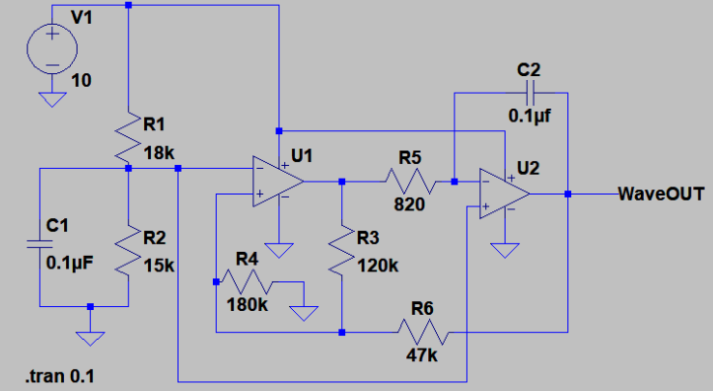

**FIGURE 4:**

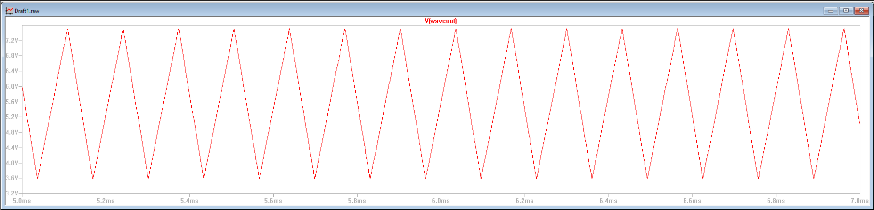

**FIGURE 5:**

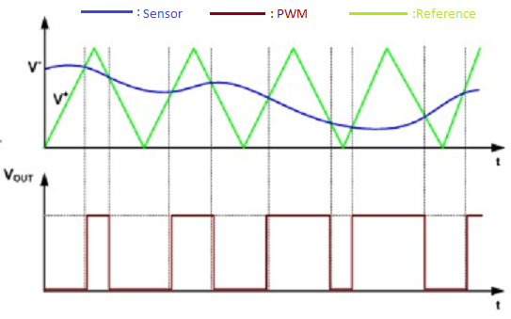

As previously described, we can see in Figure 5 the dynamic between our sensor output and the reference frequency generated by the triangle wave. In short, anytime our sensor detects the black tape/obstacle, its resistance increases and its corresponding voltage output also increases. If we send this signal through a comparator op-amp as (V-) and use the reference triangle wave as (V+), we can see a pulse waveform generated whenever (V+) exceeds the ‘threshold’ voltage of the sensor. To reiterate, as the sensor detects obstacles, the average voltage (i.e. active duty cycle) sent to the motor it controls is lowered and that wheel spins slower than its counterpart. This dynamic accomplishes our goal of turning a car without the effect of ‘stop-go’ that we were trying to avoid.

**Parts List:**

|  |  |
| --- | --- |
| * 2 x IRLR3110ZPbFn-channel MOSFET * 2 x Brushed DC Motor * 4 x 1.5V AA Batteries * 2 x IR emitter/receiver PAIR * 2 x Screw terminals * 1 x Gearbox | * **Resistors (Ω):** 18K (1), 15k (1), 180K (1), 120K (1), 820 (1), 47K (3), 6.8K (1), 100K (1), 200K (2) * **Capacitors:** 0.1µF (2) * **Integrated circuits (ICs):** LM358 (2), LM741 (3) |

**Implementation and Analysis**

Thanks to the entrepreneurship of one member of our team, we chose to go with a custom etched PCB for a more efficient design and to avoid confusing layouts – see below for the board design (left image = bottom of board, right image = top of board).

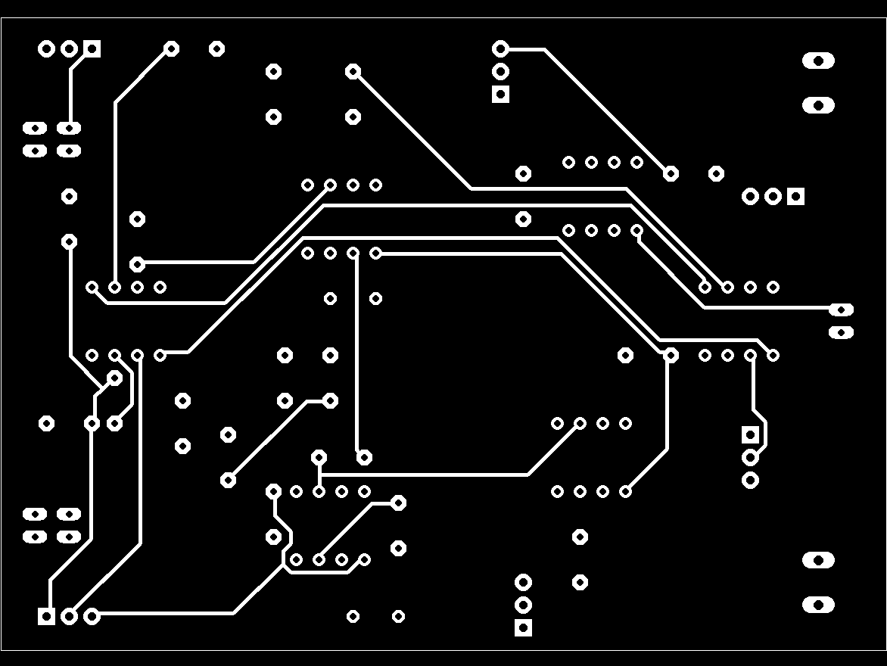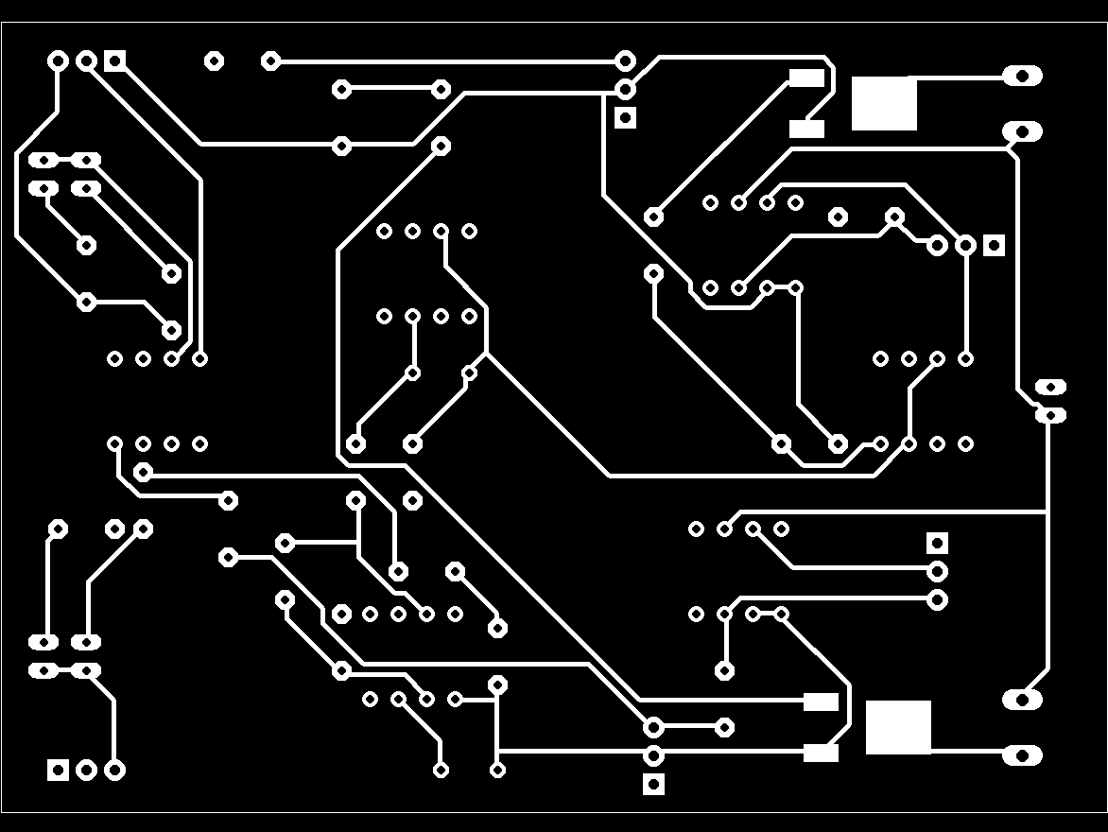

To expand on our sensor circuit design in Figure 1, we paired both sensors to a single LM358 IC. This jellybean part has two comparators that serve our purpose of differentiating between a set reference voltage we wish to stay above and what our LDR sensors actually detect. Figure 6 is the general schematic for this part of our control board.

**FIGURE 6:**

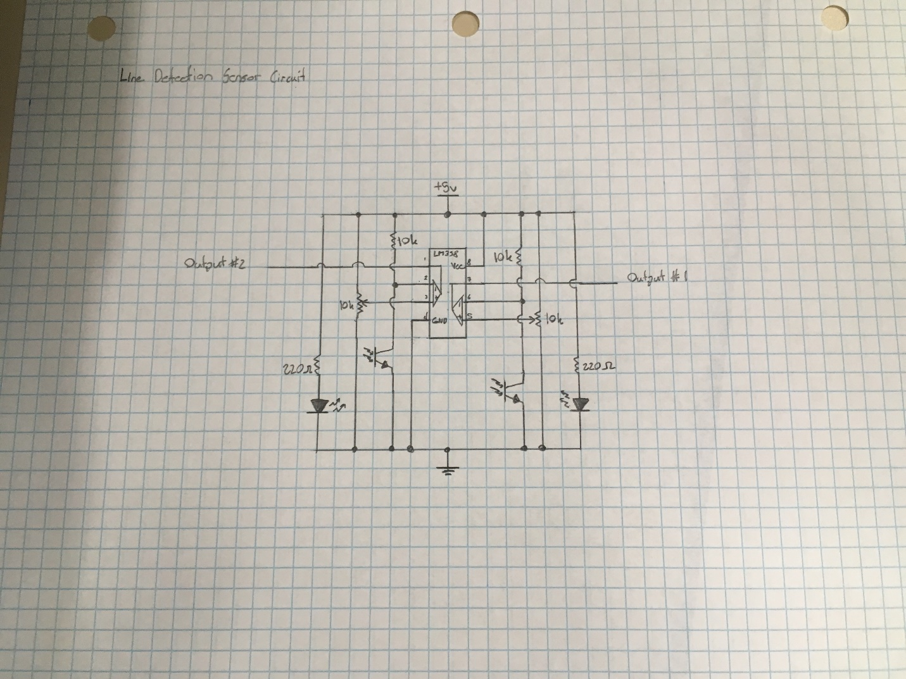

Figure 7 is a scope capture that shows our implementation of our PWM/active duty cycle signal as the sensor transitions from detecting a clear path (left image) to detecting our electric tape (right image). Notice the active duty cycle pulse decreasing – which is in line with our theoretical design goal.

**FIGURE 7:**

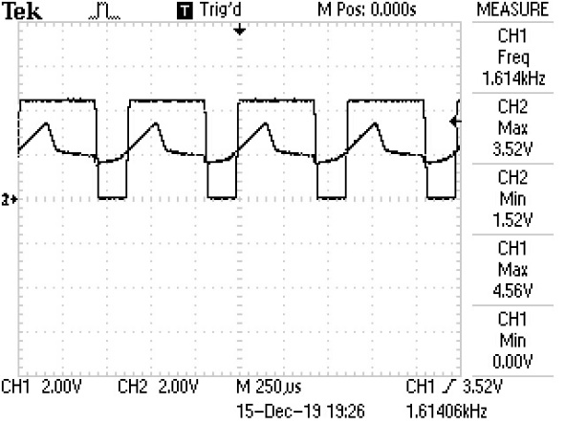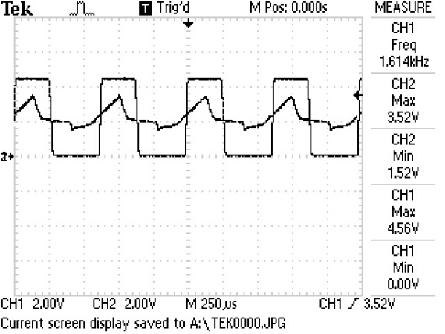

Figure 8 shows a simplified schematic of the flow of sensor data from end to end. Our motor is driven by a MOSFET that operates based on the PWM signal it receives as the gate voltage. The datasheet suggests a VGS(th) of 2.5V which should be easily met by the output (i.e. PWM) of the op-amp receiving signals from both our triangle wave generator and the sensor.

Considering an R(DS) = 12mΩ for this MOSFET and a R(motor) = 2Ω, we estimate the drain current (ID) = 6V / (R(DS) + R(motor)) = 2.98A. This gives us a drain-to-source voltage (VDS) = ID * RDS = 35.8mV and a V(motor) = Vcc – VDS = 5.96V. We can see from these numbers the power dissipated by the MOSFET (PMOSFET) = ID * VDS = 106.6mW and dissipated by the motor itself (PMOTOR) = ID * V(motor) = 17.77W.

Interestingly, while the MOSFET advertises maximum dissipation value of 140W, if we consider more reasonable values without the use of a heatsink, we can derive that PMOSFET = (Tempoperating junction – Tempambient) / junction-to-ambient resistance is actually closer to 3.75W. This is, of course, far in excess of what our MOSFET generated but it is an interesting academic point to notice.

**FIGURE 8: \*\***

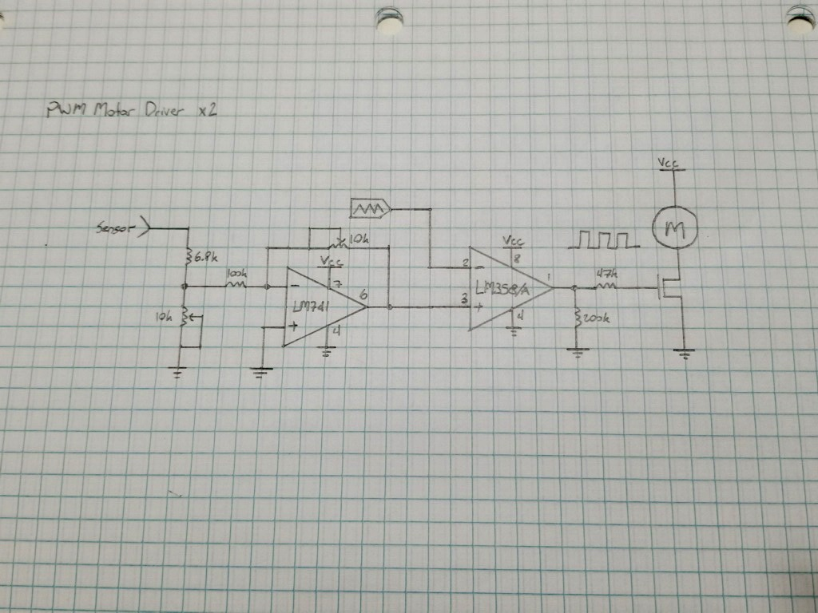

**Note also the inclusion of a current delimiting resistor (47KΩ) as well as another ‘failover’ pulldown resistor (100KΩ) to limit the current during charge/discharge of the MOSFET as it switches open or close.

**Conclusion**

Initially, our design goal was to incorporate a three-term control loop that would adjust for errors as it received information from the sensors. This (P)roportional, (I)ntegral and (D)erivative control system is common in other self-guided applications and would have allowed our end product to handle the sensor data in a smoother and more dynamic way. Unfortunately, the inclusion of this feature involved fine tuning resistor and capacitor values, cleaning high noise levels and matching output and input impedances and other iterative problems that required more time than we had to meet our goal. This could serve to be a viable solution for a future project.

Ultimately, our process met the goal we agreed would be most feasible and which could still offer an advantage over other systems: that is, a design based off analog components that could convert an analog signal into a PWM signal and provide a smooth locomotive action in contrast to traditional ‘stop-go’ robots.