

Wpa_supplicant STUDY
IC: RTL8822B

Rev. 0.1
31 May 2017
Mantis ID:

 | Realtek Semiconductor Corp.  No. 2, Innovation Road II, Hsinchu Science Park, Hsinchu 300, Taiwan  Tel.: +886-3-578-0211. Fax: +886-3-577-6047  www.realtek.com

Wpa_supplicant

Compile/Install/Run
Package : wpa_supplicant_8_n_7.x_rtw_r20445.20161208

Before compile : Install library - libnl
e.g. Ubuntu
sudo apt-get install libnl-dev
PS1: If without installing this library, there comes the compiler error :
../src/drivers/driver_nl80211.c:17:31: fatal error: netlink/genl/genl.h: No such file or directory

PS2: If we want to use libnl3
sudo apt-get install libnl-3-dev libnl-genl-3-dev

Compile:
# cd ./wpa_supplicant
# make

Run :
sudo ./wpa_supplicant –Dnl80211 –iwlan0 –c ./wpa.conf -B

-D<driver> : 驅動類型名稱
-i<ifname>: 網路端口名稱
-c<conf> : 配置檔名稱
-B : 背景執行

NL80211
In 1996, Jean Tourrihes creates wireless extensions (WE or WEXT)

In 2006, John Linville creates mac80211 and Johannes Berg creates cfg80211 and nl80211, and netlink library is used instead of ioctl.

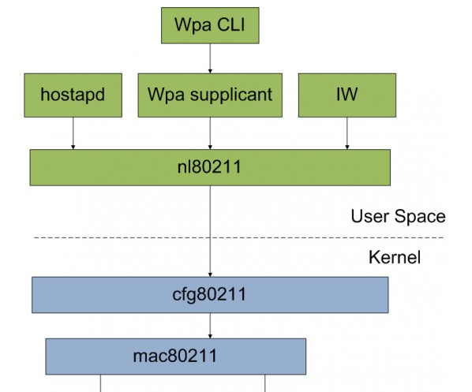

Wpa_supplicant is the application, which is in the user space
Mac80211 and cfg80211 is implemented in wifi driver, which is in the kernel

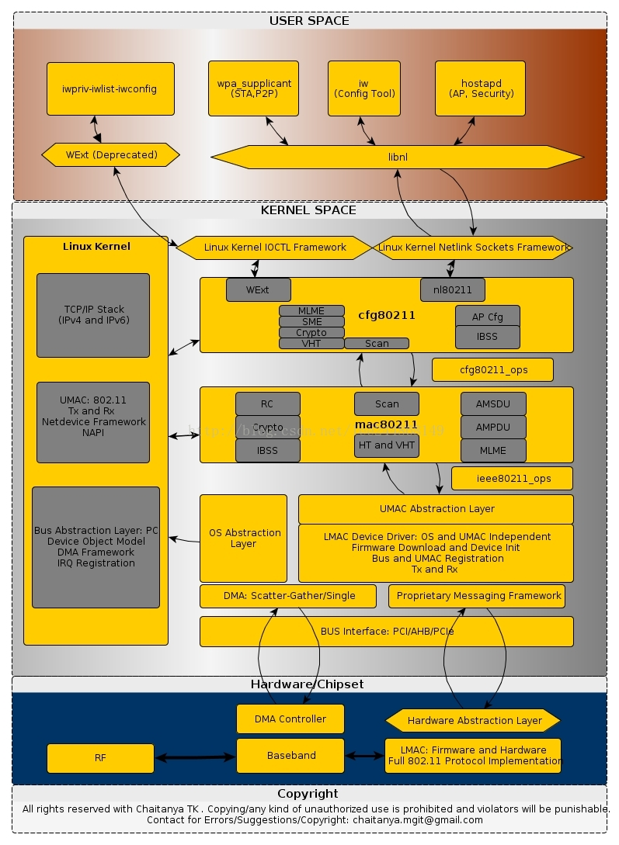

iw tools

https://wireless.wiki.kernel.org/en/users/Documentation/iw
iw wlan0 scan

wpa_cli
sudo ./wpa_cli –p /var/run/wpa_supplicant scan
sudo ./wpa_cli –p /var/run/wpa_supplicant scan_results

Android

Android Service 啟動 wpa_supplicant 流程
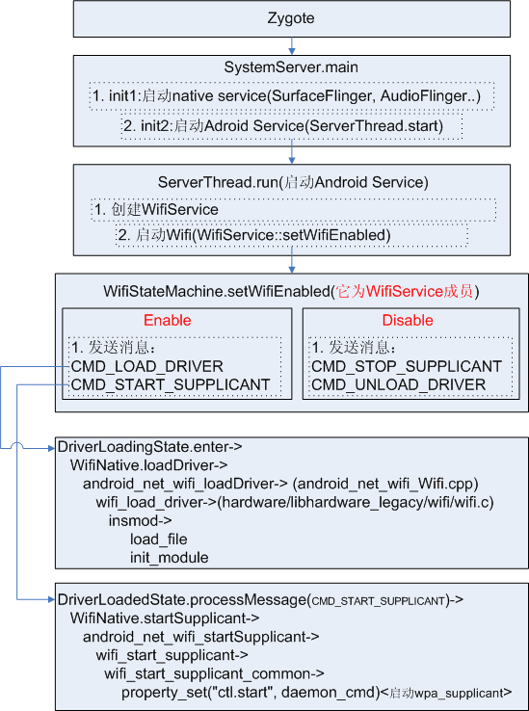

Android 平台 wifi 框架

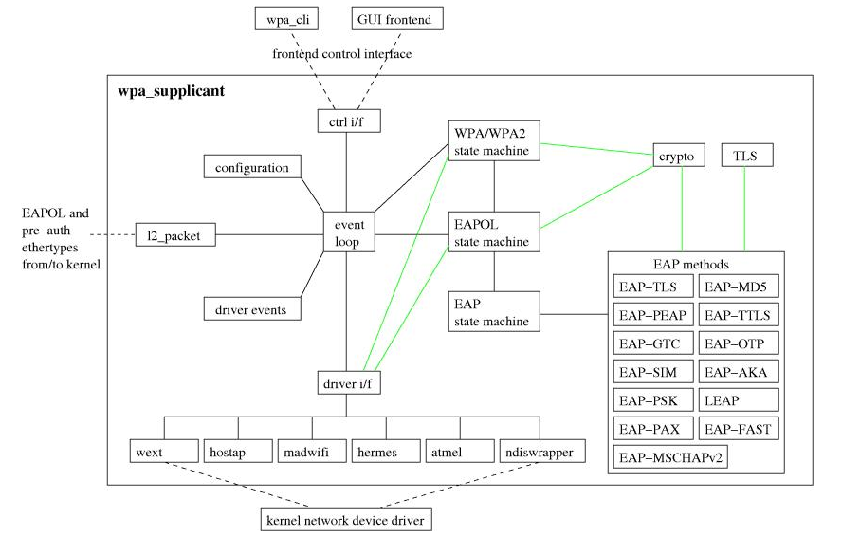

Program Analysis

Initial : wpa_supplicant.c::wpas_init_driver
wpa_supplicant_set_driver()
- Select_driver() : will call registered function – global_init
wpa_driver_init() : will call registered function – init2

NL80211

kernel

主要的 .c / .h 為
include /uapi/linux/nl80211.h
net/wireless/nl80211.c

在 nl80211.c, 透過 struct genl_family , 將 nl80211 netlink socket 名稱建立進去
/* the netlink family */
static struct genl_family nl80211_fam = {
.id = GENL_ID_GENERATE, /* don't bother with a hardcoded ID */
.name = NL80211_GENL_NAME, /* have users key off the name instead */
.hdrsize = 0, /* no private header */
.version = 1, /* no particular meaning now */
.maxattr = NL80211_ATTR_MAX,
.netnsok = true,
.pre_doit = nl80211_pre_doit,
.post_doit = nl80211_post_doit,
};

test application - scan

這個測試程式是在 user mode 的 application,
主要是為了更了解如何透過 libnl 與 kernel 的 nl80211 (cfg80211) 溝通
https://github.com/neojou/nl80211/blob/master/test_scan/src/test_scan_nl80211.c

可以透過 底下方式 建立 socket 傳輸訊息
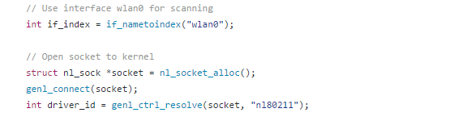
傳送 NL80211_CMD_TRIGGER_SCAN
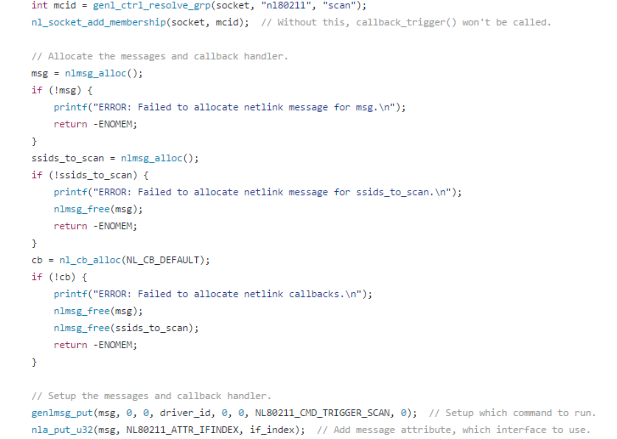

wpa_supplicant

Implemented in driver_nl80211.c, wpa_driver_nl80211_ops is registerd.

const struct wpa_driver_ops wpa_driver_nl80211_ops = {
.name = "nl80211",
.desc = "Linux nl80211/cfg80211",
…
.global_init = nl80211_global_init

So when set “-Dnl80211”, it links to this driver.

--
driver_nl80211.c :: nl80211_global_init()

- 初始化 netlink : global->netlink = netlink_init(cfg);
- Socket :
global->ioctl_sock = socket(PF_INET, SOCK_DGRAM, 0);
libnl3 : nl_socket_alloc
--

Scan example

scan
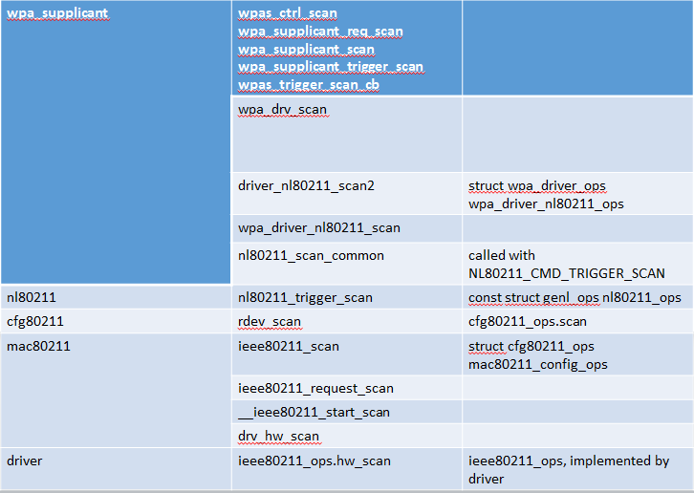

Scan complete
