Fraser,Morgan
w0209279 @NSCC.CA
Portfolio design document

Background blue Menu Desktop Version
Text Black

Hero image and section

CTA : Meet Morgan Fraser

Mission statement (About section)

Skills

Contact

Resume and Linkedin Links

Background blue Text Black Mobile Version
Menu (dropdown)

Hero image and section

CTA : Meet Morgan Fraser

Mission statement (About section)

Skills

Contact

Resume and Linkedin Links

HTML Validation screenshot
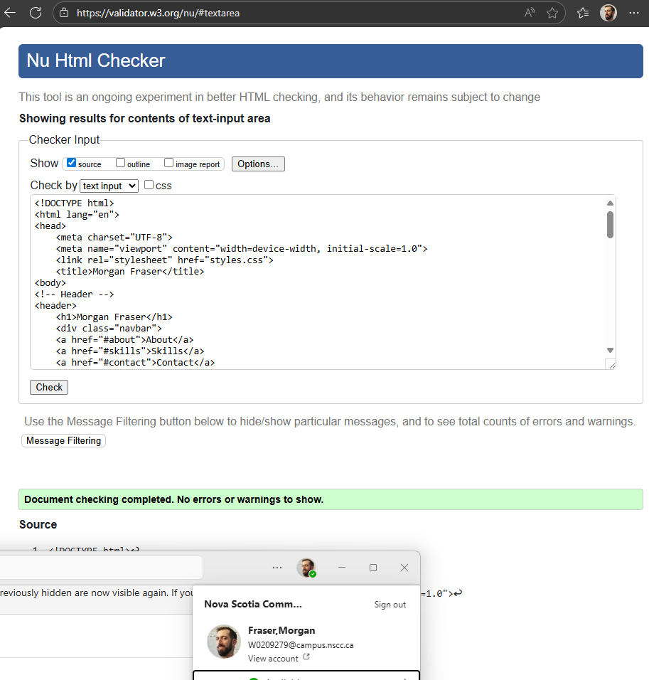

Practical 8 Screenshots
Mobile nav view
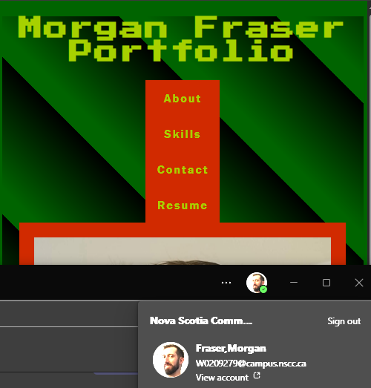
Tablet and Desktop nav view
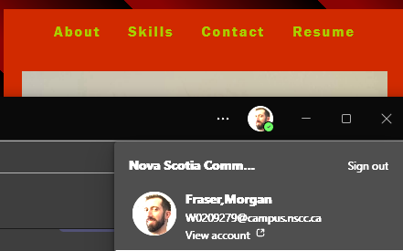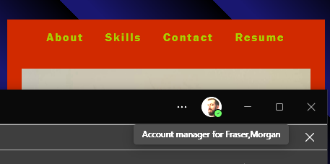

Flex box added to Skills Section
Mobile
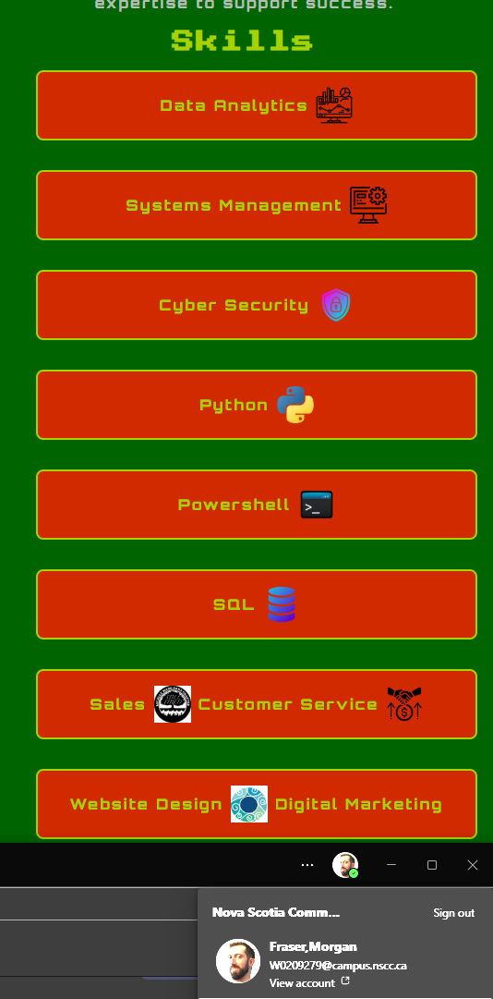
Tablet
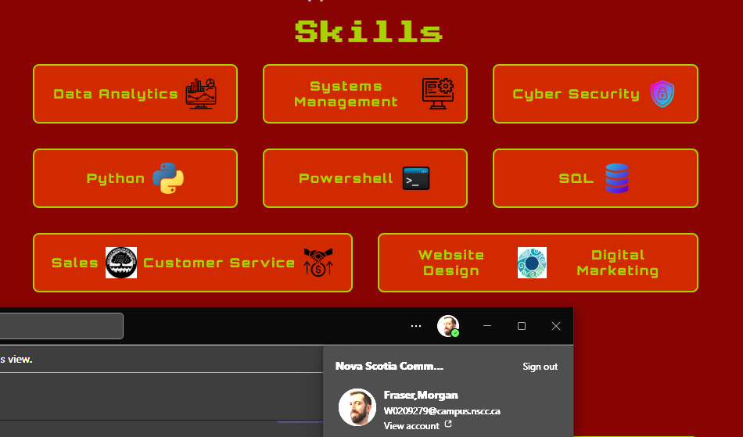
Desktop
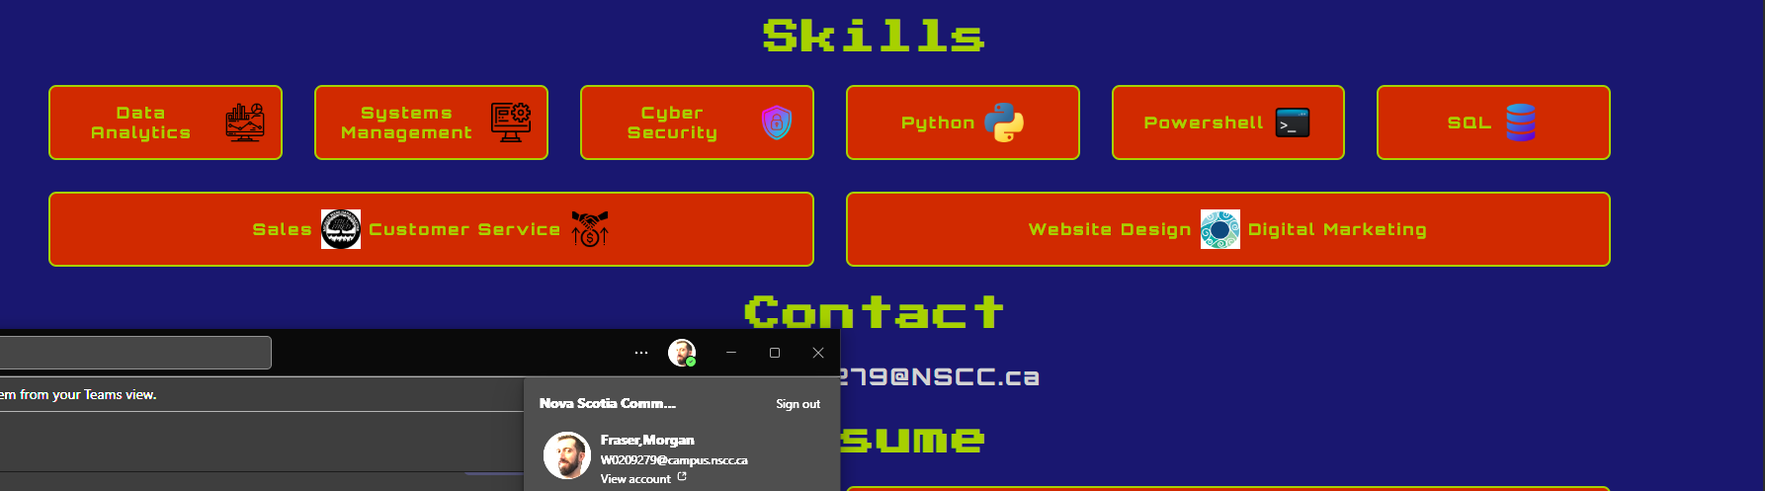

Html and CSS verification
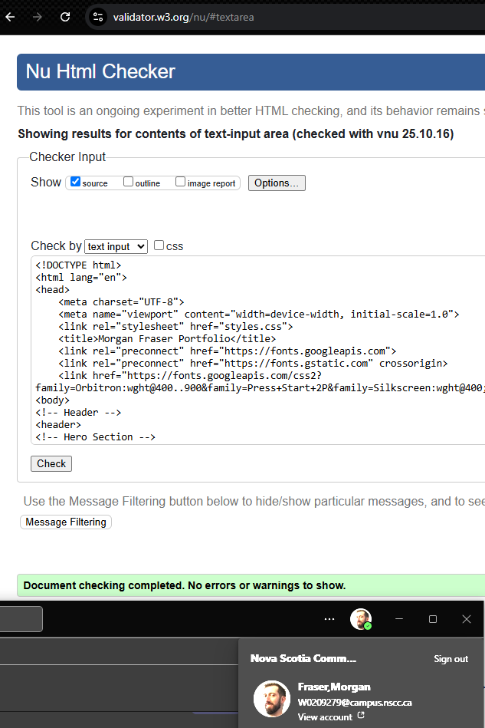
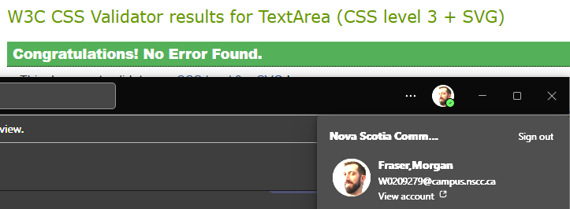

Practical 9
Reflection
The only changes I have made comparing the original wireframe and the current design are to create different backgrounds for each screen size, also didn’t make the menu on mobile a hamburger menu on the right side, and made it a list menu centered with the rest of the content, as it looks more cohesive and flows better. If this were my actual portfolio, I would have used more eye-pleasing fonts and colors, as well as had all backgrounds the same uniform color. Didn’t so much learn new things but reinforced my current skills and allowed me to explore and try a few different ways to do the same design element.

Practical 10
Added an animation to the H1 in the header to rotate though a few colors. This was done by making a tag and using keyframes.

