# Memo

**To**: Bill Cunningham

**From**: Jamie Lu

**CC**: N/A

**STATEMENT OF REQUIREMENT:**

* Provide completed process flow diagrams for the three processes, including business inputs, business outputs, and processes.
* Make a Data Dictionary for the things named in the entity relationship diagram
* Using the information from the Data Dictionary, design an ERD that contains all the information from the data files.

**ENTITY RELATIONSHIP DIAGRAM:**

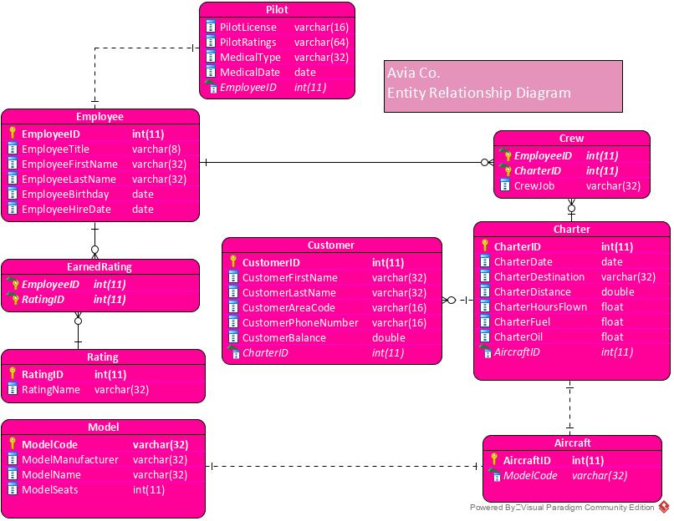

**DATA DICTIONARY**

|  |  |  |  |  |
| --- | --- | --- | --- | --- |
| Object Name | Object Type | Datatype | Methods | Notes |
| Employee | table | N/A | N/A | This table will store information for the employees. |
| EmployeeID | field | INTEGER (11) | PK | Unique identifier assigned to Employees |
| EmployeeTitle | field | VARCHAR (8) |  | This data holds information of the Employee Title, the length of the field is specified to 8 to accommodate title name |
| EmployeeFirstName | field | VARCHAR (32) |  | This Data tracks the Employees First Name. The length of the field is specified to 32 to accommodate typical names. The length of the field is specified to 32 to accommodate name. |
| EmployeeLastName | field | VARCHAR (32) |  | This Data tracks the Employees Last Name, the length of the field is specified to 32 to accommodate the name. |
| EmployeeBirthday | field | DATE |  | The Employee date of Birth which includes (DD), month (MM), and year (YYYY) |
| EmployeeHireDate | field | DATE |  | Data to help identify the date which the employee was hired. includes (DD), month (MM), and year (YYYY) |
| Crew | table | N/A |  | This table tracks information of the crew |
| EmployeeID | field | INTEGER (11) | FK | This is the Foreign Key that references the Employee in the Crew Table |
| CharterID | field | INTEGER (11) | FK | This is a Foreign Key that references the Charter in the Crew Table |
| CrewJob | field | VARCHAR (32) |  | A field describing the task of each crew member. The length of this field is specified to 32 to accommodate the task description. |
| Employee | table | N/A | N/A | This table will store information for the employees. |
| EmployeeID | field | INTEGER (11) | PK | Unique identifier assigned to Employees |
| EmployeeTitle | field | VARCHAR (8) |  | This data holds information of the Employee Title, the length of the field is specified to 8 to accommodate title name |
| Earned Rating | Table | N/A | N/A | This is the entity that stores information about the Earned Rating |
| Employee ID | Field | Integer (11) | FK | A foreign key that references the Employee ID |
| Rating ID | Field | Integer (11) | FK | A foreign key that references the Rating ID |
| Rating | Table | N/A | N/A | This is the entity that stores information about the Rating |
| Rating ID | Field | Integer (11) | PK | The primary key that identifies the Ratings |
| Rating Name | Field | Varchar (32) | N/A | This field holds information about the rating names |
| Earned Rating | Table | N/A | N/A | This is the entity that stores information about the Earned Rating |
| Employee ID | Field | Integer (11) | FK | A foreign key that references the Employee ID |
| Rating ID | Field | Integer (11) | FK | A foreign key that references the Rating ID |
| Rating | Table | N/A | N/A | This is the entity that stores information about the Rating |
| Rating ID | Field | Integer (11) | PK | The primary key that identifies the Ratings |
| Rating Name | Field | Varchar (32) | N/A | This field holds information about the rating names |
| Earned Rating | Table | N/A | N/A | This is the entity that stores information about the Earned Rating |
| Employee ID | Field | Integer (11) | FK | A foreign key that references the Employee ID |
| Rating ID | Field | Integer (11) | FK | A foreign key that references the Rating ID |
| Rating | Table | N/A | N/A | This is the entity that stores information about the Rating |
| Rating ID | Field | Integer (11) | PK | The primary key that identifies the Ratings |
| Rating Name | Field | Varchar (32) | N/A | This field holds information about the rating names |
| Earned Rating | Table | N/A | N/A | This is the entity that stores information about the Earned Rating |
| Charter | Table | NA | N/A | An entity to keep track of information regarding charters |
| Charter ID | Field | Integer | PK | A unique field used to identify a charter |
| Charter Date | Field | Date | N/A | The date of the charter |
| Charter Destination | Field | Varchar | N/A | The destination of the charter |
| Customers | Table | N/A | N/A | A table to represent customer information for the charter |
| CustomerID | Field | INTEGER(11) | PK | A field required to uniquely identify the customers. |
| CustomerFirstName | Field | VARCHAR(32) | N/A | A field that represents the customers first names. |
| CustomerLastName | Field | VARCHAR(32) | N/A | A field that represents the customers last names. |
| CustomerAreaCode | Field | VARCHAR(16) | N/A | A field that represents the customers area code. |
| CustomerPhoneNumber | Field | VARCHAR(16) | N/A | A field that represents the customers phone number |
| CustomerBalance | Field | DOUBLE | N/A | A field that represents the customers balance for the charter. |
| CharterID | Field | INTEGER(11) | FK | A field that uniquely represents the charter |
| Models | Table | N/A | N/A | A table that represents aircraft model information |
| ModelCode | Field | VARCHAR(32) | PK | A field that uniquely identifies the model. |
| ModelManufacturer | Field | VARCHAR(32) | N/A | A field that represents the manufacturer of the model |
| ModelName | Field | VARCHAR(32) | N/A | A field that represents the name of the model |
| ModelSeats | Field | INTEGER(11) | N/A | A field that represents the number of seats in the model |

# SWOT ANALYSIS:

# 