# Memo

**To**: Bill Cunningham

**From**: Antoine Asanga

Jeremy Bankes

Cherish Browne

Jamie Lu

Mohammad Shreim

**CC**: N/A

|  |  |
| --- | --- |
| TEAM MEMBER | ROLE |
| Jeremy Bankes | Team Lead |
| Antoine Asanga | Member |
| Cherish Browne | Member |
| Jamie Lu | Member |
| Mohammad Shreim | Member |

Method of sharing files: Whatsapp Messenger

Business Process:

EVENT

PARTICIPANT

EVENT

DONATION

TOTAL DONATIONS

PARTICIPANT TOTAL

PARTICIPANT

PERSON

EVENT

TEAM

**STATEMENT OF REQUIREMENT:**

* Provide completed process flow diagrams for the three processes, including business inputs, business outputs, and processes.
* Make a Data Dictionary for the things named in the process flow diagram.
* Using the information from the Data Dictionary, design an ERD that contains all the information from the process flow diagram.

**ENTITY RELATIONSHIP DIAGRAM:**

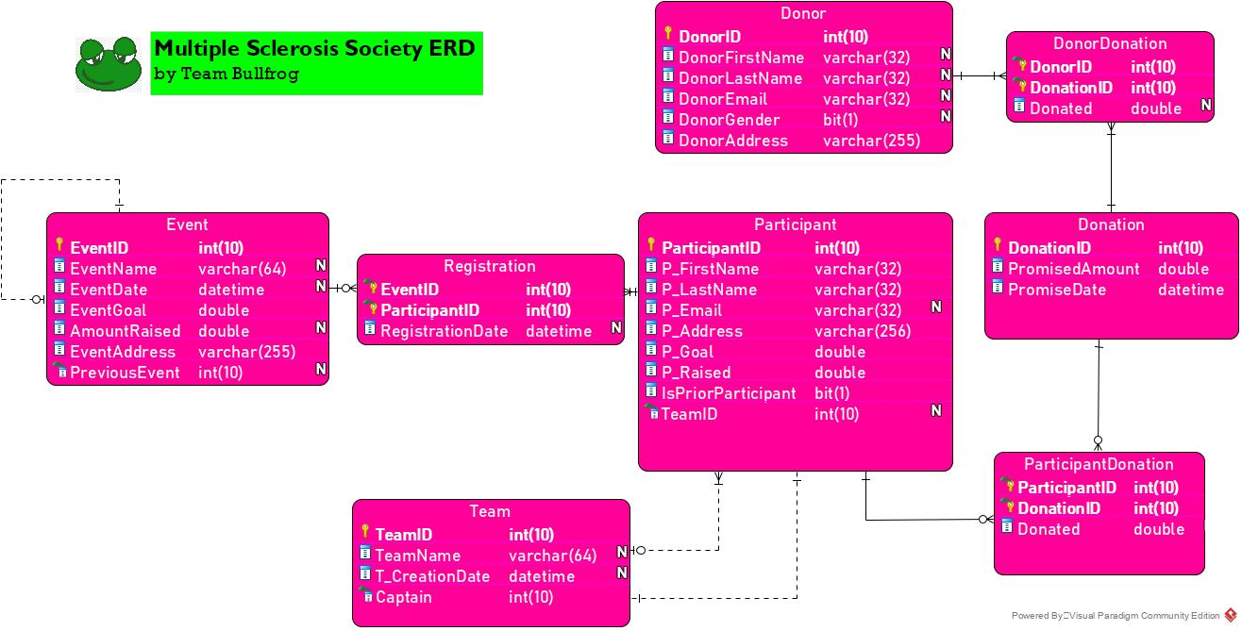

**DATA DICTIONARY**

|  |  |  |  |  |
| --- | --- | --- | --- | --- |
| Object Name | Object Type | Datatype | Methods | Notes |
| Event | table | N/A | N/A | This table is needed to track event information, events must be uniquely identified. |
| EventName | field | INTEGER  NULLABLE | PK | A field required to uniquely identify events. |
| EventDate | field | DATETIME  NULLABLE | N/A | A field to represent the date and time of the event. |
| EventGoal | field | DOUBLE | N/A | A field to represent the goal amount for the event. |
| AmountRaised | field | DOUBLE  NULLABLE | N/A | A field to represent the actual amount raised at event. |
| EventAddress | field | VARCHAR(255) | N/A | A field to represent the address for the event. |
| PreviousEvent | field | INTEGER(10)  NULLABLE | N/A | A field to represent the previous event. |
| Registration | table | N/A | N/A | This table relates participants with events. |
| EventID | field | INTEGER(10) | PK,FK | This field is required to uniquely identify events with participants. |
| ParticipantID | field | INTEGER(10) | PK,FK | This field is used to represent the participants with registration. |
| RegistrationDate | field | DATETIME  NULLABLE | N/A | A field to represent the registration date for the participant for a an event. |
| Participant | Table | N/A | N/A | The scenario dictates a need to track participant information. Participant must be uniquely identified. |
| P_FirstName | Field | VARCHAR(32) | PK | This is the data used to track the Participant’s first names. The length of the field is specified to 32 to accommodate typical names. |
| P_LastName | field | VARCHAR(32) | N/A | This is the data used to track the Participant’s last names. The length of the field is specified to 32 to accommodate typical names. |
| P_Email | field | VARCHAR(32)  NULLABLE | N/A | This is data used to store the participant’s email address information. |
| P_Address | field | VARCHAR(256) | N/A | This is the field used to store the participant’s address information. |
| P_Goal | Field | DOUBLE | N/A | This is a field in the table to store information on what a participant’s goal amount to be raised is. |
| P_Raised | Field | DOUBLE | N/A | This is a field in the table to store information on what the actual amount the participant raised is. |
| IsPriorParticipant | Field | BIT(1) | N/A | This is the field in the table to determine if the participant has participated in prior events. |
| TeamID | Field | INTEGER(10)  NULLABLE | FK | A field in the table that references the TeamID in the Team table. It also determines which team a participant belongs to. This field is NULLABLE because it’s not necessary for a participant to belong to a team. |
| Team | Table | N/A | N/A | This entity will store information on the various teams. |
| TeamID | Field | INTEGER(10) | PK | A unique identifier for a specific team. |
| TeamName | Field | VARCHAR(64)  NULLABLE | N/A | A field that stores information on what each team’s name is. |
| T_CreationDate | Field | DATETIME  NULLABLE | N/A | A field that stores information on when the team was created. |
| Captain | field | INTEGER(10) | FK | A field in the table that references the ParticipantID in the Participant entity. |
| Donor | table | N/A | N/A | This table stores all the donor information. |
| DonorID | field | INTEGER(10) | PK | This field is used to uniquely identify Donor. |
| DonorFirstName | field | VARCHAR (32)  NULLABLE | N/A | This field stores the donors’ first names. |
| DonorLastName | field | VARCHAR (32)  NULLABLE | N/A | This field stores the donors’ last names. |
| DonorEmail | field | VARCHAR (32)  NULLABLE | N/A | This field stores the donors’ email addresses |
| DonorGender | field | BIT (1)  NULLABLE | N/A | This stores information on what gender the donor is. |
| DonorAddress | Field | VARCHAR (255) | N/A | This stores information on where the donor lives. |
| DonorDonation | Table | N/A | N/A | This table relates the Donor and Donation table. |
| DonorID | field | INTEGER (10) | PK,FK | This is a Foreign Key that references the Donor in the DonorDonation Table. |
| DonationID | field | INTEGER (10) | PK,FK | This field references the DonationID in the Donation table. |
| Donated | field | DOUBLE  NULLABLE | N/A | This field stores information on the actual amount donated by the donor. |
| Donation | Table | N/A | N/A | This entity that stores information about the donation. |
| DonationID | Field | INTEGER (10) | PK | The primary key that identifies donations. |
| PromisedAmount | Field | DOUBLE | N/A | The amount of money promised by the donor. |
| PromiseDate | Field | DATETIME | N/A | The date that the promise was made for the donation. |
| ParticipantDonation | Table | N/A | N/A | This entity holds information about the Participant making the donation. |
| ParticipantID | Field | Integer (10) | PK, FK | A foreign key that references the participant. |
| DonationID | Field | Integer (10) | PK, FK | A foreign key that references the donation ID in the donation table. |
| Donated | Field | DOUBLE | N/A | This field holds information about the actual amount donated. |

# RECOMMENDATIONS:

The main goal of the Multiple Sclerosis Society events was to raise more money. The recommendation of the analysts is to either increase the number of donations made, or to increase the amount of each donation. Factors such as where the event is held, where the donations are coming from and whether participants in teams make larger donations are important in determining how to increase total donation for an event. From the data collected, it was found that participants in teams generally raised more money. It was also found that participants that come from the place where the event is held raise more money. Please also see the requirements above in the statement of requirement.