

odi 12c mappings

ASSIGNMENT #3 – DBAS 3018 DATA MOVEMENT AND INTEGRATION



February 11, 2021

JAMIE LU

W0441213

# Figure 4-13

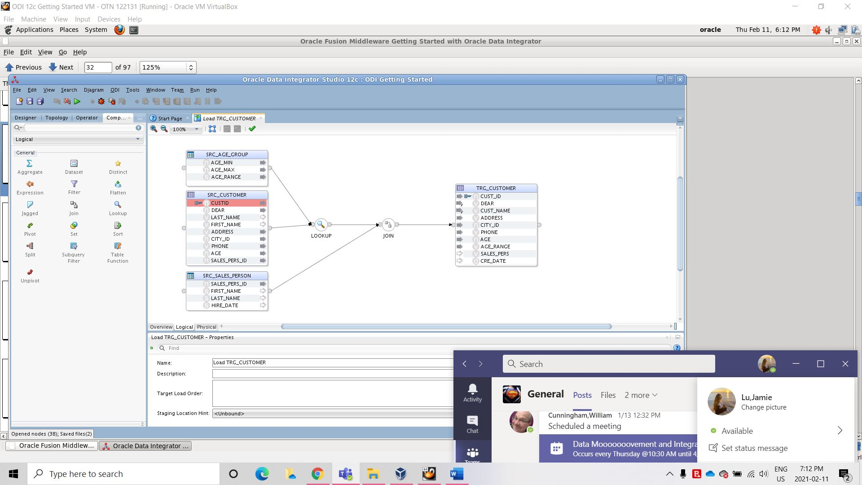

# Figure 4-18

# Figure 4-22

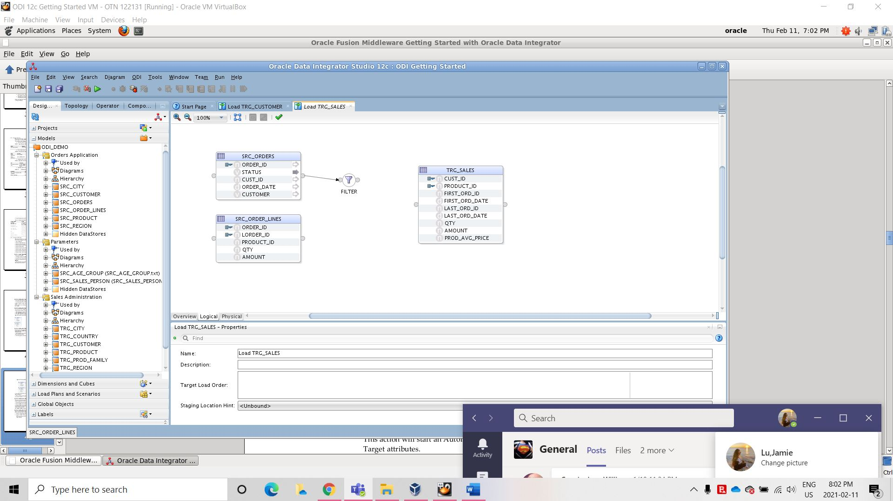

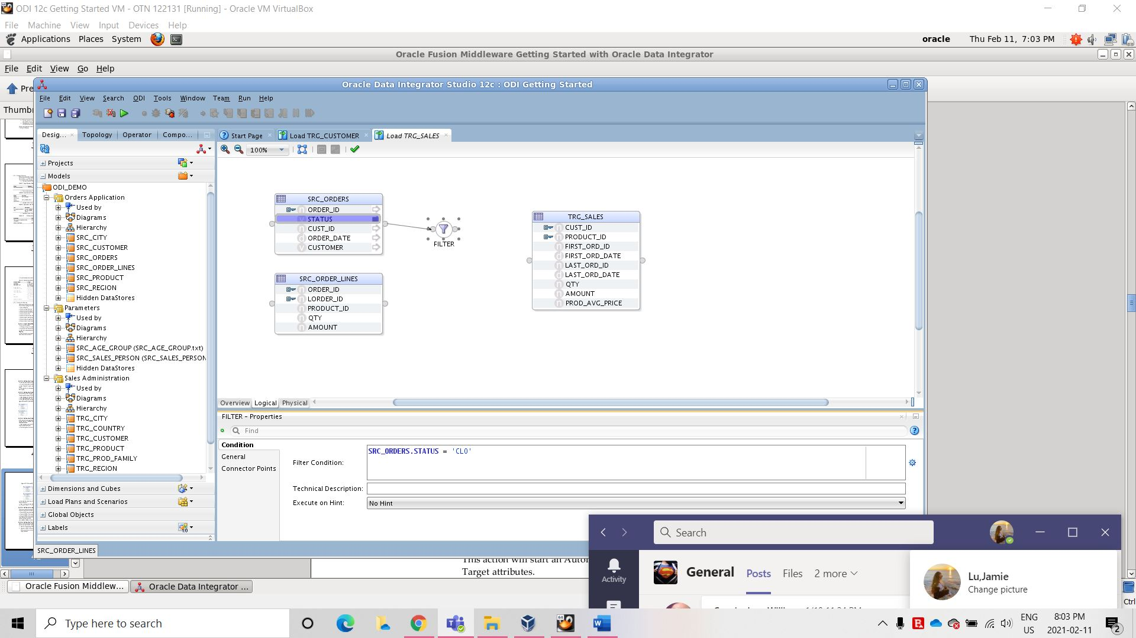

# Why is it vital to understand SQL SELECT statement logic in order to use tools like ODI and Informatica and SSIS to perform Data Movement and Integration?

* It is vital to understand because it is the most basic form and understanding SQL SELECT statement logic will enable one to comprehend different tools like ODI and Informatica and SSIS easier. It will provide a basic understanding of how to map out the database. This is seen in the transformation portion of the assignment wherein the Aggregate component is added in. The Oracle Data Integrator, through the use SQL standard coding practices, will grab the necessary information so that one does not have to specify group by rules.

# Figure 4-28

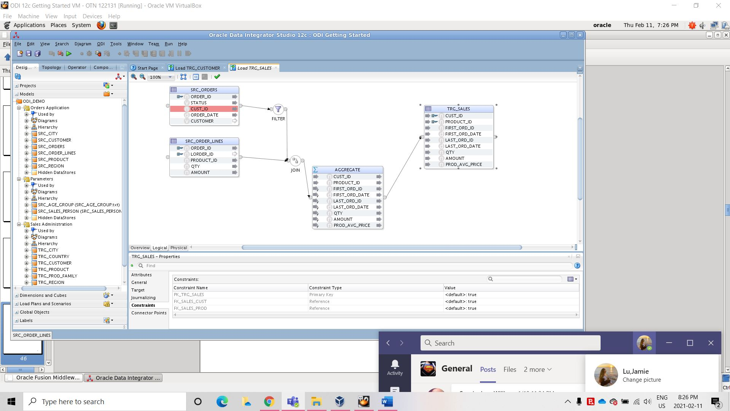

# 4.2.3.9

