|  |  |
| --- | --- |
|  | November 28, 2020 |

|  |  |
| --- | --- |
| to: | BILL CUNNINGHAM |
| from: | JAMIE LU |
| subject: | PORTFOLIO |
|  |  |

**Learning Outcomes**

1. Identify the best practices to equip an organization for potential data breaches or threats.
2. Apply strong controls that consider the data lifecycle for an organization.
3. Consider privacy and accountability concerns in the age of Big Data.

**Local Job Posting[1]**

Application Database Administrator – DBMS

IBM – Bedford, NS

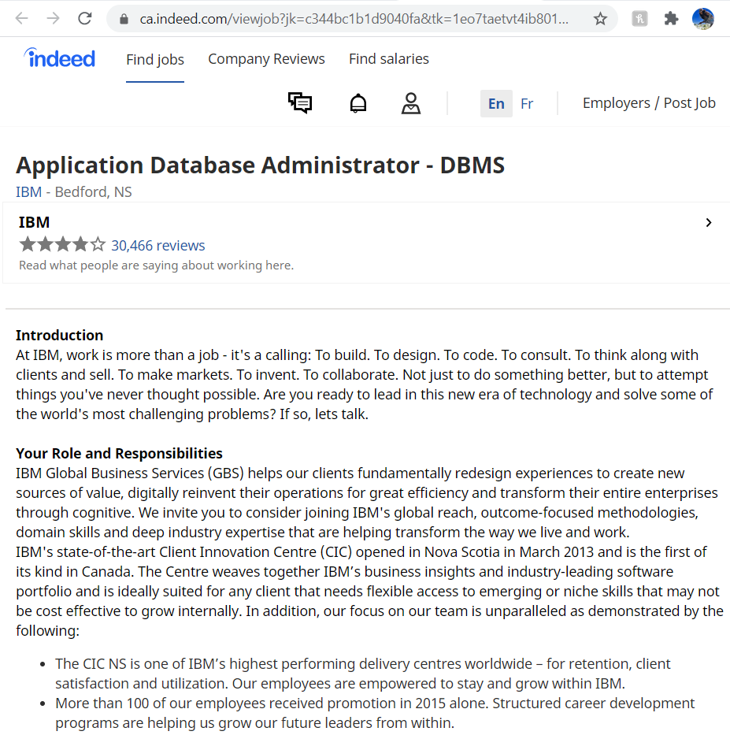

There is a reason why they call it Big Data. It is very vast and is everywhere. It is information and it can be powerful. When working with data, it is essential to know what can be done to protect it, most especially the confidential ones. It is important to identify the best practices we can apply to secure data and avoid any breaches or threats. This course explores the skills needed to do that. The entirety of the course basically revolves around the importance and application of data security. The work plan includes assignments that will explore physical, logical, and application data security threats. This is good because once we familiarize ourselves with these threats, we can anticipate what can go wrong and prepare for it. We can fortify data to avoid these threats and breaches. The local job posting I found on indeed is for an Application Database Administrator. The job posting talks about how the position will require creating, communicating, and maintaining best practices and holding teams accountable to follow these. This course will help us practice that skill of adhering to the best practices that are set.

Data has a lifecycle. It starts from when it is created, to when it is either reused or destroyed. It is necessary to keep this in mind when securing a database system because data must be secured in every stage of the lifecycle. The final project aides us in learning this skill because it requires us to create and secure a database system. We are also able to test the system we have created and check for any possible security threats or issues. This is also relevant in the IBM job posting because the job posting requires the candidate to have experience with the creation, maintenance, and optimization of a SQL Server database. This is because they want a person that can be self- sufficient and can work independently with just little supervision. I think the final project would be a good exercise in being self-sufficient and exercise our analytical skills as well.

It is important to remember that there have been multiple privacy and accountability concerns with regards to data. There have even been questions if there is a need to reshape laws surrounding the privacy of data because of spatial and temporal dimensions. We are in an age of technology where technology is being used rampantly in our everyday lives. From social media to even our personal bank accounts, technology is used. Technology and data go hand in hand because when we are using technology, like in social media for example, our data is put out there. Data is power, it is even sometimes said to be more valuable than oil or gold. It is information and a lot can be derived from it and it can be used in multiple ways. Therefore, an important goal to set when creating or having a database system is to make sure that it is secure, to make sure data is safe and protected, to ensure that it is only being used by the people who are intended to see and use it. It is hard to find just one or two assignments that will help us in learning more about privacy and accountability concerns with regards to data as it seems like the entirety of the course does this. It also goes hand in hand with the lectures we have had in Ethics and Law in Data Analytics. This course talks about the data security threats, learning how to prevent them, anticipating them, assessing systems that are already in place, and our Ethics and Law in Data Analytics class complements this with researching the actual legislations in place surrounding data privacy. In the job posting, and basically any company or organization, it is essential to know the importance of data privacy and accountability.

# References

IBM. (2020, October). *Application Database Administrator - DBMS*. Retrieved November 28, 2020, from Indeed: https://ca.indeed.com/viewjob?jk=c344bc1b1d9040fa&tk=1eo7taetvt4ib801&from=serp&vjs=3

1. Referenced from (IBM, 2020)