CHATBOTS

**WHAT ARE THEY?**

A **Chatbot** is a software or computer program that will perform automatic tasks by communicating with human users through the internet e.g. Cortana, Alexa, and Siri which we might have used to set an alarm, make a call and even send a text message.

**HOW DO THEY WORK?**

* Uses pattern recognition to understand
* Listens for specific words and phrases
* Recognize these words/phrases
* Deliver a pre-calculated response related to the words/phrases mentioned by the user
* Mimics human language
* Tries to respond to sentences to the best of its ability
* Chatterbots have a set of input and output rules
* Other chatterbots learn through user interactions
* Chatbots require constant internet access to function
* More chatbots require larger servers to be more effective, maintain speed

**HOW ARE THEY USED?**

* Conversational Agents
* Help direct customers to different customer service employees
* Can answer simple questions about a business if a customer has questions
* Acts as an information hub
* Rule-based
  + Rely on keywords to output properly
  + Without keywords, will not properly function
* Generative model
  + Can generate new sentences based on similar patterns of data
* **Chatbots you may know: SIRI, GOOGLE, ALEXA**

**THE ROLE OF MACHINE LEARNING**

Learns from the inputs it experiences through natural language processing (NLP) that could easily be understood and interpreted with the system to

* Offer an informative answer
* Maintain the context of the dialogue
* Aims to be indistinguishable from a real person

**THE ROLE OF ARTIFICIAL INTELLIGENCE**

* Smart chatbots rely on AI’s adaptability to advance current technology
* People expect fast response times when interacting with a chatbot, slow speeds will just annoy people.
* Chatbots that have AI...
  + A picture containing icon

    Description automatically generatedCan answer more complex queries
  + Can have more lively and engaging conversations.
  + Have better capacity to learn from every interaction. It improves with each interaction!

**THE ROLE OF BIG DATA**

* Interactions with users are part of the sources of data that the chatbot uses, so they collect the data from these interactions and store them in a database
* Big data essential to chatbot progression
  + Voice patterns are picked up and compiled by millions of phones, other tech that uses voice commands
  + Data techs must sift through that data and make sense of it for the bots, if not then bots will not improve

**CHALLENGES IN PROGRAMMING**

* Chatbot needs to understand the different variations of how a user phrases an inquiry/statement
  + Voice recognition and understanding of speech patterns still in early stages
* Chatbot needs to understand what the context of the conversation is
  + Chatbot needs to understand QUESTION SEQUENCING, this is when a user would as a question to the chatbot that is related to the previous question
  + For example:
    - User: What is the best restaurant in Halifax?
    - Chatbox: ABCDE Restaurant
    - User: How do we get there?
* The chatbox may not know what "there" means if it was not programmed to "remember" the original question or not programmed to "understand" the sequence of questions

**CHATBOT DECISION TREE**

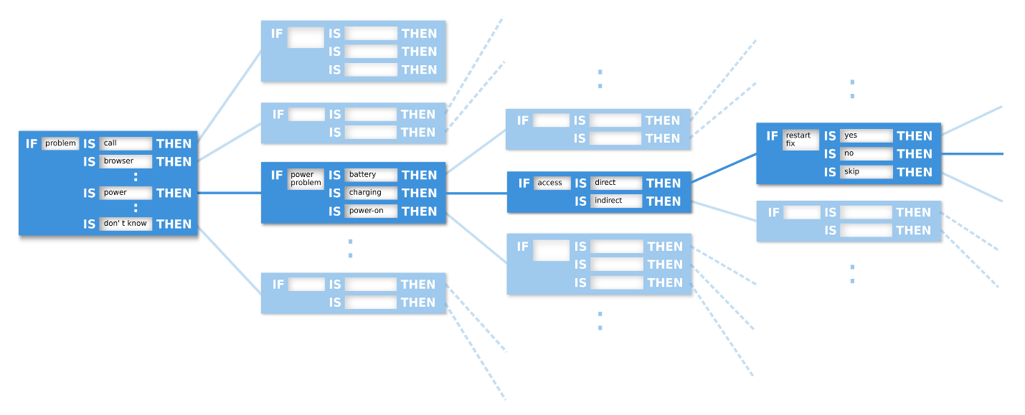

If-then statements are essential in encoding complex conversations. Thus, a chat box would need to build and maintain large If-then decision trees.

Chatbot decision trees do not have to be complicated, but that depends on how well you would like your chatbot can answer. This can get really complicated, going from a decision tree to a decision graph even! This is where the answer to any question can lead to any other question.

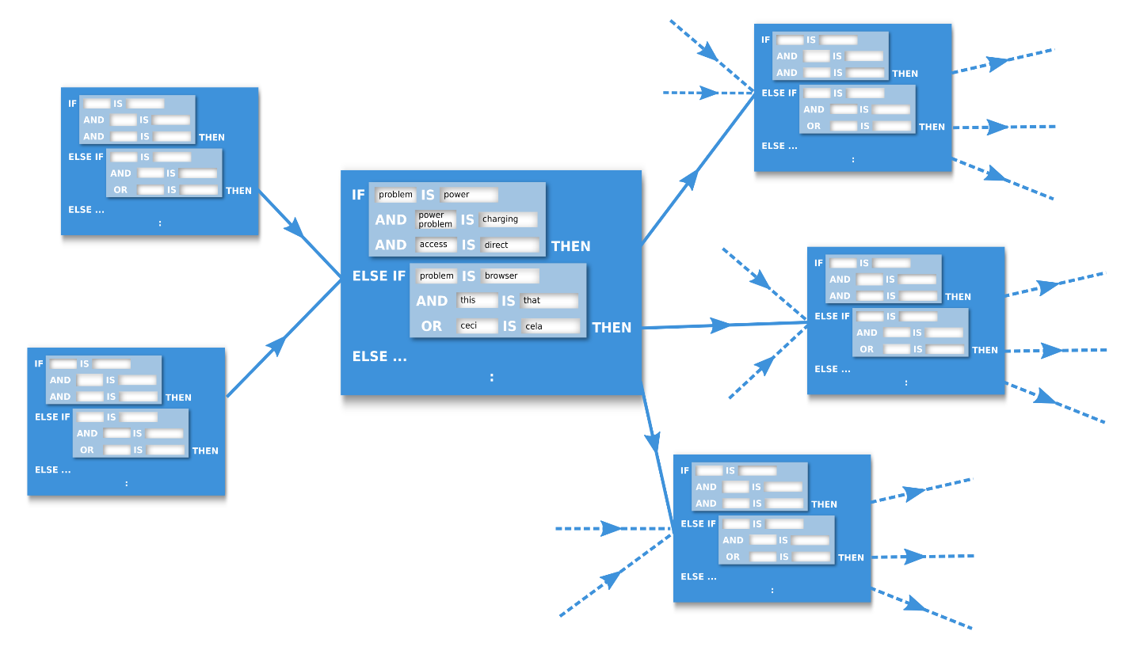

**CHATBOT PROS AND CONS**

|  |  |
| --- | --- |
| **PROS** | **CONS** |
| * Reduced labour costs   + Assist customer support with less important conversations * Available 24/7 * Near instant response times * Less human error * Scalability   + Can simultaneously manage thousands of conversations   + can be easily scalable to handle a large volume of chats without affecting the business costs. | * Virtual Assistants always listening * More complex chatbots can get expensive * Can scatter fake information by pretending to be human * Can be used to fill chatrooms with spam and advertisements * Limited Responses   + Lacks the feeling or emotion in the conversation   + Can frustrate the user |

**WRAPPING UP**

In conclusion, chatbots are advancing and getting better every day. They play a big role in big data, networking, machine learning and ai. Chatbots may have some quirks and kinks to figure out but they are certainly a very useful tool. It’s safe to say that they are going to be a big part of our future.

# References

AIVO. (2020, May 11). *Advantages and Disadvantages of Chatbots You Need to Know*. Retrieved from AIVO: https://w2.aivo.co/en/blog/advantages-and-disadvantages-of-chatbots-2/

BBC News. (2014, June 09). *Computer AI passes Turing test in 'world first'*. Retrieved from BBC News: https://www.bbc.com/news/technology-27762088#:~:text=A%20computer%20program%20called%20Eugene,talking%20to%20machines%20or%20humans.

catalyststuff. (n.d.). *freepik*. Retrieved October 09, 2020, from freepik: https://www.freepik.com/vectors/logo

freepik. (n.d.). *Background Vectors*. Retrieved October 10, 2020, from freepik: https://www.freepik.com/vectors/background

freepik. (n.d.). *Robot Design Vector*. Retrieved October 07, 2020, from freepik: https://www.freepik.com/vectors/design

Lambert, M. (2018, April 21). *Chatbot Decision Trees*. Retrieved October 8, 2020, from Chatbots Life: https://chatbotslife.com/chatbot-decision-trees-a42ed8b8cf32

Leah. (2019, November 20). *8 Ways to Know if You Need a Chatbot For Your Business*. Retrieved October 06, 2020, from Userlike: https://www.userlike.com/en/blog/do-i-need-a-chatbot

Patel, S. (2020, October 09). *10 Excellent Benefits of Using Chatbots in Your Business*. Retrieved October 10, 2020, from REVE Chat: https://www.revechat.com/blog/chatbot-business-benefits/

The Writer. (n.d.). *Ask The Writer: Is it alright to use multiple question marks?* Retrieved October 07, 2020, from The Writer: https://www.writermag.com/improve-your-writing/revision-grammar/multiple-question-marks/

upklyak. (n.d.). *Technology Vector*. Retrieved October 07, 2020, from freepik: https://www.freepik.com/vectors/technology

Wikipedia. (n.d.). *Chatbot*. Retrieved October 12, 2020, from Wikipedia: https://en.wikipedia.org/wiki/Chatbot#Malicious_use

Wikipedia. (n.d.). *Turing Test*. Retrieved October 5, 2020, from Wikipedia: https://en.wikipedia.org/wiki/Turing_testhttps://en.wikipedia.org/wiki/Turing_test

Withey, D. (2017, May 23). *What is the Chatbot Turing Test*? Retrieved October 6, 2020, from <https://blog.ubisend.com/discover-chatbots/chatbot-turing-test>

Carter, R. (2020, May 27). *How Do Bots and Chatbots Work?* Retrieved October 5, 2020, from <https://www.uctoday.com/contact-centre/how-do-bots-and-chatbots-work/>