

create a faux company

ASSIGNMENT 1 – DBAS 3025 – INFORMATION GOVERNANCE



January 29, 2021

JAMIE LU

W0441213

Table of Contents

Introduction 2

Company Profile 3

Company Name 3

Product/Service 3

Industry Sector 3

Country/Countries of Operation 3

Competition 3

Mission Statement 4

Vision Statement 4

Data Collection and Management 5

Databases 5

What data is collected? 5

How will the data be stored? 5

Data Governance 6

Ethics, Law and Security of the collection of stored and shared data 7

Team 7

Employees 7

Turnover 8

Organizational Chart 10

References 14

# Introduction

It is essential to know what data governance and information governance is and how they differ but overlap as well. Both are important in the management of a company and its data. This assignment will exercise my understanding of the two topics and will put it into real-world practice.

This assignment tasked us with creating a faux company that we will be using for the rest of the semester. It contains the company’s profile with relevant information on its data and employee organization.

It is important to note that the faux company I have created is modeled after Shein, an international online fashion website that provides products that are trendy at a lower cost.

# Company Profile

## Company Name

Psalms Inc.

## Product/Service

Clothing, shoes, accessories

## Industry Sector

E-commerce

## Country/Countries of Operation

Argentina Australia Belgium Bolivia

Botswana Brazil Canada Chile

China Colombia Ecuador Egypt

France Germany India Indonesia

Iran Italy Japan Mexico

Mongolia Myanmar Nambia New Zealand

Norway Oman Pakistan Paraguay

Peru Philippines Russia Saudi Arabia

South Africa South Korea Spain Sudan

Tanzania Turkey Ukraine UK

USA Uruguay Venezuela Yemen

## Competition[1]

ASOS *asos.com*

Boohoo *boohoo.com*

PrettyLittleThing *prettylittlething.ca*

Romwe *romwe.com*

Rosegal *rosegal.com*

Shein *shein.com*

Zaful *zaful.com*

## Mission Statement



We at Psalms Inc., aim to provide on trend fashion and accessories without breaking the bank or our environment. We keep a close eye on current and upcoming trends as well as find and create sustainable ways to be fashion forward and chic. We pride ourselves with providing our clientele with the outmost style. We want our clientele to be the style icons while also being economical and sustainable. We at Psalms Inc., uphold the philosophy that ***“One can be trendy while being economical and sustainable.”***

## Vision Statement



At Psalms Inc., we envision a world filled with practical and eco-conscious style icons. Style Icons that care and think about the future. We help our clientele achieve this by providing them with the best economical and eco-friendly clothing that is not only stylish, but on trend!

# Data Collection and Management

## Databases

## What data is collected?

* Previous purchases
* log in information
* payment information
* email information (if user will subscribe to emails)
* previous browsing history (such as items that were taken a look at before)

## How will the data be stored?

* It is important to note that data will only be collected and stored with the consent or permission of the customer.
* Data will be stored using a virtual storage model or cloud. This is beneficial because it not only is cost-effective, but also provides security, data integrity, automation, and syncing.[2]

## Data Governance

**Data Governance**

This section is concerned with the technical side of data, which is why this is mostly an IT responsibility.

This model is good for this company because data will go through all the steps necessary in order for it to be useful for the company. It is important to have metadata management as it will make the data more meaningful and understandable to its users. Since this company will deal with customer’s information, specifically, sensitive information like their payment information, security is essential. This is why the data will have to go through data security so that it can only be accessed by the proper individuals.

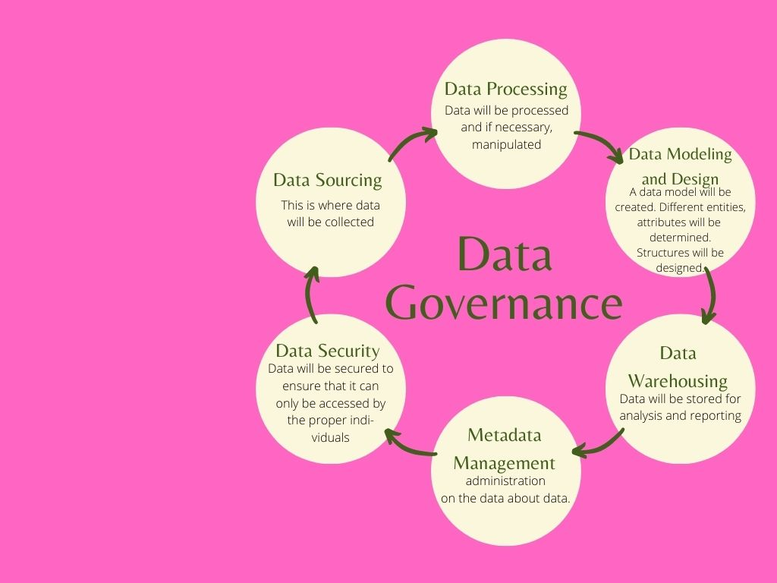

## Ethics, Law and Security of the collection of stored and shared data

* SecurePay is used to ensure that user’s payment information is secured. It is also beneficial as it provides a variety of payment options, [3]

- SecurePay terms and conditions prompt will be available as well before putting in the payment information

* A prompt will ask user if they consent to cookie, privacy, and terms and conditions.
* Terms and Conditions checkbox will need to be checked when making purchases.
* User will be prompted upon opening the site if they would like to subscribe to emails
* User will be asked if they would like to check out as a guest or log in/sign up, if they choose to log in/sign up, their contact, payment and purchase (contact and payment after user has consented) information will be collected for future purchases.
* If user decides to log in/register, information in the bottom will inform the user that signing in will automatically give consent that they agree to the cookie, privacy policy and terms and conditions.
* Data will only be collected if the user has consented/agreed to the cookie and privacy policy, and the terms and conditions.
* A cybersecurity organization will be employed as well to ensure customers’ security and privacy especially when checking out (such as Trustwave and DMCA[4])

# Team

## Employees

CEO

VP of Operations

VP of Finance

Head of Customer Relations

Customer Support Team

Customer Service Team

Head of Development

Product Development

Project Lead

Design Team

Product Research Team

Logistics and Transportation

Marketing Team

Quality Assurance Department

Photography

Manufacturing Department

IT Development

Project Lead

QA Engineer

Testing Experts

Programmers

Web Developers

Database Administrators

Graphic Designer

Backend Developers

Head of Human Resources

Human Resources Department

Head of Accounting

Accounting Department

Head of Legal Team

Legal Team

## Turnover[5]

A high turnover rate is not good for a company. This is because a company has already invested so much time, and effort to an individual to help the company. The time and effort it would take to train someone is a lot, they have to know the basics, standards, and policies of the company. They have to know the flow of the processes involved, especially in their department. They also have an adjustment period wherein they start to develop their own practices to make their workflow more efficient. All this time and effort is a lot, and time and effort are money. This means that it is quite expensive to train someone. The company is investing in a person, that is why it is quite important for the company to keep that person that they have hired.

To prevent turn overs, there are factors of an employee’s behavior that will constantly be checked by superiors. If the said factors are low, it could be an employee is unhappy or unsatisfied and may quit. These factors are:

1. Productivity

- can show how engaged an employee is in the work they are doing.

1. Teamwork

- are they ready to help other co workers? Are they willing to help the company as a whole?

1. Effort/Amount of work

- are they only doing enough to keep going? Or are they taking that extra step

1. Interest

- do they show interest in the project and the well being of the company?

- are they interested in creating and building relationships with their co-workers and managers?

1. Commitment

- are they committed to long-term deadlines, future projects?

It is important to note that these factors should be looked at and if they are low, it can be seen as a red flag, not necessarily showing that an employer will quit but might be a good time to have an open discussion with the employee to ensure their satisfaction with the company.

It is also important to take note of the common behaviors shown by an employee before they leave the company to ensure that the company is moving forward and correcting its past mistakes that might have made the employee unhappy.

## Organizational Chart

Below is an organizational chart of the employees mentioned above. A PDF file has been submitted as well for clarity.

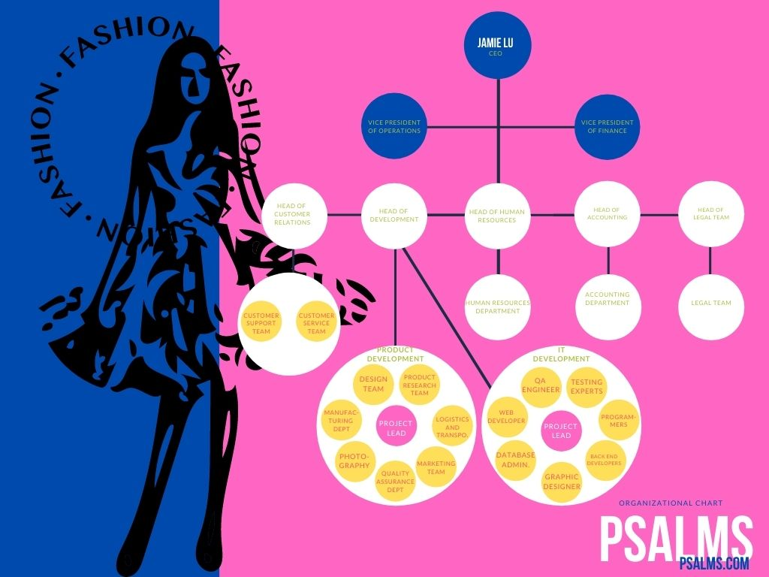

**Information Governance[6]**

This section is concerned with the business side of data. It includes both the structured and unstructured data. It includes the use, access, organization, categorization of data, as well as policy making.

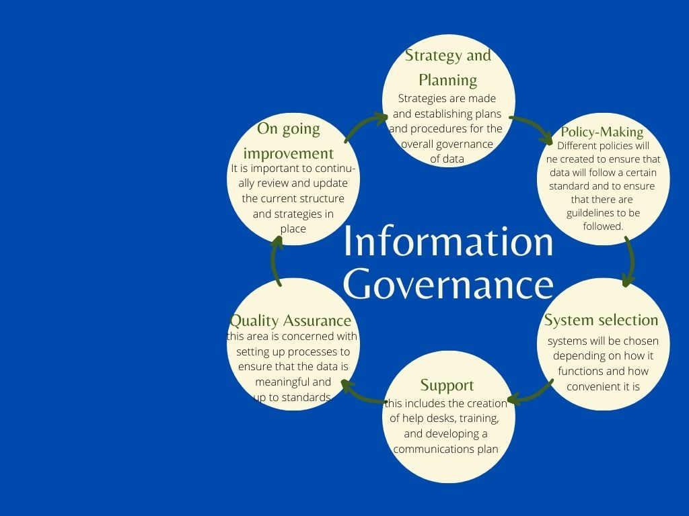

It is essential to have on-going improvement with any structure or strategy as it will ensure that the business is continually growing and adapting to the changes in its environment.

**Role of each employee/department in the information governance:**

Strategy and Planning:

CEO

Vice President of Operations

Head of Customer Relations

Head of Development

Head of Human Resources

Project Lead

Database Administrators

Policy Making:

CEO

Vice President of Operations

Vice President of Finance

Head of Development

Project Lead (IT Development)

Database Administrator

Head of Legal Team

Legal Team

Head of Accounting

Head of Customer Relations

System Selection:

Project Lead

Database Administrators

Back end developers

Programmers

Web Developer

Support:

Head of Customer Relations

Customer Support Team

Customer Service Team

Head of Human Resources

Human Resources Department

Quality Assurance:

Quality Assurance Department (Product Development)

QA Engineer (IT Development)

Testing Experts (IT Development)

Database Administrators

Product Research Team

On-going improvement:

Head of Development

Project Lead (IT Development)

Project Lead (Product Development)

Database Administrators

I found that having all the departments represented in the policy making important as data is everywhere in the company, whether it is the customer’s information, the product information, sales information, etc. I think it will be beneficial to have all these representations during policy making to see different ideas coming from different mindsets.

# References

Bi-Survey. (n.d.). *Data Governance Definition, Challenges and Best Practices*. Retrieved January 28, 2021, from Bi-Survey: https://bi-survey.com/data-governance

CompareCamp. (n.d.). *SecurePay*. Retrieved January 26, 2021, from CompareCamp: https://comparecamp.com/securepay-review-pricing-pros-cons-features/

DMCA. (n.d.). Retrieved January 27, 2021, from DMCA: https://www.dmca.com/

Eileen. (2020, July 13). *Websites Like SHEIN for Stylish, Affordable Clothes*. Retrieved January 26, 2021, from yesmissy: https://yesmissy.com/websites-like-shein/

Gibbs, M. (n.d.). *What is online storage?* Retrieved January 29, 2021, from Study.com: https://study.com/academy/lesson/what-is-online-data-storage.html#:~:text=Online%20data%20storage%20is%20a,also%20access%20the%20same%20infrastructure.

Guru99. (n.d.). *Data Modelling: Conceptual, Logical, Physical Data Model Types*. Retrieved January 28, 2021, from Guru99: https://www.guru99.com/data-modelling-conceptual-logical.html

Imperva. (n.d.). *Data Governance*. Retrieved January 28, 2021, from Imperva: https://www.imperva.com/learn/data-security/data-governance/

*Information Governance: the Risks of Getting it Wrong*. (n.d.). Retrieved January 28, 2021, from ChangeFactory: https://www.changefactory.com.au/our-thinking/articles/information-governance-risks-getting-wrong/

Kopytsya, P. (2020, August 11). *Data Governance: What for, Why and How?* Retrieved January 28, 2021, from Avenga: https://www.avenga.com/magazine/data-governance-what-for-why-and-how/

*Research Data Management: Research data lifecycle*. (n.d.). Retrieved January 28, 2021, from Nanyang Technological University: Singapore: https://libguides.ntu.edu.sg/rdm/researchdatalifecycle

Sacolick, I. (2018, July 30). *What is Data Governance? Data practices that address risk and drive opportunities*. Retrieved January 28, 2021, from Starcio: https://blogs.starcio.com/2018/07/what-is-data-governance.html

Shein. (n.d.). *Shein*. Retrieved January 26, 2021, from Shein: https://ca.shein.com/?ref=www&rep=dir&ret=ca

Sumitani, A. (2020, March 10). *7 Common (but Fixable) Causes of Employee Turnover*. Retrieved January 28, 2021, from TinyPulse: https://www.tinypulse.com/blog/7-common-causes-of-high-employee-turnover

TechTarget Contributor. (n.d.). *metadata management*. Retrieved January 28, 2021, from TechTarget: https://whatis.techtarget.com/definition/metadata-management#:~:text=Metadata%20management%20is%20the%20administration,best%20effect%20across%20the%20organization.

Trustwave. (n.d.). Retrieved January 27, 2021, from Trustwave: https://www.trustwave.com/en-us/

Wikipedia. (n.d.). *Data Warehouse*. Retrieved January 27, 2021, from Wikipedia: https://en.wikipedia.org/wiki/Data_warehouse#:~:text=In%20computing%2C%20a%20data%20warehouse,one%20or%20more%20disparate%20sources.

1. Referenced from (Eileen, 2020)
2. Referenced from (Gibbs, n.d.)
3. Referenced from (CompareCamp, n.d.)
4. Modeled after Shein.com:

   Trustwave: https://www.trustwave.com/en-us/

   DMCA: https://www.dmca.com/
5. Referenced from (Sumitani, 2020)
6. Referenced from: (Information Governance: the Risks of Getting it Wrong, n.d.)