

create a faux company

ASSIGNMENT 2 – DBAS 3025 – INFORMATION GOVERNANCE



February 28, 2021

JAMIE LU

W0441213

Table of Contents

Introduction 2

Task One 3

The Customer Relations Department 3

Data Management 4

What data is collected? 4

How will the data be stored? 4

How will the data be disseminated? 5

Stakeholders 5

Task Two 5

Scenario: 5

What needs to be changed: 5

Task Three 6

References 7

# Introduction

In the previous assignment, a faux company was made that is to be used for the remainder of the semester. It went through the basic structure of the company. This assignment goes in further with how the data is managed in the company. It takes a closer look at the blue and green models or data and information governance and relates them to the different aspects of the company. It also helps in exploring the different change and project management principles and skills.

# Task One

## The Customer Relations Department

The Customer Relations department of Psalms is composed of the Head of the Customer Relations department, customer support team, and the customer service team. This department is mainly concerned with aiding and conversing with customers in order to provide them with a wonderful experience with the company. The head of the Customer Relations department is in charge of the management of the teams under the department, as well as carrying out different plans and strategies of how the company wants to interact with the customer. The customer support team is mostly concerned with providing support on the products that we sell, tech issues, and needs both hard and soft skills, whereas the customer service team is mostly concerned with assisting customers with how they can maximize a product’s value and mostly needs soft skills. Customer support is reactive, whereas customer service is proactive.[1] This department, although mentions customers in the name, will also deal with some issues experienced by other employees. They will deal with some help desk matters. These functions allow us to identify this department as part of the blue model or information governance model.

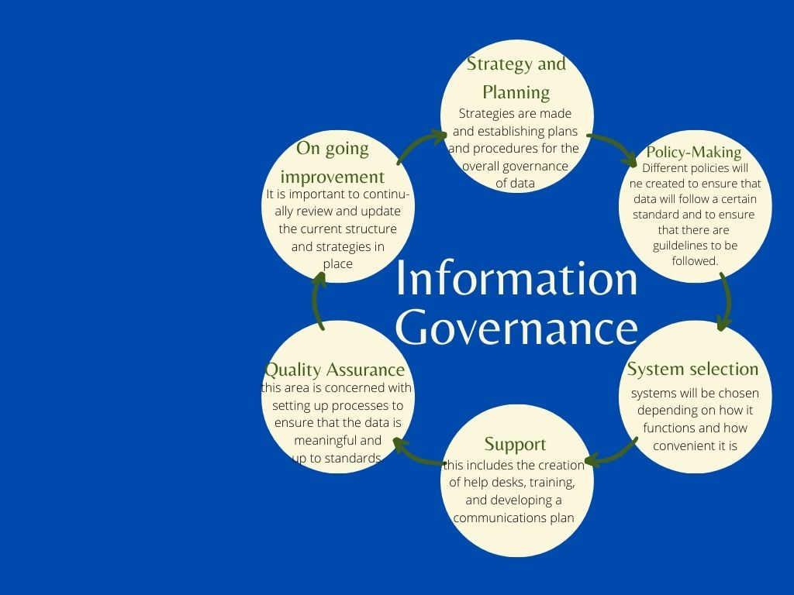

As seen in the images above, this department is mainly concerned with the Support aspect of Information Governance as it involves itself with communicating with customers and possibly other staff that would need the help desk. It also contributes to the ongoing improvement of the company as interacting with customers will give the company feedback. All the other aspects as well would be influenced in some way as this feedback is essential to how the company will continue going on.

## Data Management

### What data is collected?

* Previous purchases
* log in information
* payment information
* email information (if user will subscribe to emails)
* previous browsing history (such as items that were taken a look at before)
* product information, such as its description, availability, price history, sales history, etc.
* statistical information as such web traffic, etc.

### How will the data be stored?

* It is important to note that data will only be collected and stored with the consent or permission of the customer.
* Data will be stored using a virtual storage model or cloud. This is beneficial because it not only is cost-effective, but also provides security, data integrity, automation, and syncing.[2]

### How will the data be disseminated?

* Only data relevant to the customer will be disseminated to them. For example, if a customer clicks on a product, that product’s information/data will be disseminated to the customer.
* The data disseminated to the customer will only be through electronic format due to the nature of the business.
* Things such as statistical data would be disseminated to the finance departments through electronic format.
* Due to the nature of the business/company, most if not all of the data would be disseminated through electronic format and only the data that is necessary would be stored and disseminated.

### Stakeholders

* Customers
* Staff/employees
* Suppliers
* Investors
* 3rd party companies (such as the security companies hired to help with secure payment methods, or companies that help with cloud storage)

# Task Two

## Scenario:

There is a shift of the common method of communication with customers. The company was used to using call centers to help with customers’ needs and communicate with them using telephones. This was the trend or norm with most online businesses.

## What needs to be changed:

The method of communication with customers has to be updated to the new norm. With the advancement of technology, the growing use of laptops, tablets, cellphones, and other devices, the company has to determine other ways that we can communicate with customers.

1. A meeting will be conducted to assess the scenario and the current system.
2. Several meetings would need to be conducted within the different departments to grab ideas from the staff with what they can suggest. This is good as it enables all the staff to feel like they are important and heard.
3. Several meetings would be conducted with the different heads of the departments to bring up all the suggestions that were made, analysis of the current system would be done, strategy and planning would need to take place, and a change management plan would be created.
4. The plans would need to be analyzed and approved by the different departments.
5. The approved plans would be disseminated to the various departments and training would commence to implement these plans. Staff would still be allowed to give feedback to their managers.
6. IT department would need to develop a live chat so that the customer relations department can communicate with customers through this as well as the current system of communicating through phone calls.
7. IT department would need to develop an app, with chatbots available for easier questions (such as return policies, etc.), live chats, and easier way to make purchases and view products.
8. Training would be done with those involved in the assistance of using these apps.
9. Continuous meetings would be held to check how well the change is going and how well all the changes are being integrated into the current system.
10. Final meeting will be done wherein the future of the company will be planned and a final project report from each department is assessed.

To handle the scenario, project management principles have to be considered. We need to initiate, which is seen in step 1, wherein the problem or scenario is identified, and the current system is assessed. From this initial initiation of a need for change, planning commences. This can be seen in steps 2-4; multiple meetings are held to ensure that the company has a solid plan for handling the scenario. We then move on to execution, which is done in steps 5-8. These steps are concerned with the execution of the plans that were put in place to handle the scenario. Next, we have to monitor the progress, this can be seen in step 9. Meetings will continue until the scenario is handled. In these meetings, progress reports are essential. The company will need to check the compliance, risks, and the quality management. Once everything seems to have settled down a bit and progress reports are looking good, there will be a call for creation of a final project report from each department involved in tackling the scenario. This is part of the close principle of project management. I chose to do project management because I feel like it fits with the scenario the most. The principles involved with project management handles the scenario very well because it tackles the entirety of what needs to be done and goes through it step by step and ensures that the very effective method of planning, execution, and monitoring is done before a project can be closed.[3]

The changes sort of integrates mostly the Blue model but part of the Green model. The blue model because it involves strategy and planning, policy changes, support, and on-going improvement. It has part of the green model due to the need of the help of the IT department. The integration of a live chat, chatbot, and creation of an app requires data governance thus the different processes such as data warehousing, modeling and design, and security are used.

# Task Three

ManageEngine would be a good company to use as it offers different tools for both project and change management. Since the scenario I have created in the previous tasks deals with more of the blue model specifically the support aspect of the business, I thought it would be great to use ManageEngine’s ServiceDesk Plus. This tool is great because it deals with incident management, problem management, change management, reports, and IT Project management. Contextually, it is great because it has an accessible search which allows for easy information recoveries. It also manages the use of the screen space very well as its tool design shows significant details and has slide out menus for things like notifications, requests, and quick actions. This would suit the company and scenario well due to the nature of the business. It is easy to manage and communicate with employees and keep track of everything. It is flexible as well to suit the needs of the person looking at the tool. Their interface provides layout personalization options which I believe is very handy as different people would want their screen to display certain things based on the job they are doing. They can rearrange based on what is convenient for them.[4]

# References

Dunn, J. (2017, September 11). *INFORMATION GOVERNANCE VS. DATA GOVERNANCE: WHAT’S THE DIFFERENCE?* Retrieved February 28, 2021, from InfoGoTo: https://www.ironmountain.com/blogs/2017/information-governance-vs-data-governance-whats-the-difference#:~:text=Information%20governance%20includes%20both%20structured,is%20usually%20an%20IT%20responsibility.

Gibbs, M. (n.d.). *What is online storage?* Retrieved February 28, 2021, from Study.com: https://study.com/academy/lesson/what-is-online-data-storage.html#:~:text=Online%20data%20storage%20is%20a,also%20access%20the%20same%20infrastructure.

iDoGrants. (2018, May 22). *Project Management Principles for the New Principal Investigator.* Retrieved February 28, 2021, from iDoGrants: https://idogrants.org/2018/05/22/project-management-principles/

LiveAgent. (n.d.). *Customer service vs customer support.* Retrieved February 28, 2021, from LiveAgent: https://www.liveagent.com/academy/customer-service-vs-customer-support/

Lucidchart Content Team. (n.d.). *Understanding the difference between project management and change management.* Retrieved February 28, 2021, from Lucidchart: https://www.lucidchart.com/blog/project-change-management

Sacolick, I. (2018, July 30). *What is Data Governance? Data practices that address risk and drive opportunities*. Retrieved January 28, 2021, from Starcio: https://blogs.starcio.com/2018/07/what-is-data-governance.html

ServiceDesk Plus. (2020, October 12). *New design, layout, and features—the all-new UI of ServiceDesk Plus Cloud is here.* Retrieved February 28, 2021, from ManageEngine Blog: https://blogs.manageengine.com/help-desk/servicedesk/2020/10/12/new-design-layout-and-features-the-all-new-ui-of-servicedesk-plus-cloud-is-here.html

1. Referenced from (LiveAgent)
2. Referenced from (Gibbs, n.d.)
3. Referenced from: (iDoGrants, 2018)
4. Referenced from: (ServiceDesk Plus, 2020)