

DDL AND DML

ASSIGNMENT 1 – DBAS 3035 INFORMATION SYSTEMS DESIGN



February 26, 2021

JAMIE LU

W0441213

# MS SQL DATABASE AND TABLES

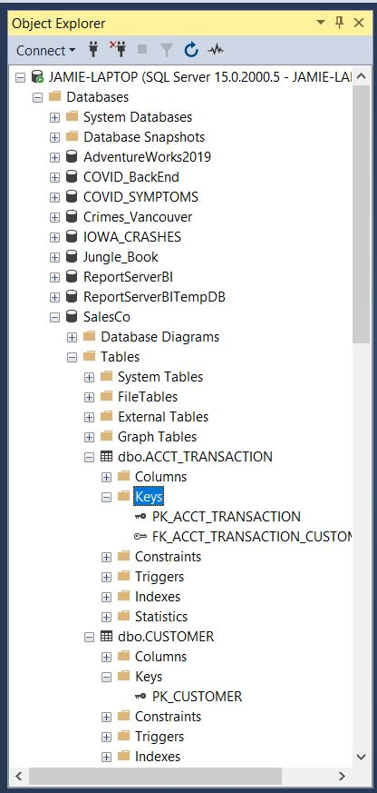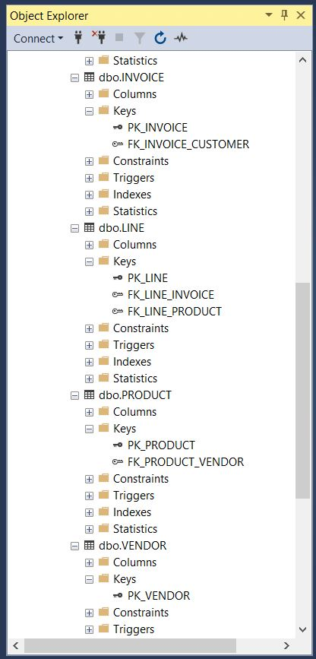

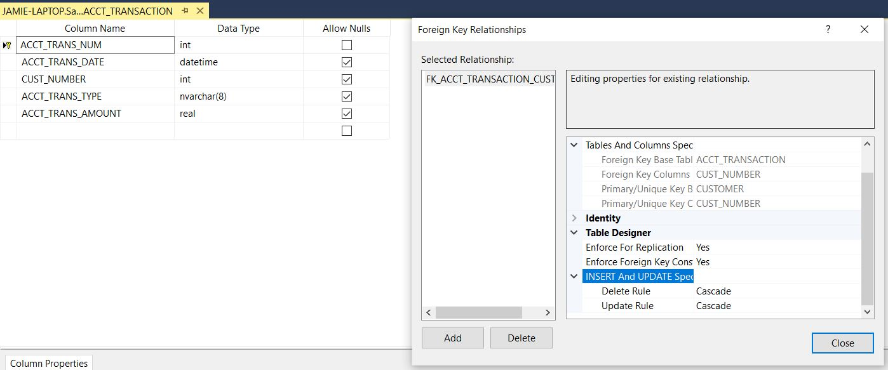

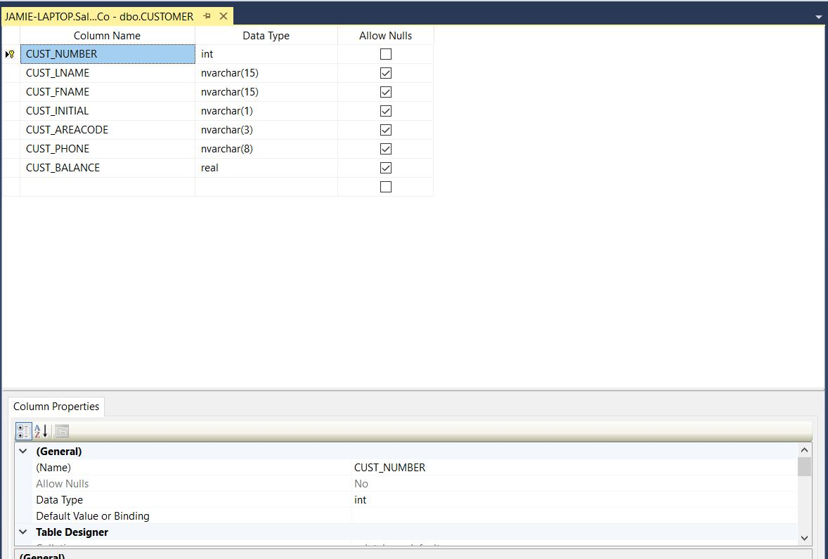

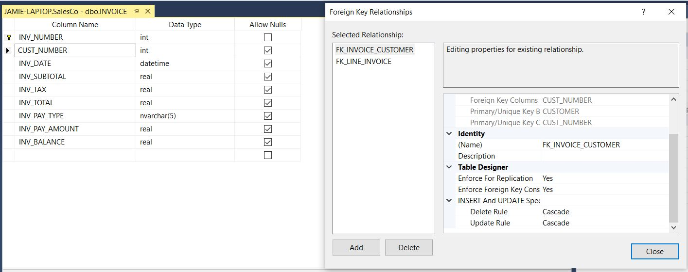

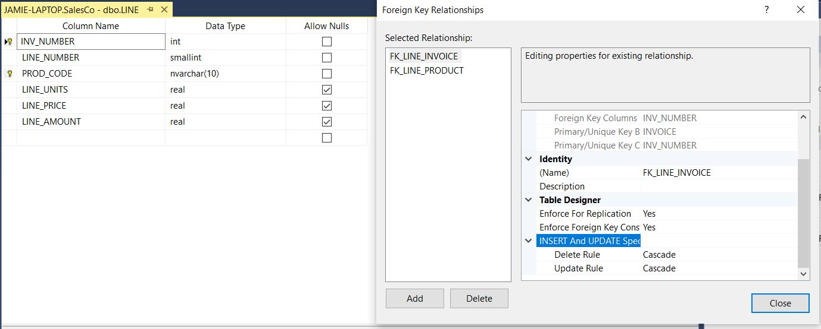

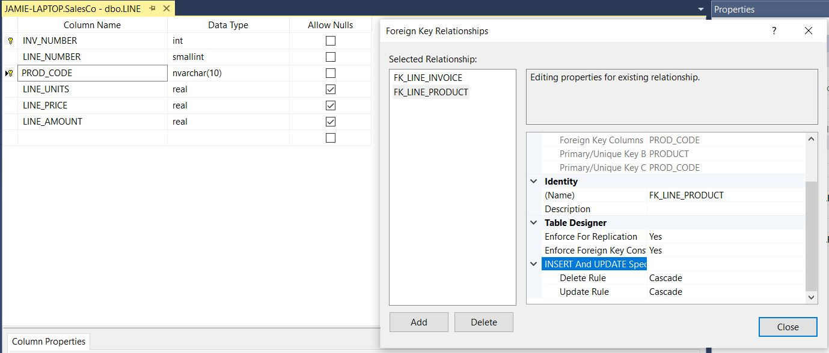

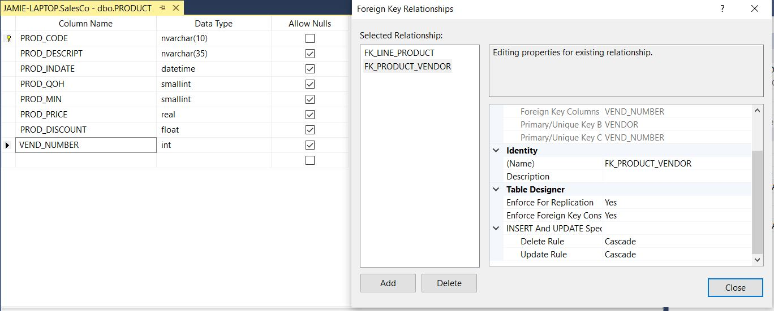

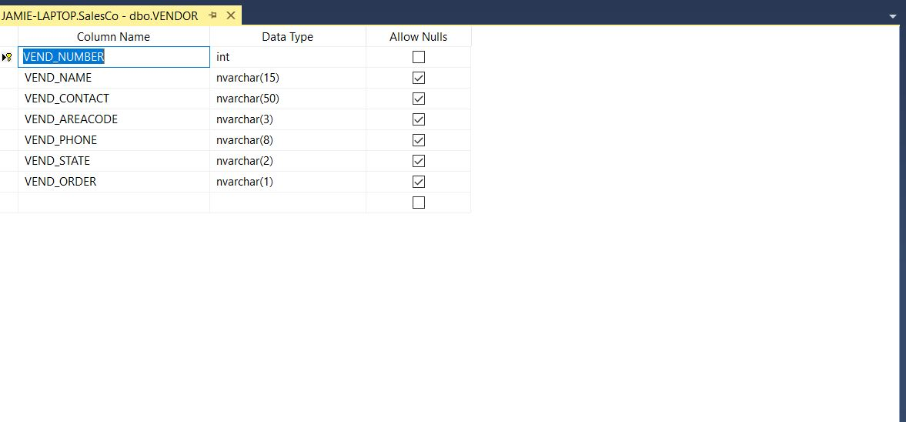

# VIEWS

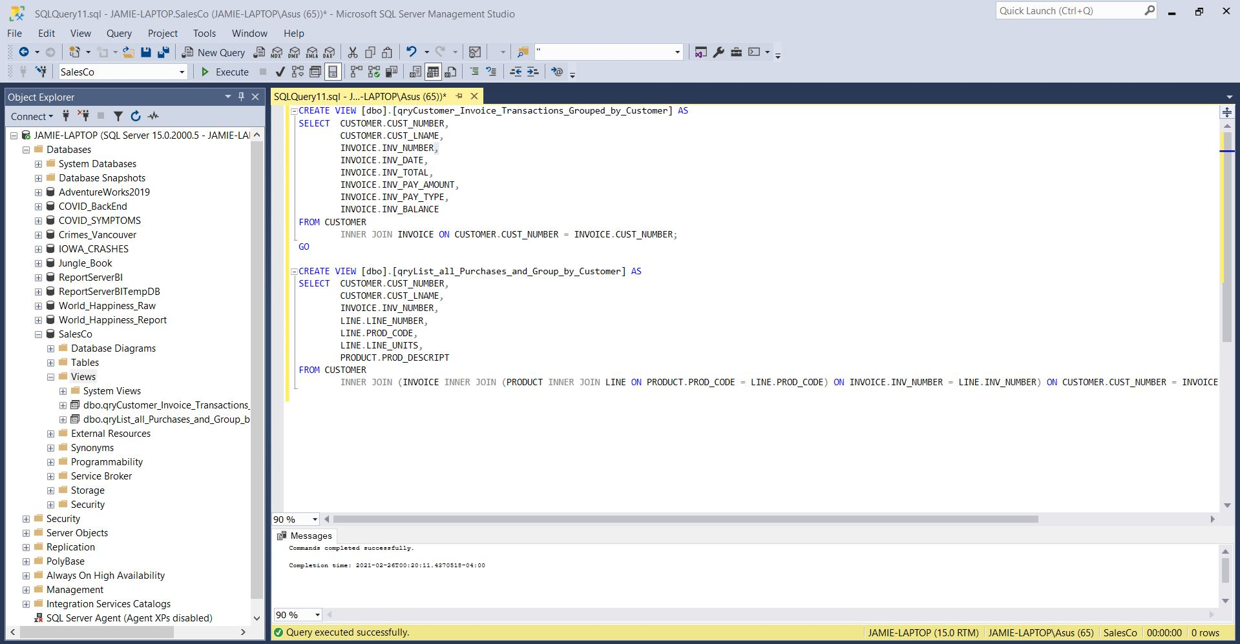

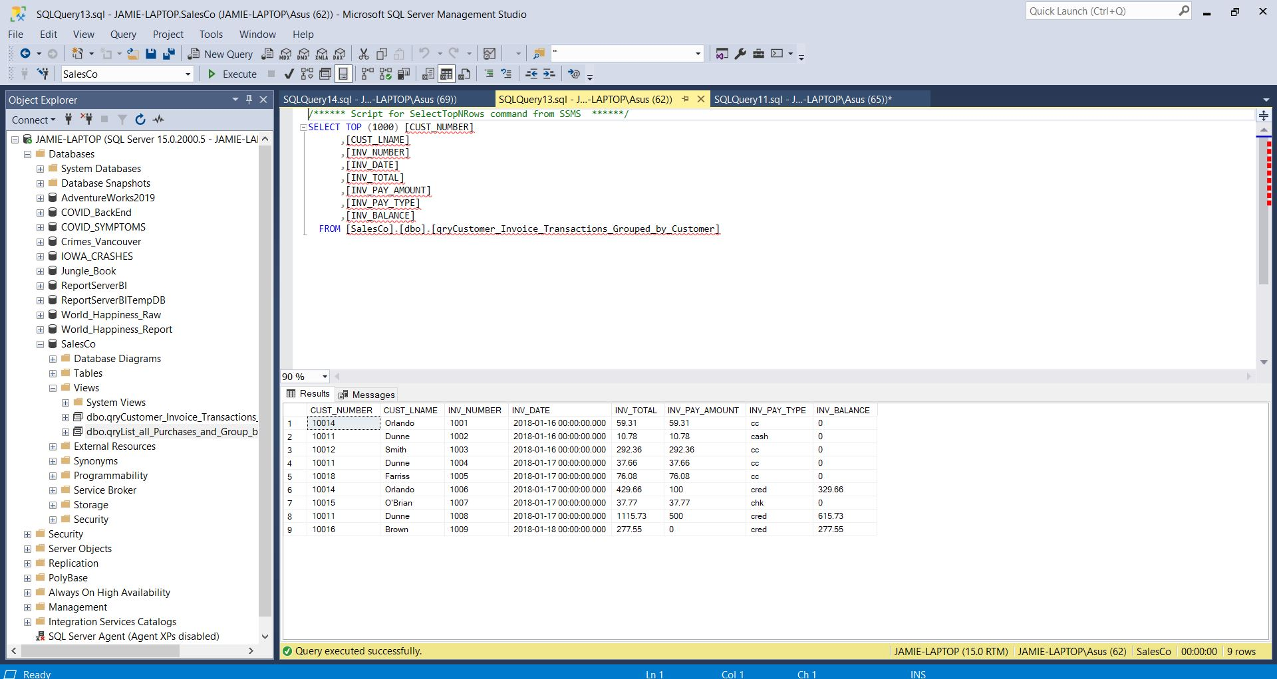

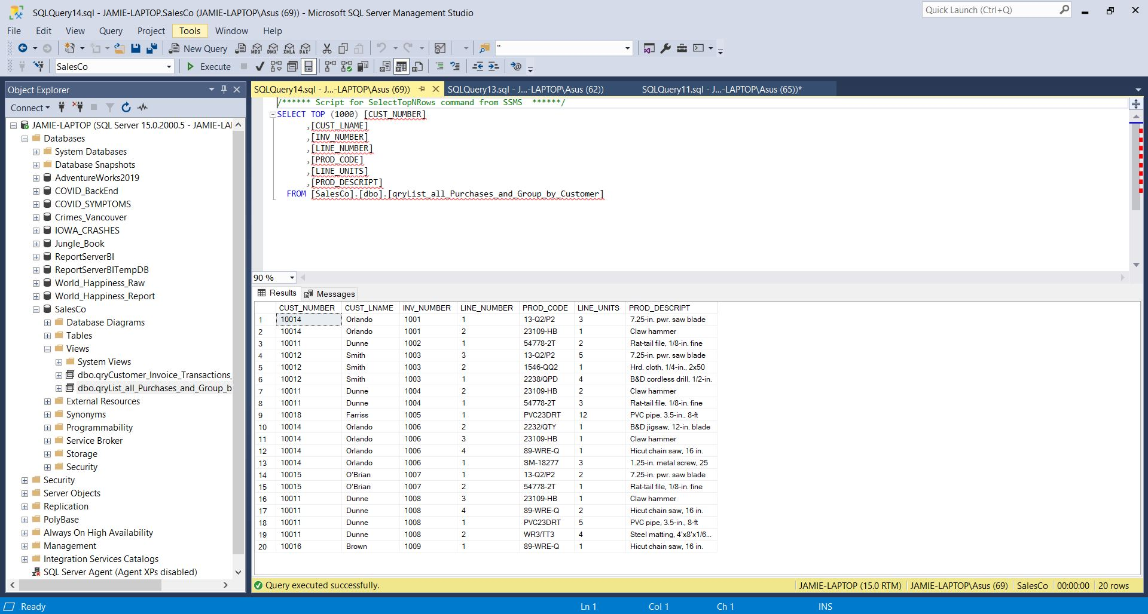

# COMPOSITE SQL CODE TO RECREATE THE DATABASE

USE [master]

GO

/****** Object: Database [SalesCo] Script Date: 2021-02-26 5:01:52 PM ******/

CREATE DATABASE [SalesCo]

CONTAINMENT = NONE

ON PRIMARY

( NAME = N'SalesCo', FILENAME = N'C:\Program Files\Microsoft SQL Server\MSSQL15.MSSQLSERVER\MSSQL\DATA\SalesCo.mdf' , SIZE = 8192KB , MAXSIZE = UNLIMITED, FILEGROWTH = 65536KB )

LOG ON

( NAME = N'SalesCo_log', FILENAME = N'C:\Program Files\Microsoft SQL Server\MSSQL15.MSSQLSERVER\MSSQL\DATA\SalesCo_log.ldf' , SIZE = 8192KB , MAXSIZE = 2048GB , FILEGROWTH = 65536KB )

WITH CATALOG_COLLATION = DATABASE_DEFAULT

GO

ALTER DATABASE [SalesCo] SET COMPATIBILITY_LEVEL = 150

GO

IF (1 = FULLTEXTSERVICEPROPERTY('IsFullTextInstalled'))

begin

EXEC [SalesCo].[dbo].[sp_fulltext_database] @action = 'enable'

end

GO

ALTER DATABASE [SalesCo] SET ANSI_NULL_DEFAULT OFF

GO

ALTER DATABASE [SalesCo] SET ANSI_NULLS OFF

GO

ALTER DATABASE [SalesCo] SET ANSI_PADDING OFF

GO

ALTER DATABASE [SalesCo] SET ANSI_WARNINGS OFF

GO

ALTER DATABASE [SalesCo] SET ARITHABORT OFF

GO

ALTER DATABASE [SalesCo] SET AUTO_CLOSE OFF

GO

ALTER DATABASE [SalesCo] SET AUTO_SHRINK OFF

GO

ALTER DATABASE [SalesCo] SET AUTO_UPDATE_STATISTICS ON

GO

ALTER DATABASE [SalesCo] SET CURSOR_CLOSE_ON_COMMIT OFF

GO

ALTER DATABASE [SalesCo] SET CURSOR_DEFAULT GLOBAL

GO

ALTER DATABASE [SalesCo] SET CONCAT_NULL_YIELDS_NULL OFF

GO

ALTER DATABASE [SalesCo] SET NUMERIC_ROUNDABORT OFF

GO

ALTER DATABASE [SalesCo] SET QUOTED_IDENTIFIER OFF

GO

ALTER DATABASE [SalesCo] SET RECURSIVE_TRIGGERS OFF

GO

ALTER DATABASE [SalesCo] SET DISABLE_BROKER

GO

ALTER DATABASE [SalesCo] SET AUTO_UPDATE_STATISTICS_ASYNC OFF

GO

ALTER DATABASE [SalesCo] SET DATE_CORRELATION_OPTIMIZATION OFF

GO

ALTER DATABASE [SalesCo] SET TRUSTWORTHY OFF

GO

ALTER DATABASE [SalesCo] SET ALLOW_SNAPSHOT_ISOLATION OFF

GO

ALTER DATABASE [SalesCo] SET PARAMETERIZATION SIMPLE

GO

ALTER DATABASE [SalesCo] SET READ_COMMITTED_SNAPSHOT OFF

GO

ALTER DATABASE [SalesCo] SET HONOR_BROKER_PRIORITY OFF

GO

ALTER DATABASE [SalesCo] SET RECOVERY FULL

GO

ALTER DATABASE [SalesCo] SET MULTI_USER

GO

ALTER DATABASE [SalesCo] SET PAGE_VERIFY CHECKSUM

GO

ALTER DATABASE [SalesCo] SET DB_CHAINING OFF

GO

ALTER DATABASE [SalesCo] SET FILESTREAM( NON_TRANSACTED_ACCESS = OFF )

GO

ALTER DATABASE [SalesCo] SET TARGET_RECOVERY_TIME = 60 SECONDS

GO

ALTER DATABASE [SalesCo] SET DELAYED_DURABILITY = DISABLED

GO

EXEC sys.sp_db_vardecimal_storage_format N'SalesCo', N'ON'

GO

ALTER DATABASE [SalesCo] SET QUERY_STORE = OFF

GO

USE [SalesCo]

GO

/****** Object: Table [dbo].[CUSTOMER] Script Date: 2021-02-26 5:01:52 PM ******/

SET ANSI_NULLS ON

GO

SET QUOTED_IDENTIFIER ON

GO

CREATE TABLE [dbo].[CUSTOMER](

[CUST_NUMBER] [int] NOT NULL,

[CUST_LNAME] [nvarchar](15) NULL,

[CUST_FNAME] [nvarchar](15) NULL,

[CUST_INITIAL] [nvarchar](1) NULL,

[CUST_AREACODE] [nvarchar](3) NULL,

[CUST_PHONE] [nvarchar](8) NULL,

[CUST_BALANCE] [real] NULL,

CONSTRAINT [PK_CUSTOMER] PRIMARY KEY CLUSTERED

(

[CUST_NUMBER] ASC

)WITH (PAD_INDEX = OFF, STATISTICS_NORECOMPUTE = OFF, IGNORE_DUP_KEY = OFF, ALLOW_ROW_LOCKS = ON, ALLOW_PAGE_LOCKS = ON, OPTIMIZE_FOR_SEQUENTIAL_KEY = OFF) ON [PRIMARY]

) ON [PRIMARY]

GO

/****** Object: Table [dbo].[INVOICE] Script Date: 2021-02-26 5:01:52 PM ******/

SET ANSI_NULLS ON

GO

SET QUOTED_IDENTIFIER ON

GO

CREATE TABLE [dbo].[INVOICE](

[INV_NUMBER] [int] NOT NULL,

[CUST_NUMBER] [int] NULL,

[INV_DATE] [datetime] NULL,

[INV_SUBTOTAL] [real] NULL,

[INV_TAX] [real] NULL,

[INV_TOTAL] [real] NULL,

[INV_PAY_TYPE] [nvarchar](5) NULL,

[INV_PAY_AMOUNT] [real] NULL,

[INV_BALANCE] [real] NULL,

CONSTRAINT [PK_INVOICE] PRIMARY KEY CLUSTERED

(

[INV_NUMBER] ASC

)WITH (PAD_INDEX = OFF, STATISTICS_NORECOMPUTE = OFF, IGNORE_DUP_KEY = OFF, ALLOW_ROW_LOCKS = ON, ALLOW_PAGE_LOCKS = ON, OPTIMIZE_FOR_SEQUENTIAL_KEY = OFF) ON [PRIMARY]

) ON [PRIMARY]

GO

/****** Object: View [dbo].[qryCustomer_Invoice_Transactions_Grouped_by_Customer] Script Date: 2021-02-26 5:01:52 PM ******/

SET ANSI_NULLS ON

GO

SET QUOTED_IDENTIFIER ON

GO

CREATE VIEW [dbo].[qryCustomer_Invoice_Transactions_Grouped_by_Customer] AS

SELECT CUSTOMER.CUST_NUMBER,

CUSTOMER.CUST_LNAME,

INVOICE.INV_NUMBER,

INVOICE.INV_DATE,

INVOICE.INV_TOTAL,

INVOICE.INV_PAY_AMOUNT,

INVOICE.INV_PAY_TYPE,

INVOICE.INV_BALANCE

FROM CUSTOMER

INNER JOIN INVOICE ON CUSTOMER.CUST_NUMBER = INVOICE.CUST_NUMBER;

GO

/****** Object: Table [dbo].[PRODUCT] Script Date: 2021-02-26 5:01:52 PM ******/

SET ANSI_NULLS ON

GO

SET QUOTED_IDENTIFIER ON

GO

CREATE TABLE [dbo].[PRODUCT](

[PROD_CODE] [nvarchar](10) NOT NULL,

[PROD_DESCRIPT] [nvarchar](35) NULL,

[PROD_INDATE] [datetime] NULL,

[PROD_QOH] [smallint] NULL,

[PROD_MIN] [smallint] NULL,

[PROD_PRICE] [real] NULL,

[PROD_DISCOUNT] [float] NULL,

[VEND_NUMBER] [int] NULL,

CONSTRAINT [PK_PRODUCT] PRIMARY KEY CLUSTERED

(

[PROD_CODE] ASC

)WITH (PAD_INDEX = OFF, STATISTICS_NORECOMPUTE = OFF, IGNORE_DUP_KEY = OFF, ALLOW_ROW_LOCKS = ON, ALLOW_PAGE_LOCKS = ON, OPTIMIZE_FOR_SEQUENTIAL_KEY = OFF) ON [PRIMARY]

) ON [PRIMARY]

GO

/****** Object: Table [dbo].[LINE] Script Date: 2021-02-26 5:01:52 PM ******/

SET ANSI_NULLS ON

GO

SET QUOTED_IDENTIFIER ON

GO

CREATE TABLE [dbo].[LINE](

[INV_NUMBER] [int] NOT NULL,

[LINE_NUMBER] [smallint] NOT NULL,

[PROD_CODE] [nvarchar](10) NOT NULL,

[LINE_UNITS] [real] NULL,

[LINE_PRICE] [real] NULL,

[LINE_AMOUNT] [real] NULL,

CONSTRAINT [PK_LINE] PRIMARY KEY CLUSTERED

(

[INV_NUMBER] ASC,

[PROD_CODE] ASC

)WITH (PAD_INDEX = OFF, STATISTICS_NORECOMPUTE = OFF, IGNORE_DUP_KEY = OFF, ALLOW_ROW_LOCKS = ON, ALLOW_PAGE_LOCKS = ON, OPTIMIZE_FOR_SEQUENTIAL_KEY = OFF) ON [PRIMARY]

) ON [PRIMARY]

GO

/****** Object: View [dbo].[qryList_all_Purchases_and_Group_by_Customer] Script Date: 2021-02-26 5:01:52 PM ******/

SET ANSI_NULLS ON

GO

SET QUOTED_IDENTIFIER ON

GO

CREATE VIEW [dbo].[qryList_all_Purchases_and_Group_by_Customer] AS

SELECT CUSTOMER.CUST_NUMBER,

CUSTOMER.CUST_LNAME,

INVOICE.INV_NUMBER,

LINE.LINE_NUMBER,

LINE.PROD_CODE,

LINE.LINE_UNITS,

PRODUCT.PROD_DESCRIPT

FROM CUSTOMER

INNER JOIN (INVOICE INNER JOIN (PRODUCT INNER JOIN LINE ON PRODUCT.PROD_CODE = LINE.PROD_CODE) ON INVOICE.INV_NUMBER = LINE.INV_NUMBER) ON CUSTOMER.CUST_NUMBER = INVOICE.CUST_NUMBER;

GO

/****** Object: Table [dbo].[ACCT_TRANSACTION] Script Date: 2021-02-26 5:01:52 PM ******/

SET ANSI_NULLS ON

GO

SET QUOTED_IDENTIFIER ON

GO

CREATE TABLE [dbo].[ACCT_TRANSACTION](

[ACCT_TRANS_NUM] [int] NOT NULL,

[ACCT_TRANS_DATE] [datetime] NULL,

[CUST_NUMBER] [int] NULL,

[ACCT_TRANS_TYPE] [nvarchar](8) NULL,

[ACCT_TRANS_AMOUNT] [real] NULL,

CONSTRAINT [PK_ACCT_TRANSACTION] PRIMARY KEY CLUSTERED

(

[ACCT_TRANS_NUM] ASC

)WITH (PAD_INDEX = OFF, STATISTICS_NORECOMPUTE = OFF, IGNORE_DUP_KEY = OFF, ALLOW_ROW_LOCKS = ON, ALLOW_PAGE_LOCKS = ON, OPTIMIZE_FOR_SEQUENTIAL_KEY = OFF) ON [PRIMARY]

) ON [PRIMARY]

GO

/****** Object: Table [dbo].[VENDOR] Script Date: 2021-02-26 5:01:52 PM ******/

SET ANSI_NULLS ON

GO

SET QUOTED_IDENTIFIER ON

GO

CREATE TABLE [dbo].[VENDOR](

[VEND_NUMBER] [int] NOT NULL,

[VEND_NAME] [nvarchar](15) NULL,

[VEND_CONTACT] [nvarchar](50) NULL,

[VEND_AREACODE] [nvarchar](3) NULL,

[VEND_PHONE] [nvarchar](8) NULL,

[VEND_STATE] [nvarchar](2) NULL,

[VEND_ORDER] [nvarchar](1) NULL,

CONSTRAINT [PK_VENDOR] PRIMARY KEY CLUSTERED

(

[VEND_NUMBER] ASC

)WITH (PAD_INDEX = OFF, STATISTICS_NORECOMPUTE = OFF, IGNORE_DUP_KEY = OFF, ALLOW_ROW_LOCKS = ON, ALLOW_PAGE_LOCKS = ON, OPTIMIZE_FOR_SEQUENTIAL_KEY = OFF) ON [PRIMARY]

) ON [PRIMARY]

GO

ALTER TABLE [dbo].[ACCT_TRANSACTION] WITH CHECK ADD CONSTRAINT [FK_ACCT_TRANSACTION_CUSTOMER] FOREIGN KEY([CUST_NUMBER])

REFERENCES [dbo].[CUSTOMER] ([CUST_NUMBER])

ON UPDATE CASCADE

ON DELETE CASCADE

GO

ALTER TABLE [dbo].[ACCT_TRANSACTION] CHECK CONSTRAINT [FK_ACCT_TRANSACTION_CUSTOMER]

GO

ALTER TABLE [dbo].[INVOICE] WITH CHECK ADD CONSTRAINT [FK_INVOICE_CUSTOMER] FOREIGN KEY([CUST_NUMBER])

REFERENCES [dbo].[CUSTOMER] ([CUST_NUMBER])

ON UPDATE CASCADE

ON DELETE CASCADE

GO

ALTER TABLE [dbo].[INVOICE] CHECK CONSTRAINT [FK_INVOICE_CUSTOMER]

GO

ALTER TABLE [dbo].[LINE] WITH CHECK ADD CONSTRAINT [FK_LINE_INVOICE] FOREIGN KEY([INV_NUMBER])

REFERENCES [dbo].[INVOICE] ([INV_NUMBER])

ON UPDATE CASCADE

ON DELETE CASCADE

GO

ALTER TABLE [dbo].[LINE] CHECK CONSTRAINT [FK_LINE_INVOICE]

GO

ALTER TABLE [dbo].[LINE] WITH CHECK ADD CONSTRAINT [FK_LINE_PRODUCT] FOREIGN KEY([PROD_CODE])

REFERENCES [dbo].[PRODUCT] ([PROD_CODE])

ON UPDATE CASCADE

ON DELETE CASCADE

GO

ALTER TABLE [dbo].[LINE] CHECK CONSTRAINT [FK_LINE_PRODUCT]

GO

ALTER TABLE [dbo].[PRODUCT] WITH CHECK ADD CONSTRAINT [FK_PRODUCT_VENDOR] FOREIGN KEY([VEND_NUMBER])

REFERENCES [dbo].[VENDOR] ([VEND_NUMBER])

ON UPDATE CASCADE

ON DELETE CASCADE

GO

ALTER TABLE [dbo].[PRODUCT] CHECK CONSTRAINT [FK_PRODUCT_VENDOR]

GO

USE [master]

GO

ALTER DATABASE [SalesCo] SET READ_WRITE

GO