**In-Class Exercise 3 – Using CTEs and Pivots**

Using the AdventureWorks2019.bak Database found here:

<https://docs.microsoft.com/en-us/sql/samples/adventureworks-install-configure?view=sql-server-ver15&tabs=ssms>

Question 1 (5pts)

SELECT soh.[SalesPersonID],

p.[FirstName] + ' ' + COALESCE (p.[MiddleName], '') + ' ' + p.[LastName] AS [FullName],

e.[JobTitle],

st.[Name] AS [SalesTerritory],

soh.[SubTotal],

YEAR(DATEADD(m, 6, soh.[OrderDate])) AS [FiscalYear]

FROM [Sales].[SalesPerson] sp INNER JOIN

[Sales].[SalesOrderHeader] soh ON sp.[BusinessEntityID] = soh.[SalesPersonID]

INNER JOIN [Sales].[SalesTerritory] st ON sp.[TerritoryID] = st.[TerritoryID]

INNER JOIN [HumanResources].[Employee] e ON soh.[SalesPersonID] = e.[BusinessEntityID]

INNER JOIN [Person].[Person] p ON p.[BusinessEntityID] = sp.[BusinessEntityID]

1. Using the sql statement above, please create a CTE query and select all columns in the result (2pts) [paste your query below]

WITH Sales_CTE

AS

(

SELECT soh.[SalesPersonID],

p.[FirstName] + ' ' + COALESCE (p.[MiddleName], '') + ' ' + p.[LastName] AS [FullName],

e.[JobTitle],

st.[Name] AS [SalesTerritory],

soh.[SubTotal],

YEAR(DATEADD(m, 6, soh.[OrderDate])) AS [FiscalYear]

FROM [Sales].[SalesPerson] sp INNER JOIN

[Sales].[SalesOrderHeader] soh ON sp.[BusinessEntityID] = soh.[SalesPersonID]

INNER JOIN [Sales].[SalesTerritory] st ON sp.[TerritoryID] = st.[TerritoryID]

INNER JOIN [HumanResources].[Employee] e ON soh.[SalesPersonID] = e.[BusinessEntityID]

INNER JOIN [Person].[Person] p ON p.[BusinessEntityID] = sp.[BusinessEntityID]

)

SELECT * FROM Sales_CTE;

1. What is the purpose of the COALESCE in the “COALESCE (p.[MiddleName], '')” part of the sql statement ? (1pt)

The purpose of the COALSCE function in the sql statement, is to ensure that it returns the first non-null value in the list.

1. Why does the “YEAR(DATEADD(m, 6, soh.[OrderDate])) AS [FiscalYear]” convert to a Fiscal Year? (2pt) Please provide the expected result for 1-Aug-2019 and 1-Mar-2019

The DATEADD function takes in the parameters: interval, number, and date. Interval here means the time/interval to be added. It can be month, year, quarter, day, minute, second, etc. In this example, it takes in m or month. The number here takes in the number of the interval to add to the date. This is positive if the date is in the future, and negative if the date is in the past. Date here takes in the date that is to be modified. That is why if we used, 1-August-2019 in place of the soh.[OrderDate], the expected result would be fiscal year 2020. Since 1 August 2019 + 6 months is February 2020. However, if we used 1 March 2019, we would expect the fiscal year to be 2019 as the result as 1 March 2019 + 6 months is August 2019.

With 1-August-2019 as the date parameter:

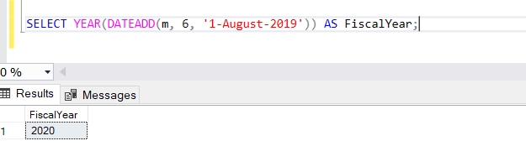

With 1-March-2019 as the date parameter:

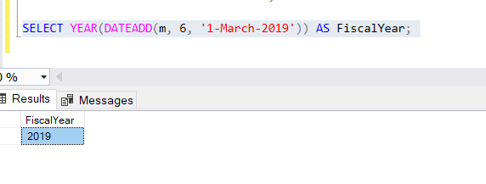

Question 2 (10pts)

Using the CTE query created in your answer to Question 1a please create a pivot table of Avg Sales by SalesPerson (Years: 2012, 2013, 2014). Please provide the sql below. Your output should be as follows: (

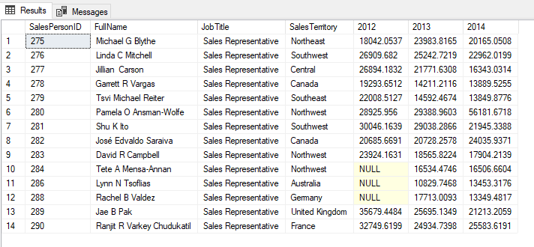

Hint:

SELECT pvt.[SalesPersonID], pvt.[FullName], pvt.[JobTitle], pvt.[SalesTerritory], pvt.[2012], pvt.[2013], pvt.[2014]

FROM (

SELECT soh.[SalesPersonID],

p.[FirstName] + ' ' + COALESCE (p.[MiddleName], '') + ' ' + p.[LastName] AS [FullName],

e.[JobTitle], st.[Name] AS [SalesTerritory], soh.[SubTotal], YEAR(DATEADD(m, 6, soh.[OrderDate])) [FiscalYear]

FROM [Sales].[SalesPerson] sp

INNER JOIN [Sales].[SalesOrderHeader] soh ON sp.[BusinessEntityID] = soh.[SalesPersonID]

INNER JOIN [Sales].[SalesTerritory] st ON sp.[TerritoryID] = st.[TerritoryID]

INNER JOIN [HumanResources].[Employee] e ON soh.[SalesPersonID] = e.[BusinessEntityID]

INNER JOIN [Person].[Person] p ON p.[BusinessEntityID] = sp.[BusinessEntityID]) AS soh

PIVOT (SUM([SubTotal]) FOR [FiscalYear] IN ([2012], [2013], [2014])

) AS pvt;

**(Answer in the next page)**

WITH Sales_Pivot

AS

(

SELECT soh.[SalesPersonID],

p.[FirstName] + ' ' + COALESCE (p.[MiddleName], '') + ' ' + p.[LastName] AS [FullName],

e.[JobTitle],

st.[Name] AS [SalesTerritory],

soh.[SubTotal],

YEAR(DATEADD(m, 6, soh.[OrderDate])) AS [FiscalYear]

FROM [Sales].[SalesPerson] sp INNER JOIN

[Sales].[SalesOrderHeader] soh ON sp.[BusinessEntityID] = soh.[SalesPersonID]

INNER JOIN [Sales].[SalesTerritory] st ON sp.[TerritoryID] = st.[TerritoryID]

INNER JOIN [HumanResources].[Employee] e ON soh.[SalesPersonID] = e.[BusinessEntityID]

INNER JOIN [Person].[Person] p ON p.[BusinessEntityID] = sp.[BusinessEntityID]

)

SELECT pvt.[SalesPersonID], pvt.[FullName], pvt.[JobTitle], pvt.[SalesTerritory], pvt.[2012], pvt.[2013], pvt.[2014]

FROM Sales_Pivot

PIVOT (AVG([SubTotal]) FOR [FiscalYear] IN ([2012], [2013], [2014])

) AS pvt;

Please submit your answer via BrightSpace by midnight Mon, 22nd March.