ASSIGNMENT #1

FOR

PROG1400

SUBMITTED BY

JAMIE LU

W0441213

ASSIGNMENT 1A

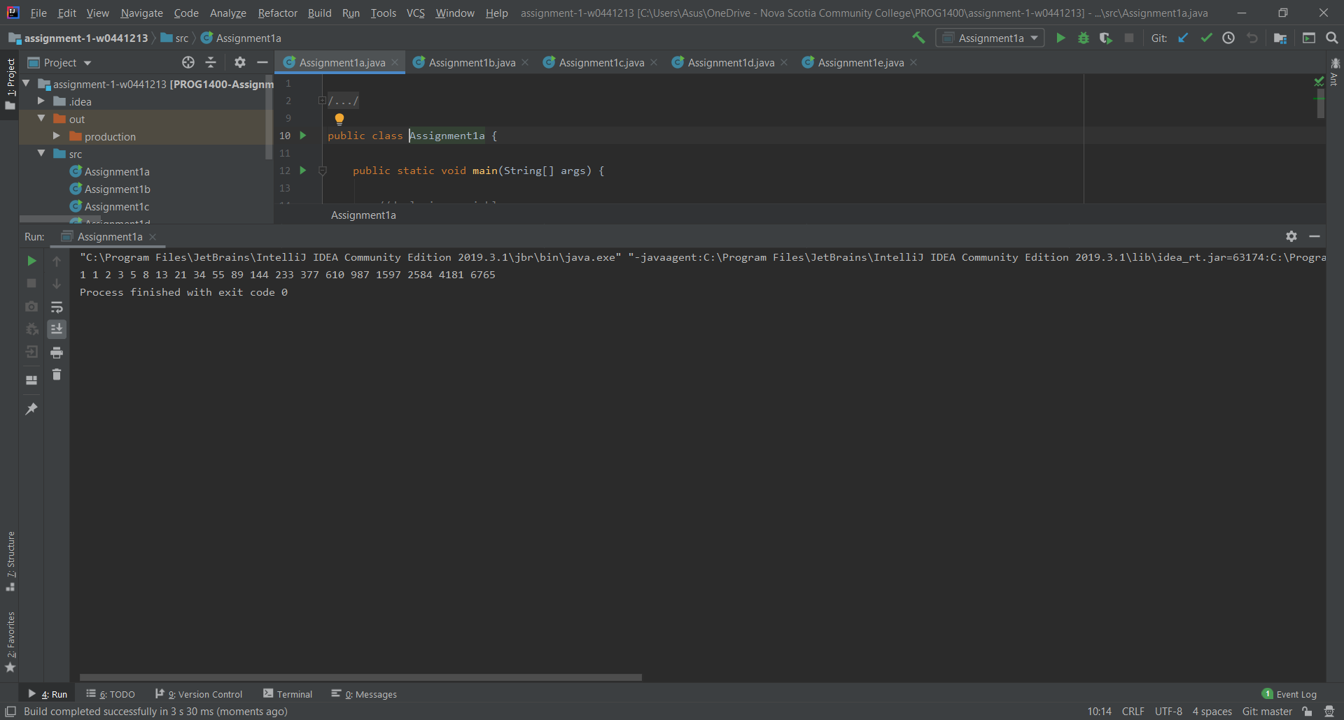

ASSIGNMENT 1B

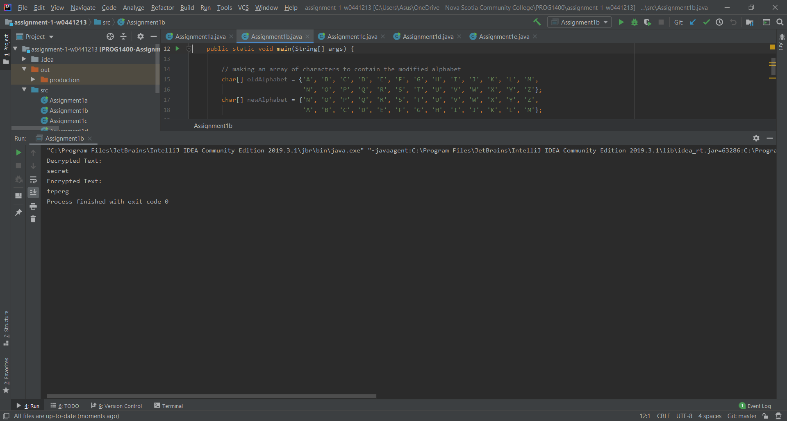

ASSIGNMENT 1C

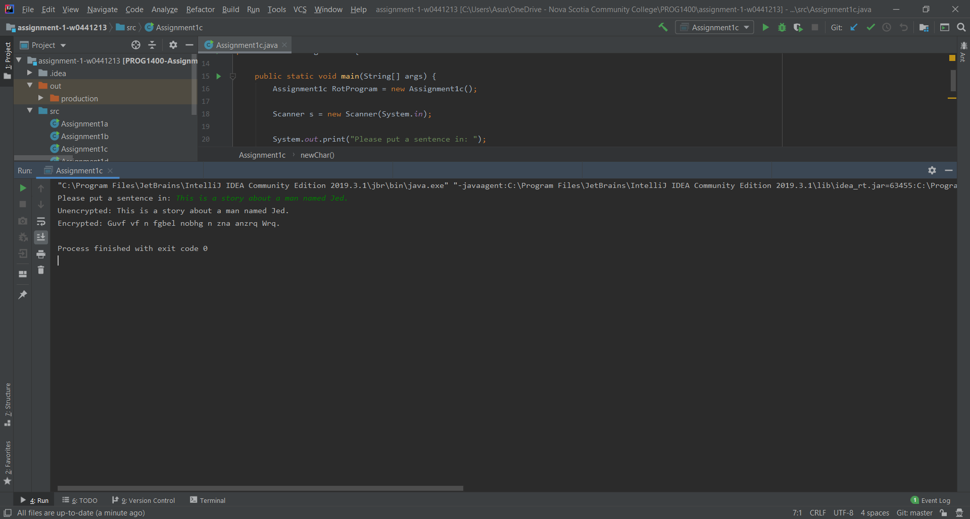

ASSIGNMENT 1D

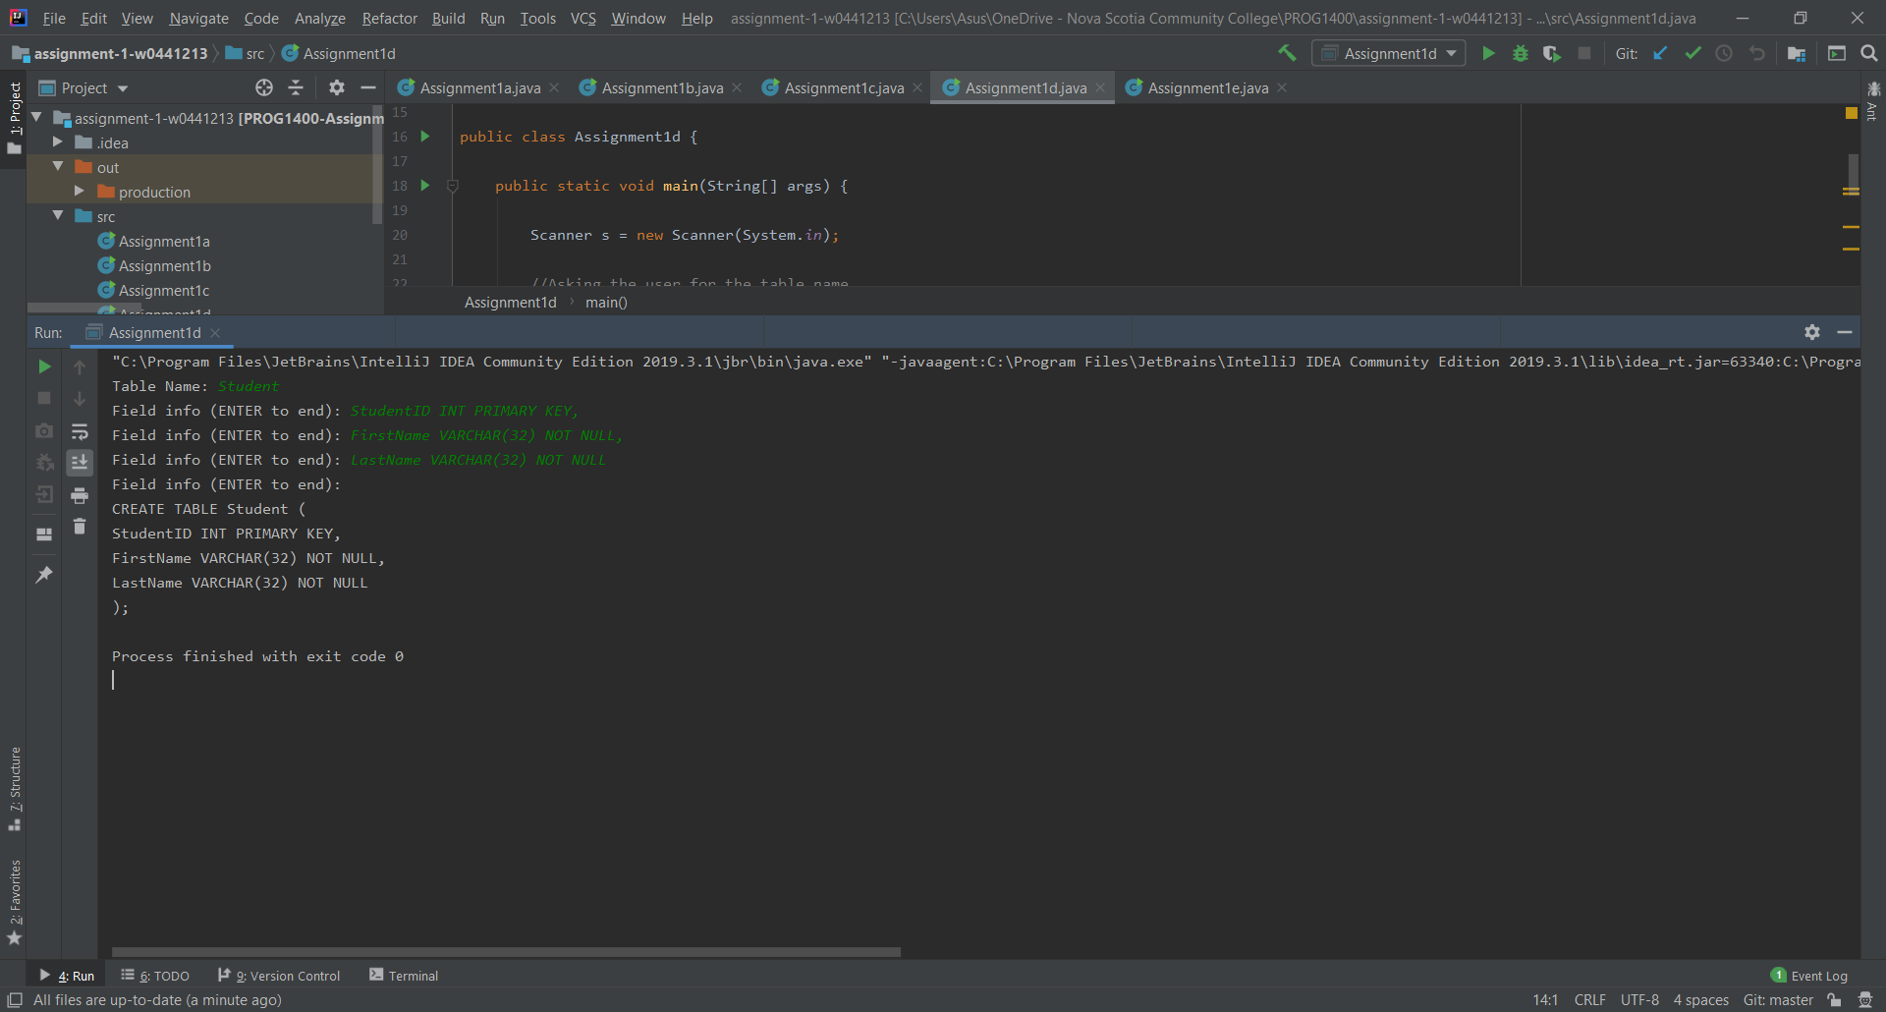

ASSIGNMENT 1E

