

REVERSE ENGINEERING

ASSIGNMENT 4 – TASK 1, PART 1



November 10, 2020

JAMIE LU

W0441213

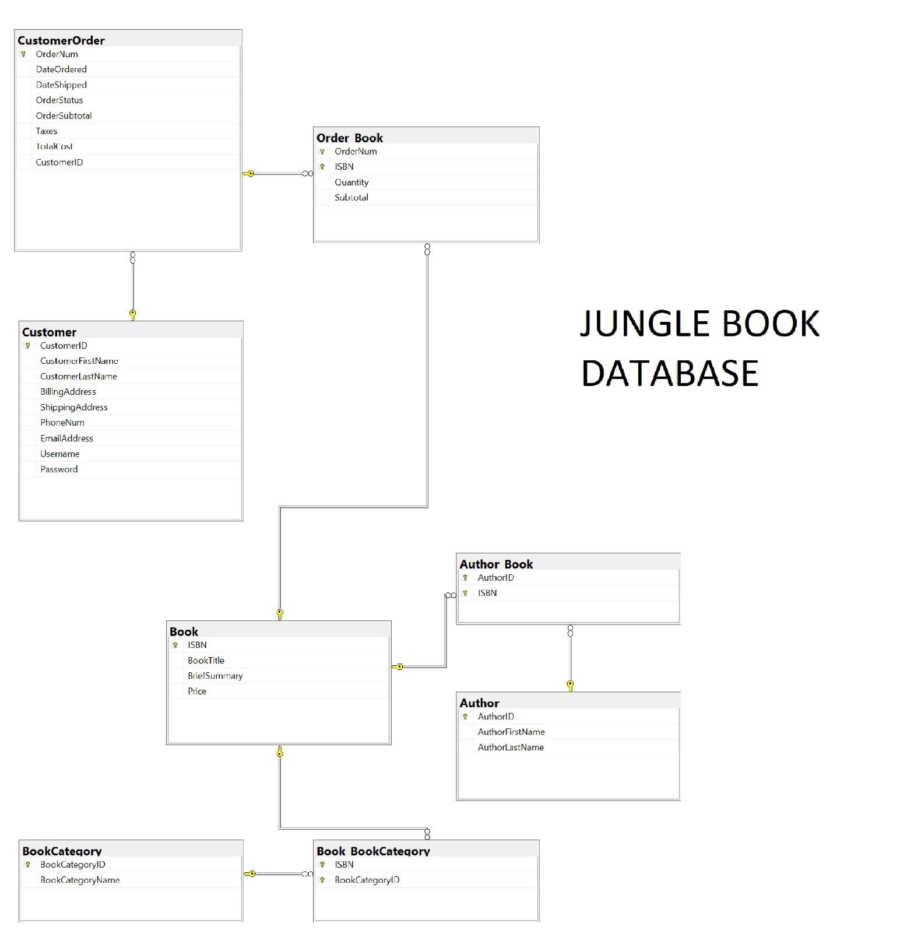

* **What product you used?**
  + I used SQL Server Management Studio
* **Why you chose it**
  + I chose it because I already had it installed and I found it easier to use. Prior to that, I tried ERBuilder and MySQL Workbench, but I had some issues with the connectivity. I also looked into doing it on Visual Paradigm, but I needed to have the non community version.
* **Did it work?**
  + Yes, it worked.
* **Why did/didn’t it work?**
  + I used a database from my class last year. The Jungle Book database. I was going to use the one I had this year but for some reason, when I finished reverse engineering the database, the application crashed.
* **Extra data you had to add**
  + I did not have to add any data
* **Rate how easy it was to do**
  + 8/10