

MIND MAPPING

ASSIGNMENT 4 – TASK 1, PART 2



November 13, 2020

JAMIE LU

W0441213

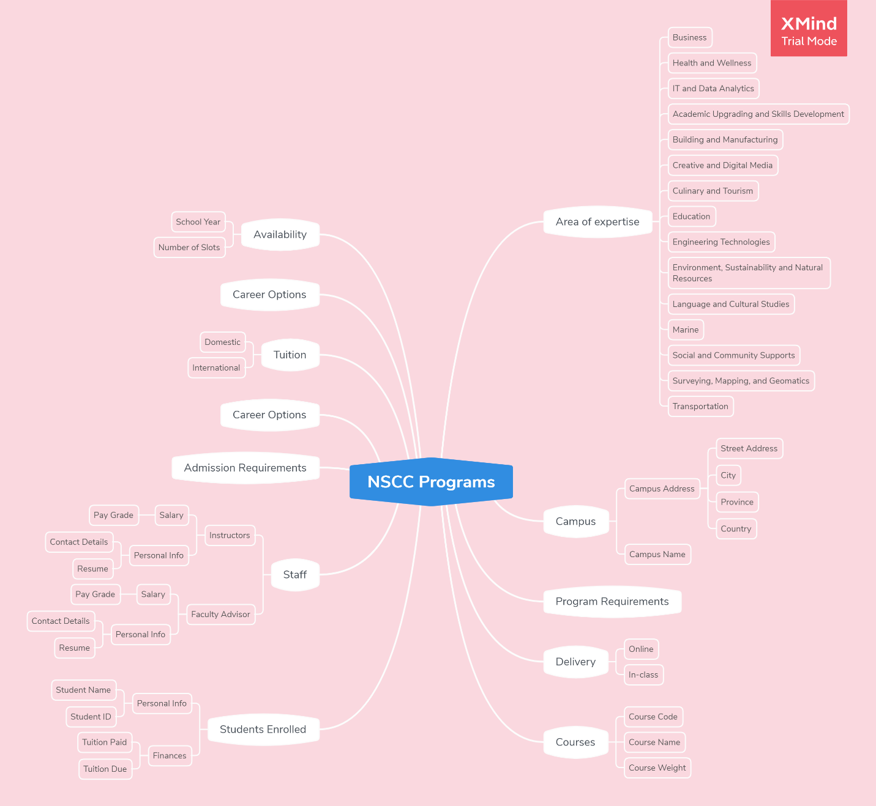

# MIND MAP OF NSCC PROGRAMS[1]

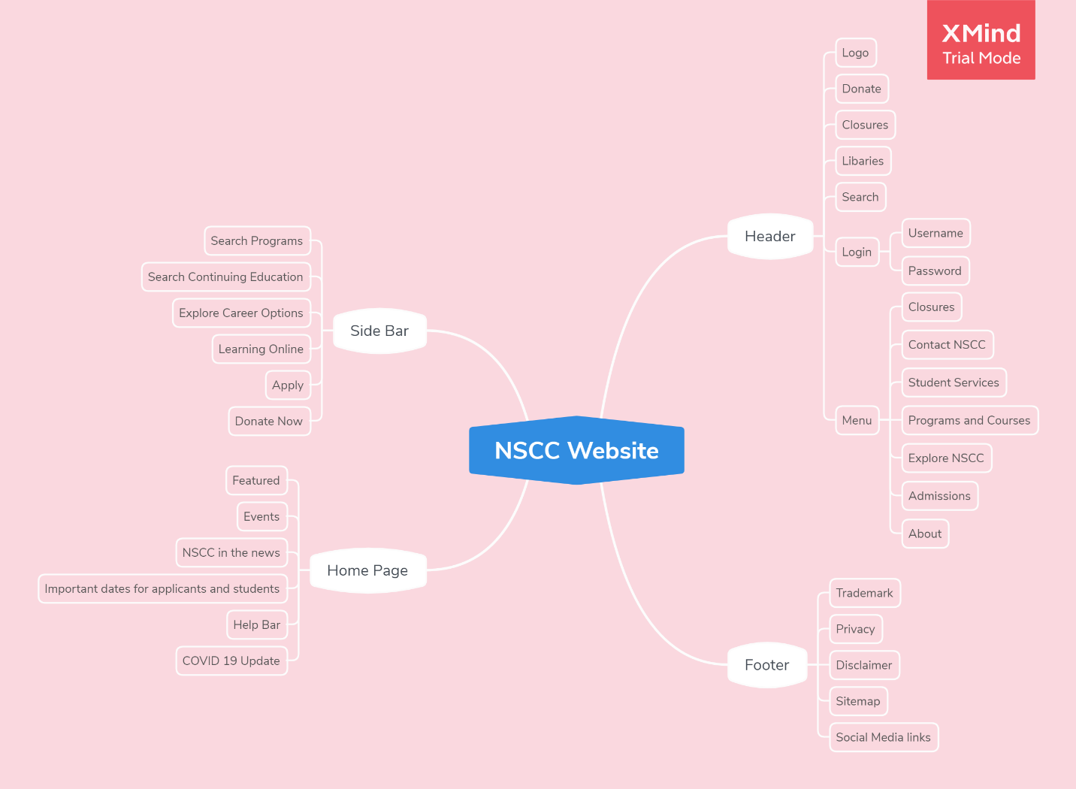

# MIND MAP OF NSCC WEBSITE[2]

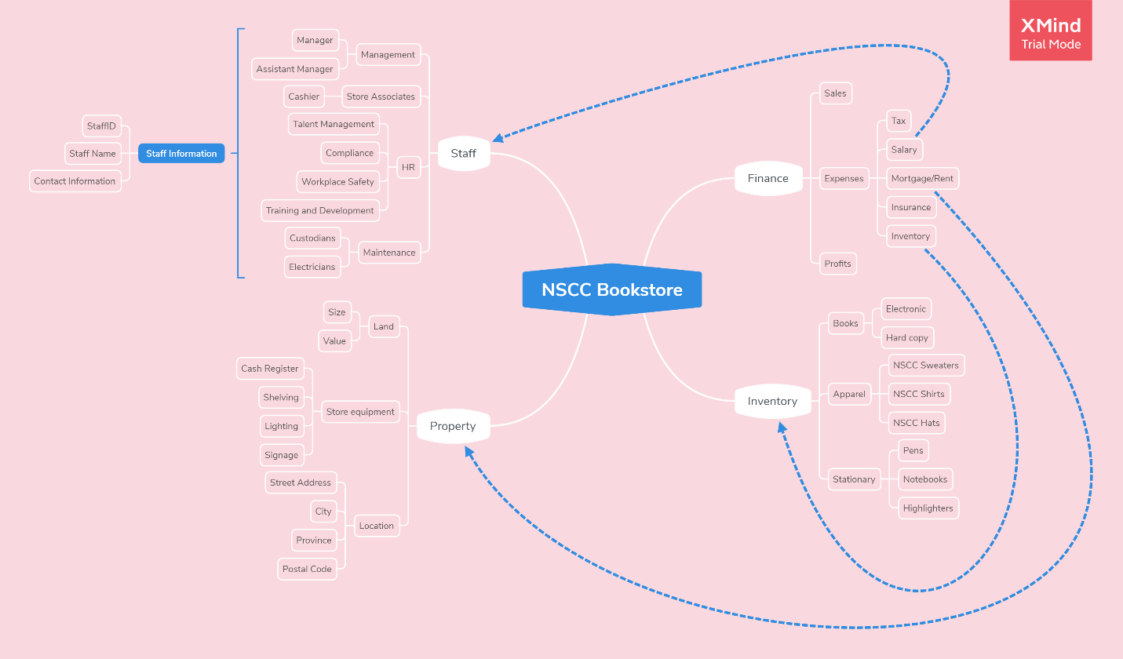

# MIND MAP OF NSCC BOOKSTORE

# References

Lucidchart. (n.d.). *Web Mind Map Template*. Retrieved November 13, 2020, from Lucidchart: https://www.lucidchart.com/pages/templates/mind-map/web-mind-map-template

Nova Scotia Community College. (n.d.). *Nova Scotia Community College*. Retrieved November 13, 2020, from Nova Scotia Community College: https://www.nscc.ca/

1. Referenced from (Nova Scotia Community College, n.d.)
2. Referenced from (Lucidchart, n.d.) and (Nova Scotia Community College, n.d.)