

metadata definition

ASSIGNMENT ONE



October 2, 2020

jAMIE LU

W0441213

Table of Contents

Introduction: 2

Business Glossary 3

Task One 4

Table 1: Business Glossary 4

Task Two 5

Business Metadata 5

Table 2A: Example of Business Metadata 5

Table 2B: Example of Business Metadata 5

Technical Metadata 6

Process Metadata 7

Diagram 1: Example of Process Metadata, Emergency Room Scenario 7

Diagram 2: Example of Process Metadata, Student’s Average 8

Task Three 9

Structured Data 9

Table 3A: Example of Structured Data, Address 9

Table 3B: Example of Structured Data, Cellphone Number 9

Table 3C: Example of Structured Data, Dates 9

Table 3D: Example of Structured Data, Movies 9

Table 3E: Example of Structured Data, Health Card Number 9

Unstructured Data 10

Image 1: Example of Unstructured Data, Text Message 10

Image 2: Example of Unstructured Data, Facebook Activity Log 10

Image 3: Example of Unstructured Data, Email Message 11

Image 4: Example of Unstructured Data, Audio Files 11

Image 5: Example of Unstructured Data, photo 12

References 13

# Introduction:

Metadata is everywhere and it is very essential because it is the data about data. It helps provide definition of the data and what the data's context is. Metadata is also important to keep consistencies with how data is understood and used. It helps reconciling different terminologies especially when you are going from one application/organization/business to the next. It also helps with finding and using data.

There are different types of metadata which is explored and studied in this assignment. This assignment showcases my comprehension about Metadata, and its various types.

## Business Glossary

*A means of sharing internal vocabulary within an organization* (Knight, 2018)

A business glossary is essential in a business or organization to make sure that all the terms used in the business are understood by each member of it.

For example, if a company creates a handbook for their employees, it should have a business glossary that way all the terms are understood well.

It is like when you are from the United States and are speaking to someone from England. You think **lift** means to raise up or pick up but **lift** to them can mean elevator.

# Task One[1]

|  |  |
| --- | --- |
| BUSINESS TERMINOLOGY | DEFINITION |
| Assets | Assets are the properties that possessed by the business. They have value and can be used for payment of debt. Examples of assets are cash, inventory, investments, or equipment. |
| Brand | Brand is the identity of a business. It includes the name and logo of a business. It uniquely identifies the business from it’s competitors. |
| Inventory | Inventory refers to an itemized list of goods,  whether they are parts or materials or a finished  product that the business has. |
| Loss | Loss is when the business does not make a profit. To see if there is a loss, you can grab the sales and subtract expenses and tax from it, if the result is negative, then it is considered a loss. |
| Materials | Materials are used to put together or assemble the goods that the business is selling. These can either be raw or processed. |
| Outsourcing | Outsourcing is procuring a good/service from an outside source in lieu of acquiring it from an internal source. This is usually done to reduce costs. |
| Payroll | Payroll has multiple definitions. It could mean the actual amount that is paid to the employees (wages/salary) or the list of employees that a business pays. |
| Profit | Profit is when the business has financial gain. To see if there is a profit, you can grab the sales and subtract expenses and tax from it, if the result is negative, then it is considered a loss. |
| Target Marketing | Target Marketing is the exercise of targeting a specific group of people who share common characteristics (For example, age grouping: Under 18 years, 18-30 years, 30-60 year, above 60 years). |
| Value[2] | Value is the appraised worth of a product, asset, or service. This can be expressed in monetary form such as the price a product/service. |

### Table 1: Business Glossary

# Task Two

## Business Metadata

This is data that describes what the other data’s definition is and what it’s context is within the business.

|  |  |
| --- | --- |
| Term | Definition |
| Employee | a person that currently works for a business and receives a bi-weekly wage or salary in exchange for the work done |
| Customer | a person or organization who has acquired goods/services from the business |
| Product | The good or service offered by the business which can be purchased or acquired by the customer |

### Table 2A: Example of Business Metadata

|  |  |
| --- | --- |
| Term | Definition |
| Capital | Refers to the amount of money that was put into the business |
| Expenses | An itemized list of the things the business has purchased or acquired. This describes the cost of each as well. |
| Net | The amount that the business has made after factors like tax have been deducted |

### Table 2B: Example of Business Metadata

## Technical Metadata

This is the data that details how data is accessed, where it is located, and how it is structured.

**SAMPLE ONE:**

CREATE TABLE **Book** (

ISBN VARCHAR(13) NOT NULL,

BookTitle VARCHAR (80) NOT NULL,

BookPrice FLOAT NOT NULL,

PRIMARY KEY (ISBN)

);

**SAMPLE TWO:**

CREATE TABLE **Author** (

AuthorID INT(11) NOT NULL AUTO_INCREMENT,

AuthorFirstName VARCHAR(32) NOT NULL,

AuthorLastName VARCHAR(32) NOT NULL,

PRIMARY KEY (AuthorID)

);

## Process Metadata

This is the data that describes the different operations in a data warehouse. It contains the details of the process that loads data into the data warehouse. (The IT Law Wiki, n.d.)

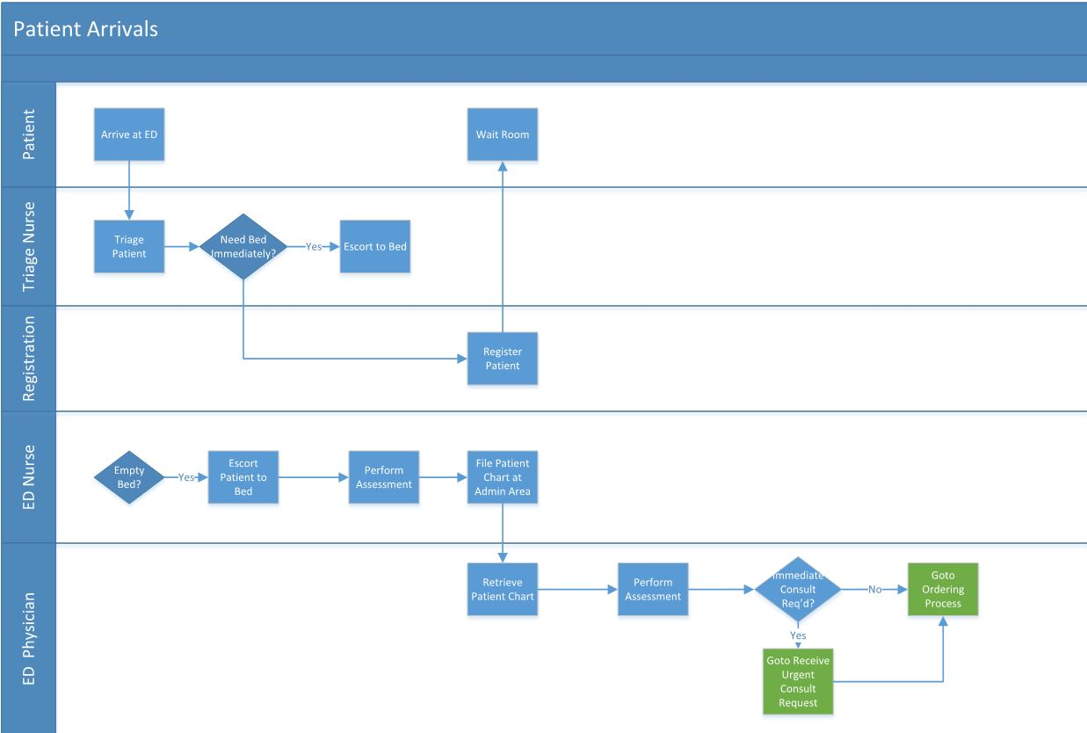

### Diagram 1: Example of Process Metadata, Emergency Room Scenario

This is a sample I made for process metadata. The diagram above shows the process done in the Emergency Room to retrieve data, which is what treatment they should use, using the metadata they have collected from the patient.

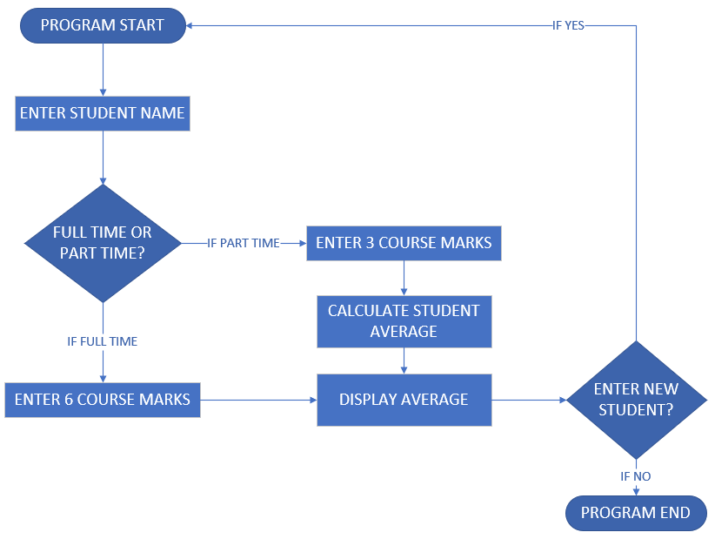

### Diagram 2: Example of Process Metadata, Student’s Average

This is a sample I made for process metadata. This shows how to retrieve data, the student’s average, using metadata that is collected from the student’s course marks.

# Task Three

## Structured Data

This is the data that can be organized because it is standardized or has a format.

Address

|  |  |  |  |  |
| --- | --- | --- | --- | --- |
| Employee # | Street Address | City | Province | Country |
| 001 | 123 Alpha Road | Dartmouth | Nova Scotia | Canada |
| 002 | 456 Bravo Drive | Toronto | Ontario | Canada |
| 003 | 789 Charlie Street | Calgary | Alberta | Canada |

### Table 3A: Example of Structured Data, Address

Cellphone Number

|  |  |  |  |  |
| --- | --- | --- | --- | --- |
| Employee # | Employee First Name | Employee Last Name | Phone Number | Phone Provider |
| 001 | Bob | Bilder | 902 487 9952 | Eastlink |
| 002 | Jane | Doe | 602 588 9521 | Telus |
| 003 | Mark | Smith | 902 888 7177 | Rogers |

### Table 3B: Example of Structured Data, Cellphone Number

Dates

|  |  |  |  |
| --- | --- | --- | --- |
| Employee # | Employee First Name | Employee Last Name | Birth date |
| 001 | Joey | Tribbiani | 11-July-1996 |
| 002 | Chandler | Bing | 18-March-1977 |
| 003 | Monica | Geller | 06-November-1977 |

### Table 3C: Example of Structured Data, Dates

Movies

|  |  |  |  |
| --- | --- | --- | --- |
| Movie ID | Movie Title | Year Released | Movie Genre |
| A7895 | Twilight | 2008 | Fantasy |
| A7896 | A Walk to Remember | 2002 | Romance |
| A7897 | John Wick: Chapter 1 | 2014 | Action |

### Table 3D: Example of Structured Data, Movies

Health Card Number

|  |  |  |  |
| --- | --- | --- | --- |
| Patient ID | Patient Last Name | Patient First Name | Health Card Number |
| 001 | Buffay | Phoebe | 8000 741 943 |
| 002 | Geller | Ross | 0001 974 772 |
| 003 | Green | Rachel | 8001 754 991 |

### Table 3E: Example of Structured Data, Health Card Number

## Unstructured Data

This is data that is unorganized and cannot be put into columns and rows because it has no pre-defined format/standard.

Text Messages



### Image 1: Example of Unstructured Data, Text Message

Social Media Activity Log



### Image 2: Example of Unstructured Data, Facebook Activity Log

Email



### Image 3: Example of Unstructured Data, Email Message

Audio Files

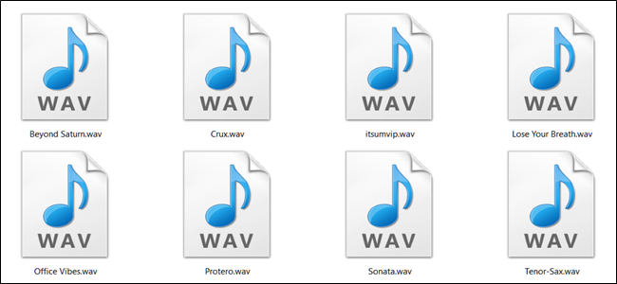

### Image 4: Example of Unstructured Data, Audio Files

(*Photo retrieved from* (Gavin, 2018)

Photo



### Image 5: Example of Unstructured Data, photo

# References

Anderson, J. C., & Narus, J. A. (1998, November-December). *Business Marketing: Understand What Customers Value*. Retrieved October 1, 2020, from Harvard Business Review: https://hbr.org/1998/11/business-marketing-understand-what-customers-value

Berry, T. (n.d.). *Business Term Glossary*. Retrieved October 1, 2020, from Bplans: https://articles.bplans.com/business-term-glossary/

Gavin, B. (2018, October 29). *What Are WAV and WAVE Files (and How Do I Open Them)?* Retrieved October 2, 2020, from How-To Geek: https://www.howtogeek.com/392504/what-are-wav-and-wave-files-and-how-do-i-open-them/

Knight, M. (2018, January 24). *What is a Business Glossary?* Retrieved October 2, 2020, from Dataversity: https://www.dataversity.net/what-is-a-business-glossary/#:~:text=A%20Business%20Glossary%20differs%20from,internal%20vocabulary%20within%20an%20organization.

Pickell, D. (2018, November 16). *Structured vs Unstructured Data – What's the Difference?* Retrieved October 2, 2020, from Learning Hub: https://learn.g2.com/structured-vs-unstructured-data

The IT Law Wiki. (n.d.). *IT Law Wiki*. Retrieved October 2, 2020, from wikia.org: https://itlaw.wikia.org/wiki/Process_metadata#:~:text=Process%20metadata%20describes%20the%20results,data%20into%20the%20data%20warehouse.

1. References used: (Berry, n.d.)
2. References used: (Anderson & Narus, 1998)