DIGITAL NEGOTIATOR GAME

REPORT 2020

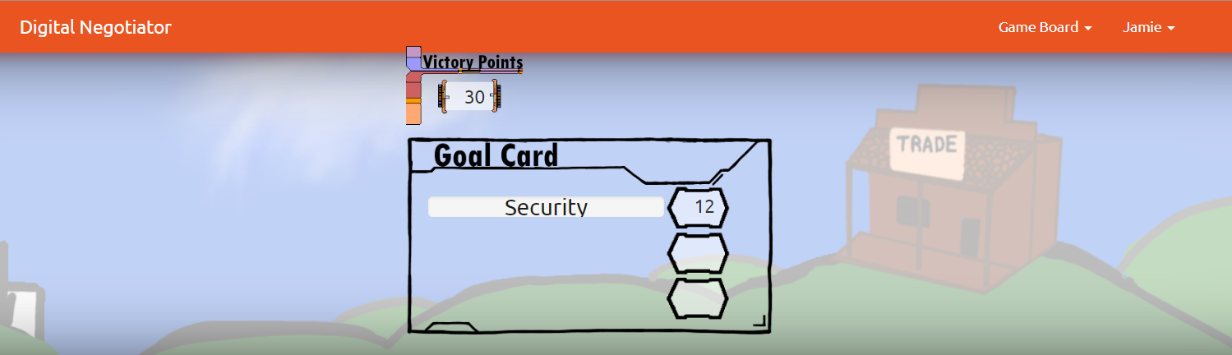

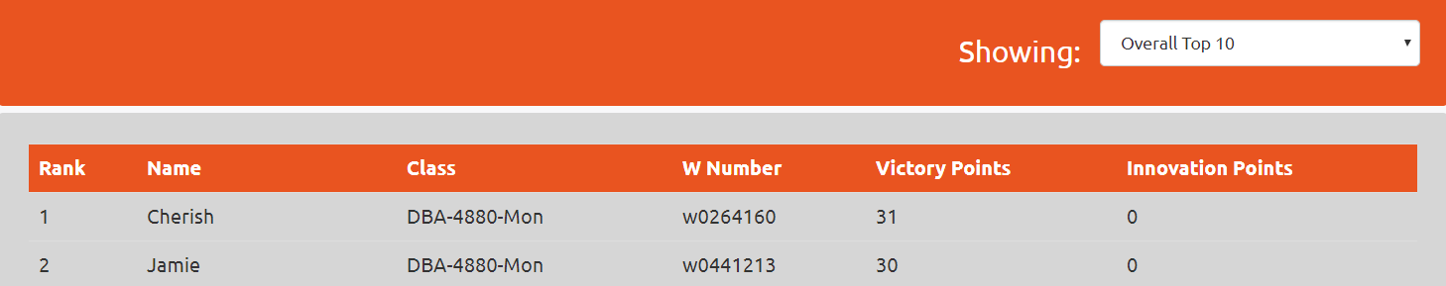

BY: JAMIE LU, W0441213

FOR COMM270

THE TRADING STRATEGY:

I’m going to be honest; I had a slow start with this game. I honestly didn’t understand it much and i was so busy with work, school and home stuff that i barely had time to talk with my classmates about it, or about anything for that matter. I finally had some down time and decided i had to get serious about playing the game. I was being “strategic” about it thinking that i had to negotiate to do trades. This plan did not really go well for me. I earned points slowly and the only time I could trade was during lunch breaks, which is not really a long amount of time. I had to think it through, a couple of my classmates/friends did as well. We then realized it was clear. There was a pattern to the game. Any cards you were not tasked to find, would be the next set of cards you needed for the next task. This was a great realization, but insufficient. While at the library, a couple of us were trading and talking and realized we that we needed to agree on all getting at least 25 points. We planned to gather after class in one room and just keep trading UNTIL each person got at least 25 points. We would help each other one person at a time. It was so tiring, and we probably spent 4 hours straight trading between about 8-9 people and making sure everyone left with at least 25 points. Another strategy was communicating with the whole CLASS IN OUR “DBA” CHAT GROUP WITH WHICH INVENTION WE WOULD INVEST ON. THOSE WERE MY/OUR STRATEGIES, AND IT PROVED TO WORK WELL.

ASSESSMENT ON USER INTERFACE/WORKFLOW:

THE USER INTERFACE IS PLEASING TO THE EYES EXCEPT FOR WHEN YOU TRY TO TRADE DURING WEEKENDS. I LEARNED IN PROGRAMMING THAT IT IS NEVER NICE TO SEE THE PROGRAMMER’S CODE IN A WEBSITE, IT’S ALWAYS BETER TO HAVE A MESSAGE ABOUT AN ERROR LIKE “OOPS, SOMETHING WENT WRONG”. ANOTHER THING I NOTICED AS WELL, IS THAT SOMETIMES WHEN DOING MULTIPLE TRADES, THE SYSTEM SORT OF CAN’T HANDLE IT AND BUFFS A BIT AND YOU HAVE TO REFRESH IT. ANOTHER THING THAT CAN BE QUITE ANNOYING IS HAVING TO TYPE IN THE W NUMBER EVERYTIME YOU INITIATE A TRADE WITH SOMEONE.

OTHER THAN THOSE NOTES, THE USER INTERFACE/WORKFLOW IS GOOD AND THE GAME IS AN AMAZING IDEA AND A LOT OF FUN.