

requirements management and network design

ASSIGNMENT ONE



October 7, 2020

JAMIE LU

W0441213

Table of Contents

INTRODUCTION: 2

RATIONALE: 3

**SERVERS AND THEIR REQUIREMENTS:** 4

**DEDICATED BACKUP SERVER** 4

**APPLICATION SERVER** 5

**WEB SERVER** 6

**DATABASE SERVER** 7

**PROXY SERVER** 8

NETWORK DIAGRAM 10

References 11

# INTRODUCTION:

This document contains a proposal for the requirements management and network design of a new Emergency Room Registration system that maintains patient’s medical history in order to prevent having to keep inputting the same information for the next time a patient needs to register to go to the ER. It also maintains the symptoms the patient has for when they want to go to the emergency, and the record of the time when the patient registered and when they were seen by the doctor. It sends the patient’s information to the hospital where it will be triaged by the hospital staff then categorized based on the severity of condition. It also keeps a live queue or estimation of time of when the patient can leave to go to the ER, to reduce the time that the patient physically waits in the emergency room.

With this new Emergency Room Registration System, I am looking to use a private cloud. I am also looking to use several servers, a dedicated backup server, an application server, a web server, database server, and proxy server.

# RATIONALE:

I chose to use a **private cloud** because of the nature of the ER registration system. The data that is being shared by the patient and the hospital is confidential and a private cloud would mean less security risk than that of a public cloud. Private clouds provide an added level of security because there is limited access. It offers customization of the cloud environment to shape it to what the organization needs. It also handles storage demands better than public clouds because of the increased infrastructural capacity. A lot of healthcare organizations choose to use a private cloud over public cloud because public cloud would mean hosting data in the same place as other organizations (O'Dowd, 2018).

I also choose to have the **on-premise private cloud** because of the control over the data and the network, as well as the flexibility to customize the cloud environment. Whereas, a hosted private cloud, although less costly, would mean less control because the host of the private cloud (the vendor) would have the final say on what security protocols are used. You get complete control of the security, scalability, and configurability of the servers with the on-premise private cloud.

I chose to include a **dedicated backup server** because it makes sure that there are enough resources to handle the backup demand. If we do not use a dedicated back up server, there might not be enough resources to handle the backup demand. With the dedicated back up server as well, we would have more control, more operational flexibility to handle spikes in traffic, server customization, or any other specified changes to meet the needs for the application.

I chose to include an **application server** because it acts as the middleman between the web server and the database servers. It will provide the memory and processing power to run the application that the patient will use in real time.

I chose to include a **web server** because it will deliver the content to end users over the internet. It will receive the http request from the patient/end user and sends the relevant http response back as well. It will store, process and deliver the web pages to the patient/end user. It will also be used to provide the monthly patient count and wait times.

I chose to include a **database server** because it handles data management tasks (data storage, data manipulation, data analysis, archiving, etc.). It will handle all the data that was collected when a patient registers (HCN, Allergies, Medications, Symptoms, etc.)

Lastly, I chose to include a **proxy server** because it acts as the connection between the endpoint device and another server who is requesting a service. It will provide more security and can be configured for encryption. It will also filter out malicious websites/malware sites.

# **SERVERS AND THEIR REQUIREMENTS:**

## **DEDICATED BACKUP SERVER**

#### CPU REQUIREMENTS

Intel Core i9-10900 Comet Lake 10-Core 2.8 GHz

* Will require good CPU capacity to help keep up with the backup demand

#### MEMORY REQUIREMENTS

G.Skill Trident Z RGB 128 GB (4 x 32 GB) DDR4-3600 CL18 Memory

* Will require good memory capacity to help keep up with the backup demand

#### STORAGE REQUIREMENTS

Seagate Nytro Enterprise 15.36 TB 2.5" Solid State Drive

* Will require good storage capacity to keep up with back up demand
* solid state drives have better reliability, performance and power consumption

#### SOFTWARE REQUIREMENTS

Operating System: Windows 10 Pro

* Because a lot of backup software run on windows, it is also widely used so it has good compatibility
* Fast and has high resource usage (disk space and memory)

Database: SQL Server (Standard)

* Reliable, great performance, reduced network traffic and scalable

Language: C Programming

* Powerful and efficient, flexible, it can extend itself
* A lot of backup software use C Programming
* Structure based and supports both high- and low-level programming
* Dynamic memory allocation

Web Service: BitLocker

* has full-disk encryption
* you can create a USB key that will be needed in order to boot a protected OS. It is a protection against ransomware. If someone wanted to get a hold of the backup, they need to break the encryption and get a hold of the physical USB key.

Iperius Backup

* Can backup any database, includes drive imaging and backup to NAS, remote backup to FTP and Cloud
* AES 256 bit encryption and has live backup, without any database lock

Windows PowerShell 5.0

* Used in the management and control of Windows-based environments
* Backward compatible and is easy and comprehensive to use

#### ANTICIPATED COSTS FOR HARDWARE AND SOFTWARE

ESTIMATED TOTAL WOULD BE AROUND $8,000

## **APPLICATION SERVER**

#### CPU REQUIREMENTS

Intel Core i9-10900 Comet Lake 10-Core 2.8 GHz

* Based on the application requirements, we will need a heavy load of CPU capacity because of the number of possible users that will use the application.

#### MEMORY REQUIREMENTS

G.Skill Trident Z RGB 128 GB (4 x 32 GB) DDR4-3600 CL18 Memory

* Based on the application requirements, we will need a heavy load of memory capacity because of the number of possible users that will use the application.

#### STORAGE REQUIREMENTS

Seagate Nytro Enterprise 15.36 TB 2.5" Solid State Drive

* Based on the application requirements, we will need heavy load of storage capacity because of the number of possible users that will use the application.
* solid state drives have better reliability, performance and power consumption

#### SOFTWARE REQUIREMENTS

Operating System: Windows 10 Pro

* Because a lot of application software run on windows, it is also widely used so it has good compatibility
* Fast and has high resource usage (disk space and memory)

Database : SQL Server (Standard)

* Reliable, great performance, reduced network traffic and scalable

Language : C Programming

* Powerful and efficient, flexible, it can extend itself
* A lot of backup software use C Programming
* Structure based
* Supports both high- and low-level programming
* Dynamic memory allocation

Application Server Software: Oracle Weblogic Server Standard Edition

* Scalable, robust and secure

Windows PowerShell 5.0

* Used in the management and control of Windows-based environments
* Backward compatible and is easy and comprehensive to use

#### ANTICIPATED COSTS FOR HARDWARE AND SOFTWARE

ESTIMATED TOTAL WOULD BE AROUND $14,000

## **WEB SERVER**

#### CPU REQUIREMENTS

Intel Core i9-10900 Comet Lake 10-Core 2.8 GHz

* Based on the needs of the ER registration system, we will need a heavy load of CPU capacity and around the clock performance

#### MEMORY REQUIREMENTS

G.Skill Trident Z RGB 128 GB (4 x 32 GB) DDR4-3600 CL18 Memory

* Based on the needs of the ER registration system, we will need a heavy load of memory capacity to have better performance in its ability to respond to requests

#### STORAGE REQUIREMENTS

Seagate Nytro Enterprise 15.36 TB 2.5" Solid State Drive

* Based on the needs of the ER registration system, we will need a heavy load of memory capacity to have better performance in its ability to respond to requests

#### SOFTWARE REQUIREMENTS

Operating System: Windows 10 Pro

* Because a lot of web server software run on windows, it is also widely used so it has good compatibility
* Fast and has high resource usage (disk space and memory)

Database : SQL Server (Standard)

* Reliable, great performance, reduced network traffic and scalable

Language : C Programming

* Powerful and efficient, flexible, it can extend itself
* A lot of backup software use C Programming
* Structure based
* Supports both high- and low-level programming
* Dynamic memory allocation

FTP Server software

* Example is FileZilla FTP

Windows PowerShell 5.0

* Used in the management and control of Windows-based environments
* Backward compatible and is easy and comprehensive to use

#### ANTICIPATED COSTS FOR HARDWARE AND SOFTWARE

ESTIMATED COST AROUND $8000

## **DATABASE SERVER**

#### CPU REQUIREMENTS

Intel Core i9-10900 Comet Lake 10-Core 2.8 GHz

* Will require CPU with multiple cores to handle multiple users at once

#### MEMORY REQUIREMENTS

G.Skill Trident Z RGB 128 GB (4 x 32 GB) DDR4-3600 CL18 Memory

* Will require more RAM because the database server has to provide really fast access to data and

#### STORAGE REQUIREMENTS

Seagate Nytro Enterprise 15.36 TB 2.5" Solid State Drive

* Will require high storage because of the number of end users/patients expected to use the ER Registration system, this means that the average number of data that is put in is high

#### SOFTWARE REQUIREMENTS

Operating System: Windows 10 Pro

* Because a lot of database software run on windows, it is also widely used so it has good compatibility
* Fast and has high resource usage (disk space and memory)

Database : SQL Server (Standard)

* Reliable, great performance, reduced network traffic and scalable

Language : C Programming

* Powerful and efficient, flexible, it can extend itself
* A lot of backup software use C Programming
* Structure based
* Supports both high- and low-level programming
* Dynamic memory allocation

Windows PowerShell 5.0

* Used in the management and control of Windows-based environments
* Backward compatible and is easy and comprehensive to use

Microsoft SQL Server Management Studio 2019

* Will complement well with the Database used
* Will manage the SQL infrastructure. It will access, configure, manage, administer and develop the components of the SQL Server (Microsoft Contributors, 2019)

#### ANTICIPATED COSTS FOR HARDWARE AND SOFTWARE

ESTIMATED COST IS AROUND $8000

## **PROXY SERVER**

#### CPU REQUIREMENTS

Intel Core i9-10900 Comet Lake 10-Core 2.8 GHz

* Will need fast multi core CPU to compress and decompress files for numerous patients quickly and simultaneously

#### MEMORY REQUIREMENTS

Corsair Vengeance LPX 16 GB

* Will need good memory capacity for higher speed and faster transporting of information to other components

#### STORAGE REQUIREMENTS

Seagate Nytro Enterprise 15.36 TB 2.5" Solid State Drive

* Will need adequate disk space to

#### SOFTWARE REQUIREMENTS

Operating System: Windows 10 Pro

* Because a lot of software run on windows, it is also widely used so it has good compatibility
* Fast and has high resource usage (disk space and memory)

Database : SQL Server (Standard)

* Reliable, great performance, reduced network traffic and scalable

Language : C Programming

* Powerful and efficient, flexible, it can extend itself
* A lot of backup software use C Programming
* Structure based
* Supports both high and low level programming
* Dynamic memory allocation

Windows PowerShell 5.0

* Used in the management and control of Windows-based environments
* Backward compatible and is easy and comprehensive to use

#### ANTICIPATED COSTS FOR HARDWARE AND SOFTWARE

ESTIMATED COST AROUND $7500

# NETWORK DIAGRAM

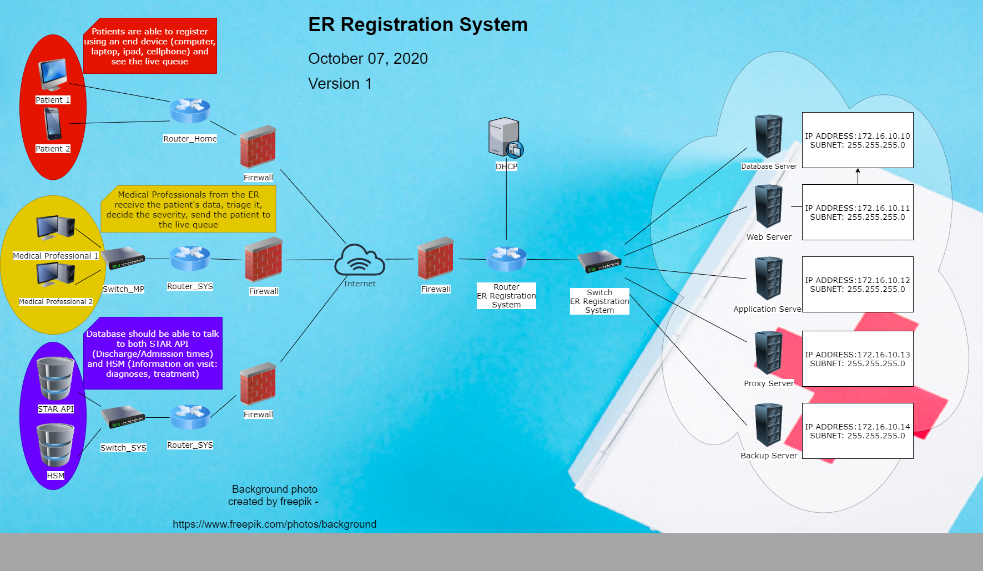

# References

Data Flair. (n.d.). *Advantages and Disadvantages of C Programming – Discover the Secrets of C*. Retrieved October 07, 2020, from Data Flair: https://data-flair.training/blogs/advantages-and-disadvantages-of-c/

Iperius Backup. (n.d.). *Database BackUp*. Retrieved October 07, 2020, from Iperius Backup: https://www.iperiusbackup.com/backup-database.aspx#:~:text=Iperius%20Backup%20is%20the%20most,%2C%20MySQL%2C%20PostgreSQL%20and%20MariaDB.

Ipsen, A. (2016, November 18). *How Granular Restores Improve Business Efficiency*. Retrieved October 07, 2020, from The Cyber Resilience Blog: https://www.backupassist.com/blog/how-granular-restores-improve-business-efficiency

IT Pro Team. (2018, December 03). *What is an application server?* Retrieved October 04, 2020, from ITPro.: https://www.itpro.co.uk/strategy/29643/what-is-an-application-server

Microsoft Azure. (n.d.). *What are public, private, and hybrid clouds?* Retrieved October 05, 2020, from Microsoft Azure: https://azure.microsoft.com/en-us/overview/what-are-private-public-hybrid-clouds/#private-cloud

Microsoft Contributors. (2019, November 09). *What is SQL Server Management Studio (SSMS)?* Retrieved October 06, 2020, from Microsoft: https://docs.microsoft.com/en-us/sql/ssms/sql-server-management-studio-ssms?view=sql-server-ver15

O'Dowd, E. (2018, July 23). *Choosing Healthcare Private Cloud Over Public Cloud*. Retrieved October 05, 2020, from Hit Infrastructure: https://hitinfrastructure.com/news/choosing-healthcare-private-cloud-over-public-cloud#:~:text=Healthcare%20organizations%20often%20choose%20private,as%20data%20from%20other%20organizations.&text=The%20control%20over%20on%2Dpremises,adhere%20to%20any%20co

Staff. (2018, June 01). *Key Differences Between Shared Hosting and Dedicated Hosting*. Retrieved October 07, 2020, from Gigenet: https://www.gigenet.com/blog/key-differences-between-shared-hosting-and-dedicated-hosting/

Vexxhost. (n.d.). *Hosted Vs On-Premise Private Cloud*. Retrieved October 03, 2020, from Vexxhost: https://vexxhost.com/blog/hosted-vs-on-premise-private-cloud/

Wheeler, S. (2017, May 06). *What's New in Windows PowerShell 5.0*. Retrieved October 06, 2020, from Microsoft: https://docs.microsoft.com/en-us/powershell/scripting/windows-powershell/whats-new/what-s-new-in-windows-powershell-50?view=powershell-7

Wikipedia. (n.d.). *Wikipedia*. Retrieved October 06, 2020, from Web server: https://en.wikipedia.org/wiki/Web_server#:~:text=A%20web%20server%20processes%20incoming,Hypertext%20Transfer%20Protocol%20(HTTP).