# M00 Lab

/**  
 * Per lab, display cost of shares, cost of commission, total cost  
 *  
 * @param int shares Number of shares purchased  
 * @param float perShare Cost per share  
 */  
void kathryn(int shares, float perShare) {  
 // 2% commission  
 const float fee = 0.02;  
 // init vars  
 float cost, commission, total;  
 // calc cost  
 cost = shares * perShare;  
 // calc commission  
 commission = cost * fee;  
 // calc total cost  
 total = cost + commission;  
 // output all the things  
 printf("The total cost of %d shares at $%.2f per share is $%.2f for a total of $%.2f including a %.2f percent commission of $%.2f",  
 shares, perShare, cost, total, fee * 100.0, commission);  
}  
  
int main() {  
 kathryn( 750, 35);  
  
 return 0;  
}

## Output

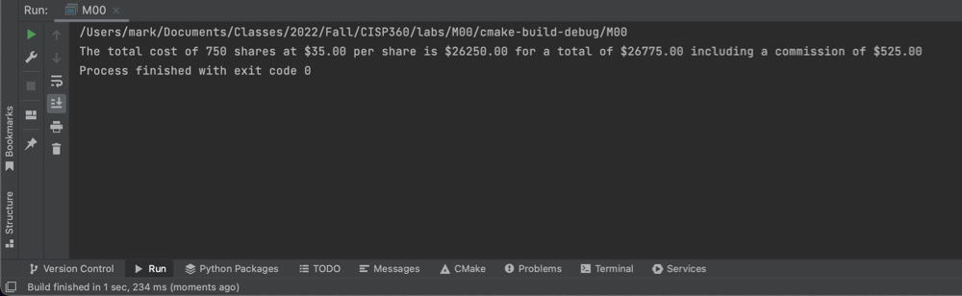

Output

## Expanded Program With User Input (no input validation)

/**  
 * Expanded version that requires user to input values  
 */  
void anyone() {  
 // init vars  
 int shares;  
 float perShare, cost, fee, commission, total;  
 // assign user input to vars  
 cout << "How many shares?\n";  
 cin >> shares;  
 cout << "Per share cost?\n";  
 cin >> perShare;  
 cout << "Percent commission?\n";  
 cin >> fee;  
 // convert fee into percent decimal  
 fee /= 100;  
 // calculations  
 cost = shares * perShare;  
 commission = cost * fee;  
 total = cost + commission;  
 // output all the things  
 printf("The total cost of %d shares at $%.2f per share is $%.2f for a total of $%.2f including a %.2f percent commission of $%.2f",  
 shares, perShare, cost, total, fee * 100.0, commission);  
}

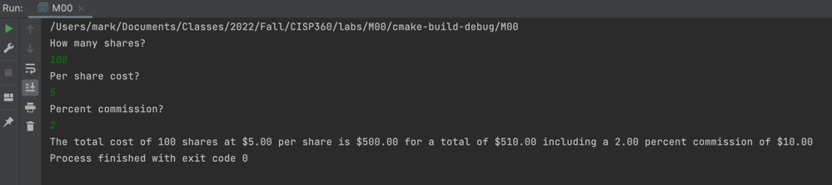

Expanded