# Lab M02 Results

## Invalid Menu Choice

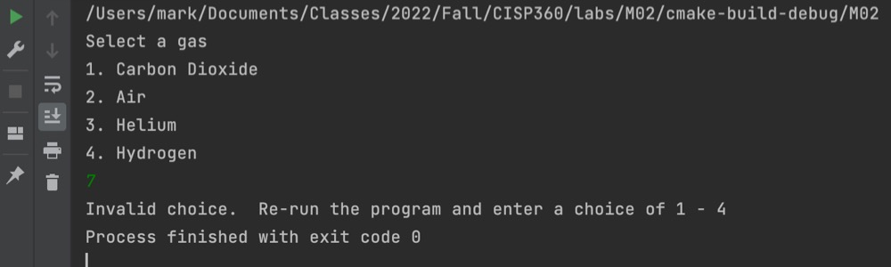

## Invalid Time Input

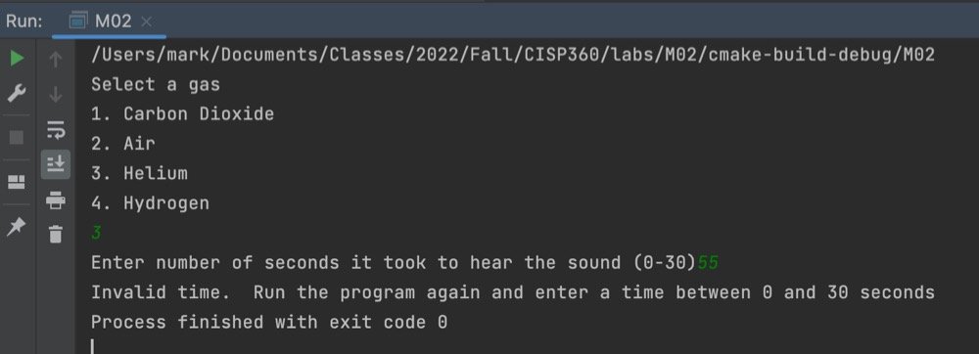

## Valid Run

