# M04 Lab

## Screenshots

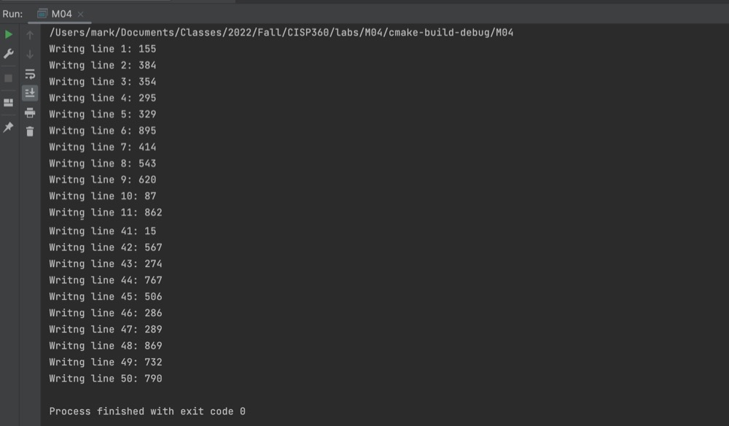

Writing 50 random numbers to file (1 - 1000) clipped image

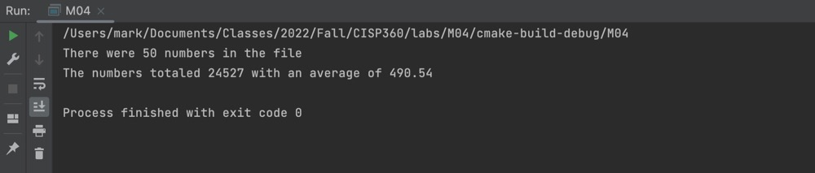

Reading numbers from file and displaying total and average