# M05 Lab

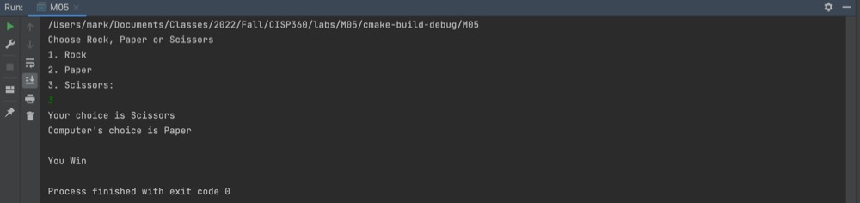

Win

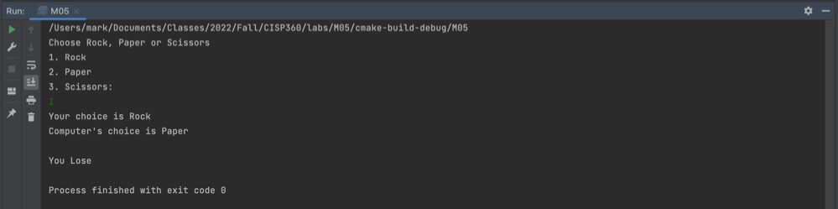

Lose

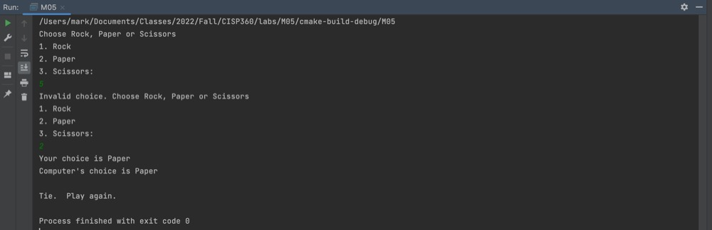

Draw | Input Validation