# Module 7 | Lab

int main() {  
 // Declare and instantiate vars  
 int numbers[] = {100, 48, 93, 20, 19, 49, 53, 84, 46, 27, 90, 56, 78, 39, 59, 22, 24, 14, 72, 80, 67};  
 int found, needle = 80;  
  
 // Linear Search  
 cout << "Linear\n";  
 found = myLinearSearch(numbers, 20, needle);  
 showResults(found, needle);  
  
 // Binary Search  
 cout << "Binary\n";  
 found = myBinarySearch(numbers, 0, 19, needle);  
 showResults(found, needle);  
  
 return 0;  
}

## Test Runs

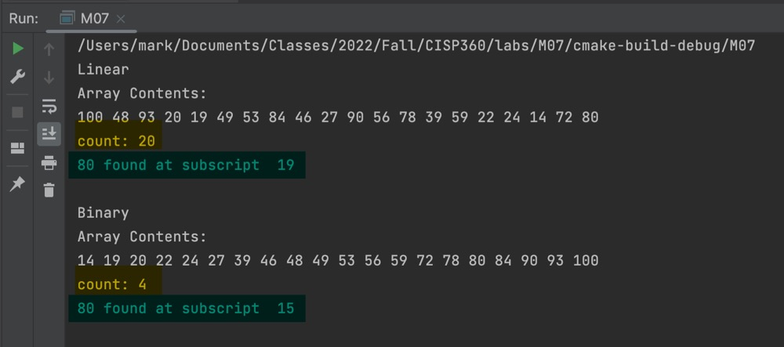

Binary Wins

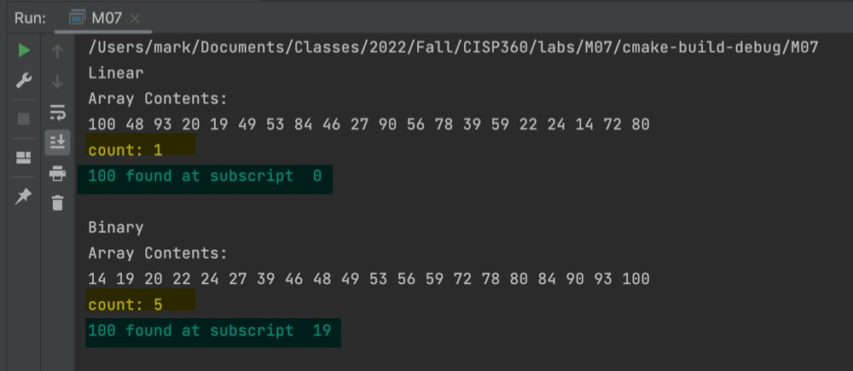

Linear Wins

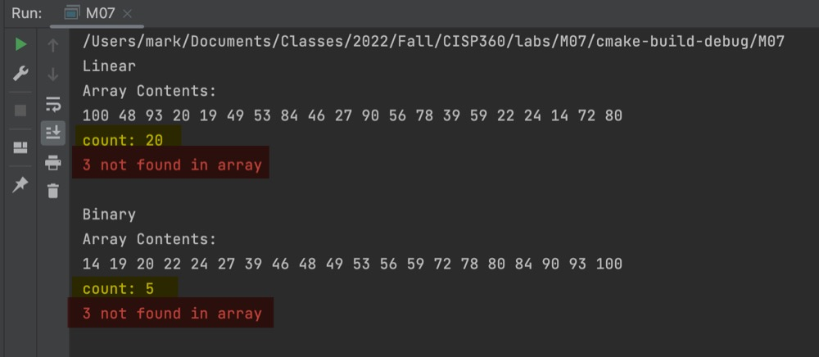

Not Found