# M08 Lab

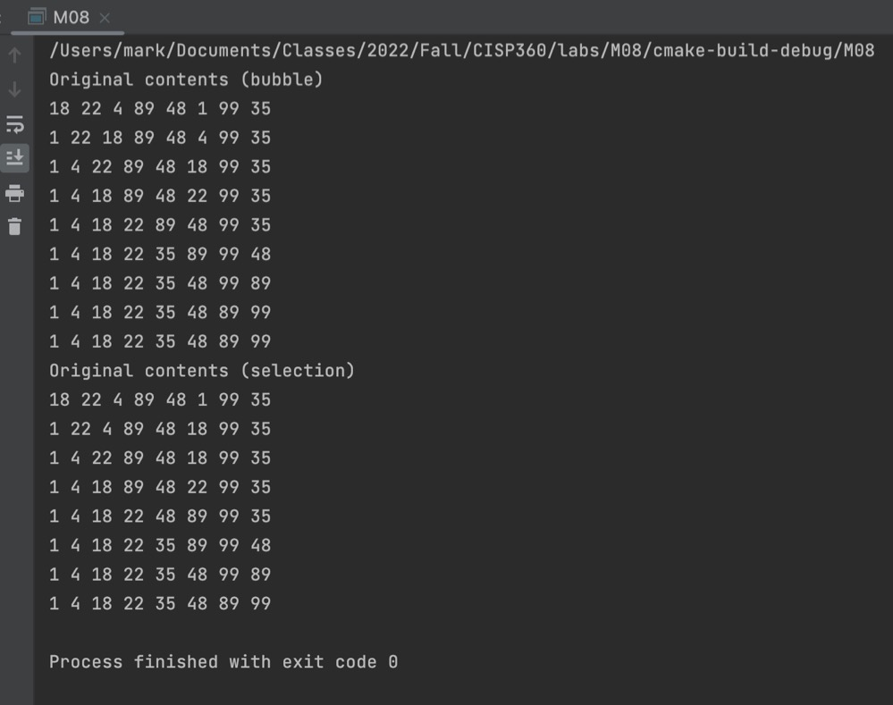

| Device | Function | Cost |
| --- | --- | --- |
| Switch | Connect devices on LAN | $220 |
| WiFi AP | Provide WiFi LAN access | $85 |