# M01 Assignment

## Questions (15 - 25)

### 15. What is the difference between a methodology and a work plan? How are the two terms related?

A workflow is a dynamic schedule that keeps track of everything that needs to be done. Methodology determines *how* those things get done. I suppose workflow manages information about the project to keep it on track while methodologies manage the process of accomplishing the tasks needed to complete the project. Kind of 2 sides of the same coin.

### 16. Some companies hire consulting firms to develop the initial project plans and manage the project, but use their own analysts and programmers to develop the system. Why do you think some companies do this?

A consulting firm likely has more experience with different methodologies.

### 17. Describe the differences between a technical lead and a functional lead. How are they similar?

Technical has more to do with programmers and understanding the role of tech in the project while functional is more managerial. They’re both responsible for the teams under them and should be able to interact with each other to keep the project on track.

### 18. Describe three technical skills and three interpersonal skills that would be very important to have on any project.

I’d say 3 universal technical skills would be familiarity with one or more programming languages, being well-versed in version control and have the ability to write unit tests. 3 desirable interpersonal skills might be the ability to comfortably speak to a wide range of people, be able to function in stressful situations and the ability to referee disagreements between people involved.

### 19. What are the best ways to motivate a team? What are the worst ways?

Apparently it’s nice to buy dinner, write a nice letter, or present someone with an award. But none of that means squat if everyone receives the same. Worst ways - ignoring team’s input or efforts, setting unrealistic deadlines or maintain poor working conditions.

### 20. List three techniques to reduce conflict.

* Assign clearly defined roles.
* Develop project charter.
* Develop schedule commitments ahead of time.

### 21. What is the difference between upper CASE and lower CASE?

Upper is more planning while lower is more implentation.

### 22. Describe three types of standards, and provide examples of each.

1. Coding - how the code should be formatted and commented, tabs or spaces, spaces in parenthesis, etc…
2. Procedural - Things done on a regular basis. Recording progress, creating reports, managing changes…
3. UI Design - How things should look and work for the user. How buttons look, how form labels appear, element tab order…

### 23. What belongs in the electronic project binder? How is the electronic project binder organized?

Project deliverables, internal notes, communication, and anything else that helps document the project’s progress and history. It could be organized in a directory structure with subdirectories for each phase of the project and other subdirectories for things such as internal communications. It should also be available to the entire team.

### 24. What are the trade-offs that project managers must manage?

It’s a balancing act between size, time and cost.

### 25. What is scope creep, and how can it be managed?

Anything added to the project that was not originally defined or agreed upon. Personally I provide a written document describing the scope of a project along with a breakdown of the costs. If the client wants to add something mid-stream I say “sure, but it’s going to cost you”. Ideally, a clearly defined project with a solid work plan and budget *should* prevent scope creep but with human nature being what it is, there’s no sure-fire way around it.

## Exercises (A - G)

### A. Suppose that you are a project manager using the waterfall development methodology on a large and complex project. Your manager has just read the latest article in Computerworld that advocates replacing the waterfall methodology with Scrum and comes to your office requesting you to switch. What do you say?

I’d be happy to give Throwaway Prototyping a shot but Scrum isn’t appropriate for this complex of a project.

### B. Suppose that you are an analyst developing a new information system to automate the sales transactions and manage inventory for each retail store in a large chain. The system would be installed at each store and would exchange data with a mainframe computer at the company’s head office. What methodology would you use? Why?

For a new, complex project I’d go with Throwaway Prototyping.

### C. Suppose that you are an analyst developing a new executive information system (EIS) intended to provide key strategic information from existing corporate databases to senior executives to help in their decision making. What methodology would you use? Why?

I’d go with System Protyping becuase of the unclear user requirements, and high schedule visibility likely required by these Senior Execs.

### D. Suppose that you are an analyst working for a small company to develop an accounting system. What methodology would you use? Why?

Small company makes me think small team. Because it’s an accounting system an iterative approach doesn’t make sense - giving users a partially working system would likely cause confusion. I’d go with Agile here.

### E. Visit a project management website, such as the Project Management Institute (www.pmi.org). Most have links to project management software products, white papers, and research. Examine some of the links for project management to better understand a variety of Internet sites that contain information related to this chapter.

Okay. I have to say that if the Project Management Institute’s website can’t be reached without the www, someone dropped the ball.

### F. Select a specific project management topic like CASE, project management software, or timeboxing, and use the Web search for information on that topic. The URL listed in exercise E or any search engine (e.g., Yahoo!, Google) can provide a starting point for your efforts.

Okay

### G. Pretend that the career services office at your university wants to develop a system that collects student résumés and makes them available to students and recruiters over the Web. Students should be able to input their résumé information into a standard résumé template. The information then is presented in a résumé format, and it also is placed in a database that can be queried through an online search form. You have been placed in charge of the project. Develop a plan for estimating the project. How long do you think it would take for you and three other students to complete the project? Provide support for the schedule that you propose.

Assuming this system is only responsible for gathering resume data, storing that data, and searching/displaying that data, I’d say assign each of those 3 components to the 3 students and give them each a day to write it. Forms/templates, db input, and db search. It would have to take on a waterfall type approach since these items would need to be completed sequentially. I’d give it 3 days for development and maybe another 2 for testing & bug fixes. But I’ve also learned to always double my initial estimate.

## Minicases #4

### Your professor has asked you and two classmates to create a small website to describe this course to potential students and also provide current class information (e.g., syllabus, assignments, readings) to current students. You have been assigned the role of team leader, so you will need to coordinate your activities and those of your classmates until the project is completed.Using the concept of a work plan, you need to develop an organized set of steps, tasks, and deliverables to guide the work of your team.

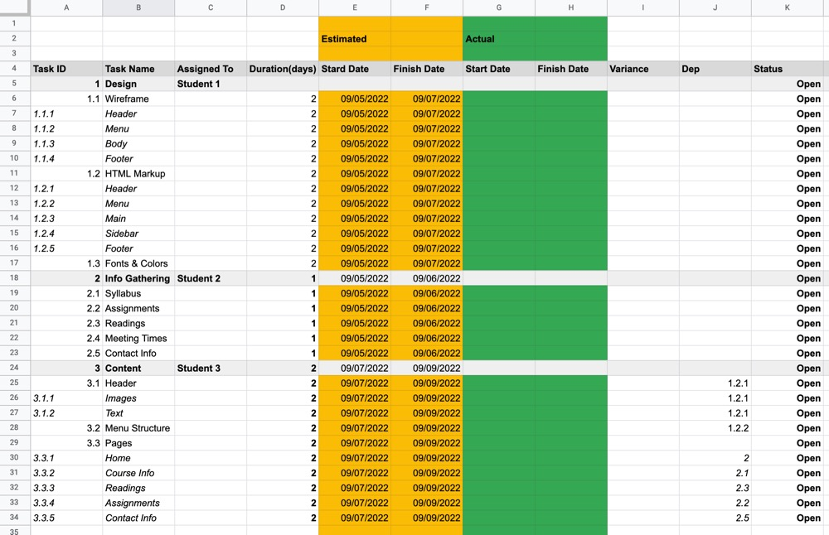

Work Plan