# M03 Assignment

## Pg 150 Questions 1 - 7;

### 1. What is the purpose of developing use cases during systems analysis?

They’re used to identify, clarify and organize system requirements.

### 2. How do use cases relate to the requirements stated in the requirements definition?

They help define how the system will support requirement definitions.

### 3. Describe the elements of the use case’s basic information section.

* Name
* Number
* Brief Description
* Priority: May be assigned to indicate the relative significance.
* Actor: Refers to a person, another system, or a piece of hardware.
* Trigger: The event that causes the use case to begin.

### 4. What is the purpose of the inputs and outputs section of the use case?

Map sources to inputs and destinations to outputs.

### 5. What is the purpose of stating the primary actor for the use case?

Identify the external entity or role that initiates the event the system responds to.

### 6. Why is it important to state the priority level for a use case?

It represents the relative significance of the use case in the system.

### 7. What is the distinction between an external trigger and a temporal trigger? Give two examples of each.

External Trigger - based on something outside the system that the system should respond to.

* Customer places order
* Customer updates address

Temporal Trigger - based on time/date/calendar

* Time to pay electric bill
* Time to create status reports

# Excercises D - G

## D. Create a set of use cases for an online university registration system.

### Use Case Name: Search Courses. ID: UC-1 Prioity: High

Actor: Student

Description: This use case describes how the student finds a course to register

Trigger: Student decides to register for course

Type: External

Preconditions: Course catalog must be available online

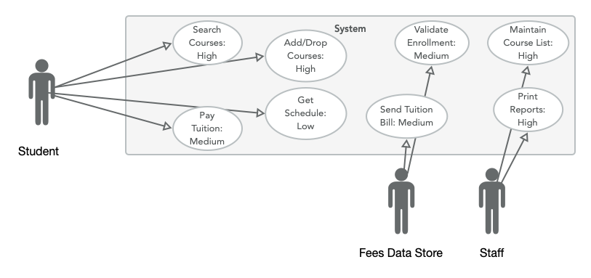

## E. Create a set of use cases for the following system: A Real Estate, Inc. (AREI), sells houses.

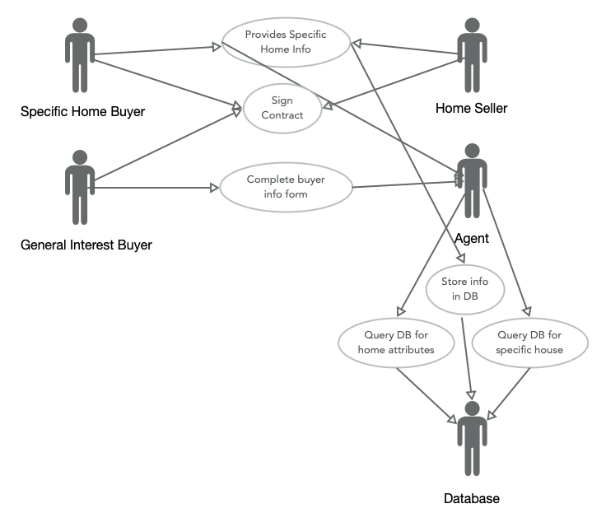

## F. Create a set of use cases for the following system: a Video Store (AVS) runs a series of fairly standard video stores.

### Use Case Name: Catalog Video ID: UC-1 Priority: High

Actor: Employee

Description: This use case describes how the videos are entered into the system.

Trigger: Video arrives at store

Type: Could be external, as videos arrive or it could be temporal, on a regular basis, in bulk

Preconditions: None

### Use Case Name: Customer Rents Video ID: UC-2 Priority: High

Actor: Customer

Description: This use case describes how the customer rents a video

Trigger: Customer puts video on counter

Type: External

Preconditions:

* Customer has valid card
* No overdue videos or fees

### Use Case Name: Manager Prints Overdue List ID: UC-3 Priority: Medium

Actor: Manager

Description: Describes how manager tracks overdues and late fees daily

Trigger: Every Morning

Type: Temporal

Preconditions:

* None

PostConditions:

* Calls customers with overdue movies or late fees.

## G. Create a set of use cases for the following health club membership system: when members join the health club, they pay a fee for a certain length of time.

### Use Case Name: Member Joins ID: UC-1 Priority: High

Actor: Member

Description: describes what happens when a member joins

Trigger: Member joins

Type: External

Preconditions:

* None

PostConditions:

* Member pays fee
* Member info in db
* Schedule renewal mail

### Use Case Name: Track Member Visits ID: UC-2 Priority: Medium

Actor: Staff

Description: describes tracking membership usage

Trigger: Member enters gym

Type: External

Preconditions:

* Member enters gym

PostConditions:

* Date/Time entered into db

### Use Case Name: Renewal Reminders ID: UC-3 Priority: Medium

Actor: Staff

Description: describes sending renewal reminders

Trigger: 1 month prior to renewal date

Type: Temporal

Preconditions:

* Membership must exist
* Membership must be up for renewal

PostConditions:

* Renewal mail is sent
* Membership is renewed

### Use Case Name: Print Reports ID: UC-4 Priority: Medium

Actor: Staff

Description: describes early renewal offers

Trigger: Members who visit gym more frequently than others

Type: External

Preconditions:

* Member must be heavy user

PostConditions:

* Member is given chance to renew early

### Use Case Name: Membership Discounts ID: UC-5 Priority: Low

Actor: Staff

Description: describes membership discount offers

Trigger: Holidays

Type: Temporal

Preconditions:

* Approaching holiday

PostConditions:

* New memberships spike

## Minicases #1

### A. Explain, in clear, nontechnical terms, the goals of the analysis phase of the project.

The goals of the analysis phase are to understand how the current system is being used, what difficulties it presents, and how we can improve the system to work with their more modern, complex workflow.

### B. Explain, in clear, nontechnical terms, how use cases will be used by the project team.

Use cases will be derived to understand how each person who uses the system performs their jobs and to track how this might be affected by any changes we introduce with the new system. We want to make sure we’re making things easier for everyone, and not leaving anyone out.