# M04 - Assignment

## Questions 1 - 10

### 1. What is a process model? What is a data flow diagram (DFD)? Are the two related? If so, how?

Process model describes a business process, or the activities people do to facilitate the process. DFD graphically displays how these processes work and the data they use.

### 2. Distinguish between logical process models and physical process models.

Logical process models describe how the process should function, or work. Physical models are more concerned with how the process is implemented.

### 3. Define what is meant by a process in a process model. How should a process be named? What information about a process should be stored in the CASE repository?

A process is a series of steps and decisions involved in the way work is completed. Should be named using verb phrases. Should store:

* name
* process
* type
* description
* number

### 4. Define what is meant by a data flow in a process model. How should a data flow be named? What information about a data flow should be stored in the CASE repository?

Data flow represents a piece of data or set of related data that move between processes. Named using nouns. Should store:

* name
* type
* description
* alias

### 5. Define what is meant by a data store in a process model. How should a data store be named? What information about a data store should be stored in the CASE repository?

A data store does what it implies - stores data. Named using noun. Shoul store:

* name
* type
* description
* alias

### 6. Define what is meant by an external entity in a process model. How should an external entity be named? What information about an external entity should be stored in the CASE repository?

External entities are things outside the scope of the project but they interact with the project. Person, organization, other system… Names using noun. Should store:

* name
* type
* description
* alias

### 7. Why is a process model typically composed of a set of DFDs? What is meant by decomposition of a business process?

Most processes are too complex to be shown using a single DFD. Decmposing is breaking down a summary DFD into smaller processes.

### 8. Explain the relationship between a DFD context diagram and the DFD level 0 diagram.

Context diagram is a high-level representation of the entire system. Only shows data flowing into and out of the system and any external systems it interacts with.

Level 0 diagram is a high-level view of the internal processes of the system. Includes same info as context but also includes data stores.

### 9. Explain the relationship between a DFD level 0 diagram and DFD level 1 diagram(s).

Level 1 shows detail about any given process generally depicted in level 0. Level 0 is decomposed into several, more detailed level 1 diagrams.

### 10. Discuss how the analyst knows how to stop decomposing the process model into more and more levels of detail.

Each DFD page should have at least 3 but no more than 7 -9 processes. Generally complete when a process can be explained on one sheet of paper.

### 11. Suppose that a process on a DFD is numbered 4.3.2. What level diagram contains this process? What is this process’s parent process?

Level 2 diagram. The parent process is 4.3 (level 1)

### 12. Explain the use of structured English in process descriptions.

Structured English uses short sentences to describe the work that a process performs.

### 13. Why would one use a decision tree and/or decision table in a process description?

To assist in making structured decisions - decisions based on experience with certain conditions.

### 14. Explain the process of balancing a set of DFDs.

Every data flow, data store, and external entity on a higher level DFD is shown on the lower-level DFD that decomposes it.

### 15. How are mutually exclusive data flows (i.e., alternative paths through a process) depicted in DFDs?

Both alternative paths are shown in the DFD and labeled as such.

### 16. Discuss several ways to verify the correctness of a process model.

* Every process has a unique name that is an action-oriented verb phrase, a number, and a description.
* Every process has at least one input data flow.
* Every process has at least one output data flow.
* Output data flows usually have different names than input data flows because the process changes the input into a different output in some way.
* There are between three and seven processes per DFD.

### 17. Identify three typical syntax errors commonly found in DFDs.

1. Moving data without a process 1. Process with no inputs 1. Process with no outputs

## Exercises A & B

### A. Draw a level 0 data flow diagram (DFD) for the process of buying glasses in Exercise A, Chapter 4.

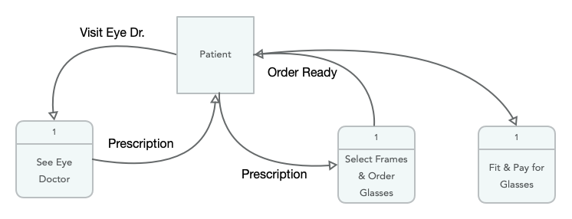

### B. Draw a level 0 DFD for the dentist office system in Exercise B, Chapter 4.

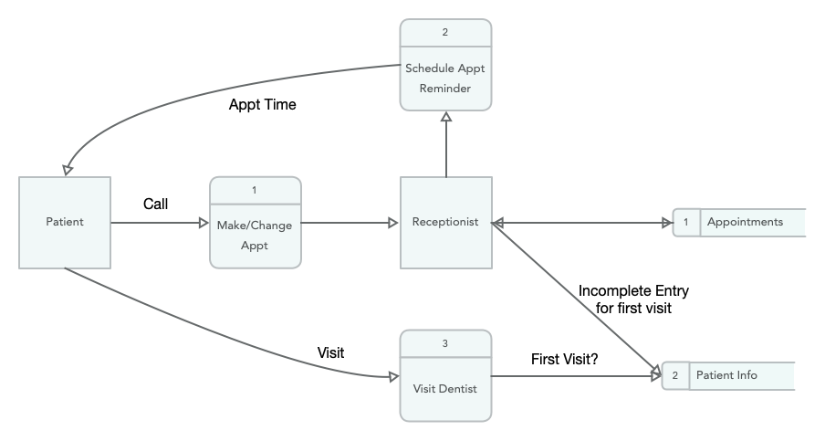

## Minicase #1 | The Hatcher Company

### Redraw the DFD to more correctly represent the Receive Supplier Shipments process.

