# M05 Assignment

## Pg 210 Questions 1 - 9

### 1. Provide three different options that are available for selecting an identifier for a student entity. What are the pros and cons of each option?

In order of my preference, least to most favored:

* Combine attributes - first 2 letters of first name + last name, etc…
* Use existing unique attribute, like Social Security Number
* Create new attribute, such as StudentID

### 2. What is the purpose of developing an identifier for an entity?

To make sure we can target any entity without confusion.

### 3. What type of high-level business rule can be stated by an ERD? Give two examples.

Any rule having to do with the relationship between entities. Constraints, or guidelines for the system to follow.

* An order can belong to only one customer
* A shipped order cannot be modified

### 4. Define what is meant by an entity in a data model. How should an entity be named? What information about an entity should be stored in the CASE repository?

An entity is like a noun - person, place, thing or event, about which data is collected and stored.

Stored info:

* Name
* Definition
* Notes

### 5. Define what is meant by an attribute in a data model. How should an attribute be named? What information about an attribute should be stored in the CASE repository?

Attributes are characteristics that describe an entity and should be named like nouns.

* Name
* Definition
* Notes

### 6. Define what is meant by a relationship in a data model. How should a relationship be named? What information about a relationship should be stored in the CASE repository?

Relationships describe the association between entities and should be named as verbs.

* Name
* Definition
* Notes

### 7. A team of developers is considering including “warehouse” as an entity in its data model. The company for whom they are developing the system has just one warehouse location. Should “warehouse” be included? Why or why not?

No. By definition, there must be multiple instances of a thing for it to be considered an entity.

### 8. What is meant by a concatenated identifier?

A combination of attributes that make the entity unique.

### 9. Describe, in terms a businessperson could understand, what are meant by the cardinality and modality of a relationship between two entities.

They both refer to quantitive relationships between entities. Cardinality refers to the number of entities allowed in both directions - one to one, one to many, many to many.

Modality refers to the ability of one entity to exist depending on the existence of the related entity. This is either null or not null, or required or optional.

## Pg 211 D. Draw an entity relationship diagram (ERD) for the following situations:

### D1

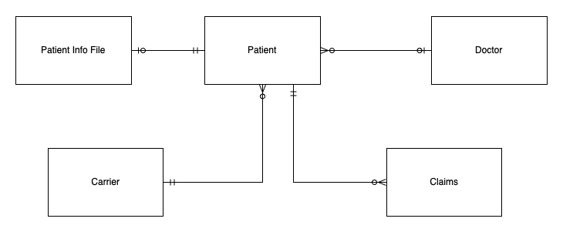

### D2

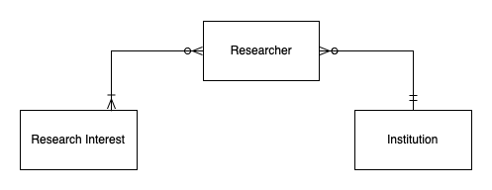

### D3

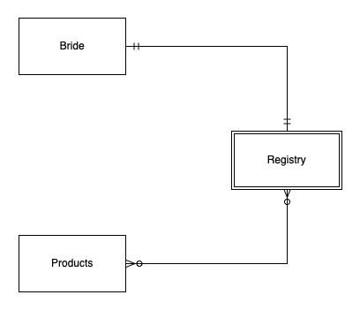

## Pg 212 Minicase #1 What is your response to the director of operations?

### Why do we perform data modeling?

To ensure we understand what data we need and what needs to be done with it.

### Is there any benefit to developing a data model of the current system at all?

Yes - to see what’s working and what can be improved

### How does the process model help us develop the data model?

It gives us a map of where the data comes from and the path it takes. It allows us to make sure we have the data we need when we need it.