8 前端页面及对应前后端代码

8.1 实验环境说明
本实验采用前后端分离架构。前端负责页面展示、表单校验和用户交互，后端负责业务处理、身份认证和数据库访问。前后端通过 RESTful API 传输 JSON 数据，具体环境如下。
层次 | 技术与运行环境
前端 | Vue 3、TypeScript、Vite、Naive UI、Pinia、Vue Router、Axios
后端 | Spring Boot、MyBatis-Plus、JWT、Maven、JDK 17
数据服务 | MySQL 8.0、Redis 7、Elasticsearch 8.13.4
通信方式 | 前后端分离，通过 RESTful API 和 JSON 数据交互
开发地址 | 前端 http://localhost:5173；后端 http://localhost:8080

8.2 登录功能
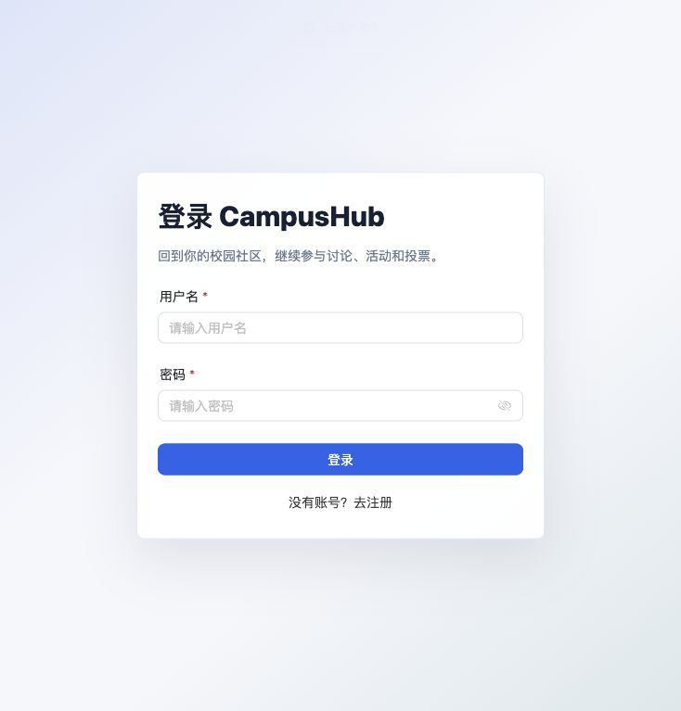
图 8-1 登录界面
用户填写用户名和密码后，前端完成非空校验并调用登录接口。后端查询用户、校验密码，成功后生成 JWT 令牌并返回用户信息。

代码 8-1 登录功能前端代码
const rules: FormRules = {
username: [{ required: true, message: '请输入用户名' }],
password: [{ required: true, message: '请输入密码' }]
}
async function handleSubmit() {
try {
await formRef.value?.validate()
submitting.value = true
await authStore.loginAction({
username: form.username.trim(),
password: form.password
})
message.success('登录成功')
router.replace('/')
} finally {
submitting.value = false
}
}
export function loginApi(data: LoginDTO) {
return request.post('/auth/login', data)
}
代码 8-2 登录功能后端代码
@PostMapping("/login")
public ResponseEntity<Result> login(
@RequestBody LoginDTO loginDTO) {
Result result = authService.login(loginDTO);
return ResponseEntity.status(result.getCode()).body(result);
}
public Result login(LoginDTO dto) {
User user = userMapper.selectOne(
new LambdaQueryWrapper<User>()
.eq(User::getUsername, dto.getUsername()));
if (user == null) {
return Result.fail(404, "user not found");
}
if (!passwordEncoder.matches(
dto.getPassword(), user.getPassword())) {
return Result.fail(401, "login failed");
}
String token = JwtUtil.generateToken(
user.getId(), user.getUsername());
stringRedisTemplate.opsForValue().set(
"login:token:" + user.getId(),
token, 7, TimeUnit.DAYS);
UserInfoVO userInfo = new UserInfoVO();
BeanUtils.copyProperties(user, userInfo);
userInfo.setRole(String.valueOf(user.getRole()));
LoginVO loginVO = new LoginVO();
loginVO.setToken(token);
loginVO.setUserInfo(userInfo);
return Result.ok(loginVO);
}

8.3 帖子数据管理功能
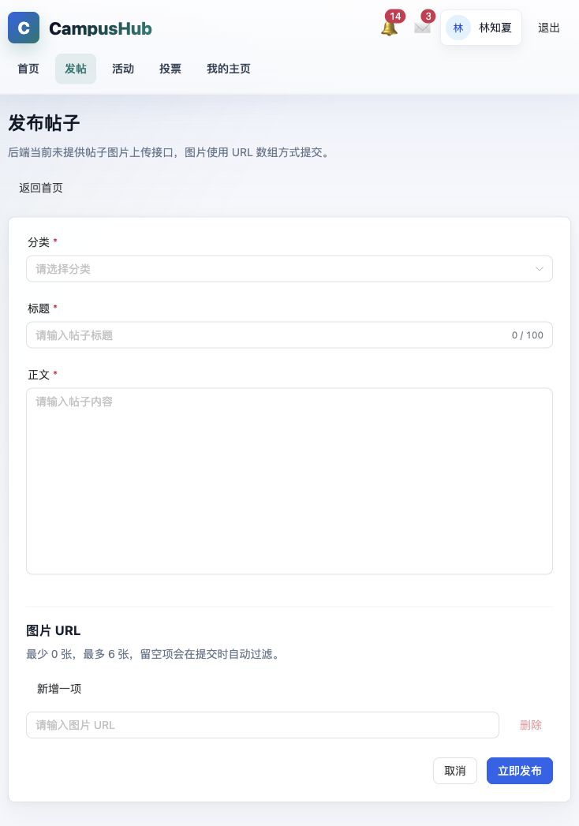
图 8-2 帖子发布与管理界面
帖子管理模块支持新增、查询、修改和删除。发布与编辑共用同一个表单页面，根据路由中是否存在帖子编号判断操作类型；删除操作在帖子详情页完成。
代码 8-3 帖子管理前端代码
const isEdit = computed(() => Boolean(route.params.id))
async function handleSubmit() {
await formRef.value?.validate()
const data = {
categoryId: Number(form.categoryId),
title: form.title.trim(),
content: form.content.trim(),
images: form.images.map(v => v.trim()).filter(Boolean)
}
if (isEdit.value) {
await updatePostApi(editPostId.value, data)
} else {
await createPostApi(data)
}
}
export const createPostApi = (data: SavePostDTO) =>
request.post('/posts', data)
export const updatePostApi = (id: number, data: SavePostDTO) =>
request.put(`/posts/${id}`, data)
export const deletePostApi = (id: number) =>
request.delete(`/posts/${id}`)
代码 8-4 帖子接口控制层代码
@PostMapping
public Result createPost(@RequestBody CreatePostDTO dto) {
postService.createPost(dto);
return Result.ok();
}
@PutMapping("/{postId}")
public Result updatePost(
@PathVariable Long postId,
@RequestBody UpdatePostDTO dto) {
return postService.updatePost(postId, dto);
}
@DeleteMapping("/{postId}")
public Result deletePost(@PathVariable Long postId) {
return postService.deletePost(postId);
}
代码 8-5 帖子新增服务代码
@Transactional(rollbackFor = Exception.class)
public void createPost(CreatePostDTO dto) {
Long userId = UserContext.getUserId();
Post post = new Post()
.setUserId(userId)
.setCategoryId(dto.getCategoryId())
.setTitle(dto.getTitle())
.setContent(dto.getContent())
.setViewCount(0)
.setLikeCount(0)
.setCommentCount(0)
.setFavoriteCount(0)
.setIsDeleted(0)
.setCreateTime(LocalDateTime.now());
save(post);
// 将图片地址按顺序写入 image 表
eventPublisher.publishEvent(
new PostSearchSyncEvent(
post.getId(), Action.UPSERT));
}
代码 8-6 帖子修改与删除服务代码
public Result updatePost(Long postId, UpdatePostDTO dto) {
Long userId = UserContext.getUserId();
Post post = getById(postId);
if (post == null || post.getIsDeleted() == 1)
return Result.fail("帖子不存在");
if (!post.getUserId().equals(userId))
return Result.fail("无权修改此帖子");
post.setCategoryId(dto.getCategoryId());
post.setTitle(dto.getTitle());
post.setContent(dto.getContent());
updateById(post);
// 删除旧图片并写入新图片
return Result.ok();
}
public Result deletePost(Long postId) {
Long userId = UserContext.getUserId();
Post post = getById(postId);
if (post == null || !post.getUserId().equals(userId))
return Result.fail("无权删除此帖子");
post.setIsDeleted(1);
updateById(post);
eventPublisher.publishEvent(
new PostSearchSyncEvent(postId, Action.DELETE));
return Result.ok();
}

