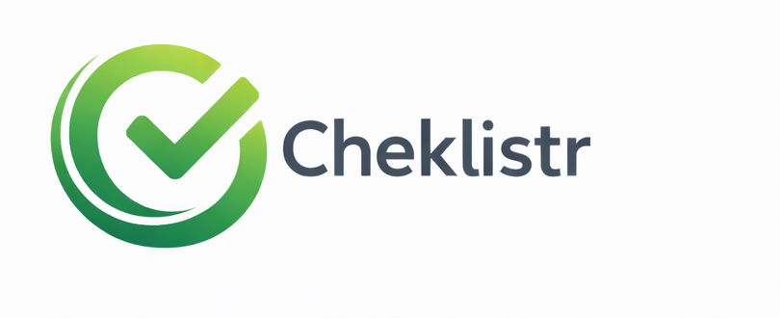

Brand Guidelines

Cheklistr
Version 1.0 | Foundational identity, product UI system, and mockup pack
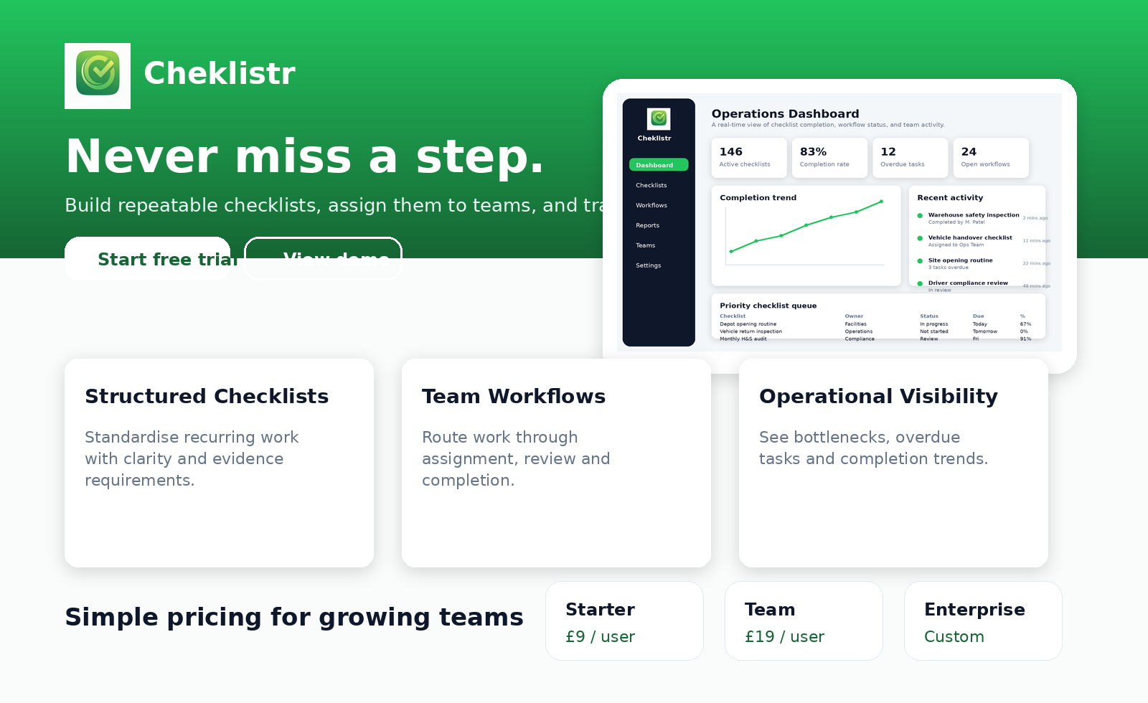
Purpose. This document defines the visual and product design system for Cheklistr: the approved logo assets, colour palette, typography, icon usage, interface patterns, landing page direction, and UI mockups for dashboard, checklist builder, workflow tracking, analytics, and mobile experience.

Contents
- 1. Brand Foundation
- 2. Positioning and Personality
- 3. Logo System
- 4. Colour Palette
- 5. Typography
- 6. Layout Principles and Spacing
- 7. Iconography and Export Set
- 8. Product UI Principles
- 9. Core Components
- 10. Dashboard Mockup
- 11. Checklist Builder Mockup
- 12. Workflow Tracking Mockup
- 13. Mobile Experience
- 14. Landing Page Direction
- 15. Usage Rules and Governance
This is a working founder-grade brand system. It is intended to be practical enough for designers, developers, and stakeholders to use immediately, while still leaving room for later refinement once the product is in market.

1. Brand Foundation
Cheklistr is a business software brand built around the idea of reliable execution. Its role is not merely to list tasks; it is to help organisations run repeatable processes with confidence, accountability, and clear visibility.
The identity should therefore feel operational, modern, and calm. It should not feel playful, over-styled, or consumer-app casual. The product exists to reduce ambiguity and missed steps in real work settings such as field operations, warehouses, facilities, compliance routines, service visits, and internal process management.
- Core promise: Never miss a step.
- Primary value: structured execution of recurring work.
- Emotional effect: confidence, order, reliability, momentum.
- Visual tone: minimal SaaS with a slightly premium edge.

2. Positioning and Personality
What the brand should feel like  - Clear and immediately understandable  - Professional rather than corporate-heavy  - Operational and dependable  - Confident without being flashy  - Modern enough for SaaS buyers and startup stakeholders | What the brand should avoid  - Generic task-app aesthetics  - Overly playful illustration-led design  - Busy gradients, noisy backgrounds, or visual clutter  - Low-contrast dashboards or cramped data displays  - Unstructured iconography that drifts from the approved symbol

3. Logo System
Two approved marks are in active use and should be treated as the canonical source assets for the brand.
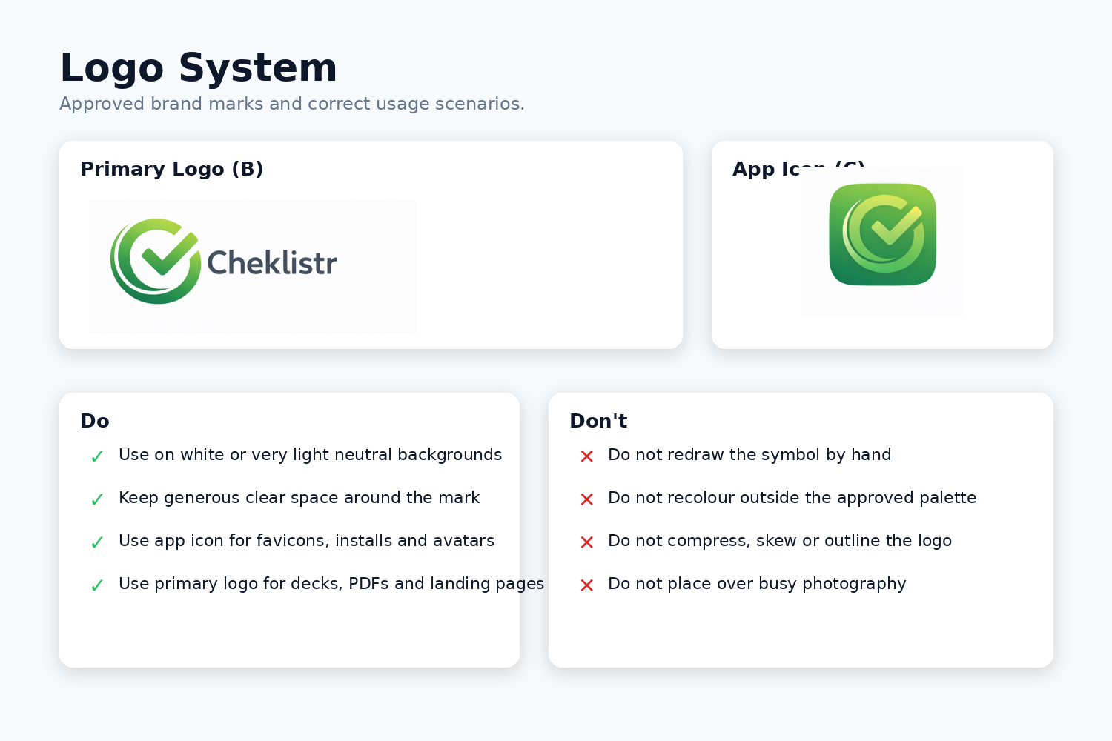
Primary Logo (Version B). The primary logo is used anywhere the brand needs to be read as a company or product name. This includes the marketing website header, presentations, brand documents, proposals, PDFs, and product splash screens.
App Icon (Version C). The app icon is the preferred mark for dashboard sidebars, favicons, install icons, browser tabs, app launchers, team avatars, and other contexts where space is constrained. It should also be the default source for raster export packs.
- Always preserve aspect ratio.
- Always keep clear space around the mark at least equal to the height of the inner check stroke.
- Do not recolour outside the approved green gradient or approved monochrome fallback.
- Do not redraw or attempt to recreate the symbol manually; use the approved master assets.

Recommended usage split:
Context | Preferred asset | Notes
Website header / PDF cover | Version B | Use full wordmark when brand recognition matters.
Dashboard sidebar | Version C | Icon-first usage supports compact navigation.
Favicon / PWA / install icon | Version C | Generate all platform sizes from approved master.
Investor deck title page | Version B | Use with generous whitespace.
Social avatar | Version C | Do not add extra borders or effects.

4. Colour Palette
Cheklistr uses a restrained palette anchored in green. The green family carries the brand identity and reinforces completion, approval, and progress. Neutral support colours provide a clean operational canvas for interfaces and documents.
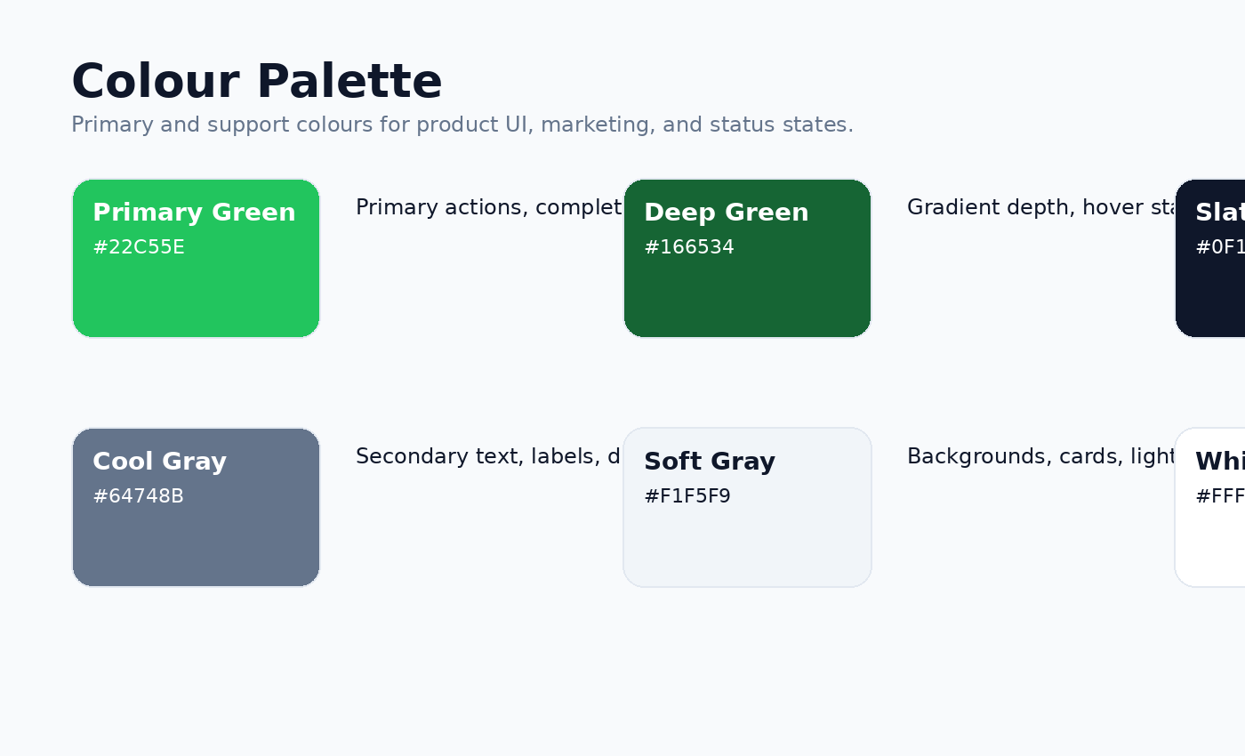

Primary palette rules
- Primary Green should lead calls to action, completion states, selected navigation, and the main brand symbol.
- Deep Green should support gradients, hover states, and more premium emphasis without replacing the primary green.
- Slate should carry most text, navigation shells, headings, and dark UI surfaces.
- Soft Gray should be the default card or page support tone when pure white feels too stark.

Status palette guidance
State | Suggested colour | Meaning | Typical use
Completed | #22C55E | Done / successful | Task completion, approved workflows
In progress | #3B82F6 | Active / underway | Live work, currently assigned items
Attention | #F59E0B | Needs attention | Warnings, partial issues, exceptions
Failed / blocked | #EF4444 | Critical issue | Failed checks, blockers, overdue escalations

5. Typography
The typographic system should feel crisp, modern, and highly legible in both product and marketing contexts. A clean sans-serif family such as Inter or a comparable UI-optimised system font is recommended for implementation.
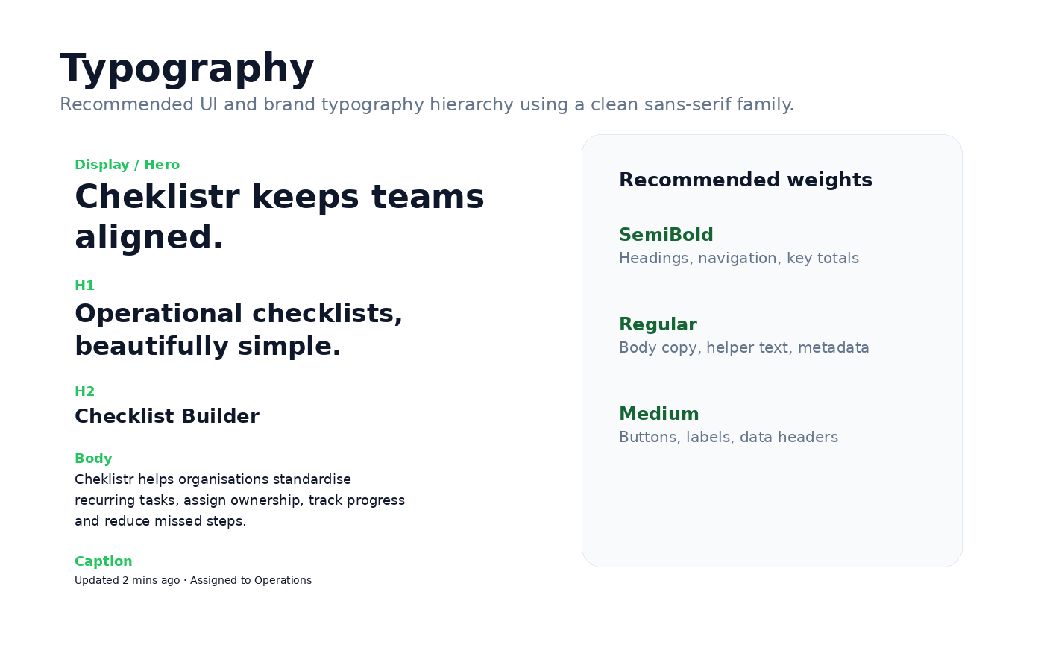

Hierarchy guidance
- Display / Hero: used only on landing pages, key covers, or major marketing moments.
- H1: primary page titles and major section starts.
- H2: card sections, screen titles, and internal document hierarchy.
- Body: default product and document copy.
- Caption: metadata, timestamps, helper text, evidence labels.

Typographic tone
Cheklistr copy should be written plainly. Labels should be concise and action-oriented. Sentences should not over-explain. A good rule is that the interface should speak like an efficient operator: calm, direct, and precise.

6. Layout Principles and Spacing
The product and associated documents should feel structured. This is achieved less through heavy decoration and more through consistent spacing, strong hierarchy, and careful alignment.
- Use an 8px spacing grid for interface design decisions: 8 / 16 / 24 / 32 / 48 / 64.
- Use generous outer padding around cards and work areas; avoid cramped edge-to-edge content.
- Keep dashboard cards visually consistent in height unless there is a clear reason to vary them.
- For forms and checklist rows, prioritise tap targets and scanability over density.
- Where possible, separate navigation, work surface, and metadata into clearly distinguishable zones.

Page archetypes
Screen type | Layout guidance | Primary purpose
Dashboard | Sidebar + top metrics + cards | Orientation and at-a-glance status
Builder / Editor | Large central work area + right properties panel | Creation and configuration
Workflow board | Multi-column stage layout | Progress and coordination
Mobile task view | Single column, high contrast, large targets | Execution in the field

7. Iconography and Export Set
All raster icon exports should be derived from the approved Version C master. This prevents subtle drift in shape, proportion, and gradient treatment over time.
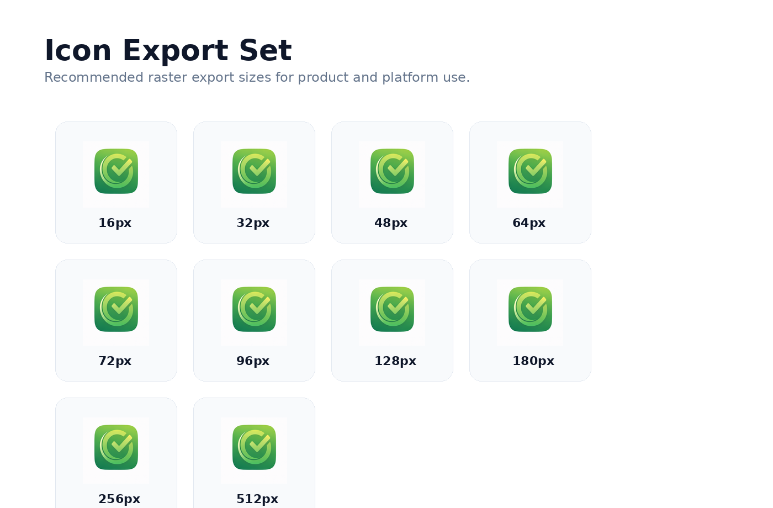
- Minimum practical web/favicon sizes: 16px, 32px, 48px.
- Useful product and platform sizes: 64px, 72px, 96px, 128px, 180px, 256px, 512px, 1024px.
- When displayed at small sizes, do not add small text, outlines, or shadows around the icon.

8. Product UI Principles
The user interface is a major part of the brand. Because Cheklistr is a software product, the way the product looks and behaves will shape perception just as strongly as the logo.
- Clarity first. Users should know what to do next without decoding the interface.
- State visibility. Completion, overdue status, ownership, and workflow stage must be visible quickly.
- Operational calm. The interface should reduce stress rather than add it.
- Consistency. Lists, cards, buttons, labels, and status badges should behave predictably.
- Evidence-friendly design. Many operational workflows require notes, photos, sign-off, or audit trace.

Voice and microcopy
- Prefer: 'Checklist completed', 'Step saved', 'Review required', 'Assigned to Operations'.
- Avoid verbose system language, vague confirmations, and overly promotional copy inside the product.

9. Core Components
The following component patterns should anchor the product UI system.
Component | Guideline | Why it matters
Primary button | Green fill, rounded corners, bold label | Drives the main user action and reinforces brand colour
Secondary button | Light neutral background, slate text | Supports alternative actions without competing with primary CTA
Checklist row | Clear checkbox area, strong title, optional helper text | Supports rapid scanning and completion
Metric card | Short number or percentage plus concise label | Improves at-a-glance dashboard understanding
Status badge | Compact shape with clear text and high contrast | Makes workflow state immediately visible
Right-hand properties panel | Grouped metadata fields with enough breathing room | Keeps configuration close to the work surface without cluttering it

10. Dashboard Mockup
The dashboard is the operational overview surface. It should orient a user quickly by combining metrics, progress visuals, recent activity, and a prioritised work queue.
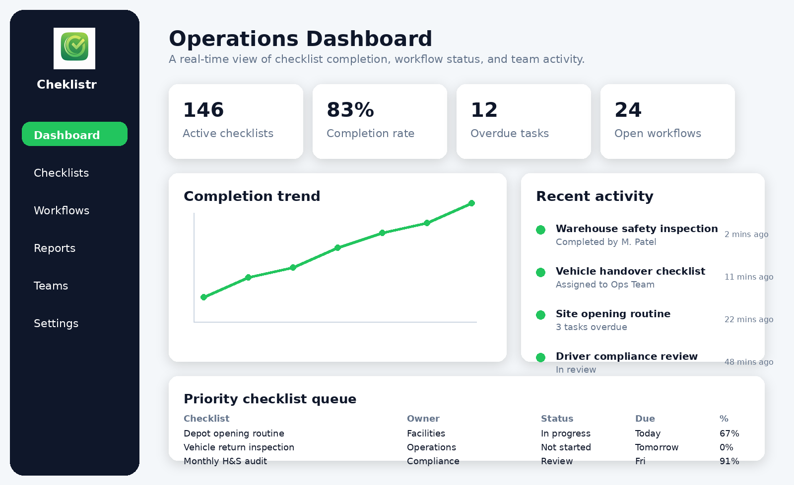

Dashboard design notes
- Dark left navigation creates a strong structural anchor and pairs well with the green brand colour.
- Metric cards are concise and prioritise one figure plus one label.
- The trend chart should not be decorative; it should answer a real operational question.
- The recent activity panel keeps the dashboard feeling live and collaborative.
- The priority queue table gives immediate next actions without forcing the user into a report.

11. Checklist Builder Mockup
The checklist builder is a core product screen and should feel spacious, editable, and dependable. The builder is where organisations codify their process logic, so it must avoid clutter and support confident editing.
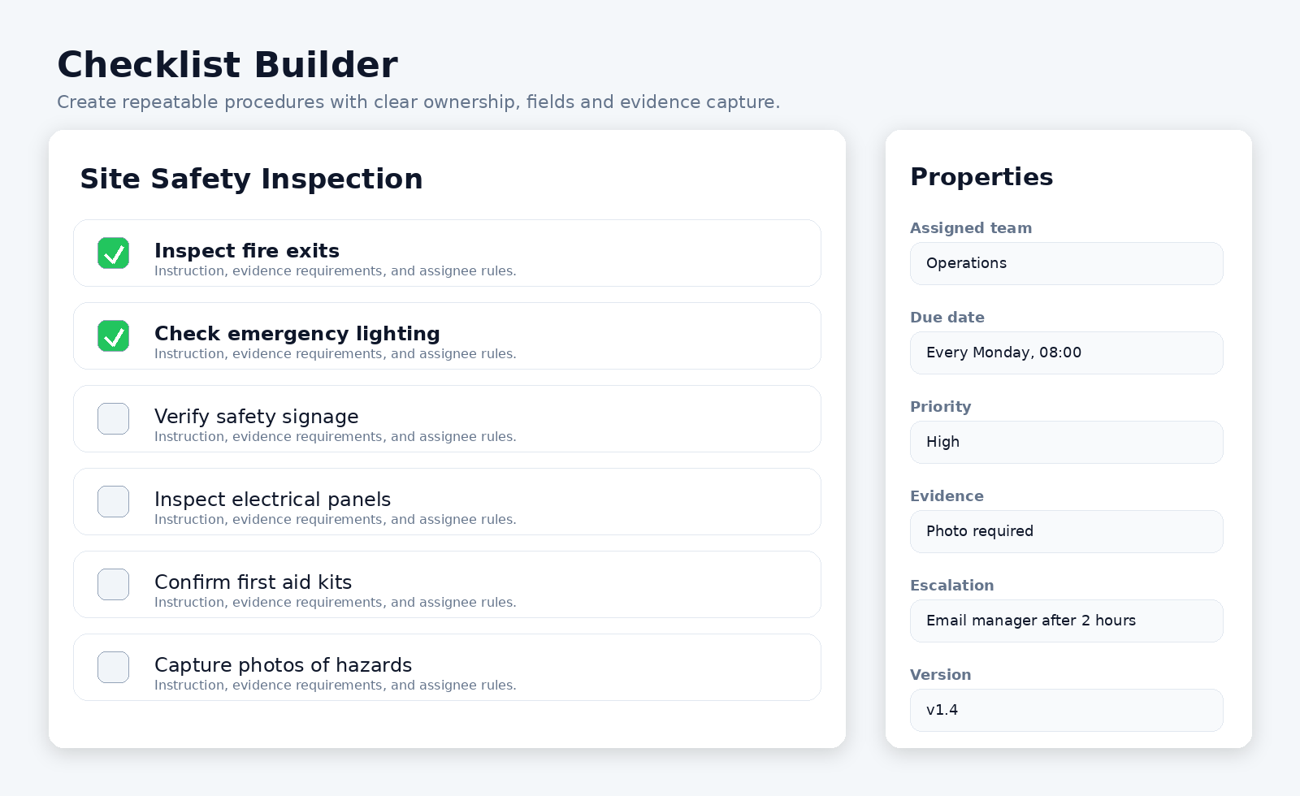

Builder design notes
- The central canvas keeps focus on the checklist itself.
- Rows provide space for both a primary step title and secondary instruction text.
- The right panel contains metadata such as schedule, assignment, evidence requirements, and escalation rules.
- Completed or validated steps can use stronger emphasis, but the screen should still feel calm.

12. Workflow Tracking Mockup
Workflow tracking translates checklists into operational progress. A board view works well because it presents movement clearly: created, assigned, in progress, review, completed.
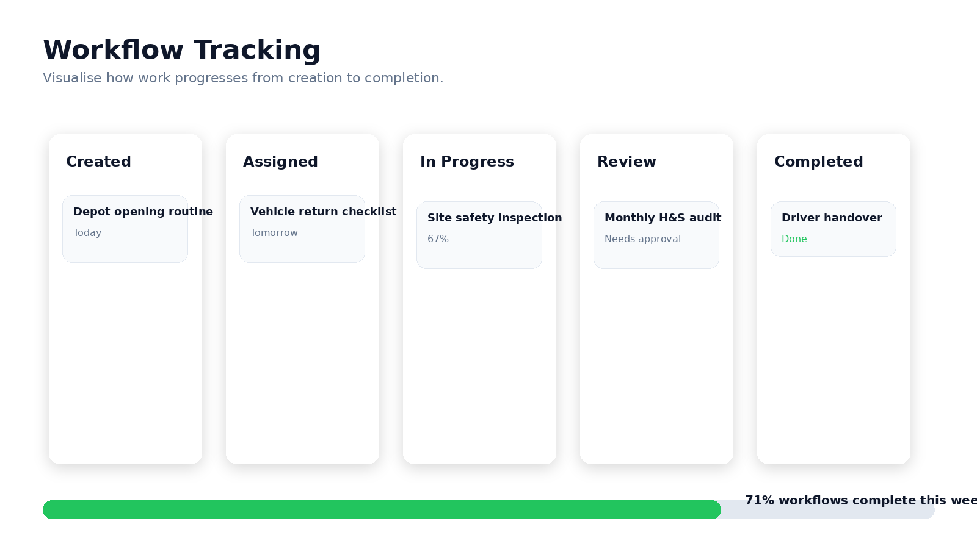

Workflow design notes
- Column labels must be short and unambiguous.
- Cards should carry only the most useful summary information: title, owner or due status, and state.
- Progress summaries can sit below the board to provide team-level context.
- Do not overload cards with too many labels or mini-charts.

13. Mobile Experience
Mobile execution is essential for many real-world workflows. The mobile UI should be action-first: large targets, straightforward status, fast evidence capture, and minimal distraction.
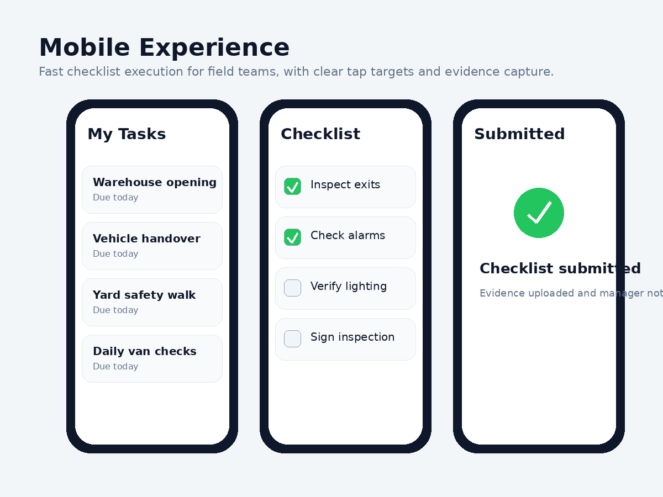

Mobile design notes
- Checklist steps need comfortable tap targets and high contrast.
- Users should always be able to see what remains to be done.
- Submission and confirmation should feel decisive and reassuring.
- Offline or poor-connection scenarios should be considered in future design and engineering rounds.

14. Landing Page Direction
The landing page is the highest-level commercial expression of the brand. It should combine a direct value proposition, clear product visuals, and a restrained premium tone. It should not feel like an over-marketed growth-hack website.


Landing page structure
- Hero: product name, promise, concise description, two calls to action.
- Product preview: real or realistic product screenshot near the hero.
- Core value blocks: structured checklists, team workflows, operational visibility.
- Pricing: simple, legible, and free of clutter.
- Proof and trust layers can be added later once customer references exist.

15. Usage Rules and Governance
To avoid fragmentation as the product develops, the following governance rules should be observed.
- All teams should source logos and icons from the approved master asset pack.
- Any future redesign of the symbol should be deliberate and versioned, not incremental drift.
- Design and engineering should share the same colour values and component definitions.
- Screenshots used in marketing should reflect the real product direction wherever possible.
- Brand usage changes should be documented in a revision log.

Recommended next design outputs
- Investor / pitch deck product screens based on the mockups in this document.
- A Figma-style product interface pack with desktop and mobile layouts.
- Developer-ready design tokens and component states.
- Dark-mode variants once the light-mode system is fully locked.

Appendix A. Quick Reference
Item | Reference
Primary logo asset | Version B approved logo
Primary icon asset | Version C approved icon
Tagline | Never miss a step.
Brand stance | Minimal SaaS + Premium SaaS
Main colours | #22C55E, #166534, #0F172A, #64748B, #F1F5F9
Main product screens | Dashboard, builder, workflow, mobile, landing page

