What is FarmPi?
A local farm monitoring prototype
FarmPi is a prototype system for viewing environmental information from different farm locations in one place.

What it is designed to help you do
- See current conditions from several locations.
- Compare locations more easily.
- View recent history and trends.
- Understand what the information means.
- Ask questions in normal language.

Designed for local use
FarmPi is being developed as a local system. That means it is intended to keep working on-site, even if Internet access is limited or unavailable.

A prototype to explore the idea
This is not a finished commercial product. It is a prototype being used to test whether this kind of system would be useful, understandable, and practical.
Let’s discuss
Where, if anywhere, could this kind of information help you on your farm?
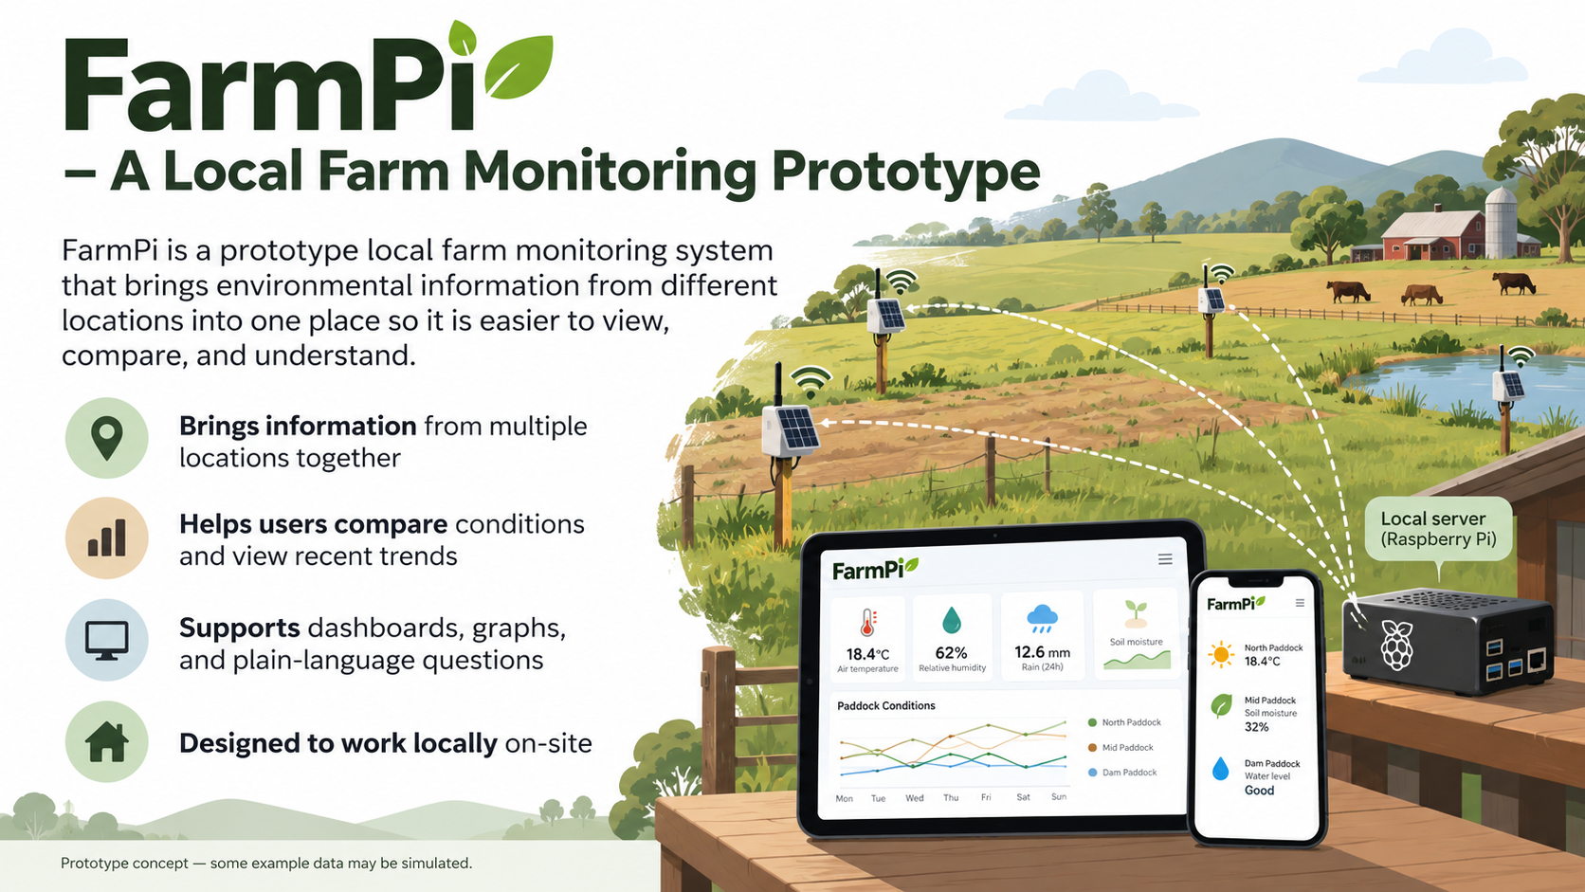

What problem is it trying to solve?
Bringing information together so it is easier to understand and use
Environmental information can be spread across different locations, devices, or manual checks.

This can make it harder to:
- See what is happening across the property.
- Compare one area with another.
- Notice trends over time.
- Know whether a reading is current or old.
- Understand what a measurement means.
- Make use of the information quickly.
FarmPi is intended to bring that information together in a simpler way.

The goal is to help you:
- See what is available to be managed.
- Understand the information more easily.
- Compare locations and conditions.
- Ask practical questions in plain language.
The focus is not only on collecting data. The focus is also on making the data easier to understand and use.
Let’s discuss
How do you get this information now? What is inconvenient, slow, confusing, or unreliable about that process?
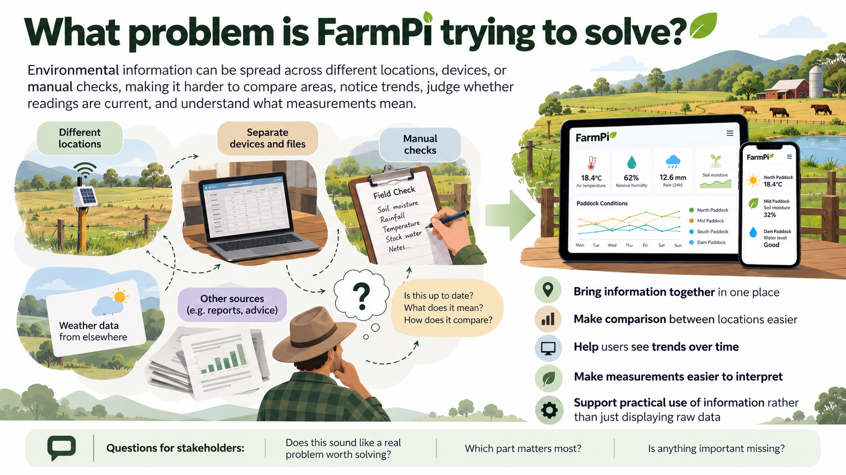

How FarmPi works
Three main parts, working together on-site

1. Sensor nodes
Small monitoring nodes would be placed in different locations. These collect environmental readings.

2. Local FarmPi server
A local Raspberry Pi runs the FarmPi system. It receives the readings, stores them, and prepares them for viewing.

3. Phone or tablet interface
You view the information on a phone or tablet. You can look at current readings, compare locations, view graphs, or ask questions.

Local access
FarmPi is intended to work as a local system. It is designed so the farm user can still access it on-site without relying on cloud services or constant Internet access.
Let’s discuss
Would it matter to you if the system still worked locally when the Internet was unavailable? Where would you expect to use it?

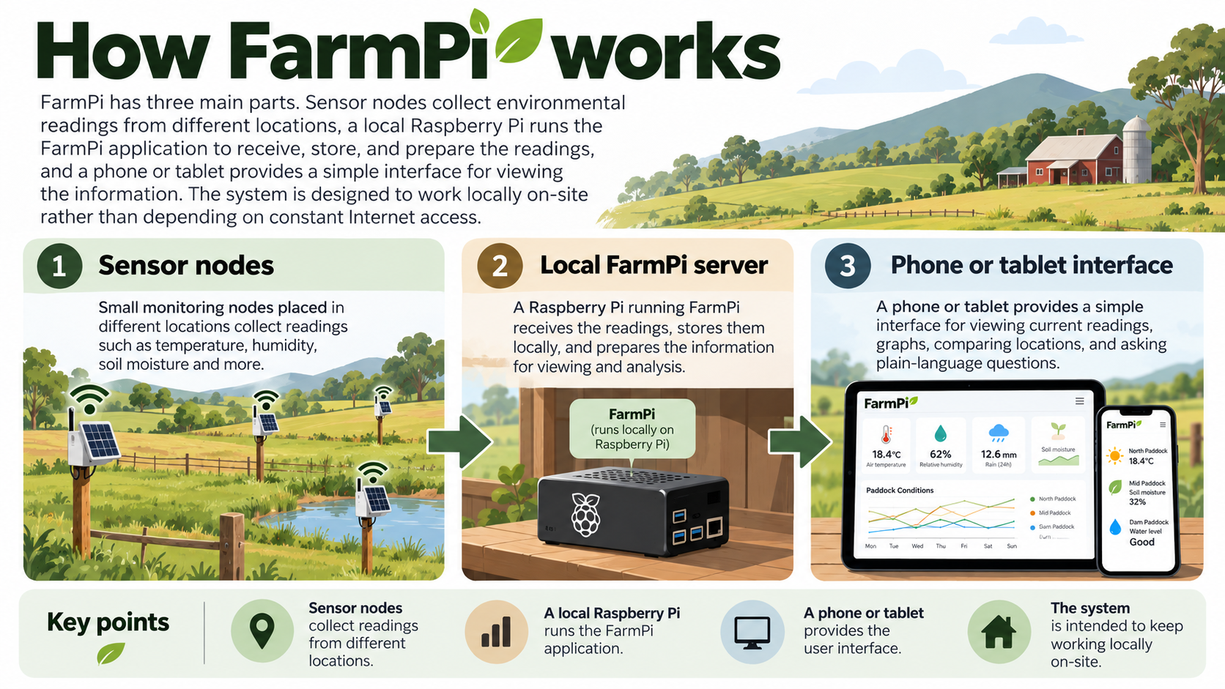

Dashboard / current conditions
An example of what a dashboard screen would help you see
A dashboard screen would show the most recent readings from different locations.

It may show things such as:
- Soil moisture.
- Soil temperature.
- Air temperature.
- Humidity.
- Light.
- Pressure.

At a glance, you should be able to see:
- Which locations are reporting.
- Which readings are current.
- Which readings are missing or old.
- Which values may need attention.
What we want to find out
Would a screen like this be useful?
Would the information be clear?
What would you want to notice first?

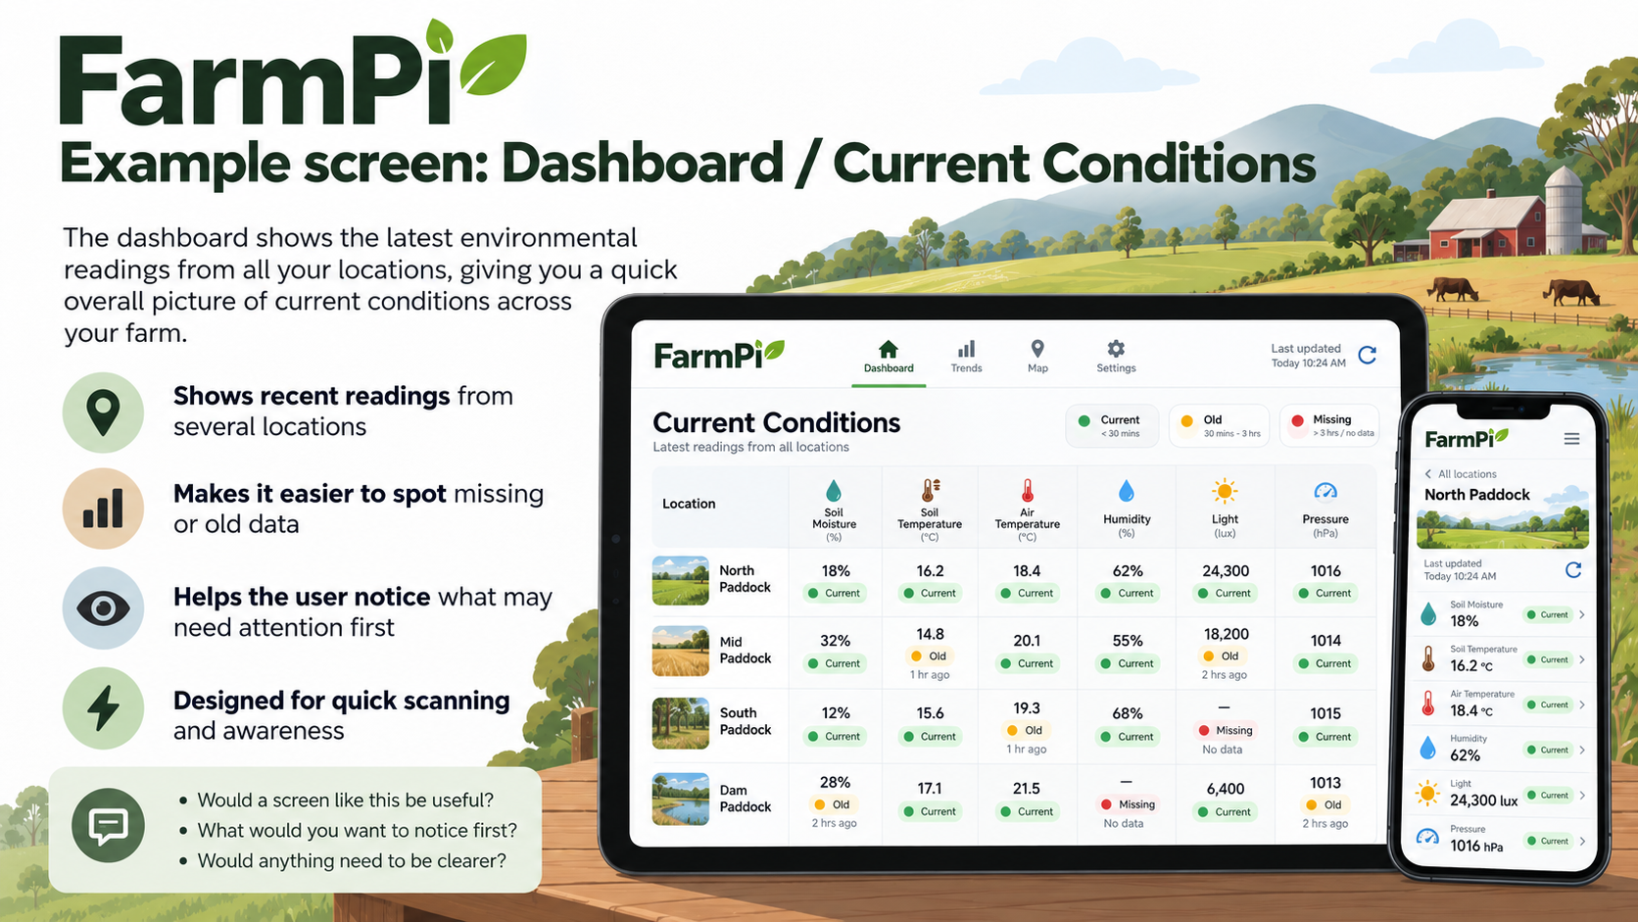

Comparison and history
Understanding differences between locations and changes over time
FarmPi is intended to help you compare locations and view changes over time.

For example, you might want to:
- Compare two paddocks.
- See which location is driest.
- View a graph of recent readings.
- See whether conditions are getting wetter, drier, warmer, or cooler.

A history view should help you explore:
- What changed?
- When did it change?
- Is this normal?
- Is the reading recent enough to trust?
What we want to find out
Would graphs and comparisons help?
What kind of comparisons would matter most?

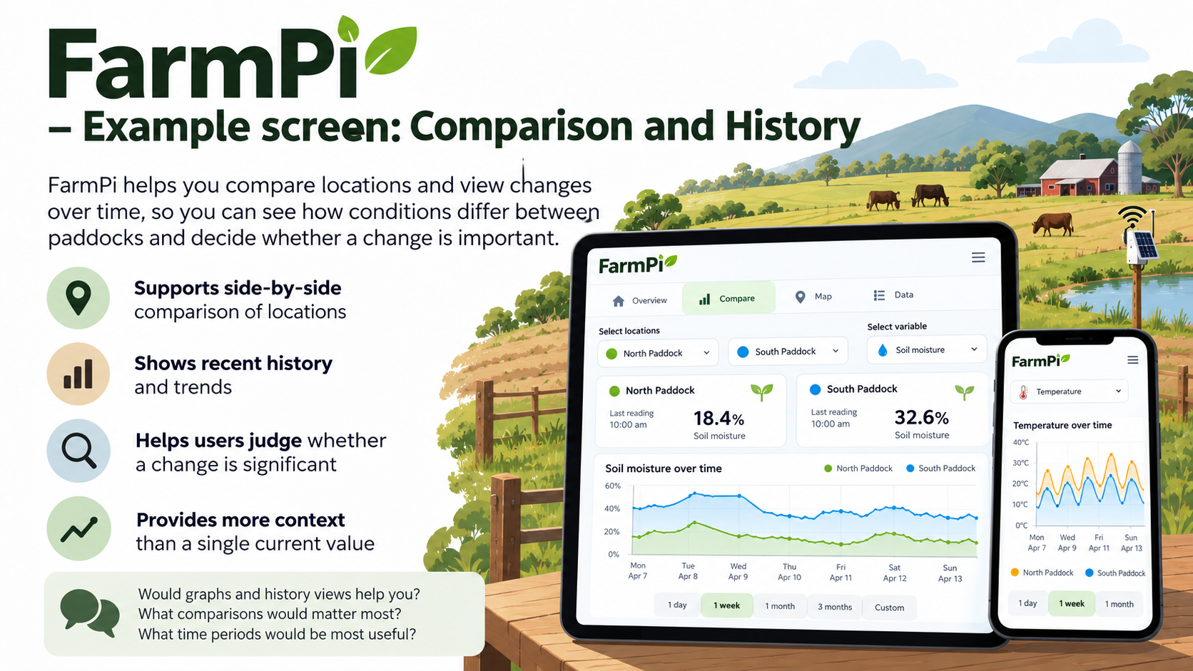

Ask FarmPi
Another way to explore the information: questions in normal language
FarmPi is also intended to support natural-language questions. This means you could ask questions such as:
- “Which paddock is driest?”
- “Compare the north paddock and the south paddock.”
- “Show me the recent soil moisture trend.”
- “Which reading is the oldest?”
- “What does this measurement mean?”

Choose the style that suits you best
- Screens and menus.
- Graphs and charts.
- Normal-language questions.

FarmPi should also make it clear:
- Where the information came from.
- How recent it is.
- When information is missing.
- When a result is based on system data rather than general explanation.
What we want to find out
Would you use this kind of question-based interface?
When would it be more useful than menus or graphs?
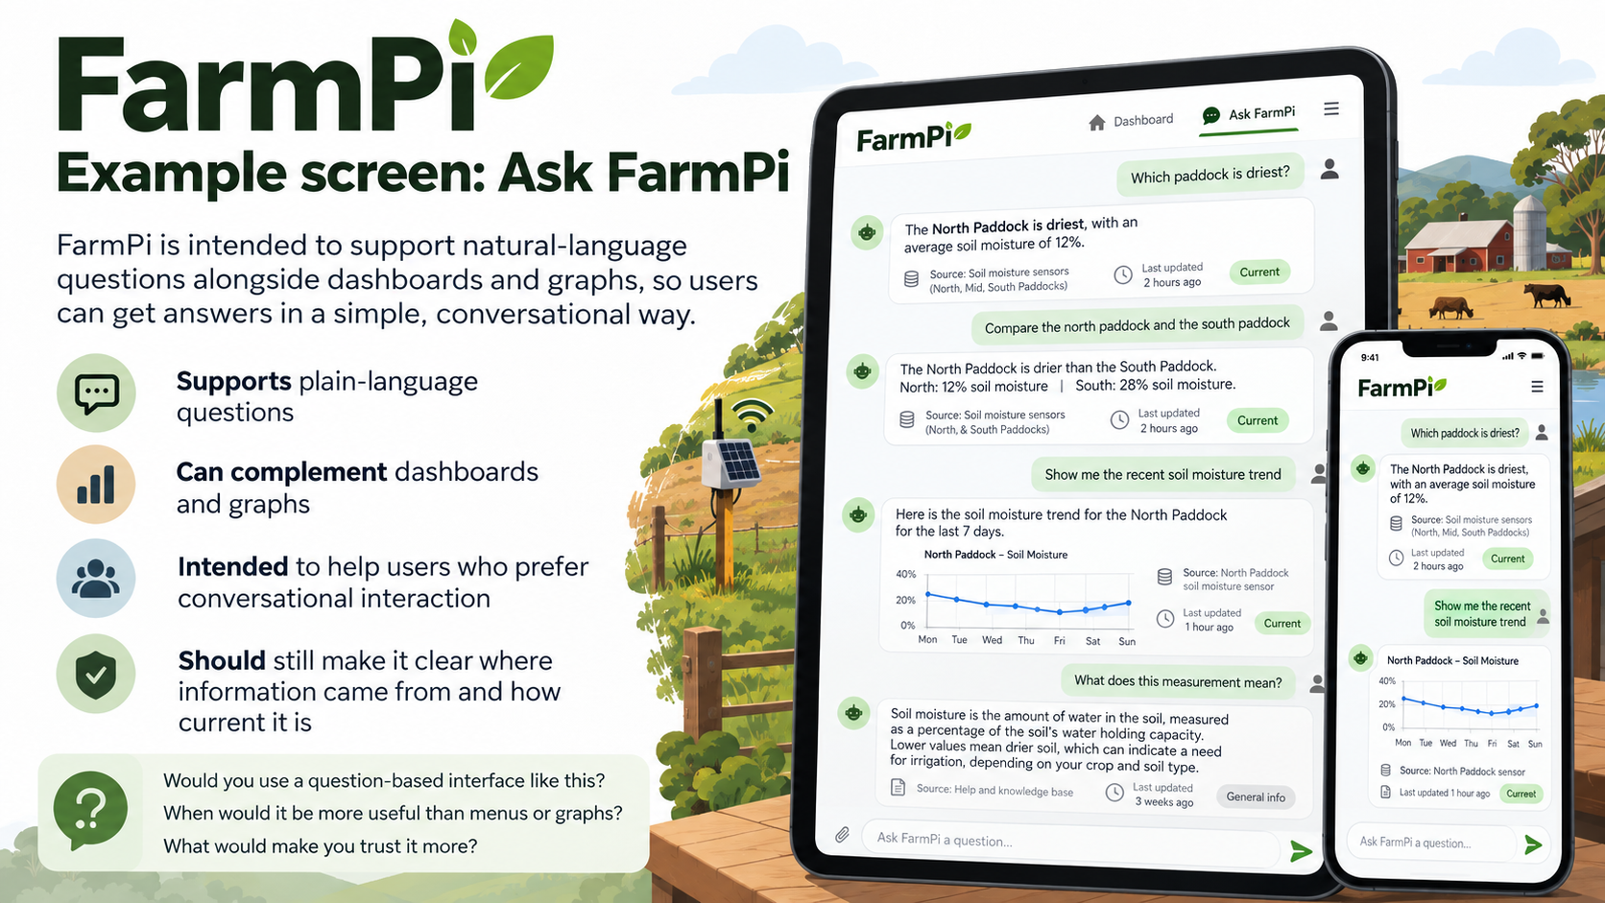

What feedback are we looking for?
Your experience will help test the assumptions behind FarmPi
This prototype is being used to test whether the idea is useful and understandable.

We are interested in feedback such as:
- What information would be most useful?
- What seems clear?
- What seems confusing?
- What would make the system more trustworthy?
- What would make the system more practical to use?
- What would you expect it to do?
- What would you not trust or not use?

There are no right or wrong answers
We are not asking whether you “like” the system. We are asking whether it would be useful, understandable, and practical.
Honest criticism is more helpful than approval.
Before we finish
Is there anything you would expect a system like this to do that we have not mentioned?

