High Level Design
for
Integration TAT⁺/VRS/SDEA
Issue 1.0.0.0
M

The Management team listed agrees to supply the necessary capital and engineering resources to support the project described in this document
Printed Name | Signature | Sign-off Date
GSG-Russia Operations Manager - Andrei Pitko
GSG-Russia Chief Architect - Sergey Baranov
Technical Leader - Vsevolod Kotlyarov
Project Leader - Vadim Sukhomlinov
Project SQA Engineer - Yelena Belyayeva
Project Test Leader - Pavel Shmelkin

Distribution List:
Vadim Rumyantsev
  - Andrei Artamonov
  - Andrey Karpov
  - Pavel Shmelkin
  - Alexander Tikhomirov
  - Andrey Garigin
  - Andrey Artamonov Jr.
  - Olga Kotlyarova
Change History
Issue | Description | Date | Author
1.0.0.0 | First version | 11-Nov-02 | V.Sukhomlinov
Table of Contents
1. Introduction 5
1.1 Purpose 5
1.2 Definitions and Acronyms 5
1.3 References 5
2. High-Level Design 6
2.1 General Architecture 6
2.2 Block Diagram 6
2.2.1 SiC Kernel (inherits TAT⁺ Kernel) 6
2.2.2 IDE 6
2.2.3 CGTC 6
2.2.4 SDEA (inherited from SDEA project) 6
2.2.5 VRS (supplied as binary component) 6
2.3 Subsystems 7
2.3.1 IDE component 7
2.3.2 SiC Kernel 8
2.3.3 VRS component 8
2.3.4 SDEA component. 8
2.3.5 CGTC component. 8
2.4 Interface Description 9
2.4.1 MSC-PR file format. 9
2.4.2 FlowGen file format. 9
2.4.3 Project configuration XML DTD. 9
2.4.4 Tool invocation API. 10
2.4.5 Macro Processor user’s module API 10
2.4.6 Test Kernel API. 10
2.4.7 Debug information file format. 10
2.4.8 Abstract Test Suite format. 10
2.4.9 IDE invocation interface shall be defined in FS. 10
2.5 Dependency Descriptions 10

- Introduction
  - Purpose
This document describes the software architecture of the ‘Silver Cartridge’ product. The document is primarily intended for use by the software engineering team designing this feature.
  - Definitions and Acronyms
The following definitions are in addition to those terms defined in the GSG-Russia Software Engineering Handbook glossary.
3CR-3 Checking Consistency and Completeness of Requirements, 2003
ATS Abstract Test Suite
API……………………………Application Program Interface
CGTC Code generation template for C
GUI Graphical User Interface
IDE Integrated Development Environment
ITU International Telecommunication Union
IUT Implementation Under Test
MSC Message Sequence Chart (ITU z.120)
MSC-PR MSC Phrasal Representation
SiC Silver Cartridge. The product of Integration TAT⁺/VRS/SDEA project.
SDEA Specification Debugger for Embedded Applications
SDL Specification Description Language (ITU z.100)
TAT Test Automation Toolset
TAT⁺ Next version of TAT
VRS Verification of Requirements and Specifications, product of 3CR-3 program

  - References
Motorola, GSG-Russia Software Engineering Handbook
  - Project Ticket for Integration TAT+/VRS/SDEA, 8-Oct-2002
  - Project Reference Table SiC_1_0\doc\plans\ ref-table.xls
  - Requirements Book for Integration TAT+/VRS/SDEA
  - HLD for TATplus project, issue 1.0.0.0
  - HLD for SDEA project, issue 1.0.0.0
  - HLD for VRS project, issue 2.2.1.0
- High-Level Design
  - General Architecture
The goal of this project is to develop a toolset - Silver Cartridge (SiC). SiC – is the product of integration TAT+/VRS/SDEA components. It is test automation toolset, which is intended for testing automation of embedded applications based on various platforms. The main distinctive feature of this toolset is covering full automation cycle of testing and code generation for MSC and SDL specification languages:
- Prove correctness of the requirements described in SDL+ MSC
- Complete verification of application:
- Including time-dependent, non-deterministic and resource balance aspects of specifications
- Increase confidence in absence of hard-to-find errors
- Avoid concurrency pathologies
- Eliminate major effort leaving only residual testing:
- Test only non-proved requirements
- Increase coverage while reducing the testing time
- Validate requirements of application proved by VRS
- Find causes of “Bad events” by Specification Debugging
- Generate 100% stand-alone tests and a test environment for various languages and platforms from consistent formal specifications.
- Minimize manual effort for verifying the product quality.
This document describes differences from TATplus HLD [5]. The design of SDEA and VRS tools described in HLD for SDEA[6] and HLD for VRS [7] accordingly.
The SiC product consists of a number of modules, utilities and templates, described in 2.2.
  - Block Diagram
SiC product is based on following components:
    - SiC Kernel (inherits TAT⁺ Kernel)
    - IDE
    - CGTC
    - SDEA (inherited from SDEA project)
    - VRS (supplied as binary component)
Complete scheme of SiC data flow is shown in Figure 1.
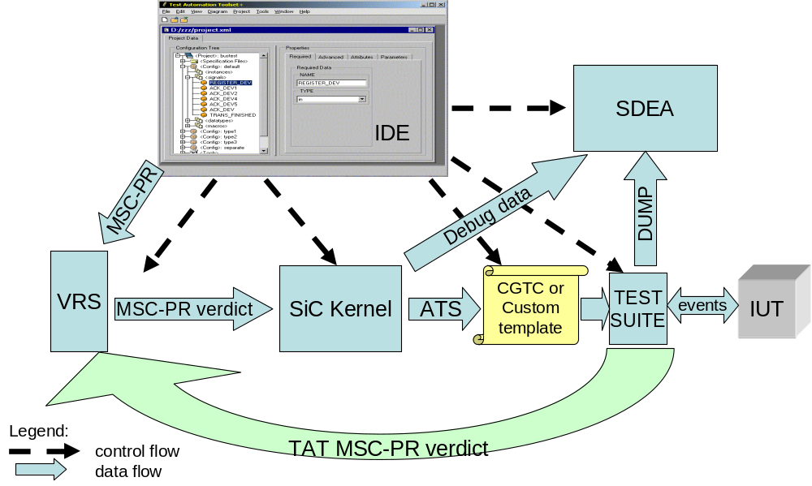
Figure 1. SiC control/data flow
In Figure 1, IDE component manages execution of other modules, including external tools; provide them with information (MSC-PR files [2.4.1], project configuration [2.4.3] etc.).
The problem that VRS is aimed at is automated requirement capturing, namely, requirements that are presented in the form of MSC diagrams. If combined with subsequent automated code and test generation this will noticeably increase the quality of software products and reduce the cycle time of its development.
VRS component receives MSC-PR files, checks them for completeness and consistency, and generates a verdict in MSC-PR format. This verdict is passed to SiC Kernel which generates test cases stored in ATS [2.4.8], debug data [2.4.7] (source files, messages, data types etc.).
CGTC processes ATS and generates target code in C. CGTC can be replaced with a custom code generation template. In this case generation of debug dump shall be coded in this template.
Generated test suite interacts with IUT, validates IUT responses, and checks dynamic time constraints and store information in log file, debug dump and/or MSC-PR verdict files.
Debug dump and debug data passed to SDEA which shows the trace of IUT behavior step-by step.
MSC-PR verdicts generated by test suite are passed to VRS component for further analysis.
The main idea of abovementioned scheme is to implement iterative solution for smart search of suspicious places in IUT specifications by using real responses from IUT. In addition to specification level analysis conducted by VRS, this approach allows to reduce the sets of classes where errors occurs, specify more detailed constraints in requirements.
  - Subsystems
    - IDE component
The purpose of the IDE module is to provide an interface and interaction with a user. The IDE shall allow user to input and modify configuration data files and execute tests. The configuration data for SiC contains test description data stored in the XML format.
The basic structure of IDE is defined in TATplus HLD [5]. Additional scheme of execution tool integration is shown in Figure 2.
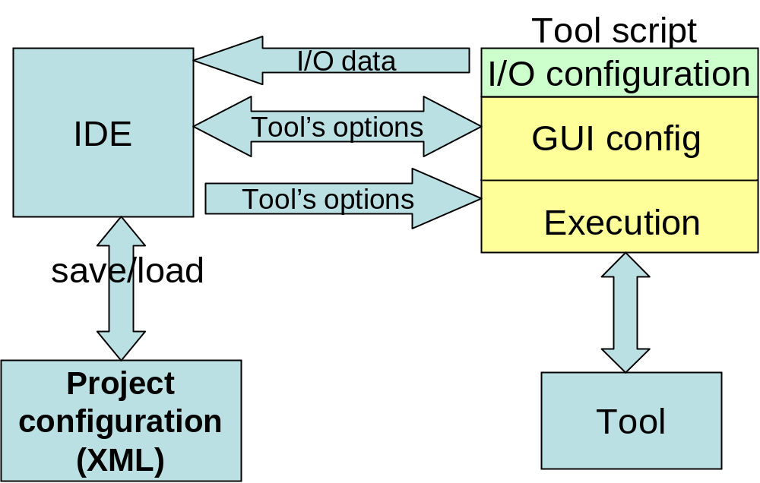
Figure 2. Execution tools integration
Tool script consists of 3 parts with defined API [2.4.4]. When tool script is attached to project information about tool’s inputs and outputs passed to IDE and stored in XML. This is done by I/O configuration API. Each tool in IDE may be used with various sets of options. Tool’s options edits visually by invoking GUI config. Tool configuration data is stored in project configuration.
      - IDE shall provide ability to invoke SDEA.
      - IDE shall provide ability to invoke VRS on selected sets of MSC (SDL).
      - The IDE shall have an ability to run in terminal mode for automated execution of test scenarios.
      - IDE shall handle tool execution, generate logs and handle error codes for the result of the execution.
    - SiC Kernel
SiC Kernel is a set of tools for MSC-PR processing. The output of MSC-PR processing in SiC Kernel is Abstract Test Suite [2.4.8]. HLD for SiC Kernel is described in TATplus HLD [5].
      - SiC Kernel shall provide ability to generate debug information [2.4.7].
    - VRS component
The design of VRS is defined in HLD for VRS [7].
      - VRS component shall generate verdict in MSC-PR format [2.4.1].
      - VRS component shall input files in MSC-PR format [2.4.1], generated by SiC C code generated tests and containing TAT verdicts.
    - SDEA component
The purpose of SDEA component is to allow analysis of test case execution by step-by-step trace of events. The structure of SDEA is defined in HLD for SDEA project [6].
    - CGTC component
The purpose of CGTC is to provide automotive standalone test generation from MSC+SDL test description transformed in ATS. The structure of generated C test cases is shown in Figure 3.
Test Case block is generated by CGTC from ATS. It communicates with I/O adapter written by user via calling function for sending message to IUT. I/O adapter transmits this message to IUT via internal interface and passes the IUT responses to Test Kernel block. Test Kernel block stores messages in queue and calls Test Case when necessary. Being initialized the I/O adapter registers functions for dumping events. It is possible to specify various log modules working simultaneously for the same Test Case.
EVENT_INSTANCE structure is the unified method for representation all possible events and data including MSC events, variables, time labels etc. TEST_INSTANCE structure contains Test Case’s message queue, pointers to I/O adapter functions, attached dump modules. I/O adapter is responsible for creating TEST_INSTANCE structures before starting Test Case. Creating TEST_INSTANCE, starting Test Cases and message processing shall be done by use of defined API [2.4.6].
      - CGTC shall generate C code from ATS [2.4.8] in transition system form and behavior-tree form [5].
      - CGTC shall output verdict in format, defined in FS.
      - CGTC shall receive parameters from command-line.
      - C code generated by CGTC shall be ANSI C compliant.
      - CGTC shall include dump modules for storing log in text format (defined in FS), MSC-PR format (defined in FS) and SDEA debug dump format by using SDEA agents [6].
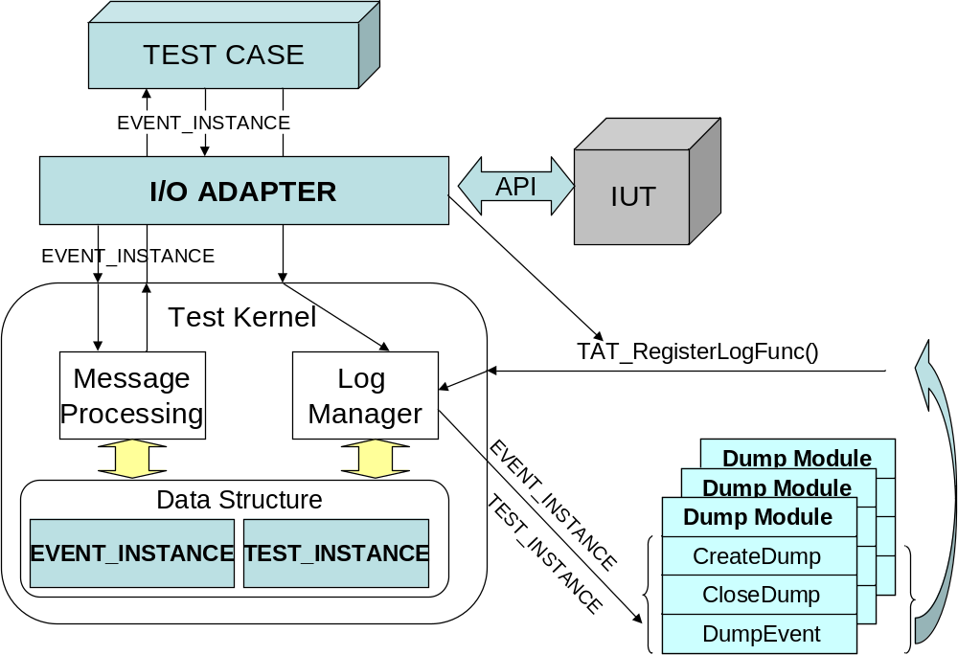
Figure 3. CGTC generated code structure
  - Interface Description
Following interfaces shall be implemented and documented:
    - MSC-PR file format.
Shall be defined in FS. This format shall be supported by Telelogic 4.3.
    - FlowGen file format.
Shall be defined in FS.
    - Project configuration XML DTD.
Shall be defined in FS.
    - Tool invocation API.
Tool invocation API is used in IDE external tool configuration scripts for tool invocation. Shall be defined in FS.
    - Macro Processor user’s module API
This API is used for implementation of user’s macro functions. Shall be defined in FS.
    - Test Kernel API.
Shall be defined in FS.
    - Debug information file format.
Shall be defined in FS.
    - Abstract Test Suite format.
Shall be defined in FS. This interface is used for customization of test code generation.
    - IDE invocation interface shall be defined in FS.
This interface shall support following features:
      - Specification of project configuration XML file.
      - Specification of test cases to execute.
      - Specification of log file information. This is to provide feedback to user or 3rd party tool invoking IDE with results of test cases execution.
  - Dependency Descriptions
No special dependencies.

