Test Automation Toolset UMLine (TAT)
USER’S
MANUAL


TAT
USER’S MANUAL
Motorola reserves the right to make changes without further notice to any products herein to improve reliability, function or design. Motorola does not assume any liability arising out of the application or use of any product described herein; neither does it convey any license under its patent rights nor the rights of others. Motorola products are not designed, intended, or authorized for use as components in systems intended for surgical implant into the body, or other applications intended to support or sustain life, or for any other application in which the failure of the Motorola product could create a situation where personal injury or death may occur. Should Buyer purchase or use Motorola products for any such unintended or unauthorized application, Buyer shall indemnify and hold Motorola and its officers, employees, subsidiaries, affiliates, and distributors harmless against all claims, costs, damages, and expenses, and reasonable attorney fees arising out of, directly or indirectly, any claim of personal injury or death associated with such unintended or unauthorized use, even if such claim alleges that Motorola was negligent regarding the design or manufacture of the part. Motorola and  are registered trademarks of Motorola. Motorola is an Equal Employment Opportunity/Affirmative Action Employer.

Legal Notices
The information in this document has been carefully checked and is believed to be entirely reliable, however, no responsibility is assumed for inaccuracies. Furthermore, Motorola reserves the right to make changes to any products herein to improve reliability, function or design. Motorola does not assume liability arising out of the application or use of any product or circuit described herein; neither does it convey any license under its patent rights or the rights of others.
The software described in this document is furnished under a license agreement. The software may be used or copied only in accordance with the terms of the agreement.
© Motorola, Inc. 2001-2004.
No part of this publication may be reproduced or transmitted in any form or by any means - graphic, electronic, electrical, mechanical, chemical, including photocopying, recording in any medium, taping, by any computer or information storage retrieval systems, etc., without prior permissions in writing from Motorola Inc.
Permission is granted to reproduce and transmit the Problem Report Form and the Customer Satisfaction Survey to Motorola.

IMPORTANT NOTICE TO USERS
While every effort has been made to ensure the accuracy of all information in this document, Motorola assumes no liability to any party for any loss or damage caused by errors or omissions or by statements of any kind in this document, its updates, supplements, or special editions, whether such errors are omissions or statements resulting from negligence, accident, or any other cause. Motorola further assumes no liability arising out of the application or use of any product or system described herein; nor any liability for incidental or consequential damages arising from the use of this document. Motorola disclaims all warranties regarding the information contained herein, whether expressed, implied or statutory, including implied warranties of merchantability or fitness for a particular purpose.

TRADEMARKS
Microsoft, MS-DOS and Windows are trademarks of Microsoft.
UNIX is a trademark of AT&T Bell Laboratories.
Telelogic is a trademark of Telelogic AB.

Section 1 Overview 1
1.1 What is Silver Cartridge? 1
1.2 Objectives 1
1.3 Results and benefits of using Silver Cartridge 2
Section 2 Notations 4
2.1 Manual Structure 4
2.2 Conventions 5
2.3 References 5
2.4 Technical Support Information 5
2.5 Definitions, Acronyms and Abbreviations 5
Section 3 Getting Started 7
3.1 Installation and system requirements 7
3.2 General approaches for SiC usage 7
3.3 SiC approach for requirements specification 8
Section 4 Installing Silver Cartridge 10
4.1 Common requirements 10
4.1.1 Optional requirements 10
4.2 System prerequisites 10
4.3 Windows 2000 10
4.3.1 Introduction 10
4.3.2 SiC installation procedure 10
4.3.3 SiC uninstallation procedure 11
4.3.4 SiC MSC Converter issues 11
4.4 Sun Solaris platform 11
4.4.1 SiC installation procedure 11
4.4.2 SiC uninstallation procedure 11
4.5 SiC contents after installation 12
Section 5 Developing MSCs for Silver Cartridge 14
5.1 Methodology 14
5.1.1 Scope 14
5.1.2 What is verified? 14
5.1.3 Execution environment integration 14
5.1.4 Processing non-deterministic features of MSC 14
5.1.5 MSC structural enhancements used in SiC 15
5.2 Macro preprocessing 15
5.3 MSC syntax considerations 16
5.4 MSC Data types 16
5.5 MSC Expressions 16
5.6 Time supervision 16
5.6.1 Using time labels in MSC 17
5.7 Using time specification with MSC instances 18
5.8 MSC message 18
5.8.1 Message synchronization 19
5.8.2 Messages with conditions of existence 19
5.8.3 Time specification of messages 20
5.8.4 Pattern matching mechanism of messages 20
5.9 Using MSC variables 21
5.10 MSC timers 22
5.11 References with parameters 22
5.12 MSC inline expressions 23
5.12.1 Alternative: ALT 23
5.12.2 Parallel: PAR 23
5.12.3 Optional: OPT 24
5.12.4 Loops: LOOP 24
5.12.5 Exception : EXC 25
5.12.6 Handling of multivariant behavior 25
5.13 MSC Conditions 26
5.13.1 Using conditions as ‘if’ statements 27
5.13.2 Using conditions as assertions 27
5.13.3 Using conditions as ‘while’ loop statements 27
5.14 MSC Actions 28
5.15 MSC Coregions 28
Section 6 Specification Files 29
6.1 IUT definition 29
6.2 MSC-PR files description 29
6.2.1 Binary and text forms of MSCs 29
6.3 Developing macro definition file 29
6.3.1 Developing C functions for macro definitions used 29
6.3.2 Relations between instances of different instance tags 30
Section 7 Using Silver Cartridge 32
7.1 Concepts 32
7.2 Test development overview 32
7.3 SiC organization 33
7.4 Components 35
Section 8 Integrated Development Environment 37
8.1 Silver Cartridge at start-up 37
8.2 Project organization 38
8.3 Creating a new project 39
8.4 Adding input specification files to the project: ‘Files’ workspace 39
8.5 Developing an MSC configuration: ‘MSC configurations’ workspace 40
8.6 Annotating MSC instances 41
8.7 Describing MSC signals 42
8.8 Mapping MSC data types to target code types 43
8.9 Defining macros 44
8.10 Working with tools and pipes: ‘Tools & Pipes’ workspace 45
8.11 Typical scenario of using a tool with the SiC IDE 46
8.11.1 Working with the internal tools of Silver Cartridge 47
8.12 Linking to an external tool via SiC API 47
8.13 Using tool as a file editor 49
8.14 Configuring tool options with a ‘tool configuration’ tag 49
8.14.1 Where a tool configuration shall be used? 50
8.15 What is a pipe? 50
8.16 Configuring a pipe 50
8.17 Pipe manipulations 51
8.18 Executing pipes: ‘Test Suite’ workspace 51
8.19 Launching SiC IDE in the batch mode 52
Section 9 XML Configuration 53
9.1 TAT Kernel Configuration 53
9.1.1 Common issues 53
9.1.2 TATPROJECT tag 53
9.1.3 TATPROJECT::CONFIG tag 53
9.1.4 CONFIG::SIGNALS tag 54
9.1.5 SIGNALS::SIGNAL tag 54
9.1.6 SIGNAL::ATTRIBUTE tag 54
9.1.7 SIGNAL::PARAMETER tag 54
9.1.8 CONFIG::DATATYPE tag 54
9.1.9 DATATYPE::TYPEDEF tag 54
9.1.10 TYPEDEF::ATTRIBUTE tag 54
9.1.11 TYPEDEF::VALUE tag 54
9.1.12 TYPEDEF::MEMBER tag 55
9.1.13 CONFIG::INSTANCES tag 55
9.1.14 INSTANCES::INSTANCE tag 55
9.1.15 INSTANCE::PARAMETER tag 55
9.1.16 INSTANCE ::ATTRIBUTE tag 55
9.1.17 CONFIG::MACROS tag 55
9.1.18 MACROS::MACRO tag 55
9.1.19 MACRO::VALUELIST tag 56
9.1.20 MACRO::ATTRIBUTE tag 57
9.1.21 VALUELIST::VALUE tag 57
Section 10 Macro Processor 58
10.1 Overview 58
10.2 Using Macro Processor 58
10.2.1 Command line 58
Section 11 Trace Generator 61
11.1 Overview 61
11.2 Benefits of semantics evaluation 61
11.3 Using Trace Generator 61
11.4 Running modes 61
11.5 Specifying type of input files 62
11.6 Command line options 62
11.7 Example 64
11.7.1 Initial input MSC 64
11.7.2 Specification files 65
11.7.3 Running SiC tools in ES or SS modes 65
11.7.4 Getting info on the number of traces with Trace Generator 68
11.8 Processing time with Trace Generator 68
11.8.1 Enabling time support 68
11.8.2 Restricting time intervals 69
11.8.3 Processing partial order with respect to time specification 69
11.9 Restricting the number of output traces 69
11.9.1 Ordering of traces 70
Section 12 MSC Linker 71
12.1 Overview 71
12.2 Using MSC Linker 71
12.3 MSC Linker functionality 71
12.3.1 Command line options 71
12.4 Example 71
Section 13 MSC Transformer 73
13.1 Overview 73
13.2 Using MSC Transformer 73
13.3 Functionality 73
Section 14 MSC Converter 74
14.1 Overview 74
14.2 Using MSC Converter 74
14.3 Command line 74
Section 15 Abstract Test Generator 75
15.1 Overview 75
15.2 Using Abstract Test Generator 75
15.2.1 Functionality 75
Section 16 SDL/MSC Wrapper 78
16.1 Purpose 78
16.2 Methodology 78
16.3 Using SDLMSC 78
16.4 API of generated wrapper 80
16.5 SDLMSC example 81
Section 17 Smart Template 83
17.1 Overview 83
17.2 Types of code generation templates 83
17.3 Development of non-generating part 84
17.3.1 Inside data structures 84
17.3.2 Controlling functionality 85
17.3.3 Getting system responses functionality 85
17.3.4 Time support 85
17.3.5 Start process and finish of test suites execution 85
17.3.6 Impact delivery to tested system 85
17.3.7 Test suites process execution recordation (log) 86
17.4 Wrapper development 86
17.4.1 Defining minuteness of formal description 86
17.4.2 Input data description (ATS – Time Transition Form) and aspects, connected with constructions of generated code 87
17.4.3 “State” procedure 88
17.5 Command Line 94
17.6 API in code generated by CGTC 95
17.6.1 Creating Test Instance 95
17.6.2 Closing Test Instance 96
17.6.3 Registering dump module 96
17.6.4 Test Instance Message receiving function 97
17.6.5 Control over Test Cases execution 98
17.7 User defined data types support 99
17.7.1 Dump function 99
17.7.2 Free function 99
17.7.3 Copy function 99
17.7.4 Compare function 99
17.8 Tau SDL Integration 100
17.8.1 SDL data type support 100
17.8.2 Wrapper generation 100
Section 18 Developing Wrappers for SiC Generated Code 101
18.1 What is wrapper? 101
18.1.1 TAT_TEST_INSTANCE data structure 101
18.1.2 TAT_EVENT_INSTANCE data structure 104
18.1.3 Function resetSys 104
18.1.4 Function sendMess 105
18.1.5 Function clockF 106
18.1.6 Functions startCase and finishCase 107
18.1.7 Function TAT_ReceiveMessage 107
18.1.8 Function main 109
18.2 Example wrapper 110
18.2.1 Transmitting messages to IUT 110
18.2.2 Transmitting messages from IUT 112
18.2.3 Launching tests and sending clocks to the generated test environment 113
Appendix A -- Extended MSC Syntax Declarations Used in SiC 114
A.1 General lexical rules 114
A.2 Text definition 116
A.3 Macro substitutions 116
A.4 Message Sequence Chart document 116
A.5 Message Sequence Chart 116
A.6 Event’s comment 117
A.7 Text Statement 117
A.8 Extended Event Specification 118
A.9 Message 118
A.10 Condition 119
A.11 Timer 119
A.12 Action 119
A.13 Instance creation 119
A.14 Instance stop 119
A.15 Coregion 119
A.16 Inline expression 119
A.17 MSC reference event 120
Appendix B -- Grammar for SiC Abstract Test Suite 121
B.1 ATS 121
B.2 Common definitions 121
B.3 ATS Definition 121
B.4 Command granule 121
B.5 ATS Header 123
B.6 ATS termination 126
B.7 Test Case Wrapper 126
B.8 TTS Specific commands 126
B.9 BHT Specific commands 127
B.10 MSC-direct form commands 127
Appendix C -- Document Type Definition for SiC XML configuration 129

Figure 1. SiC paradigm 7
Figure 2. TAT technological process 8
Figure 3. Example of asynchronous behavior 15
Figure 4. Using target language expressions in MSC 16
Figure 5. Relative time specification 17
Figure 6. Labeled time specification 17
Figure 7. Time labels in MSC 18
Figure 8. Time relatives for MSC instances 18
Figure 9. Example MSC message with additional constructs 19
Figure 10. Message synchronization - example MSC 19
Figure 11. Condition of existence in MSC’2000 20
Figure 12. Example MSC parameter alternative 20
Figure 13. ‘Don’t care’ message parameters in MSC 21
Figure 14. Using variables in MSC 22
Figure 15. Example timer with an interval 22
Figure 16. Example of parameterized reference 23
Figure 17. Example loop 24
Figure 18. The original MSC (left) and the MSC with unrolled loops 25
Figure 19. EXC inline expression meaning 25
Figure 20. Restricting the number of traces in MSC operators 26
Figure 21. Using conditions as ‘if’ statements 27
Figure 22. Example asserting condition 27
Figure 23. Using conditions as a ‘while’ iteration statement 28
Figure 24. Example of Action event 28
Figure 25. General scheme of SiC usage 32
Figure 26. Dataflow diagram for SiC 34
Figure 27. Silver Cartridge window structure 37
Figure 28. Creating a new project 38
Figure 29. Working with the ‘Files’ workspace 39
Figure 30. Describing MSC constructs 40
Figure 31. Defining signal parameters 42
Figure 32. Defining macro conditions and values 44
Figure 33. Configuring tools and pipe 45
Figure 34. An example tool configuration 49
Figure 35. An example pipe scheme 49
Figure 36. Configuring a pipe component 51
Figure 37. Configuring pipes for execution 52
Figure 38. Trace Generator example - initial MSC 60
Figure 39. Trace Generator example - Resulting MSCs 61
Figure 40. MSCEXP Example - launching Trace Generator in “message overlapping” mode 63
Figure 41. Trace Generator example - initial (left ) and the resulting MSCs 64
Figure 42. Trace Generator example - initial MSC 65
Figure 43. Restricting trace order - initial (left) and the resulting MSCs 65
Figure 44. Example MSC - initial scenarios 67
Figure 45. Resulting MSC scenario_common 67
Figure 46. SDLMSC example 77
Figure 47. Use of DCGT 78
Figure 48. Use of MPCGT 79
Figure 49. Description minuteness level 82
Figure 50. Generation of “IF” term 84
Figure 51. Generation of “WHILE” term 85
Figure 52. Generation of “ASSERT” term 85
Figure 53. Generation of passive alternative 86
Figure 54. Generation of “ACTION” construction 87
Figure 55. Generation of active alternative 88
Figure 56. Generation of mixed alternative 89
Figure 57. Structure of generated code 93
Figure 58. Developing wrappers - general scheme 95

Table 1: Metrics illustrating major benefits of SiC 2
Table 2: Actions performed on signals directed between instances with different tags 31
Table 3: Executable components of SiC 35
Table 4: Fields used for annotating MSC instances 40
Table 5: Fields used for annotating MSC signals 41
Table 6: Actions performed on signals depending on an instance type 42
Table 7: Fields used for mapping MSC data types 43
Table 8: Fields used for defining a macro 43
Table 9: Signal types and their description 50
Table 10: Command line options of Macro Processor 53
Table 11: Trace Generator command line options 57
Table 12: Command line switches of MSC Linker 66
Table 13: Description 66
Table 14: Command line options of MSC Transformer 68
Table 15: MSC Converter command line options 69
Table 16: Abstract Test Generator command line options 70
Table 17: Option switches of SDLMSC 74
Table 18: Output files of SDLMSC 75
Table 19: Description of files used in the example 76
Table 20: Command line options of Smart Templates 89
Table 21:Elements of data structure TAT_TEST_INSTANCE 96
Table 22: Elements of data structure TAT_EVENT_INSTANCE 98
Table 23: Parameter description of resetSys function 99
Table 24: sendMess function description of parameters 99
Table 25: clockF function parameters description 100
Table 26: startCase and finishCase functions parameter description 101
Table 27: TAT_ReceiveMessage function parameter description 101

- Overview

This document contains hands-on description of TAT tool. TAT tool is used as component of integrated toolset Silver Cartridge (SiC). Purposes and tasks of Silver Cartridge are pointed, including all internal and supported tools. The document answers the question what is TAT, SiC, and how it can be used.
First part of User Manual (Sections 5-9) presents general approach to SiC, required procedures and options to product installation, main blocks and scenarios of SiC utilization, and tool functionality.
Second part of User Manual (Sections 10-17) presents detailed approach to SiC tools, concepts of tools, description of their configuration, launching tools to SiC, and tools execution, and benefits of using SiC.
  - What is Silver Cartridge?
A key to make testing technologies cheaper and more efficient lies in the area of test generation techniques, i.e. efficient and compact description of test sets and thus significantly reduces tester’s manual efforts to develop them. Another key is visualization of formal description by means of graphs. Present document contains technology construction concepts of testing automation tool – test generator TAT. The TAT tool is used as component of integrated toolset Silver Cartridge. Document describes features of test generation tool only. So, in the document it can consider name TAT and SiC as synonyms.
Silver Cartridge is a joint toolset, which provides complete, fully automated testing cycle based on user-defined scenarios developed on the mix of formal languages MSCs - Message Sequence Charts and SDL – Specification Description Language.
Silver Cartridge (SiC) encompasses several tools that offer complete set of solutions for efficient specification analysis and test generation. SiC contains following tools:
- Test Automation Toolset – set of tools, which processes and analyzes input specifications, generates test traces and target code, debugs MSC specifications.
- Verifier of Requirements Specifications – set of tools, which proves correctness of the requirements, stated within a diagram and produces the final verdict.
SiC also offers Integrated Development Environment. It contains: 1) GUI specifically developed to provide easy and efficient use of current SiC components, and easy supplementation of 3-rd party tools as new SiC components; 2) XML interface to provide opportunity of including SiC components to customer’s toolsets.
We propose unified approach to software product development, which stems from initial requirement specifications. In addition to standardized MSCs, Silver Cartridge supports extended MSC notations, enhanced with macros, allowing significant reduction of code size developed manually. This extended notation allows absolute, relative, and more complex time specifications in test scenarios. With such framework, we can get significant time and cost savings through reuse and efficient workaround of time and macro definitions.
  - Objectives
Silver Cartridge provides formal approach to be used at the design phase. It consists of developing engineering specifications in graphical formal language (MSC/SDL) with subsequent proving of their properties using the integrated technology of verification and testing. Due to this integrated technology in testing area, a paradigm shift occurs from conventional programming in terms of code and observed behaviors to programming in initial specifications expressed in MSC/SDL with their automated verification and testing.
So, SiC provides two trends – automated formal requirements verification and automated test generation and testing. TAT and VRS tools support these trends.
TAT generates standalone tests and test environment for a system under test, which can be attached to a hardware device, an application model, launched on a simulator or a program system, and can be also executed on an instrumental computer. The user can develop more complex scenarios, e.g., to verify non-deterministic and time-dependent features of the system’s behavior. Complete testing solutions provided by TAT allows user to cope with various platforms and environments.
VRS Verifier proves correctness of the formal specifications (verifies it). Complete verification of application provides for testing: 1) Include time-dependent, non-deterministic and resource balance aspects of specifications, 2) Increase confidence in absence of hard-to-find errors, 3) Avoid concurrency pathologies, 4) Eliminate major effort (50-70%) leaving only residual testing, 5) Leave testing only non-proved requirements, 6) Increase coverage while reducing the testing time.
However, we still need to run tests in order to validate the system (to demonstrate that it performs as expected). Validation needs much less test cases than direct testing due to the already proved correctness of implementation. Verifier may not prove correctness of a certain subset of requirements; then we need to perform residual testing of these requirements. However, we estimate that the residual testing requires much less efforts than direct testing of the application.
The main features of SiC and the respective technology are:
- Manual formalization of specification and requirements
- Verification requirements to find proved and unproved fragments and fix specification defects for correction
- Generate tests for validation for proved parts of specification and requirements
- Generate test for testing (residual testing) of unproved parts of specification and requirements
- Release validation and residual testing
The host platforms for Silver Cartridge are UNIX (Solaris) and Windows (Windows 2000).
  - Results and benefits of using Silver Cartridge
Silver Cartridge has demonstrated its adaptive capabilities and has been successfully implemented in the following domains:
- Modeling and Simulation
- Real Time Operating Systems
- Telecommunications
- Telematics
Average metrics illustrating the major benefits of these experiments are shown in the following table:
Table 1: Metrics illustrating major benefits of SiC
Domain | Decrease of Hand Written Code Size | Increase of Test Code Size | Increase in the Number of Tests
Modeling and Simulation | 6 | 50 | 100
Real Time Operating Systems | 3 | 1 | 2
Telecommunications | 10 | 40 | 150
Telematic | 4 | 4 | 5
Average | 6 | 24 | 64

With each implementation of this technology in Motorola software centers the following benefits are expected:
- at an average 5X reduction of manual work for developing code and test suites by automated code and test generation with over 2X increase of code quality
- at an average 2X reduction of the required testing effort by proved elimination of extra testing
- at least 20% reduction of quality cost and cost of poor quality due to the automated means of code verification and debugging at the level of the source specifications rather than at the level of execution code
After GSG-Russia implements the proposal technology in its software development process, it would share this innovation with other Motorola software centers and divisions.
This technology along with toolsets may be offered to external companies on the market of software tools for developing embedded software applications.
- Notations

The following notation, symbols, and conventions are used throughout the manual.
  - Manual Structure
SECTION 1 Overview gives general overview of SiC purpose and capabilities. Section provides SiC definition, main objectives, results and benefits of using Silver Cartridge.
SECTION 2 Notations describes notations used throughout the document.
SECTION 3 Getting Started gives general approaches for SiC usage, installation and system requirements, and SiC approach for requirements specification.
SECTION 4 Installation describes required procedures and options to product installation on Windows and Sun Solaris platform, common and optional requirements to product installation.
SECTION 5 Developing MSCs for SiC describes methodology for MSC development, MSC syntax and extensions supported by tools of Silver Cartridge and gives information on how to develop tests for SiC.
SECTION 6 Specification Files describes macro definition files that shall be developed to use SiC, explaining development of C functions for macro definitions used in system and relations between instances of different instance tags.
SECTION 7 Using SiC outlines the main blocks and usage scenarios of SiC, i.e. main concepts of SiC usage, test development overview, organization of executable components of SiC.
SECTION 8 Integrated Development Environment describes Silver Cartridge at start-up, shows general concepts of solving common task in SiC.
SECTION 9 XML Configuration describes the format of a configuration file used by Sic.
SECTION 10 Macro Processor describes Macro Processor functionality: configuration, launching to project, execution of the tool plus its options, automatically set in SiC.
SECTION 11 Trace Generator describes Trace generator functionality: configuration, launching to project, execution of the tool plus its options, automatically set in SiC.
SECTION 12 MSC Linker outlines MSC Linker functionality: configuration, launching to project, execution of the tool plus its options, automatically set in SiC.
SECTION 13 MSC Transformer This section describes the purpose and functionality of MSC Transformer: configuration, launching to project, execution of the tool plus its options, automatically set in SiC.
SECTION 14 MSC Converter This section describes the purpose and functionality of MSC Converter: configuration, launching to project, execution of the tool plus its options, automatically set in SiC.
SECTION 15 Abstract Test Generator describes the functionality of Abstract Test Generator: configuration, launching to project, execution of the tool plus its options, automatically set in SiC.
SECTION 16 SDL/MSC Wrapper describes the functionality of SDL/MSC Wrapper.
SECTION 17 Smart code generation templates introduces smart code generation templates used in SiC: configuration, launching to project, execution of the tool plus its options, automatically set in SiC.
SECTION 18 Developing wrappers for SiC generated code provides the information how to develop wrappers for SiC generated code.
APPENDIX A- Extended MSC Syntax Declarations Used in SiC describes grammar of MSC-PR files, supported in SiC.
APPENDIX B - Grammar for SiC Abstract Test Suite describes the structure of generated ATS.
APPENDIX C – Document Type Definition for SiC XML configuration contains the description of XML configuration format used by SiC tools.

  - Conventions
The following typographical conventions are used throughout the manual.
Boldface type
Bold is used for important terms, notes and warnings. Also, it is usually used for cross-references.
Boldface italic type
Bold italic type is used for terms when these are first introduced in the document.
Italic type
Italics are used for all names of directives, macros, constants, routines and variables. Also, this type is used for naming of GUI elements and special product terms.
Courier font
Courier typeface is used for code examples in the text.
  - References
ITU Recommendation Z.120 - Message Sequence Chart (MSC)
  - ITU Recommendation Z.100 - Specification and Description Language (SDL)
  - XML Information Set. W3C Recommendation 24 October 2001. http://www.w3.org/
  - S.Baranov, V. Kotlyarov. Automation of Design and Development of Embedded Software on the Basis of a Strictly Defined Software Architecture, COMPSAC, 2001.
  - V.Kotlyarov, A.Tikhomirov, V.Sukhomlinov. An approach for the generation of test cases for systems of automation testing, SES2002, Chicago 2002.
  - Technical Support Information
This manual is a result of a work of many people who thoroughly search and refine the information contained within this book.
If you have any questions or comments regarding the contents of this manual, or need any additional information to resolve arising problems contact with
Motorola ZAO - St. Petersburg Branch Office, Russia
Europe House, 1 Artilleriyskaya Street,
St.Petersburg, 191104, Russia
Phones: +7 (812) 329-1942
Fax: +7 (812) 329-1912
E-mail: R36959@motorola.com
Web: http://atech.spb.mot.com
Developers: Vsevolod Kotlyarov, Vadim Sukhomlinov, Alexander Tikhomirov and Vadim Rumyantsev
  - Definitions, Acronyms and Abbreviations
ALT Alternative
ATS Abstract Test Suite
API Application Program Interface
BHT Behavior tree
CGTC SiC Smart Code Generation Template
DCGT Dedicated Code Generation Template
DTD Document Type Definition
ENV Environment
EXC Exception
FlowGen Flow Generator
GUI Graphical User Interface
IDE Integrated Development Environment
INF Infinity
IUT Implementation Under Test
LOOP Loop
SiC…………………………….Silver Cartridge toolset
SDLMSC SDL/MSC Wrapper utility
MPCGT Multi-Purpose Code Generation Template
MSC Message Sequence Chart
MSC-GR MSC Graphical Representation
MSC-PR MSC Phrasal Representation
OPT Option
PAR Parallel
SDL Specification Description Language
SDT MSC/SDL Suite of Telelogic Tau
TAT Test Automation Toolset
TAU Telelogic Tau SDL Suite
TCL Tool Command Language
TTS Timed transition system
VRS Verification of Requirement Specification
XML eXtensible Markup Language

- Getting Started

The Section gives a tutorial overview of TAT, VRS as a third party tool of SiC is described in VRS User Manual.
  - Installation and system requirements
In order to successfully use the TAT example refer to [Section 4] for system requirements and also make sure you have the utilities described in [4.1.1] installed.
Note
For any changes to installation and setup procedures please refer to readme.txt file included in the TAT installation.
  - General approaches for TAT usage
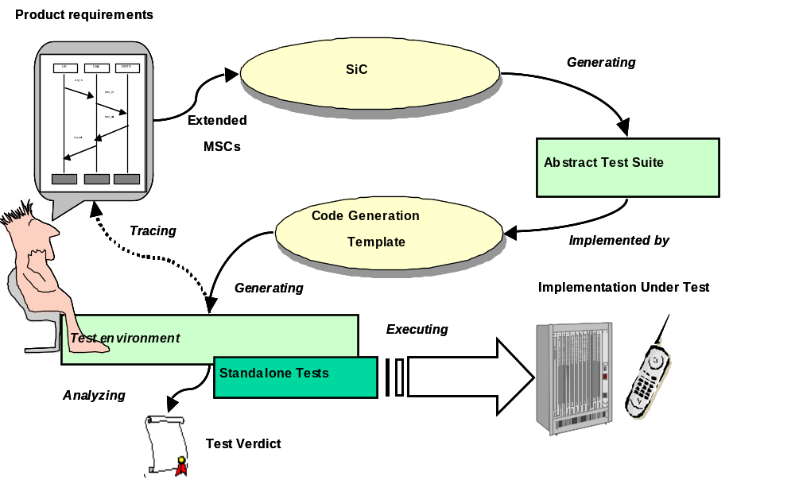
TAT is intended for black-box or grey-box conformance testing. General TAT approach is shown in Figure 1.

Figure 1. SiC paradigm
TAT allows getting tests on the early stages of program supply. Beginning from requirements analysis and projecting stage, tests can be developed, debugged and improved in parallel with program product realization (Figure 2).
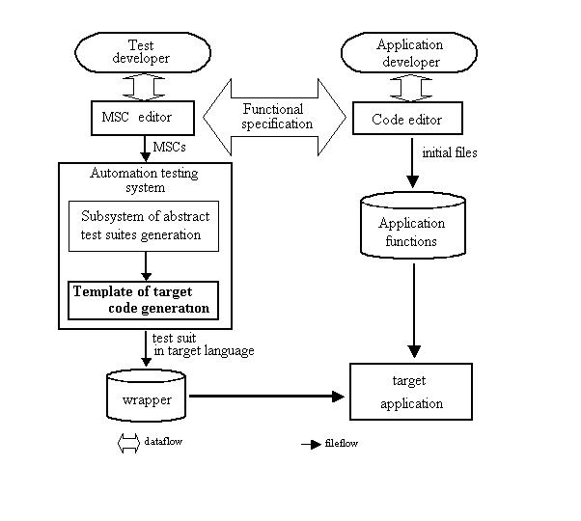
Figure 2. TAT technological process
Test developer creates tests scenarios, using MSC editor. Messages can correspond to functions and actions of real system, but sometimes it is not convenient. When testing low-level system, too detailed system calls are met. Program interface of such systems contains a lot of functions executing elementary actions. It is useful to combine several system calls (function calls) in one event (signal) on diagram. Such decision helps to get rid of extra capacity of diagram with trivial and spurious details.
Undoubtedly, compromise in the choice of abstract level conditions is necessary, when projecting test suite for correct system.
After that, test scenarios automatically are turned into abstract test suites in TCL, by means of TAT modules.
On the next step there is a need to use template of target code generation. It’s task is in transformation of abstract test suites from TCL to target code. Utilizing code generation template let pliant approach to automatic test suites creation, using TAT. On this stage it is necessary to correlate development and using template with MSC test suites scenarios design. There is the need in taking into account approach and detailed elaboration range that were accepted when designing program.
Finishing test suites creation, wrapper is to be developed. Its purpose is in coupling generated tests environment with target application. Principles of the step’s execution depends on intentions and decisions, which were taken when projecting MSC diagrams and tests’ environment target code generation template creation.
At that time, application developer realizes target application. Simple changing and additions to MSC diagrams realize modification and expansion of test suites.
  - SiC approach for requirements specification
SiC requirements consist of following parts:
- Behavior specification in MSC-PR form [Section 5]
- Object descriptions and Macro declarations in XML Configuration
- Target code generation templates
- Optional description of SDL process (requires Telelogic SDL Suite)

- Installing Silver Cartridge

This section describes required procedures and options to product installation.
  - Common requirements
For using SiC the system requires following tools to be installed:
- Tcl/Tk interpreter version 8.4 or higher (Tcl/Tk Pro recommended)
- Adobe Acrobat Reader 4.0 or higher
- SDT MSC-Editor
- Visual C 6.0 compiler or GNU C 2.8+ compiler
    - Optional requirements
- SDT SDL suite (TAU)
  - System prerequisites
Test Automation Toolset shall work on Sun Solaris 2.5.1 and Windows 2000 operating systems.
The following installation packages (distributions) of the product are provided:
- SiC binary distribution for Win32 common platform
- SiC binary distribution for Sun Solaris platform
  - Windows 2000
This section scopes an installation procedure targeted to Windows 2000 platform.
    - Introduction
It is strongly recommended to close all other programs and login with Administrator rights before installation. It helps to avoid access errors during shared files and system icons installation and updating system registry.
The full size of SiC installation file set is approximately 5.5 MB. To install the product it may be required up to 8 MB of hard disk space depending on the used installation type and file system.
It is not recommended to install SiC into the directory with spaces (like ‘Program Files’). Otherwise this may initiate problems with several versions of Tcl interpreter.
    - SiC installation procedure
To setup SiC on your hard drive:
- Insert the installation CD.
- Run setup.exe
- Follow prompts and instructions of the installation program
- Select directories
- Target directory is a directory for SiC components. It is C:\Motorola\SiC\ by default.
- After installation, verify the consistency of the package by means of comparing the real set of files and directories with the list in filelist.txt file.
Note
You may need to reboot your machine in order for SIC_PATH to be properly set as an environment variable.
    - SiC uninstallation procedure
To uninstall SiC:
- Use the ‘Silver Cartridge’ item of the ‘Add/Remove Programs’ module of the Windows Control Panel or corresponding icon in the SiC program folder.
- Delete the SiC root directory and all its subdirectories to delete data created during SiC usage.
    - SiC MSC Converter issues
MSC Converter module requires post.dll to be accessible from ‘PATH’ environment variable to invoke Telelogic Postmaster for MSC to MPR conversion. Generally, it is enough to add path to Telelogic binary files (usually C:\Telelogic\SDL_TTCN_4.3\bin\wini386).
  - Sun Solaris platform
This section scopes an installation procedure targeted to Sun Solaris host platform.
    - SiC installation procedure
To install SiC on Sun Solaris platform:
- Run
./sic.ins
from the command prompt.
- Select the Installation item from menu.
- Follow prompts and instructions of the installation program.
- Enter target installation directory or use the default path.
- The following text in the command line indicates the installation has been successfully completed
*****************************************************
* INSTALLATION SUCCESSFUL *
*****************************************************
- Make sure you have the following environment variable
SIC_PATH= <installation_directory>/tat-plus
in your startup script.
    - SiC uninstallation procedure
To uninstall SiC:
- Run
./sic.ins
from the command prompt.
- Select the UnInstallation item from menu.
- Follow prompts and instructions of the uninstallation program.
- Delete the SiC root directory and all its subdirectories to delete data created during SiC usage.
  - SiC contents after installation
After installation, the hard drive should contain the SiC root directory $SIC_PATH which will contain a set of files in the following subdirectories:
- bin/ - contains SiC binary executables
- cgtc/ - C code generation support files
- doc/ - contains SiC user’s manual
- examples/ - SiC demo example
- scripts/ - IDE scripts for SiC tools

- Developing MSCs for Silver Cartridge

This section outlines methodology, MSC syntax and extensions supported by tools of Silver Cartridge and gives information on how to develop tests for SiC.
  - Methodology
In this section a list of concepts embraced by Silver Cartridge and, also, those that differentiate it from other specification and programming techniques are presented.
    - Scope
Silver Cartridge is a system for translating MSC into optimized behavior tree or transition system. This translation can be controlled via special scripts where additional synchronization, the depth of non-determinism resolving, etc. can be specified. The result of this transformation is an Abstract Test Suite (ATS), which can be converted into code in target languages. For now, smart code generation templates included into SiC support the translation into ANSI C programming language.
    - What is verified?
- Behavior - sequence of messages to/from IUT, their parameters.
- Time specification (if supported by the tested system). The conformance of time specification of every event to its MSC specification.
- Variables - special code can be generated to check values of variables.
    - Execution environment integration
The basis for the integration with the execution environment is an abstract test suite (ATS). ATS is processed with special smart code generation templates, which transform it into the target code. A code generation template is a library with the implemented ATS primitives.
This code adaptation allows code generation for embedded and real-time applications; code generation for matching protocols and test logs against an MSC specification can also be handled in this way.
    - Processing non-deterministic features of MSC
An MSC embodies a set of communicating processes in which the precise ordering of events, such as passing of messages may occur non-deterministically. Therefore, a single MSC may represent more than one sequence of events. Hence, the challenge in generating test scripts from an MSC is to determine all possible sequences of events and construct scripts that accommodate each possible sequence.
The semantic of an example MSC in Figure 3 shows that the consumption of two messages A and B from model can occur in any order, then the generated test suite must accept the messages in either of the two possible orders. Conversely, if an MSC says that messages may be sent in any order to the model, then we have to generate one test script per a permissible order. Thus the key to test script generation is to semantically evaluate an MSC, i.e. determine all possible sequences of events.
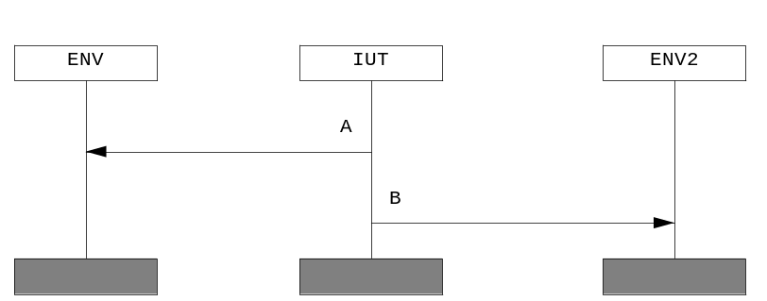
Figure 3. Example of asynchronous behavior
    - MSC structural enhancements used in SiC
There are structural extensions to MSC, which enhance capability of tests, improve performance, reduce test development time and make MSC more intuitively understandable.
MSC structural enhancements involve the following items:
- Structural enhancements:
- loops with counter variables (5.12.4)
- conditional and synchronous/asynchronous events (5.8.2)
- support of optional and ‘don’t care’ values (5.8)
- Timing extensions (5.6)
- Time specification of MSC events
- start time
- duration (or time of propagation)
- Time labels
- Time calculation
- Macro extensions
- Macro constants and combinatorial specifications
- Macro functions
- Parameterized references (5.11)
Start time, synchronization and conditional events can be applied to any element of MSC including condition and reference. MSC text and action should not have such specification since they are meaningless.
  - Macro preprocessing
In SiC macro extensions are substitutions of special terms with defined values, which changes by defined rules for each pass. Macro substitution is an effective way to work out constant message parameter constraints of MSC.
Using macro helps to specify the data flow, describe possible test cases and transform MSC structure. The result of macro substitution is the standard MSC (MSC’2000). Basically, this feature can significantly increase the number and the coverage of test cases. Refer to Section [6.3] for information on how to develop and declare macros.
In SiC, a macro is an instance (a string), which shall be substituted with text. Every macro shall conform to the following rules:
- Must be identified by a ‘#’ preceding the macro name. For example ‘#A’.
- Can have parameters which may be used for the macro implementation (substitution)
- Implementation of macro is a C programming language function that receives strings as parameters, transforms them in some way and returns the value in a string form. The implementation of these functions is the user’s responsibility and they are not verified.
- Macro may be used in message parameters, message names, instance names, time specifications and in every informal text.
  - MSC syntax considerations
Refer to [A.5] for extended syntax of MSC constructs.
  - MSC Data types
Another important part of the toolset is its support of target language types. It means that SiC can accommodate mappings from other languages. The following data types of C programming language can be considered as an example: int, float, char*, enums, etc. Complex data types, such as arrays and structures are also allowed, but shall be specially processed in code generation templates.
  - MSC Expressions
Extensions to MSC syntax allow using expressions in signal parameters, conditions, and other MSC constructs. It is possible to use standard functions of the target programming language. In Figure 4, the example of using expressions for C programming language is illustrated.
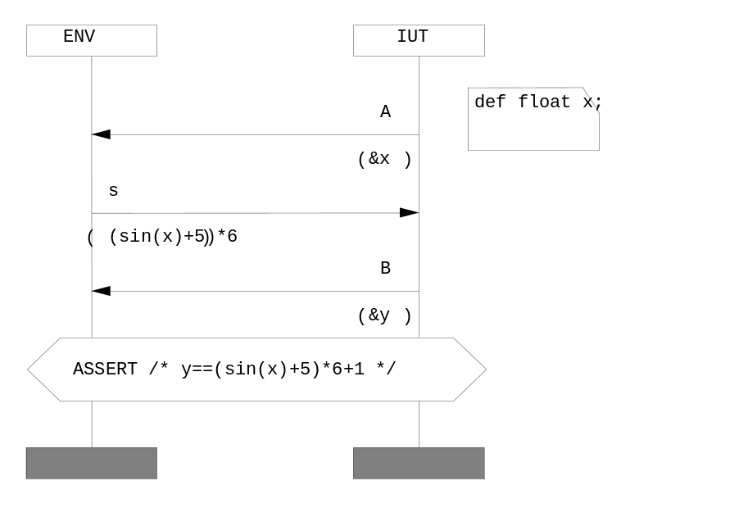
Figure 4. Using target language expressions in MSC

  - Time supervision
Time can be specified as parameters of MSC transactions and can be one of the following:
relative
Time expression is relative to the preceding event on the instance axis, e.g. {1..2}. This means that the event occurs 1 to 2 clocks after the preceding event on this instance. In Figure 5 message B shall be sent after 1 or 2 clocks after receiving message A.
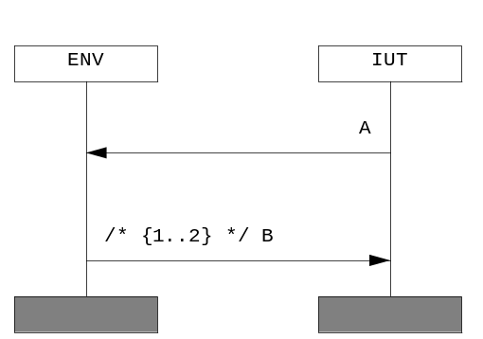
Figure 5. Relative time specification
  - absolute
Time is specified relatively to the starting point of MSC, e.g. {@1..3}. This means that an event occurs 1 to 3 clocks after the MSC start.
  - labeled
The specification of time is relative to the previously marked (labeled) event, e.g. {@NAME+2..4}.
By default, relative specification of time is assumed for every event in an MSC - {0..INF} and the default duration is {0..0}. INF is a special symbol which means infinity.
Also, an interval time is always used, e.g. in case of {@A} an interval {@A + 0..INF} is assumed.
Time can be applied to almost any object. The calculation of time can be dynamic or static, i.e. time specifications can be either taken into account or not during MSC processing phase. Partial order processing also depends on time specification of events. Time constraints can specify additional ordering for events within parallel expressions and conditions. In Figure 6 time when message A is consumed by instance ENV is stored in time label A_TIME. Message C is using this time label for determination of moment when it shall be sent.
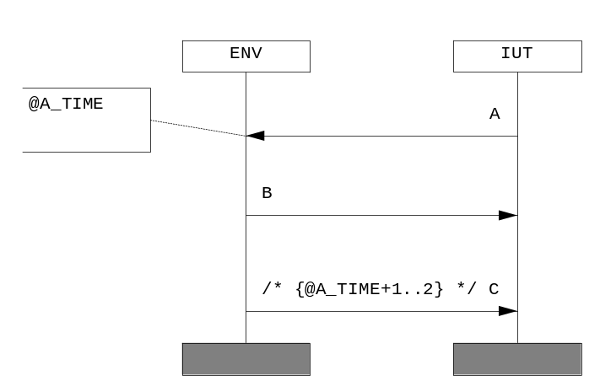
Figure 6. Labeled time specification
    - Using time labels in MSC
It is possible to specify time labels in comments and then use them in time expressions (Figure 7).

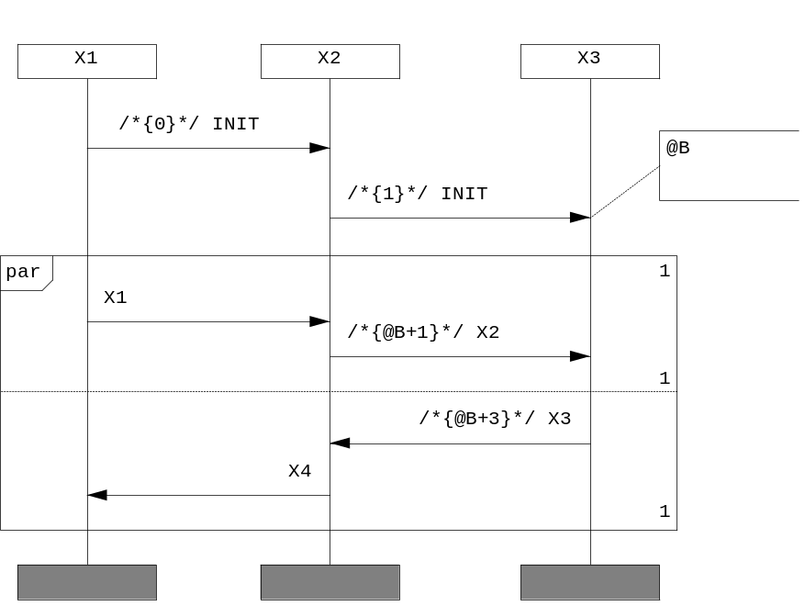
Figure 7. Time labels in MSC
An additional constraint is specified – X2 will be earlier than X3.
  - Using time specification with MSC instances
Generally, an instance (to be more precise - an instance head) identifies the beginning of a timeline for an entity in the communicating scenario. In SiC we support time relatives as illustrated in Figure 8.These relatives define the relation of time between MSC instances and are taken into account during the calculation of time.
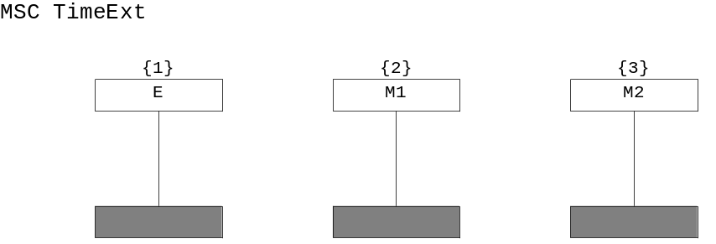
Figure 8. Time relatives for MSC instances
In MSC-PR, for specifying time a comment field is used.
Refer to [A.5] for extended syntax description.
  - MSC message
SiC introduces several extensions to MSC message definition of MSC’2000 standard [1]. With SiC an MSC message can be specified with several additional constructs (see Figure 9):
- synchronous/asynchronous specification
- a condition of existence
- start time (as a time interval)
- duration (as a time interval)
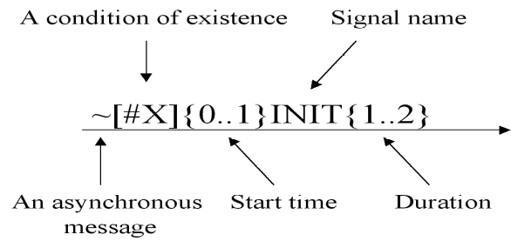
Figure 9. Example MSC message with additional constructs

For additional compatibility with MSC Editors (in particular, TAU), the additional message fields can be specified in /* */ comments, e.g.:
/*~[#X]{0..1}*/INIT/*{0..1}*/
Refer to [A.5] for extended syntax description of MSC message.
    - Message synchronization
SiC incorporates synchronous as well as asynchronous communication constraints.
Consider the example MSC in Figure 10. Originally, rules for the events are: 1<2, 3<4, 1<4 and thus the following order of events is allowed 3 -> 1 -> 2 -> 4.
But, in case an IUT reacts on out events only, X2 shall be relatively earlier than X1 which can be undesirable. In case X2 is synchronized (i.e. used with ‘~’ prefix - ~X2) the following set of pairs is obtained: 1<2, 3<4, 1<4 and 1<3. The order 3->1->2->4 is unrealizable and X1 shall be earlier than X2.
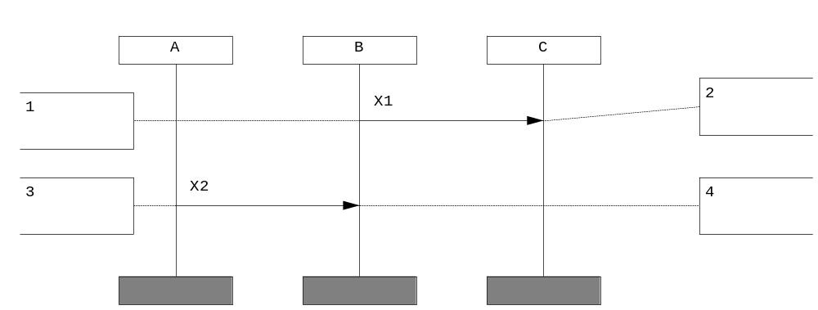
Figure 10. Message synchronization - example MSC
    - Messages with conditions of existence
An MSC message can be used with a condition of existence specified in brackets. An expression is calculated and if the result equals to ‘0’ then this event shall be ignored by SiC MSC processing utility.
Consider Figure 9 as an example: if #X takes on a value of ‘0’, a message on the corresponding MSC is removed.
Such a technique helps to remove redundant elements from the initial chart. Conditions of existence specified via event name are distorted in the same way as time. Conditions can be used both in static and dynamic situations. In dynamics conditions can be calculated via variables and expressions.
The conditional expression can be calculated both statically and dynamically. If it cannot be calculated in the MSC processing phase (i.e. dynamically) it shall appear in ATS (and consequently in target code) as a condition of message existence. Condition of existence is compact notation for MSC’2000 guarding conditions. In Figure 11 it is shown how to express condition of existence in standard MSC’2000.
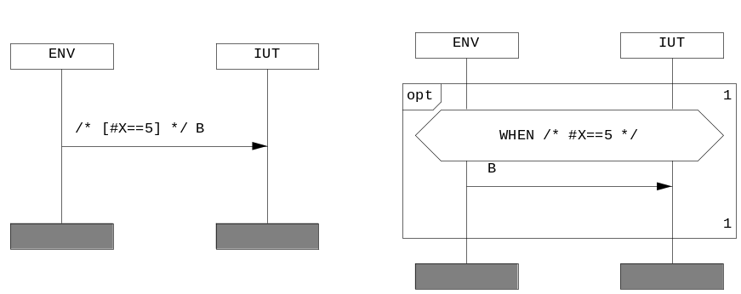
Figure 11. Condition of existence in MSC’2000
    - Time specification of messages
Time referencing in SiC gives the ability to associate messages (and other MSC events also) with time. The following fields can be used when specifying message time:
- start time
For example, the specification {0..1} indicates that the message shall be transmitted between 0 and 1 time units.
- duration (or time of propagation)
Formally, the time of message propagation can be associated with the delay between a message output and its consumption.
Note, that the duration field should contain relative time expressions only (not absolute or labeled).
There are several ways of specifying time of MSC events in SiC. For the detailed information refer to section 5.6 and 5.7 of this document.
    - Pattern matching mechanism of messages
Pattern matching mechanisms supported by SiC are extremely useful for specification of ‘don’t care’ and optional values.
SiC offers the following additional possibilities for specifying parameters of messages:
- optional values of parameters.
In Figure 12, valid values of parameters are 2 or 6 or and the value of (x+3), where x can be a declared variable.

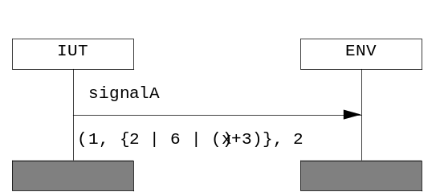
Figure 12. Example MSC parameter alternative
- ‘don’t care’ values
In Figure 13, the second and the last parameter are omitted and thus shall not be verified.

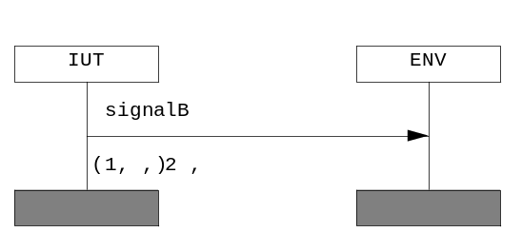
Figure 13. ‘Don’t care’ message parameters in MSC
Omitted parameters as well as optional parameters can be used only in case a signal is directed to instances which are associated with testing environment.
Using incomplete message specification in MSC
A message within an MSC is a relation between an output and an input. The output may come from either the environment (through a gate) or an instance, and an input is to either the environment (a gate) or an instance.
An incomplete message occurs if either the output or the input is lost and is represented by only one event.
- In SiC, a lost/found instance is handled as test environment.
Instances lost and found as well as incomplete messages shall not be used if a corresponding instance is of type vmodel or monitor.
  - Using MSC variables
SiC supports a notion of variables defined in MSC. Variables can be used in MSC actions, conditions and message parameters.
The following actions shall be performed by testing environment, upon signal transmission, as it is illustrated on Figure 14:
- S1 - the value of variables and expressions shall be evaluated.
- R1 - the value of the first parameter shall be compare against x, the value of the second parameter against x+y, the value of the third parameter against 1.
- R2
- the value of the first parameter shall be stored in x;
- the value of the second parameter shall be assigned to y only in case the parameter equals to 1;
- the value of the third parameter shall be assigned to z only in case the parameter is equal either to 0, 1, the current value of x or y.
Signals R3 and R4 scope some other possible application of variables and optional expressions.

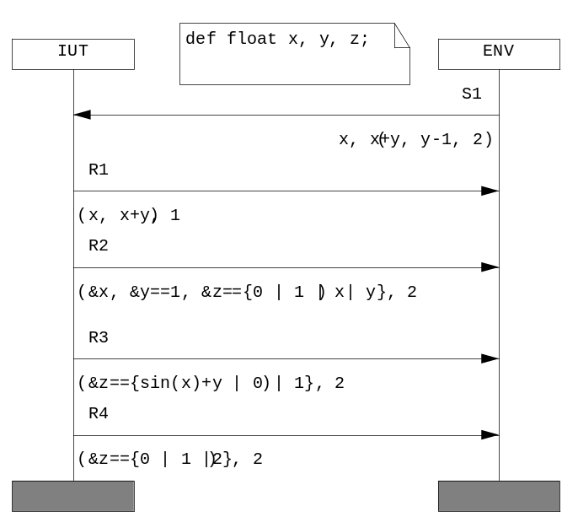
Figure 14. Using variables in MSC
  - MSC timers
Timers are used for specifying time of MSC events. There is also a special type of timers for specifying time intervals, e.g. the example timer indicates that an interval between two events is between 1 and 2 time units. When a timer is set up, the current time value is stored in a variable; the relation is verified when a timeout occurs.
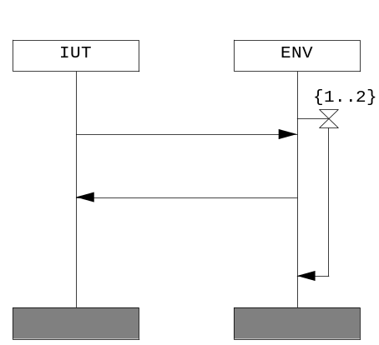
Figure 15. Example timer with an interval
  - References with parameters
MSC references are supported by SiC. The reference name used must be the same as the MSC name that is being referenced, which must also correspond to the filename of the referenced MSC.
Macro Processor supports in-lining of references, i.e. all references are replaced with the events from the referenced MSC. In the case, if Macro Processor has not been employed to process in-lined MSC references, for instance, the Abstract Test Generator utility will not perform in-lining and will merely generate a corresponding test script routine.
The restriction with references is that references cannot form an infinite recursion, e.g. if A refers to B, then B cannot refer to A.
One of the basic enhancements of SiC is that it supports parameterized references; the use of parameters should be contained within comment symbols ‘/*’ and ‘*/’ (Figure 16);
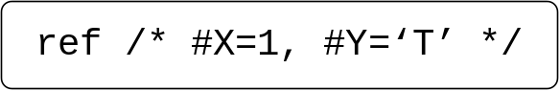
Figure 16. Example of parameterized reference

When the reference ref will be called, all occurrences of #X shall be substituted with ‘1’ and all occurrences of #Y shall be replaced with ‘T’. The value of a macro can be another macro or constant, for example #X=#Y means that the variable #X will be assigned to the current value of #Y within the referenced diagram.
The name of a macro is never processed and substituted. At this point, #X=#F (#X) and #X=#X are valid expressions. The first expression means that within the referenced diagram #X will be equal to #F (#X) calculated in the current value space.
Parameterized reference substitution is a slightly modified version of subst specification in the reference event. Subst is very useful – it helps making procedures in high-level languages within MSC. This feature increases the reuse of diagrams and introduces a different approach to behavior specification.
The MSC Editor of Telelogic Tau 4.1 doesn’t support a subst keyword. This extension uses syntax, which is similar to macro, for example (as in MSC-PR):
Reference INIT_SYSTEM /* #X=1, #Y=2, #Z=#FI(#INIT_MODE) */
This means that the INIT_SYSTEM MSC should be included into a higher level MSC with all occurrences of #X substituted with ‘1’, #Y with ‘2’ and #Z with calculated expression.
Note
You may also use empty macro values, e.g.
ref /* #X= */
In this case a macro shall be substituted with an empty string.
  - MSC inline expressions
MSC Inline expressions are a method of structuring events on instances to allow more complex behaviors to be expressed. It includes alternative and parallel composition, iterations and exceptional or optional regions.
Inline expressions can be nested inside other inline expressions. Alternative and parallel expressions can have multiple regions, which can also have nested inline expressions.
Inline expressions are drawn using the TAU toolset. The operator of the expression is placed in the top left-hand corner. The valid operators are alt, par, opt, loop and exc (they are described below). The seq operator is not a valid inline expression operator. The optional arguments for the loop operator are also placed in the top left-hand corner, following the loop operator keyword.
The operands are drawn inside the inline expression box and can include all valid MSC constructs, including MSC references and nested inline expressions. The multiple operands of the alt and par operators are delineated using inline expression separators (dotted lines).
    - Alternative: ALT
The alt operator is used to define a series of alternative executions of the MSC. An empty region within an alt operator can be used to express the fact that, either, some events occur (these would be expressed in other regions of the alt) or no events occur (from the empty region). For clarity, the opt (see 5.12.3), operator should be used instead. If an alt has only one alternative then this means that the alternative must be chosen, and therefore the alt inline box has no effect.
    - Parallel: PAR
The par operator defines a series of groups of events that occur in parallel. There will be one series of test cases created which will have the parallel nature of the events expressed inside them. An empty region, while not ignored by SiC, serves no real purpose and does not add any extra meaning to an MSC; every event occurs in parallel with nothing any way. All regions of the par are executed, with no regions being ignored.
    - Optional: OPT
The opt operator is the same as alt operator with two regions where the second region, the alternative part, is always empty. This means that the specified events either happen or they do not happen. An empty region within the opt expression specifies nothing, as either nothing happens, or nothing happens.
    - Loops: LOOP
The loop operator allows a group of events to be repeated many times within the same execution. The number of iterations is dependent on the values of two parameters that can be supplied to the expression (Figure 17).
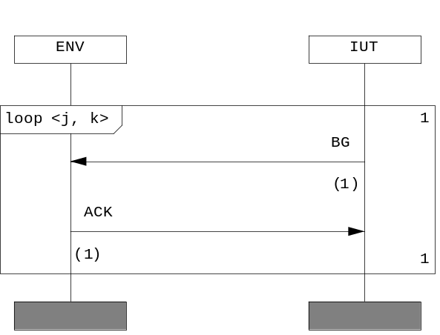
Figure 17. Example loop
- if first parameter of a loop starts with ‘$’ symbol it is treated as a loop counter
- the loop is unrolled the specified number of times and message parameters which contain loop counter shall be changed.
There is a special keyword INF which can be used as a second parameter of and means infinity, i.e. the loop will be repeated an indefinite number of times.
There are two ways of loop specification:
- specifying loop with two parameters and in this case a loop body shall be repeated the number of times varying from first to second parameter, e.g.:
loop<2,5>
using only one parameter - the loop shall be unrolled the specified number of times, e.g.:
loop <n>
Note, that the usage of variables is precluded in constant loop statements.
Note that INF keyword shall be used as a second parameter only and in this case the first parameter shall be a constant expression, but not a loop counter variable.
For example, Figure 17 illustrates the original specification and the expanded result compatible with MSC’96 [1] and Telelogic Tau toolset. The loop is unrolled the specified number of times and the message parameters which contain the loop counter will be changed.
In SiC, MSC conditions can also be used for specifying ‘while’ loops – ( 5.13.3).
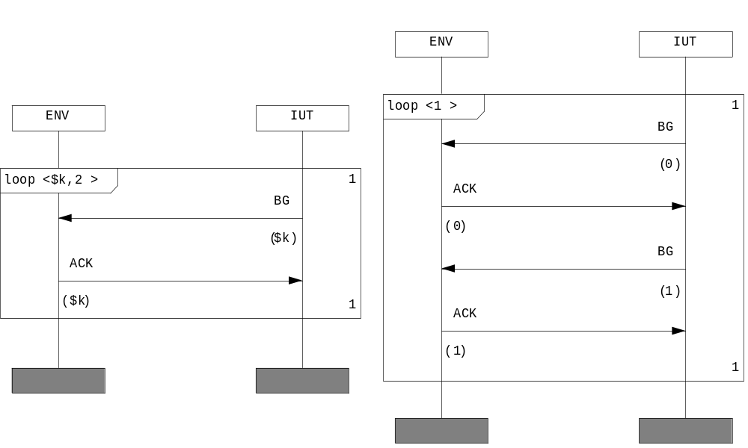
Figure 18. The original MSC (left) and the MSC with unrolled loops
    - Exception : EXC
The exc operator is a way to describe exceptional cases in an MSC. It describes an alt operator where one argument is the rest of the MSC and the other is the series of events that should happen when the exception occurs. This means that either the exception is raised or the rest of the MSC occurs as usual. MSCs on Figure 19 are identical.
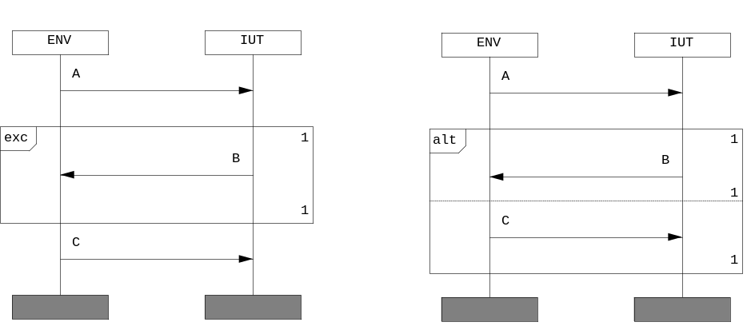
Figure 19. EXC inline expression meaning
    - Handling of multivariant behavior
Comments for inline expressions started with ‘$’ specify the number of traces per inner part. In Figure 20 the number of traces to be generated is restricted by 2.
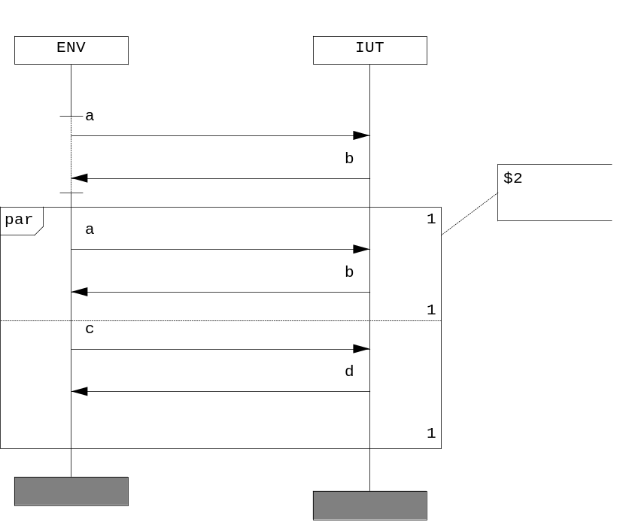
Figure 20. Restricting the number of traces in MSC operators
  - MSC Conditions
A condition describes either a global system state (global condition) referring to all instances contained in the MSC or a state referring to a subset of instances (non-global condition). In the second case the condition may be local, i.e. attached to just one instance.
In SiC a condition can be used either as
- a synchronization point
- as an ‘if’ statement (5.13.1)
- as an assertion (5.13.2)
- as a ‘while’ loop statement (5.13.3)
    - Using conditions as ‘if’ statements
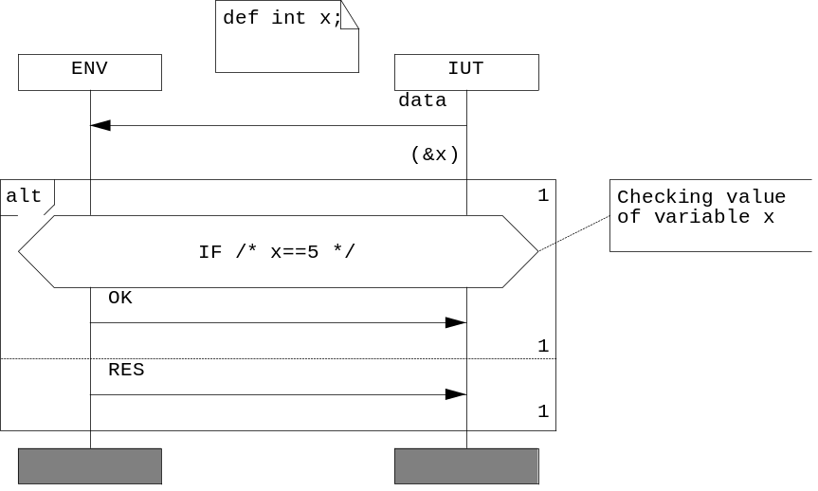
Figure 21. Using conditions as ‘if’ statements
In the example on Figure 21, if the expression x==5 is true, statement, which is the OK signal transmission, is executed. An expression of ‘if’ statement shall be in the target language syntax. These expressions are dumped to code unchanged, except for variables, which may be substituted.
    - Using conditions as assertions
An assertion evaluates an expression and when the result is FALSE, aborts the test case execution.
In Figure 22 an example assertion is illustrated.
Figure 22. Example asserting condition
    - Using conditions as ‘while’ loop statements
Using while statement in a condition that follows a loop lets you repeat a statement until a specified expression becomes false (see example in Figure 23).
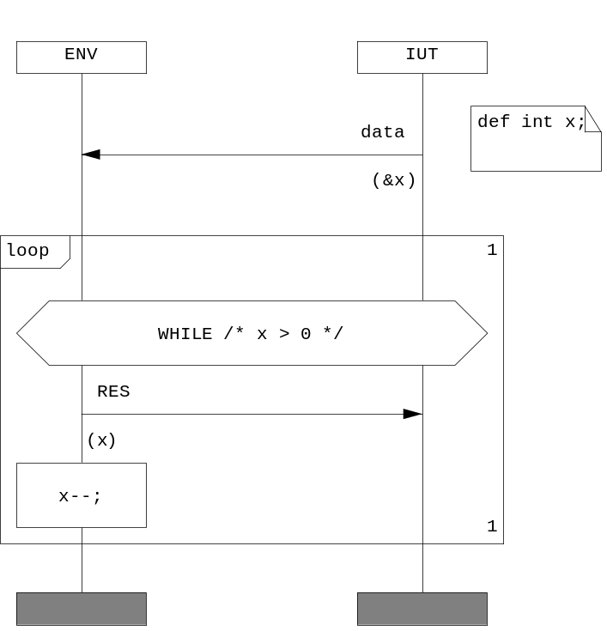
Figure 23. Using conditions as a ‘while’ iteration statement
  - MSC Actions
Using MSC action allows generating user-defined text (code) specified in the Action box in MSC.
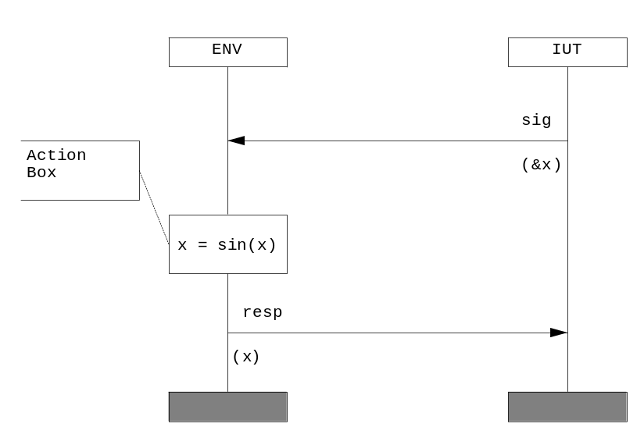
Figure 24. Example of Action event
  - MSC Coregions
A coregion is introduced for the specification of unordered events on an instance. Such a coregion in particular covers the practically important case of two or more incoming messages where the ordering of consumption may be interchanged.

- Specification Files

This section introduces specifications files utilized by SiC.
  - IUT definition
Main input file for Test Automation Toolset is MSC-PR file which is a textual representation of graphical MSC diagrams. It also uses other files which describe signals, instances and system description in SDL.
  - MSC-PR files description
SiC recognizes and correctly processes mpr-files generated by Telelogic MSC editor. It supports features of MSC’2000 ITU z.120 [1] standard supported by Telelogic MSC editor. Special extensions introduced for time handling, macro processing, etc. [5.1.5]. Grammar for extensions to the standard described in A.5.
    - Binary and text forms of MSCs
MSCs can be represented both in binary - (MSC-GR - *.msc extension) or text form (MSC-PR - *.mpr).
Binary form saves layout of elements, thus allowing the user to view extended specifications - time, conditions, etc. Text form is used by SiC and other external tools since it supports standard [1].
TAU MSCE allows loading both, but may skip extended specifications in text form (MSC-PR).
      - Translation from binary form to text
There are at least two ways of translating MSCs in binary form to text
- Using MSC Converter utility of SiC (Section 14)
- Using serverpc TAU utility. Consider the example below
serverpc 7000 7005 GRName.msc PRName.mpr MSCDiagramName 0
Serverpc is a the Service Encapsulation application that enables access to Telelogic Tau tools services from the operating system command line prompt. In the above example command line, you are using MSC Editor (7000), asking for the Service MSCGRPR(7005) and transforming MSC-GR (GRName.msc) into MSC-PR (PRName.mpr). The name of MSC-PR file will be MSCDiagramName and 0 disables the generation of references.
  - Developing macro definition file
This section gives information on how to develop macro definition file.
    - Developing C functions for macro definitions used
Each function shall have the following prototype:
int <function_name> (int argc, char *argv[], char *dest);
The function shall return the value in dest parameter. It shall return 1, if success, and 0 otherwise.
Macro declaration:
<?xml version="1.0" encoding="utf-8" ?>
<TATPROJECT name="x" version="1" info="" leader="" title="" user="">
<CONFIG name="default" base="" comment="">
<MACROS>
<MACRO name="#DEVNUM" type="list" vector="" replace="replace" datatype="number">
<VALUELIST condition="" >
<VALUE value="1" />
<VALUE value="4" />
<VALUE value="7" />
</VALUELIST>
</MACRO>
<MACRO name="#DEVNUMx" type="derive" vector="" replace="replace" datatype="undefined">
<ATTRIBUTE value="dec1"/>
<VALUELIST condition="" >
<VALUE value="#DEVNUM"/>
</VALUELIST>
</MACRO>
</MACROS>
</CONFIG>
</TATPROJECT>
It’s C function implementation:
int dec1( int argc, char *argv[], char *dest)
{
sprintf(dest,"%u",atoi(argv[0])-1);
return 1;
}
With the above function, the value of #DEVNUM macro shall be decremented and assigned to #DEVNUMx.
    - Relations between instances of different instance tags
Table 2 illustrates actions that shall be performed with signals directed to/from instances of various instance tags allowed in SiC.
Table 2: Actions performed on signals directed
between instances with different tags
Source instance type | Destination instance type
Source instance type | MODEL | ENV | MONITOR | VMODEL | IGNORE
MODEL | BREAK | RECV | EXIST | EXIST | EMPTY
ENV | SEND | BREAK | EXIST | SEND | EMPTY
MONITOR | SEND | RECV | EXIST | SEND | EMPTY
VMODEL | EXIST | RECV | EXIST | EXIST | EMPTY
IGNORE | EMPTY | EMPTY | EMPTY | EMPTY | EMPTY

The keywords in the table are:
- BREAK - a signal shall be ignored or the generation shall be halted with an error
- SEND - a signal shall be transmitted to the destination instance
- EXIST - a signal shall be checked for existence
- RECV - a signal shall be consumed by the destination instance
- EMPTY - a signal’s code implementation shall not be generated

- Using Silver Cartridge

This section outlines the main blocks and scenarios of SiC usage.
  - Concepts
This section presents some of the concepts that make up the Test Automation Toolset.
Generally, the usage of SiC involves several steps, as it is shown in Figure 25.
- Specifying test scenario in the formal language of MSC
- Providing additional data specification
- Universal Test script (ATS) is generated
- Target code generated and executed
- Test verdict obtained
The generated test cases are essentially black-box tests which communicate with the system under test via specially developed module - wrapper (Section 18). This module should be developed by user.
We define black-box tests where stimulus and observe response are compared with expected responses in order to derive a test verdict.
Generated test suites of SiC are represented by modules that can be parameterized depending on Smart Code Generation Templates’ configuration (Section 17) and also by tools that incorporate the toolset. Modules can also contain a control part, which allows the user to specify test case selection algorithms.

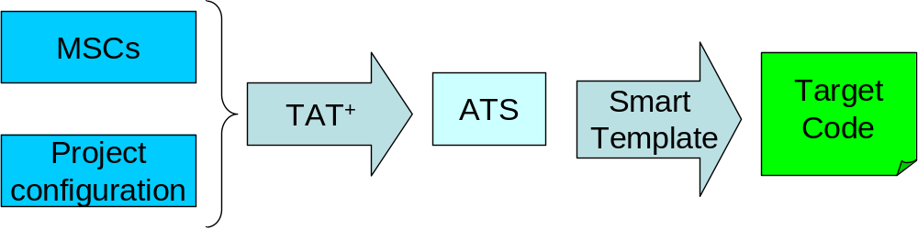
Figure 25. General scheme of SiC usage
  - Test development overview
In order to develop tests follow the following logical sequence:
- Identify all objects involved in testing and testing control. For example: Environment, Device1 and Device2, where the inputs are received from Environment and interaction of Environment and Devices can be controlled. You shall specify which instances represent the test environment and which belong to the tested application - IUT. By splitting the tested application into several instances you can handle parallel nature of tests and make the specification more intuitively understandable.
- Identify all messages and their parameters between objects. You can use both MSC constructs supported by MSC standard [1] and some powerful extensions to this standard introduced by SiC (5.1.5).
- Specify data you need for input, define macros (5.2)
- You may identify common parts of test cases and parameterize those using references and macro.
- If needed, use one of following tools:
- Macro Processor (Section 10) for macro processing,
- MSC Linker (Section 12) for concatenating MSCs,
- Trace Generator (Section 11) for processing non-determinism,
- MSC Transformer (Section 13) for adjusting your MSCs to TAU MSCE,
- MSC Converter (Section 14) for analyzing MSC dependencies and converting graphical representation of MSCs - MSC-GR to MSC-PR
- Select test case paradigm - active or passive (17.6). Develop your own code generation template if needed.
- Develop adapter (wrapper) which shall bind a test case and the tested application (Section 18).
Note that there are a number of command line and configuration options of SiC components. These options can be considered as annotations that allow the user to specify useful details of a particular constraint, for example, how a message type shall be encoded or decoded.
Other important characteristic of SiC is that it contains most of the familiar programming constructs like loops, while, if-then-else constructs seen in other programming languages and techniques.
SiC has a defined operational semantics and, finally, its solution has embraced different specification domains through its clear and enhanced presentation format.
Even though it is anticipated that most users will use graphical format for developing and maintaining MSCs, two formats have been defined - graphical and textual (phrasal) representations of MSC - MSC-GR and MSC-PR accordingly. The binary components of SiC utilize MSC-PR; however, a graphical representation can be converted into phrasal and vice versa using MSC Converter of SiC or any other standard tool, for example, serverpc utility of Telelogic Toolset.
The graphical presentation format is based upon the international standard for MSC'2000.
The graphical format, as well as the textual format of MSCs used in SiC encompasses the subset of the MSC language defining many syntactical extensions that are needed for the purpose of test specification.
  - SiC organization
The system structure and data dependencies are shown in :
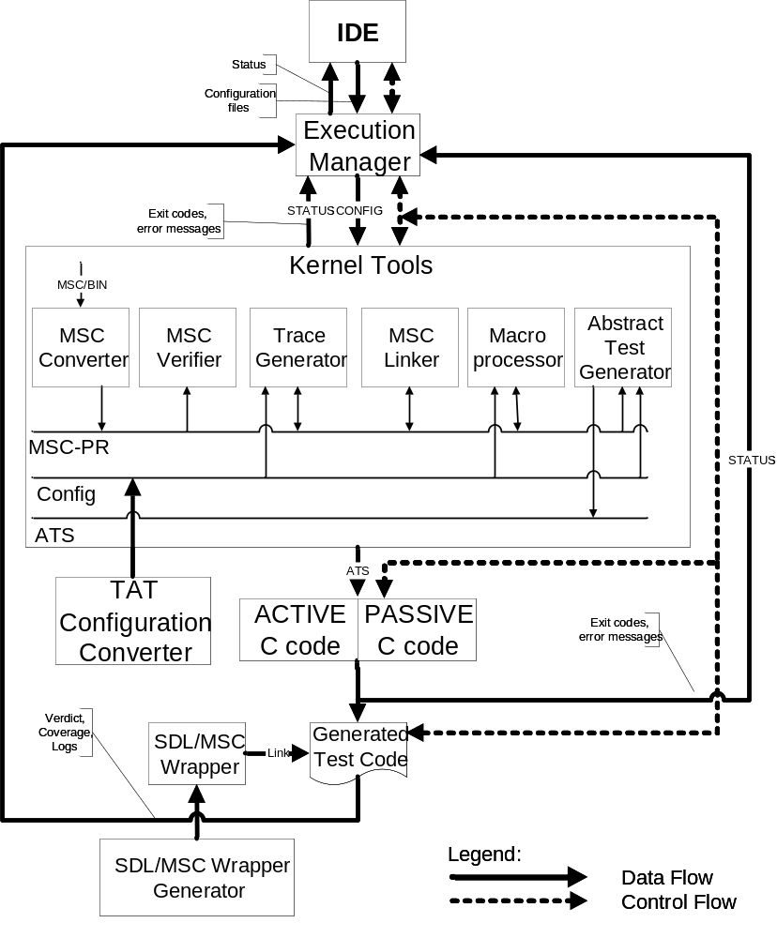
Figure 26. Dataflow diagram for SiC
  - Components
SiC falls into the following 10 executable blocks as shown in Table 3:
Table 3: Executable components of SiC
Component/  Utility | File and location | Description
IDE | bin/sic(.exe) | Integrated Development Environment. This utility offers a graphical interface to SiC configuration development and execution of tests.
Macro MSC Processor | bin/macroprc(.exe) | macroMSC preprocessor. This block accepts macroMSCs as an input processes them and outputs plain MSC-PRs with substituted macros.
MSC Converter | bin/mscdepd(.exe) | MSC Converter. Performs preliminary MSC analysis and converts MSC-GR into MSC-PR and vice-versa.
MSC Linker | bin/msclink(.exe) | MSC Linker. Sequentially concatenates MSC diagrams into a single one.
MSC Transformer | bin/mscjust(.exe) | MSC Transformer is intended for converting MSCs into TAU-friendly form.
Trace Generator | bin/tracegen(.exe) | MSC Expander processes and expands non-deterministic properties of MSCs
Abstract Test Generator | bin/atsgen(.exe) | ATS test generator.
CGTC | bin/cgtc.tcl | Smart C-code generation Template.
SDL/MSC Wrapper | bin/sdlmsc(.exe) | Generation of SDL to C wrapper. Allow integration of Telelogic SDL generated C code with SiC.

The above components allow producing standalone tests via various technology chains. These technology chains can be tailored and customized to solve particular problems of various domains. However, some of these modules can be used not only as a part of SiC, but also separately, in order to meet various requirements and provide more flexibility to the user.
SiC tools extract parameters from command line and display an error message if incorrect command line parameters have been passed.
SiC generates ATS in Tcl language and involves smart language code generation template for C code generation: CGTC(Section 17).

- Integrated Development Environment

This section describes the functionality of Integrated Development Environment
  - Silver Cartridge at start-up
When you first start Silver Cartridge, its main window appears, as shown on Figure 27.
The main window is divided into three parts – the project browser (left one), the properties pane (right one), the console window (bottom one). The project browser shows all project elements and allows the user to select them. The properties pane shows all attributes of the selected project element and allows the user to edit them. It also contains command buttons allowing the user to add, delete or rearrange project elements. The console window displays messages generated by TAT tools during project building or execution.
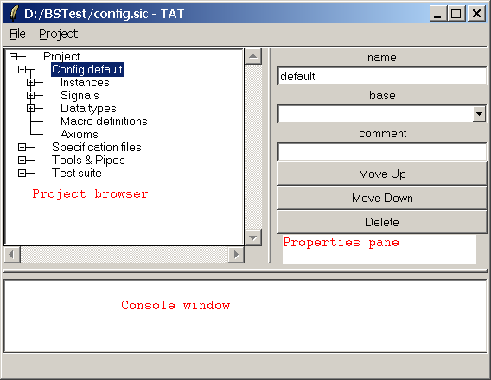
Figure 27. TAT window structure.
  - Project organization
In the Project Browser, you can view the hierarchy of the data being edited. You may add, delete or perform specific operation on the object by selecting it and clicking one of the buttons in the Properties Pane.
A TAT project usually contains the following sections:
- The ‘Config’ section defines a TAT configuration used by TAT tools (instances, signals, macros, etc.). There may be several TAT configurations in a project.
- The ‘Specification Files’ section enables you to add MSC specification files, arranged into file sets.
- The ‘Tools & Pipes’ section allows you to add and configure TAT binaries as well as third-party tools in scope of the current project. The introduced mechanism of ‘pipes’ (similar to the one of UNIX) provides one with the ability to arrange defined tools into a pipe, which might be thought of as a chain of tools executed with inputs and outputs connected to each other.
- Once the project ‘pipes’ have been configured, the ‘Test Suite’ section provides you with the ability to launch pipes with the desired inputs, automatically trace the execution and analyze testing results.
  - Creating a new project
Create a new project using the ‘New’ command from the main menu as shown on Figure 28.
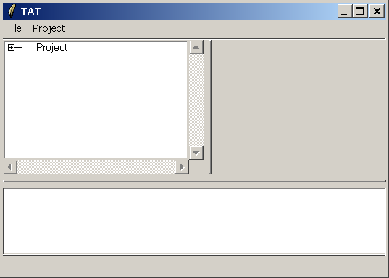
Figure 28. Creating a new project
  - Adding input specification files to the project: ‘Files’ section
Develop input MSC files (along with the SDL files, if necessary) with your favorite MSC editor. The comprehensive guide to creating an efficient test description is given in ‘SiC User’s reference’, ‘Developing MSCs’ section.
Select the <Specification Files> tag and click “Add File Set” button in properties page. Select the newly created file set and click “Add Files”. In the file browser, select files to add.
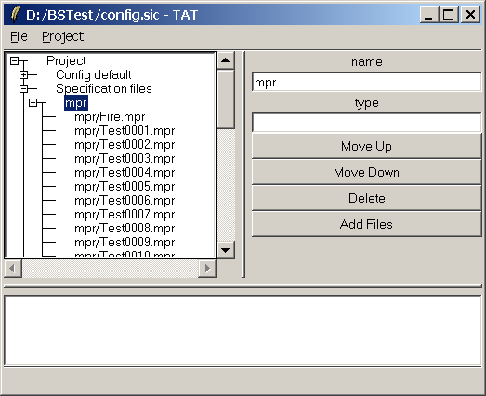
Figure 29. Working with the ‘Specification Files’ section
Note: You may also skip this step and explicitly use filename locations when stating them as an input for a linked tool (see the “Tools & Pipes” section of this document).
  - Developing an MSC configuration: ‘Config’ sections
The ‘Config’ sections define various components of the system being tested, such as instances, signals and their parameters, data types and the macro definitions.
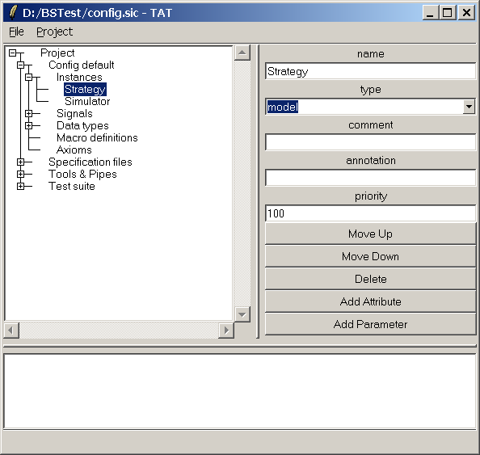
Figure 30. Describing MSC constructs

In the example in Figure 30, the selected instance is described as ‘Strategy’, an object associated with the system being tested.
Having been defined, an MSC configuration is used by the SiC tools for generating test scripts and target code.
  - Annotating MSC instances
In Silver Cartridge, an instance might be described with the following fields:
Table 4: Fields and tags used for annotating MSC instances
Name | Description
Name | An instance name as appears on the MSC
Type | An associated type of an instance. The following instance types are supported:  - env – an instance is associated with the testing environment. Messages, directed to an instance of the type shall be verified as messages to the test.  - model – an instance is thought of as an IUT object (Implementation or a system under test).  - vmodel – a viewable model  - monitor – a monitoring instance  - ignore –all events for an instance of this type shall be ignored
Annotation* | A specific algebraic annotation to an instance utilized by the SiC Verifier of Requirements Specifications.
Comment * | User’s comment to an instance definition
Priority * | The priority field shall be taken into account while handling of message order for the generation of test traces. Defaults to 100.
The following tags can be nested within INSTANCE:
ATTRIBUTE* | Specify additional attributes for instance, which may be used by code generation templates. CGTC specific information is described in the appropriate chapter of SiC User’s Manual.
PARAMETER * | Specify types of parameters for instance creation. Each instance creation statement is checked against this specification. The description is similar to the one of signals.
*- optional
  - Describing MSC signals
Table 5 outlines the data fields a signal can be annotated with.
Table 5: Fields and tags used for annotating MSC signals
Name | Description
Name | A signal name as appears on the MSC diagram
Type | An associated type of a signal. The following signal types are supported:  - in – specify signal as input signal for IUT.  - out – specify signal as output signal for IUT.  - inout – bi-directional signal.  - ignore – specify an ignored signals.
Annotation* | An additional algebraic annotation utilized by the SiC Verifier of Requirements Specifications.
Paramstype * | Should be “C”
Priority* | The priority field shall be taken into account while handling of message order for the generation of test traces. Defaults to 100.
The following tags can be nested within SIGNAL
ATTRIBUTE* | Additional signal attributes, which might be used by code the generation templates.
PARAMETER* | The description of signal parameters. An example description is shown in Figure 31, where  - Type – is the parameter type as stated on the MSC  - Field value. During the test generation in ANSI C, a data structure for each signal is created in the target code as a structure and signal parameters are output in the form of structure fields. The “field value” tag value causes the SiC test generation tool to assign a particular name to the field.  - Comment* – Parameter comment
*- optional
Basically, only model and env types might be used, indicating that an instance belongs either to the test environment or an IUT object to be tested accordingly. However, several more types can be specified. The difference in treating signals for these types is stated in Table 2.

Table 6: Actions performed on signals depending on an instance type
Source instance type | Type of a destination instance
Source instance type | MODEL | ENV | MONITOR | VMODEL | IGNORE
MODEL | BREAK | RECV | EXIST | EXIST | EMPTY
ENV | SEND | BREAK | EXIST | SEND | EMPTY
MONITOR | SEND | RECV | EXIST | SEND | EMPTY
VMODEL | EXIST | RECV | EXIST | EXIST | EMPTY
IGNORE | EMPTY | EMPTY | EMPTY | EMPTY | EMPTY

The keywords in the table are:
- BREAK - a signal shall be ignored or the generation shall be halted with an error
- SEND - a signal shall be transmitted as a stimulus to the destination instance
- EXIST - a signal shall be checked for existence
- RECV - a signal shall be consumed by the destination instance
- EMPTY - a signal’s code implementation shall not be generated
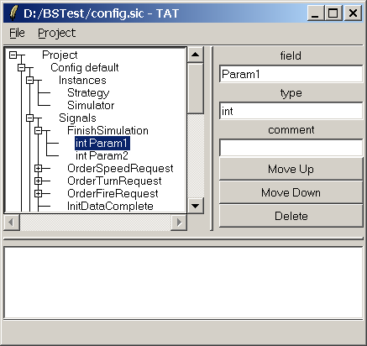
Figure 31. Defining signal parameters
  - Defining MSC data types
In the Data types tree node, user-defined data types are specified as stated in Table 7.
Table 7: Fields and tags used for mapping MSC data types
Name | Description
Name | Data type name as appears on the MSC
Type | Target language type
Dimension | Used for defining arrays, linked lists, SDL strings and other multiple data types
Annotation* | A specific algebraic annotation to the data type utilized by the SiC Verifier of Requirements Specifications.
Comment * | Commentary text
Priority * | The priority field shall be taken into account while handling of message order for the generation of test traces. Defaults to 100.
The following tags are used within TYPEDEF:
ATTRIBUTE* | Additional attributes for data types, utilized by code generation templates. CGTC-specific information is described in 17.6 User’s Manual.
MEMBER* | Defines structure member, applies to structures only.

  - Defining macros
A macro can be thought of as a variable on the MSC diagram to be substituted with a string value. In Silver Cartridge, there are several rules on how a macro can be substituted, stated in along with some other annotated data.
Table 8: Fields and tags used for defining a macro
Name | Description
Name | A macro name as appears on the MSC
Type | A macro type of one of the following:  - list  - derive  - function  - abort  - index
Data type | A macro data type specifies class of values this macro can have.  - string  - number  - id  - undefined  The values for macro are checked against this specifications in two ways: static verifications of data provided with <VALUE> tag, and dynamic verifications of values returned by user’s functions for ‘function’ and ‘derive’ macro.
Priority | Specifies a relative order in which static macro values shall be calculated. Affects an order of generated permutations. Less value denotes higher priority. The range is restricted by 0 to 255. The default value is 100.
Replace | Specifies the inheritance structure across several configurations. Used only if attribute ‘base’ for current configuration is specified. The following values are applicable:  - replace denotes replacement of ‘base’ specification with the new one.  - extend is applicable for ‘list’ macro only and denotes joining of two or more value lists.  - subset applicable for a ‘list’ macro only and specifies intersection of values lists.  - remove denotes the removal of the macro in configuration.
Vector | Affects only macros of a ‘list’ type. Denotes a shared counter for a pair of macros. This means that several macros shall be treated as a vector of values, not as a Cartesian product of values for each macro. It is possible to share one counter across several macros or use the transitive sharing of a counter (#X=>#Y=>#Z). In the last case the behavior may be different if the number of values for #Y macro is not equal to the number of values for #X macro.
The following tags are used for MACRO definition:
VALUELIST | Specifies a set of values for the macro.
VALUE | Specifies a value.

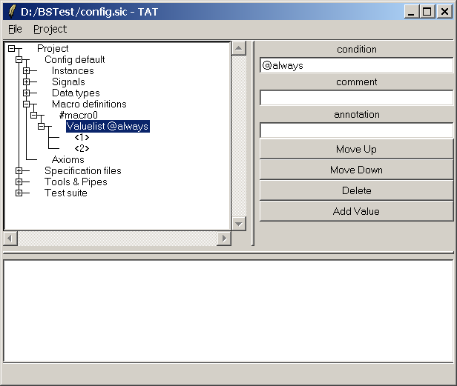
Figure 32. Defining macro conditions and values
  - Working with tools and pipes: ‘Tools & Pipes’ section
The GUI environment of Silver Cartridge possesses means for configuring and running an external tool via specifically developed flexible interface. This section will outline steps required for linking an internal Silver Cartridge component as well as an “external” tool.
To add a tool select the Tools tag and click the Add Tool button.
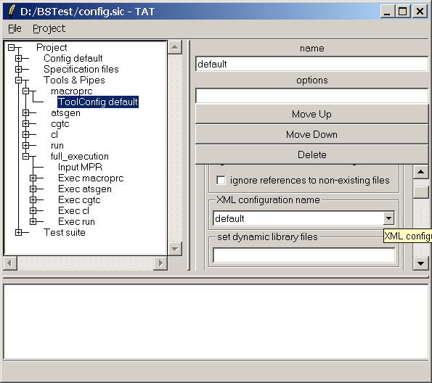
Figure 33. Configuring tools and pipe
  - Typical scenario of using a tool with the SiC IDE
Follow these steps to use a tool in the GUI environment of SiC:
1. Create a configuration script for it with API described in 8.12. You may skip this step in case a TAT tool is used, since it’s configuration script is included into TAT installation.
2. Add the tool to the project with Add Tool button. Specify the locations of tool executable file and tool configuration script.
3. Create a tool configuration if needed with the Add ToolConfig button. You can have more than one configuration for a tool.
4. Repeat steps 1 – 3 for linking all necessary tools in scope of the project.
5. Having added all of the required tools, you may proceed with constructing a pipe. (Refer to 8.15 for the detailed info on what the pipe is and how to execute it within the GUI if SiC). Select Tools&Pipes and click Add Pipe. A default pipe with name “pipe0” will be created.
6. Define pipe inputs and outputs with Add Input and Add Output buttons. Select the newly created input/output, specify its name and type (currently type is not used, reserved for future use)
7. Add tools to execute with Add Exec button. Select the Exec node, select tool to be executed and its configuration. You can leave the configuration selection combo box blank if you don’t want to use any.
8. Connect inputs and outputs of tools between each other. To define tool inputs and outputs, expand the tool exec node, select the desired input or output and select source/destination from a combo box.
Now we’re all set for executing the pipe we’ve just configured. Select the Test Suite tree node and click Add Test Case. Select the default “testcase0” and click Add Pipe. Select “pipe0” from the combo box and click “OK”. Expand the pipe node and select sources/destinations for its inputs/outputs. Choose Project->Build from main menu. Watch the components running with all warning and error messages output to the Console pane.
    - Working with the internal tools of Silver Cartridge
Silver Cartridge offers the following binary tools for MSC processing:
SiC MSC Macro Processor - accepts MSC diagrams with macros and their description as an input, outputs a set of MSC diagrams with the substituted macros.
  - SiC MSC Converter – analyzes MSC dependencies and converts graphical representation of MSCs – MSC-GR into MSC-PR – its textual representation format.
  - SiC MSC Transformer – intended for converting MSCs into a Telelogic-friendly format.
  - SiC MSC Linker – concatenates MSC diagrams into a signal one using one of the several MSC constructs.
  - SiC MSC Trace Generator – processes and expands non-deterministic properties of input MSCs. Generates MSCs with the unrolled traces.
  - SiC MSC Abstract Test Generator – processes input MSCs and generates test traces in the form of abstract test.
  - SiC Smart Code Generation Template – processes abstract tests generated by MSC Abstract Test Generator and generates tests in the target language,
For the detailed information on tools, please refer to Silver Cartridge User’s Reference, Section 11)

Several subsidiary utilities:
  - SiC MSC Loc Meter – used for collecting metrics, such as the number lines of code the frames in the input MSCs.
  - SiC SDL/MSC Wrapper – generates an “SDL to C wrapper”. Allows integrating Telelogic Tau SDL C generated code into Silver Cartridge.
  - SiC VRS Remote Run – utility for remotely running SiC VRS,
  - And also utilities for verifying and debugging MSCs:
  - SiC Verifier of Requirements Specifications –refer to SiC User’s Manual Section 13
  - SiC MSC Debugger – MSC debugging utility.

  - Linking to an external tool via SiC API
In order to properly include an external component into project contents, one would need to define its name, as shall be used in pipe, inputs and outputs, as well as to provide path for the configuration script with the following API:

#########################################################################
# Procedure : Script_configTool
# Description: Configures and packs tool configuration options
# Returns: Codes: ok, error with a string
# Notes: None
########################################################################
proc Script_configTool { frame toolconfig } {
# add your code here
return –code ok
};
#########################################################################
# Procedure : Script_getToolConfig
# Description: Saves tool configuration options
# Returns: Codes: error, ok; an array of configured options
# Notes: None
########################################################################
proc Script_getToolConfig { toolconfig } {
# save tool configuration to dest
return -code ok
};
############################################################################
# Procedure : Script_getToolSignals
# Description: Fetches list of tool inputs and outputs for tool declaration
# Returns: List of signal declarations
# Notes: None
############################################################################
proc Script_getToolSignals {} {
# save array of tool signals as: ‘array set myios $your_arr’
};
#########################################################################
# Procedure : run_Tool
# Description: Executes tool
# Returns: codes: ok, error with a string
# Notes: nspc - current namespace, path - tool execution path
# inputs - tool inputs, outputs - tool outputs
# opts - tool command line options
# dmode - debug mode (1 or 0), dinfo - debug info returned
#########################################################################
proc Script_runTool { path io toolconfig } {
global env
# form cmdLine here
if {[catch {eval exec "$cmdLine"} err]} {
return -code error "$tooltitle: \"$my_error\""
} else {
return -code ok
}
};
  - Configuring tool options with a ‘tool configuration’ tag
A tool in the ‘Tools & Pipes’ workspace may have multiple tool configurations (Note: not for SiC Verifier of Req Specifications tool, this tool works correctly with only one configuration), each defining a fixed set of tool options.
In Figure 34, an example tool configuration for the SiC MSC Abstract Test Generator is shown. The Properties pane is drawn in the configuration script of a tool with the API, the Script_configTool routine. This function is called every time a user clicks on the toolconfig node.
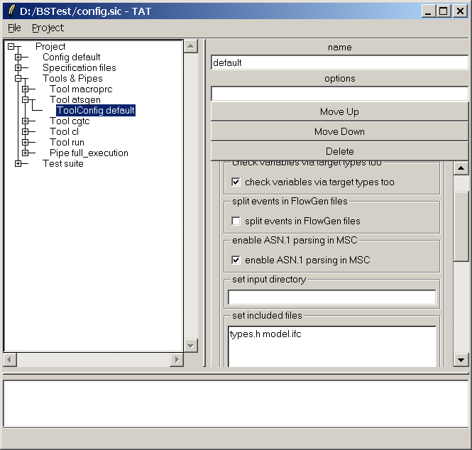
Figure 34. An example tool configuration
The description of tool options along with the detailed API of SiC might be found in the SiC User’s Manual, 8.13.
    - Where a tool configuration shall be used?
Once you’ve defined one or several tool configuration for the tool, you might specify them when describing a pipe as is shown on Figure 36, in the “Choose tool configuration” combo box.
Choose empty line in the “Choose tool configuration” combo if you do not want any tool configuration to be used or simply do not have one.
  - What is a pipe?
A pipe is an executable object with inputs and outputs, having other pipes and tools as its components.
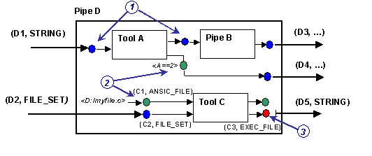
Figure 35. An example pipe scheme

An example pipe structure is shown in Figure 35. Every input and output of a pipe shall have a name and a type.
Signal types supported by Silver Cartridge are stated in Table 9.
Table 9: Signal types and their description
Signal type | Description
FILE | a filename
FILE_LIST | a file set
A pipe, as well as a tool, may have multiple inputs and outputs, but with uniquely defined names within the current object.
  - Configuring a pipe
In Figure 36, an example component configuration window is depicted. You may choose one of the following as a tool input source:
- One of pipe’s inputs.
- An output of a tool executed before this tool.
To configure tool outputs, choose one of the following:
- “Other tool input” in case the current output shall be used as an input in one the following tools. You must also set the value for the signal with the Value entry field (it is usually a file where the tool output is stored)
- One of pipe outputs in case you want to connect the current output to one of the pipe output signals. In this case you don’t need to specify output value.
A pipe is configured in case all input signals inside have values. If one of the components has no input value and is provided with no default value, a pipe is not configured and thus cannot be properly executed.
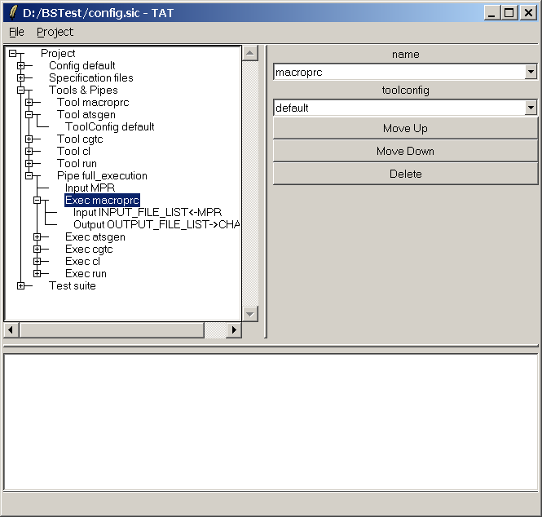
Figure 36. Configuring a pipe component
  - Pipe manipulations
- To add a pipe to the project workspace, select Tools and click Add Pipe
- To remove pipe select it and click Remove.
Note that the input values for pipes are not specified in the ‘Tools and Pipes’ workspace, - only tool and pipe declaration and the internal structure of pipes are stated.
  - Executing pipes: ‘Test Suite’ section
The ‘Test Suite’ section is intended for specifying pipes with their input values to be executed within the project. Pipes are bundled into “test cases” as shown on Figure 37. When pipe is added into a test case, its input and output values must be specified.
In the ‘Test Suite’ workspace, pipes are also distinguished between executable pipes and not. To change a pipe property select it’s node and then check or uncheck the Executable checkbox.
The following commands are available for “test cases”:
- “Build” – launches all pipes in a test case
- “Run” – launches all executable pipes within a test case
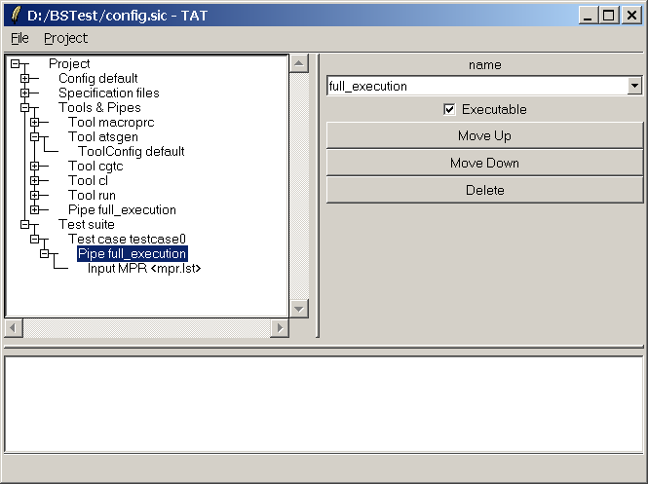
Figure 37. Configuring pipes for execution

- XML Configuration
A DTD for TAT XML Configuration is given in Appendix C.
  - TAT Kernel Configuration
    - Common issues
- In case a tag, stated as required in DTD of TAT, is missing in the input TAT Kernel Configuration and it’s default value is not provided in the DTD, an error message shall be output.
- Each tag in TAT Kernel Configuration may have attribute comment, which stores user’s comment and is not used in processing.
- Attribute priority shall specify priority of SIGNALS::SIGNAL, INSTANCES::INSTANCE, MACROS::MACRO tags (less is higher).
  - In case the specified value for priority is not within the range of 0 and 255, the message MSC_XML_ERR_OUT_OF_RANGE shall be output.
  - If the value of priority is not specified, “100” shall be assumed as default.
    - TATPROJECT tag
Defines a project and acts as a top level XML tag.
      - Attribute name specifies the project name.
      - Attribute info contains general information about the project.
      - Attribute title specifies the project title.
    - TATPROJECT::CONFIG tag
Defines a single TAT configuration
- Attribute name specifies the configuration name.
  - If the value of name is duplicated in any other TATPROJECT::CONFIG tag, an error message shall be output.
- The attribute base matches the name attribute of another TATPROJECT::CONFIG tag (i.e. specifies a “parent” tag) or contains an empty string in case the configuration does not inherit or extend any other configuration in scope of TATPROJECT. In case the base attribute is specified, but matches none of the name attributes of TATPROJECT::CONFIG tags, an error message shall be displayed. In case the base attribute for the current configuration is specified and matches the name attribute value of any other TATPROJECT::CONFIG tag, the following information shall be inherited from the parent configuration if not present in current, i.e. copied from “parent”:
  - SIGNALS::SIGNAL
  - INSTANCES::INSTANCE
  - DATATYPE::TYPEDEF
  - MACROS::MACRO
  - AXIOMS::AXIOMS
- In case the configuration contains any of XML tags, listed in present in the “parent” configuration, the XML data shall not be inherited from the “parent” configuration for these tags.
- In case an infinite recursion appears in the configuration dependencies, an error message shall be output.
    - CONFIG::SIGNALS tag
Defines a signal description block.
    - SIGNALS::SIGNAL tag
Defines a single signal description.
- Attribute name specifies the name of a signal. If the value of name is duplicated within CONFIG::SIGNALS scope, an error message shall be output.
- Attribute type specifies the signal type. The following types are allowed:
- in – specifies input signals for IUT
- out – specifies signals generated by IUT
- inout – specifies bi-directional signals
- ignore – specifies signals to be ignored
- Attribute paramstype specifies the type of a signal attribute, defined in SIGNAL::ATTRIBUTE.
    - SIGNAL::ATTRIBUTE tag
Defines a signal attribute.
- Attribute value specifies the attribute value.
    - SIGNAL::PARAMETER tag
Defines a signal parameter
- Attribute field specifies the name of a signal parameter. If the value of field is duplicated within SIGNALS::SIGNAL space, an error message shall be output.
- Attribute type specifies the data type of a signal parameter.
    - CONFIG::DATATYPE tag
Defines a data types description block.
    - DATATYPE::TYPEDEF tag
Defines a single data type description.
- Attribute name specifies the name of a data type. In case name is duplicated in any other DATATYPE::TYPEDEF tag, an error message shall be output.
- Attribute type specifies the data type cast.
- Attribute dimension specifies dimension (for array and list data types).
- Attribute paramstype specifies type of TYPEDEF::ATTRIBUTE. The value of paramstype is informal text which is interpreted by SDL/MSC wrapper, or by smart templates.
- Attribute prefix specifies string, which shall prefix message parameters with specified data type.
    - TYPEDEF::ATTRIBUTE tag
Defines a data type attribute.
- Attribute value specifies value of attribute.
    - TYPEDEF::VALUE tag
Defines one of datatype’s possible values.
- Attribute enum specifies possible value for datatype.
    - TYPEDEF::MEMBER tag
Defines datatype member (for structures, unions, etc.)
- Attribute name specifies member name
- Attribute type specifies member type
- Attribute dimension specifies member dimension
    - CONFIG::INSTANCES tag
Comprises the description of instances used in the configuration.
    - INSTANCES::INSTANCE tag
Defines a single instance used in the configuration.
- Attribute name specifies the instance name. If the value of name is duplicated , an error message shall be displayed.
- Attribute type specifies type of instance. Following types are supported:
  - env
  - model
- Attribute paramstype specifies the type of an instance attribute.
    - INSTANCE::PARAMETER tag
Defines an instance parameter.
- Attribute field specifies the name of a message parameter. If the value of field is duplicated within the scope of INSTANCES::INSTANCE, an error message shall be output.
- Attribute type specifies the data type of a message parameter.
    - INSTANCE ::ATTRIBUTE tag
- Attribute value specifies the value of an attribute.
    - CONFIG::MACROS tag
Defines the macro description block.
    - MACROS::MACRO tag
Defines a macro.
- Attribute name specifies the macro name. If the value of name is duplicated in scope of the CONFIG::MACROS tags, an error message shall be output.
- Attribute type specifies the macro type. The following types are supported:
  - list
  - index
  - derive
  - function
  - abort
- If the value of type is not specified or does not match any value listed above, an error message shall be output.
- Attribute datatype specifies the type of a macro expression. The following types are supported:
  - string
  - number
  - id
  - char
  - undefined
- If the value of datatype is specified with a string, which does not match any of the values listed above, an error message shall be output.
- Attribute replace specifies the rule for relating the current definition to the one, specified in the parent configuration. The following types are supported:
  - replace
  - extend
  - subset
  - remove
- Attribute research specifies the algorithm for the generation of macro strings. The following types are supported:
  - sequential
  - random
  - priority
- If the value of research attribute is specified and does not match any of the values listed above, an error message shall be output.
- Attribute vector specifies the name of macro of list type. It is applicable only for macros of list type and specifies that macros have shared counters and always selected in pairs.
- Attribute priolist specifies a number of values for list-typed macro used at second and further passes of research.
    - MACRO::VALUELIST tag
Defines a list of values for a macro.
- Attribute condition specifies the logical condition for parameters usage. If this attribute is empty, it means that list of VALUELIST::VALUE tags is used unconditionally. The following grammar is supported by the condition:
<condition>::=<expression>[<oper><expression>] ;
<expression>::=<relation> | ( <LPAREN> <expression> <RPAREN>) ;
<relation> ::= <macro constant> <compare> [<macro constant> | <data>] ;
<oper> :: = <OR><OR> | <AMPERSAND><AMPERSAND> ;
<compare> ::= == | > | < | <= | >= | != ;
<data> ::= <comment> | <float number> | <IDENTIFICATOR> ;
<LPAREN>, <RPAREN>, <IDENTIFICATOR>, <float number>, <comment>, <AMPERSAND>, <OR> terms are defined in Appendix A.
- During the generation of macros, the conditions of MACRO::VALUELIST tags are checked in order they appear in TAT Kernel Configuration.
    - MACRO::ATTRIBUTE tag
Defines macro’s attribute
- Attribute value specifies the attribute value.
    - VALUELIST::VALUE tag
Defines a single value in a value list of a macro.
- Attribute value specifies the value.
- Macro Processor

This section describes Macro Processor functionality.
  - Overview
Macro Processor is intended to support macro processing within the MSC language. The utility parses input MSCs with macro specifications [5.1.5] and generates a set of MSCs with substituted macros and embedded reference events.
Macro Processor outputs MSC-PR files with substituted macro definitions.
  - Using Macro Processor
Macro Processor can be executed via the command line
macroprc [options]
If no argument is given to Macro Processor then the tools prints its version and build number.
    - Command line
Both Macro Processor executable and it’s generated code executable accept specific command line parameters via the command line. This section explains each of these options, along with any considerations, which must be taken into account when executing the utilities.
      - Macro Processor options
Table 10 outlines options of Macro Processor executable.
Table 10: Command line options of Macro Processor
ID | Option/Switch | Description
I. Input file options
1 | [-incl <files>]  : input dll files | This option allows you to specify a set of dynamic link libraries with user-defined C functions for macro definitions used
2 | [-config <XML_file>] | With this option < XML_file> specifies file with XML configuration.
3 | [-cname <configuration name>] | Specifies name of configuration in XML file (default - "default")
4 | [-m <input_files>]  : set input files | With this option <input_files> specifies input filenames. If <input_files> starts with ‘@’ symbol it shall be treated as a file list [22.3]. If this option is not specified the utility shall issue an error message.  Note: Macro Processor doesn’t work with a file set under Unix platform. It works with only one input file.
5 | [-text]  : input files as text | This option causes the utility to treat the input files as text files. If this option is not specified, the input files shall be treated as MSC-PR files.
6 | [-ignorenf]  : ignore references to non-existing files | No error message shall be output and the preprocessing shall proceed if a broken reference is encountered.
II. Value generation options
7 | [-count]  : display the number of the generated MSCs | Displays number of MSCs to be generated.
8 | [-debug]  : display macro permutations | This option displays all used permutations of macro substitutions.  IMPORTANT:  MSC processing will not be started if either [-count] or [-debug] switches are specified.
9 | [-lv <filename>]  : load values of macro from an external file | This option allows you to load macro definitions from an external file. The syntax for lines of the <filename> shall be:  #<macro_name>=<value>
10 | [-n <numb>]  : MSC generated number restriction | Generation halts if the number of the generated MSCs reaches <numb>.
11 | [-rnd]  : randomize macros | This option is extremely useful for restricting the number of MSCs to be generated. It enables random selection of macro substitutions from the pre-defined possible sets. To use this switch you must also specify [-n], i.e. the maximum number of MSCs to be generated, otherwise, an error message shall be displayed.
12 | [-s <n>]  : skip permutations | If [-s] switch is specified and [-rnd] switch is absent, the number of permutations specified as a parameter of [-s] shall be skipped. This switch is ignored if [-rnd] switch is used.  This option is useful, for instance, if some part of the generated MSCs needs to be placed into a separate folder.
13 | [-seed <s_num>]  : sets a random starting point | With this option <s_num> sets a random starting point for the internal random generator of Macro Processor. This is similar to srand() function of C programming language.
III. Value generation options
14 | [-c]  : ignore event condition fields | This option causes the utility to ignore the event’s condition field during MSC processing.
15 | [-il]  : unroll single loops | This option makes all loops with counters equal to ‘1’ unrolled into plain code.
16 | [-ul]  : unroll loops wth constant number of iterations | This option causes the tool to unroll loop which number of iterations specified as a constant number, e.g.  loop <5>
17 | [-f]  : global synchronization | Causes the tool to generate ‘global’ (i.e applied to all instances specified in the diagram) conditions before every event in the generated MSCs, except for conditions and message inputs.
18 | [-fr]  : retain references with ‘$’ | If option [-fr] is specified all ‘functional’ references (name starting with ‘$’) will be retained and won’t be in-lined.
19 | [-glob]  : make macros global | This option allows you to use global parameterization in MSCs. This means, that all referenced MSCs shall accept MSC’s macro names from which they were referenced.
20 | [-iar]  : in-line references | This option allows you to in-line (i.e. to substitute a reference with it’s actual content) all references (with no parameters also), but except for references which are ‘functional’ (i.e. start with ‘$’ and in case [-fr] switch has been applied).
21 | [-l]  : save zero loops | Causes the utility to retain loops with zero counters in the generated MSCs.
22 | [-list <msclist_file>]  : MSC files list | With this option <msclist_file> specifies filename with the list of MSC filenames to be generated. Accepts only one filename.
23 | [-notime]  : exclude time specification in the generated files | This option causes the utility to exclude time specification of events in the generated files.
24 | [-nrf]  : do not expand any references | This option retains all references regardless of their functionality in the generated MSC.
25 | [-o <output_path>]  : output path | This option causes Macro Processor to generate MSCs into directory specified by <output_path>. The argument <output_path> must be given as a path to which all of the generated MSCs shall be placed and may include the relatives “.” or “..”.  If this option is not specified all MSCs shall be created in the current directory.
26 | [-plaindir]  : do not append directory to the generated filenames | This option causes the utility not to append the directory name to the generated file names. By default, if the initial files were listed with a full path, this path shall be added to the filenames as follows  <path><mpr_name>N<index>.mpr  <path> stands for a modified path to make a filename be proper, e.g. slashes (“/”) are removed from the path name.
27 | [-rf]  : MSC references | This option substitutes every ‘reference’ encountered in the diagram and frames it’s contents with the global condition named ‘REFERENCE_SYNC’.
28 | [-use <strings>]  : list of macro names | Set active macro names
29 | [-excl <strings>]  : list of macro names | Set excluded macro names

- Trace Generator

This section describes the purpose and functionality of Trace Generator.
  - Overview
The purpose of Trace Generator tool is to expand non-deterministic [6.1.4] features of MSC and generate, if possible, multiple traces defined by user requirements. The customizable requirements include time consideration, events permutations, synchronization, etc. This is useful for:
- resolving parallel and asynchronous intercommunications by generating possible traces
- checking time specification of MSC for consistency
- combining several test cases into a single one
  - Benefits of semantics evaluation
The major benefits of evaluating semantics involve:
- Validation of requirements specification using MSC - computing all possible traces represented by an MSC chart. Unexpected scenarios might need to be re-specified. This leads to more complete scenarios and better designs.
- Complete conformance testing. Because every MSC has a defined meaning, a complete set of functional test scripts can be generated. This improves test coverage and ensures complete conformance testing.
  - Using Trace Generator
Trace Generator can be executed via the command line
tracegen [switches]
If no argument is given to Trace Generator then the tool prints its version as follows and lists its command line options and switches.
  - Running modes
There are several path generation modes of Trace Generator. The utility processes MSCs in accordance with the mode chosen (10.7.3). The following are the modes the utility is able to run in:
- generation mode
Being launched in this mode Trace Generator generates multiple MSC traces, each in a separate file. Output files shall have filenames with pattern as follows
<prefix><input_msc_filename>_N<index>.mpr
There shall be no prefix if option [-o] is not specified.
To run Trace Generator in the generation mode it shall be invoked with option [-gf]. The utility prints the following text to the standard output:
Trace Generator - version 2.0 for Win2K build <build number>
COPYRIGHT 2001-2003 MOTOROLA, ALL RIGHTS RESERVED
- info mode - outputs information on the number of MSC traces that can be generated from the initial MSC. No MSC files shall be generated. To run Trace Generator in this mode the utility shall be invoked without [-gf] option and in this case the following text shall be printed to standard output:
Trace Generator - version 2.0 for Win2K build <build number>
COPYRIGHT 2001-2002 MOTOROLA, ALL RIGHTS RESERVED
REMARK: <path_numb> complete file(s) can be generated.
see Table 7 and also consider the example in (10.7.3.4).
  - Specifying type of input files
Trace Generator accepts two types of input files for processing:
- MSC-PR files (*.mpr)
- Flowgen files (*.fg),
and distinguishes the type by the file extension.
  - Command line options
The utility accepts command line options and switches listed in Table 11:
Table 11: Trace Generator command line options
ID | Option/Switch | Description
I. Generation modes
1 | [-gf]  : generate files | This option causes the utility to generate output files. If this option is not specified, no output files shall be generated and only the calculated number of possible traces shall only be printed to standard output.  Consider 10.6 and the example in section 10.7.4
II. Input file options
2 | [-i <input_path>]  : input path | The argument <input_path> must be single, specifies path to input files, must be given as a path and may include the relatives “.” and “..”.
3 | [-config <XML_file>]  : input instance files | With this option < XML_file> specifies file with XML configuration.
4 | [-cname <configuration name>] | Specifies name of configuration in XML file.
5 | [-m <msc_files>]  : input MSC files | With this option <msc_files> specifies input MSC filenames. If <msc_files> starts with ‘@’ symbol it shall be treated as a file list [22.3]. If this option is not specified the utility shall issue an error message.
6 | [-sfg]  : use out_Message /in_Message | In case this option is specified out_Message and in_Message shall be used instead of send_Signal for FlowGen files.
III. Time processing options
7 | [-ct]  : enable time calculation | if [-ct] is specified, the events’ time specificatoin shall be calculated wherever MSC provides information.
8 | [-to]  : calculate time only | if [-to] is specified only time calculation phase shall be performed.
9 | [-tf]  : time specification conformance | With this option the generated traces shall conform to time specification.
10 | [-interv]  : use full time intervals | if [-interv] switch is specified partial order generation phase shall use whole intervals instead of only minimal start time. This option shall be used only together with [-tf].
11 | [-ndefst]  : set undefined time interval for first event | If [-ndefst] switch is used, time data of the first event (if not specified) shall be interval [0 .. infinity], otherwise absolute 0 shall be assumed.
12 | [-duration]  : use duration field | If [-duration] switch is used then the duration field of a message shall be used during time calculation.
13 | [-floatt]  : enable floating point support | If [-floatt] is specified the output MSC will support floating point timings. Otherwise all timings shall be rounded to the least nearest integer.
14 | [-nosync] | Increase intervals instead of labels
15 | [-notime] | Do not output time declarations
IV. Loop processing options
16 | [-ul]  : unroll loops with constant counters | With this option all loops with constant number of iterations shall be unrolled into plain code.
17 | [-il]  : unroll single loops | This option causes the tool to unroll loops with a single (equal to 1) number of iterations.
V. Synchronization options
18 | [-mf]  : association of in/out events switch send/receive signals | This option can be used:  - together with [-is] option thus enabling the SS mode (refer to 10.7.3 and 10.7.3.2)  - together with [-ie] option enabling the ES mode (refer to 10.7.3 and 10.7.3.1).  - standalone. In this case all possible traces shall be generated without message overlapping. Refer to 10.7.3.3.
19 | [-is]  : make IUT message events primary - SS mode | This option shall be ignored if used without [-mf] option. [-is] causes the utility to run in SS mode - react on message events which are part of a “model” instance. For the description and samples refer to 10.7.3 and 10.7.3.2.
20 | [-ie]  : make environmental message events primary - ES mode | This option shall be ignored if used without [-mf] option. [-ie] causes the utility to run in ES mode - react on message events which are part of an “environmental” instance. For the description and samples refer to 10.7.3 and 10.7.3.1.
 | [-ec] | Make all condition events global
VI. Trace generation options
21 | [-sp <num>]  : restrict the number of passive branches for the generated traces | If [-sp] is specified then the generated MSC (more particularly, each node of its behavioral tree) shall not have more than the number of passive branches specified with <num>.
22 | [-sa <num>)]  : restrict the number of active branches for traces | If the utility is invoked with [-sa] option then the generated MSC (more particularly, each node of its behavioral tree) shall not have more than the number of active branches specified with <num>.
23 | [-sf]  : start with an active event | If there is an alternative for generating either an active or a passive branch in the processed MSC, using [-sf] option causes the utility to skip a passive branch and generate an active one instead.
24 | [-rf]  : start with a passive event | If there is an alternative for generating either an active or a passive branch in the processed MSC, using [-rf] option causes the utility to skip an active branch and generate a passive ones only.
25 | [-nia]  : do not interleave MSC actions | This option causes the utility to skip behavioral traces which do not contain MSC actions and leave only the trace which starts with an action.
26 | [-nic]  : do not interleave MSC conditions | This option causes the utility to skip behavioral traces which do not contain MSC conditions and leave only the trace which starts with a condition.
VII. Output options
27 | [-o <dir_name>]  : output directory name or filename prefix | This option causes the utility to output files to directory specified with <dir_name>.
28 | [-expn]  : retain in-lines | if [-expn] and [-mf] switches are specified then:  - partial order of inline operator shall not be processed if it contains passive events only.  - inline operators that contain both active and passive events shall not be processed.  Note that [-expn] option is ignored without [-mf].
29 | [-n <numb>]  : number of complete test traces to be generated | With this option <numb> specifies the maximum number of MSC traces (MSCs) to be generated. If the utility is invoked without this option, the default value for <numb> shall be 1 and thus only one trace shall be generated.
30 | [-s <numb>]  : skip specified number of traces | With this option <numb> specifies the number of traces (MSCs) that will be skipped during generation. If the tool is invoked without this option, the default value for <numb> shall be zero and thus no traces shall be skipped.
31 | [-list <list_file>]  : list of MSC filenames | With this option <list_file> specifies filename with the list of MSC file names. Accepts only one filename.
32 | [-sro]  : leave only labeled events and messages | If [-sro] is specified the output MSCs shall not contain any events except messages and labeled events.
33 | [-rmvt]  : remove timers | If [-rmvt] is specified the output MSCs will not contain timers.
34 | [-rmvc]  : remove conditions except for labeled. | If [-rmvg] is specified the output MSCs shall not contain any conditions except for conditions which contain time labels.
35 | [-envself] | Save events from environment to environment

  - Example
Trace Generator is introduced with several simple examples which illustrate its basic functionality.
    - Initial input MSC
The initial MSC is depicted in Figure 38. If TAU MSCE is used for developing MSCs, make sure to save them in MSC-PR form. Also, MSC Converter utility can be used (Section 14) for converting MSC-GR into MSC-PR. Refer to section 7.2.1 for information on binary and text forms of MSC.
The filename of MSC-PR form is TRACEGEN_EX.mpr
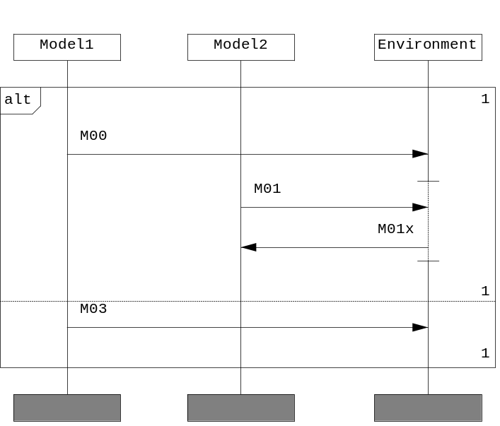
Figure 38. Trace Generator example - initial MSC
    - Specification files
Only one data specification file is required for Trace Generator invocation. Instance description has name Trace_Generator_EX.xml and its contents are listed below:
<?xml version="1.0" encoding="utf-8" ?>
<TATPROJECT name="p" version="1" info="" leader="" title="" user="">
<CONFIG name="default" base="" comment="">
<INSTANCES>
<INSTANCE name="Model1" type="model"/>
<INSTANCE name="Model2" type="model"/>
<INSTANCE name="Environment" type="env"/>
</INSTANCES>
</CONFIG>
</TATPROJECT>
    - Running SiC tools in ES or SS modes
Every MSC message transaction consists of two major events - outputting a message and its consumption. In terms of processing MSC events, SiC can work either in “environment-sensitive” or in “model-sensitive” modes. The “environment-sensitive” (ES mode) means that primary event of messages being processed by SiC shall be the one which corresponds to the instance which is declared as belonging to the testing environment (in our case - “Environment” instance). Accordingly, the event belonging to the IUT (“system”) instance (in our case - “Model1” and “Model2”) shall be chosen as primary in the “system-sensitive” (SS) mode. The mode chosen directly affects the way partial behavior is processed.
      - Launching Trace Generator in ES mode
Options [-mf] and [-ie] (Table 11) cause the Trace Generator utility to run in the ES mode. Note that [-ie] shall be ignored by the utility if not used with options [-mf] or [-ifg]. Command line:
tracegen -m TRACEGEN_EX.mpr -mf -ie -gf -n 100 -config Trace_Generator_EX.xml
The number of traces to be generated ([-n]) are restricted by 100. The utility produces MSCs with the following names
TRACEGEN_EX_N0.mpr
TRACEGEN_EX_N1.mpr
TRACEGEN_EX_N2.mpr
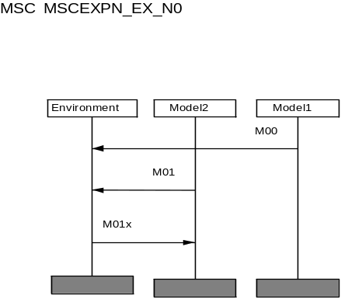
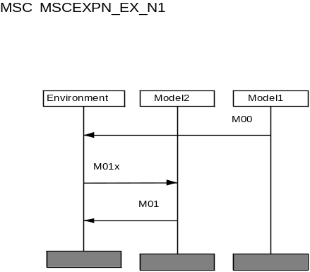
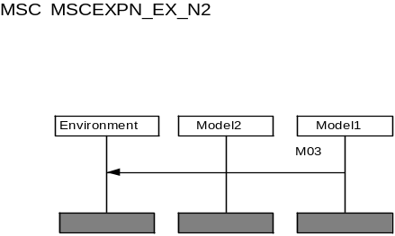
and their MSC-GR form is depicted in Figure 39:
Figure 39. Trace Generator example - Resulting MSCs
      - Launching Trace Generator in SS mode
[-is] option causes the utility to run in the “system-sensitive” (SS) mode. Unlike the ES mode, SS mode leads to a different MSC transformation. Note that [-is] shall be ignored by the utility if not used with options [-mf] or [-ifg] Command line:
tracegen -m TRACEGEN0008l.mpr -gf -config
Trace_Generator_EX.xml -mf -is
The sequence of traces shall be:
- M00->M01->M01x
- M01->M00->M01x
- M03
      - Launching Trace Generator with [-mf] option
[-mf] option can be used with options [-is] and [-ie], but can also be used separately. In this case all possible traces shall be generated without message overlapping. The command line below
tracegen -m TRACEGEN0008l.mpr -gf -config Trace_Generator_EX.txt -mf -lpath 100
shall produce 4 MSCs in the MSC-PR form with the following traces:
- M00 -> M01 -> M01x
- M00 -> M01x -> M01
- M01 -> M00 -> M01x
- M03
      - Launching Trace Generator in “message overlapping”(MO) mode
If [-mf] option is not used, the utility shall run in the MO mode. This means that each MSC message shall have two separate events - output and consumption, so messages can overlap each other. Command line:
tracegen -m TRACEGEN0008l.mpr -gf -config Trace_Generator_EX.xml -lpath 100 -n 100
This will produce 12 MSCs with different traces. Using option the command line shall restrict the number of output traces (MSCs) ([-n] option):
tracegen -m TRACEGEN0008l.mpr -gf -config Trace_Generator_EX.xml -n 4
The resulting MSCs are shown on Figure 40.
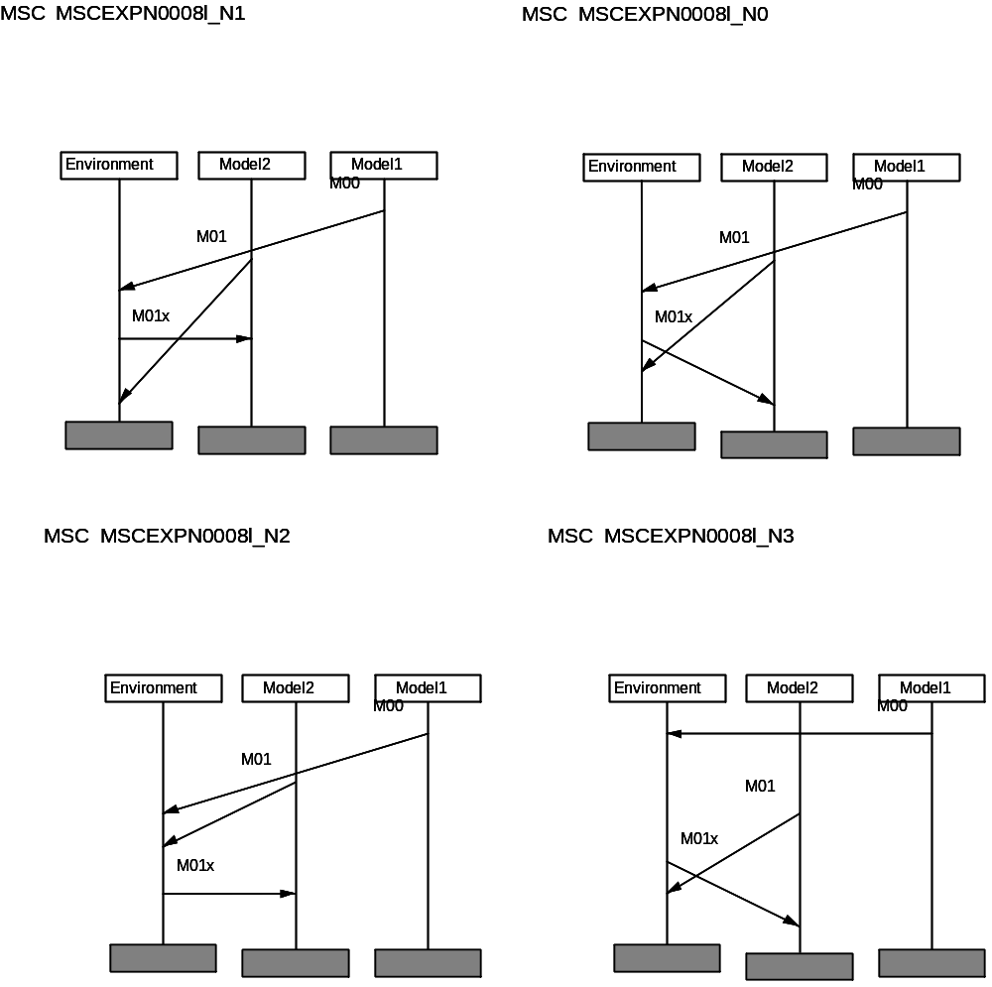
Figure 40. MSCEXP Example - launching Trace Generator in “message overlapping” mode
    - Getting info on the number of traces with Trace Generator
If option [-gf] is not used, no MSCs shall be generated and only information on the number of traces shall be output. Consider the command line below:
tracegen -m TRACEGEN0008l.mpr -config Trace_Generator_EX.xml
Output:
Trace Generator - version 2.0 for Win2K build <build_number>
COPYRIGHT 2001-2003 MOTOROLA, ALL RIGHTS RESERVED
REMARK: 12 complete trace(s) can be generated.
  - Processing time with Trace Generator
This section describes how the utility handles time in input charts, processes it and outputs. For information on time specifications of MSC supported by SiC refer to 5.6.
    - Enabling time support
Option [-ct] generally enables time support for Trace Generator. In case the utility is invoked without this option time specification of messages in input charts shall not affect message order.
If option [-ct] is specified and options [-tf] is not present, time specification will affect the order of signals but shall not be output into the resulting chart.
If option [-to] is specified, the utility shall not process partial order and only calculate time for input diagrams. The output charts shall contain initial diagrams with time specifications brought to absolute. Also, time scale for instances shall be the same.
Option [-duration] causes the utility to process partial order with respect to the duration field of messages (5.7).
    - Restricting time intervals
Option [-ndefst] restricts time intervals for signals. For example, if the first signal in the chart has {5} as it’s time specification, using [-ndefst] option shall cause the utility to assume time specification to be {5..INF}, otherwise, the interval {5..5} shall be assumed.
    - Processing partial order with respect to time specification
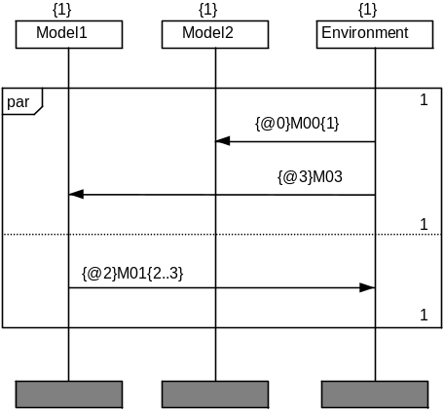
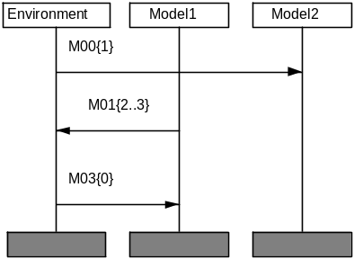
If option [-tf] is used then the partial order of messages shall be handles with respect to their time specification in the chart as on Figure 41.

Figure 41. Trace Generator example - initial (left ) and the resulting MSCs
  - Restricting the number of output traces
The utility offers several capabilities for restricting the output path number (the corresponding options are described in Table 11):
- restricting the number of active MSC paths. This means that if multiple traces can be generated from the initial single path, their number shall be restricted. The corresponding options are [-sa2] (maximum two active paths) and [-sp] (one active path).
- restricting the number of passive paths (options [-sp] and [-sp2]).
Consider the initial input MSC on Figure 42. Command line:
tracegen -m TRACEGEN0008l.mpr -config Trace Generator0008l_inst.xml -gf -mf -ie -lpath 100 -n 100 -sp
When processed, the signal sequence “M00 - M01” produces two traces: M00 -> M01 and the reverse order; [-sp] option causes the utility to ignore the second trace.
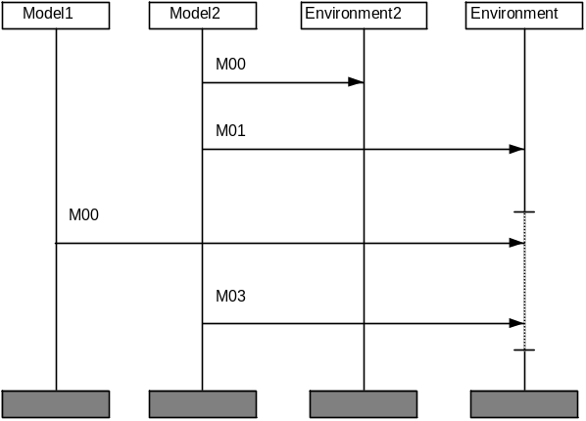
Figure 42. Trace Generator example - initial MSC
    - Ordering of traces
In case an event defines multiple traces, using [-sf] option causes the tool to put active events before passive and omit traces where they are in reverse order. Command line:
tracegen -m TRACEGEN0008l.mpr -inst Trace Generator0008l_inst.txt -gf -mf -ie -lpath 100 -n 100 –sf

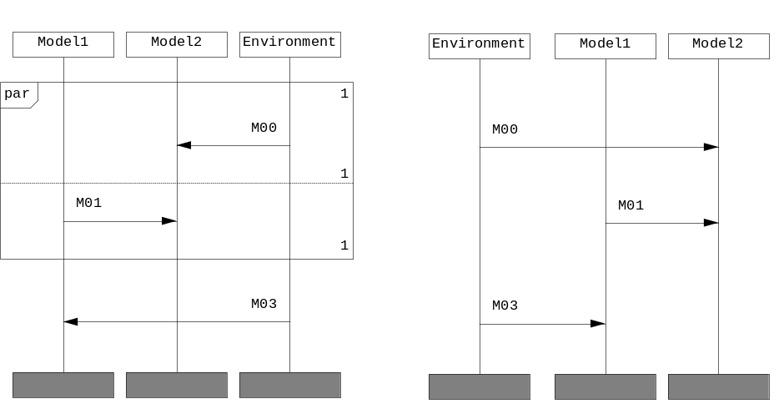
Figure 43. Restricting trace order - initial (left) and the resulting MSCs
This command line shall produce only one trace. The trace M01->M00 shall be omitted – see Figure 43.

- MSC Linker

This section describes the purpose and functionality of MSC Linker.
  - Overview
The purpose of MSC Linker lies in sequential concatenation of MSC diagrams into a single one. MSC Linker might be used when a series of tests can be run under one configuration. Charts can be concatenated using one of the following MSC constructs:
- alt
- par
- sequential binding
  - Using MSC Linker
MSC Linker can be executed via the command line
msclink [switches] [options]
If no argument is given to MSC Linker then the tool prints its version and build number.
The following sections explain each of the MSC Linker command options, along with any considerations, which must be taken into account when executing MSC Linker.
  - MSC Linker functionality
This section describes the functionality of MSC Linker.
    - Command line options
The following are command line options accepted by MSC Linker.
Table 12: Command line switches of MSC Linker
ID | Option/Switch | Table 13: Description
1 | [-m <msc_files>]  : input msc files | With this option <msc_files> specifies input MSC files. If <msc_files> starts with ‘@’ symbol it will be treated as file list [22.3]. If this option is not specified the utility shall issue an error message.
2 | [-sync]  : separate diagrams using global condition | if [-sync] switch is used the output file shall contain a global condition which separates input diagrams.
3 | [-par]  : parallel execution of diagrams | if [-par] switch is used the output file shall contain parallel inline expression with each frame containing an input diagram.
4 | [-alt]  : alternative execution of diagrams | if [-alt] switch is used the output file shall contain alternative inline expression with each frame containing input diagram.
5 | [-o <output_file>]  : output file | With this file <output_file> specifies the output file for MSC Linker.
6 | [-nommsc] | Do not output macro MSC extensions
Note, that the following command line switches should not be used together: [-alt] with [-par]; [-par] or [-alt] with [-sync]. The utility shall issue an error message in this case.
  - Example
Initial MSCs are shown on Figure 44. Command line:
msclink -m scenario1 scenario2 –sync -o scenario_common.mpr
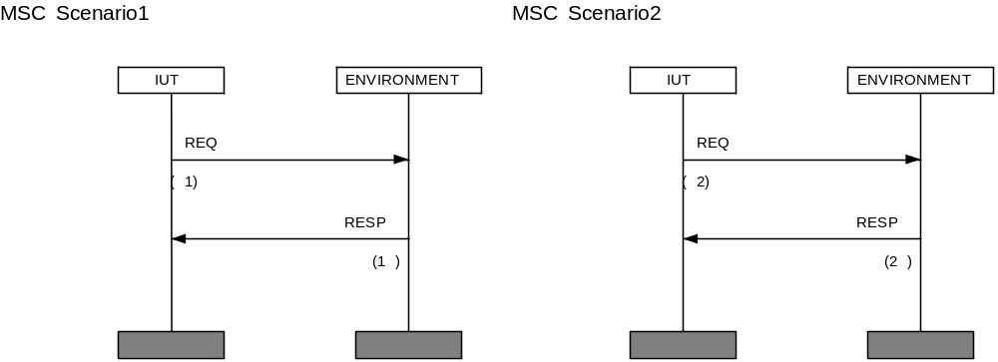
Figure 44. Example MSC - initial scenarios

The resulting scenario_common.mpr is depicted on Figure 45:
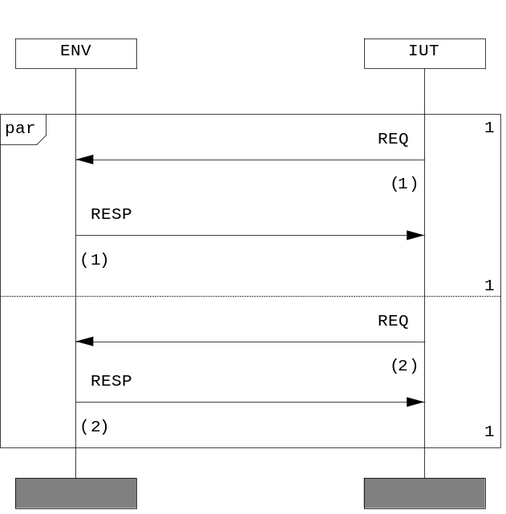
Figure 45. Resulting MSC scenario_common

- MSC Transformer

This section describes functionality of MSC Transformer tool.
  - Overview
The purpose of MSC Transformer is to convert files between MSC-PR and FG formats, check syntax of MSC-PR and FlowGen files, to provide compatibility with Telelogic Tau MSC editor.
  - Using MSC Transformer
MSC Transformer can be executed via the command line
mscjust [switches]
  - Functionality
This section describes functionality of MSC Transformer. Command line options accepted by MSC Transformer are listed in Table 14.
Table 14: Command line options of MSC Transformer
ID | Option/switch | Description
1 | [-m <msc_files>]  : input MSC files | With this option <msc_files> specifies input MSC files. If the argument <msc_files> starts with a ‘@’ symbol it will be treated as a file list. If this option is not specified the utility shall issue an error message.
2 | [-mmsc]  : output macroMSC extensions | With this option the resulting MSC shall contain macro MSC extensions, otherwise shall not.
3 | [-prefix <string>]  : append string to output filenames | With this option <string> shall be appended to output filenames as follows:  <string><MSC_name>.mpr  If the utility is invoked without this option the generated MSCs shall have the following format:  <MSC_name>.mpr
4 | [-savename]  : retain names specified in the ‘msc’ field | If the utility is invoked with this option the generated MSC shall retain original names specified in msc field in the generated files.
5 | [-ompr]  : force MSC-PR output | This option causes the utility to output files in MSC-PR format, regardless of the input files type.
6 | [-ofg]  : force Flowgen output | This option causes the utility to output files in Flowgen format, regardless of the input files type.
7 | [-list <output_file>]  : set the output list file | In case the utility is invoked with this option then <output_file> shall specify file to which the list of the converted/analyzed MSCs shall be output.
8 | [-mark] | Add debug ID to events
9 | [-nsrf] | Do not output source references
10 | [-verf] | Verify only
11 | [-verd] | Output verdict
12 | [-vtm] | Substitute time with verdict time
13 | [-comtm] | Output time in MSC comments

- MSC Converter

This section describes the purpose and functionality of MSC Converter.
  - Overview
The purpose of MSC Converter is to analyze the MSC dependencies through references and to convert MSCs from binary to text form.
  - Using MSC Converter
Before using MSC Converter, Telelogic Tau shall be installed. If Telelogic Tau is not installed or no licenses for MSC-Editor are available, MSC Converter can not be used for conversion binary .msc files to text .mpr files.
MSC Converter requires path to Telelogic Tau binary files
MSC Converter can be executed via the command line
mscdepd [switches]
And outputs its options and switches.
  - Command line
Table 15 provides the description of command lie switches supported by MSC Converter.
Table 15: MSC Converter command line options
ID | Option | Description
1 | [-m <msc_files_list>]  : set the list file with input MSCs | With this option <msc_files_list> specifies filename with list of MSC input files to be converted/analyzed.
2 | [-list <output_file>]  : set the output list file | In case the utility is invoked with this option then <output_file> shall specify file to which the list of the converted/analyzed MSCs shall be output.
3 | [-grpr]  : enable MSC-GR to MSC-PR conversion | This option causes the utility to enable conversion from MSC binary form (*.msc) to text (MSC-PR, *.mpr).
4 | [-teldir]  : set the TAU path | Sets the path to Telelogic Tau binary tools.
5 | [-i <input_path>]  : input path | Sets the input directory path.
6 | [-o <output_path>]  : set output path | Sets the output directory path.
7 | [-noserver]  : do not launch TAU SDT server | This option causes the utility not to launch SDT server duting execution. This is useful in case the SDT server is already running on your machine.
8 | [-noref] | Do not process files recursively

- Abstract Test Generator

This section provides the complete description for the Abstract Test Generator.
  - Overview
The purpose of Abstract Test Generator is to compile source test cases specifications (MSC-PR or FlowGen) into appropriate ATS with control on special features like non-determinism resolving, time specification, etc.
The utility has name atsgen.exe.
  - Using Abstract Test Generator
Abstract Test Generator can be executed via the command line
atsgen [switches]
If no argument is given to Abstract Test Generator then the tool prints its version and set of supported switches.
The following sections explain each of the Abstract Test Generator command options, along with any considerations, which must be taken into account when executing Abstract Test Generator.
    - Functionality
The utility accepts command line switches listed in Table 16

Table 16: Abstract Test Generator command line options
ID | Option/Switch | Description
I. Input file options

1 | [-i <input_dir>]  : input directory | If the utility is invoked with this option in this case <input_dir> shall specify path to the input files and represent only one path.
2 | [-m <msc_files>]  : input MSC files | With this option <msc_files> specifies input MSC files. if <msc_files> starts with ‘@’ symbol it will be treated as file list [22.3]. If this option is not specified the utility shall issue an error message.
3 | [-incl <incl_file>]  : set the file to be included | With this option <incl_file> sets the filename to be included into the generated code, for example  -incl bus.h wrapper.h  shall cause the utility to generate the following line (ATS code):  set INCLUDES [ list "bus.h" "wrapper.h" ]
4 | [-sfg]  : use out_Message /in_Message | In case this option is specified out_Message and in_Message shall be used instead of send_Signal for FlowGen files.
5 | [-config <XML_file>]  : input instance files | With this option < XML_file> specifies file with XML configuration.
6 | [-cname <configuration name>] | Specifies name of configuration in XML file.
7 | [-tt] | Check variables via target types too
8 | [-asn1] | Convert ASN.1 array/structure notation in MSC to nested lists in ATS
II. Output file options

9 | [-o <filename>]  : set output file name | With this option <filename> specifies the output ATS filename.
10 | [-conf <string>]  : sets the configuration tag specification | With this option string sets the configuration tag specification.
11 | [-envself]  : save events from environment to environment | This option causes the utility to retain MSC signals being directed between instances associated with the test environment. The utility shall transform such messages into send_Signal routines of ATS.
12 | [-list <list_file>]  : list file with MSCs | With this option <list_file> specifies filename with the list of MSC file names. Accepts only one filename.
13 | [-smt] | Single message table for test cases
14 | [-optexc]  : optimize MSC excludes | If the utility is invoked with this option all possible optimizations for MSC excludes shall be performed.
15 | [-state]  : generate FSM-like ATS | If the utility is invoked with this option the generated ATS shall represent an FSM, i.e. be in a passive mode.  IMPORTANT:  Note, that CGTC is intended for the FSM mode only.
16 | [-flat]  : generate flat (linear) MSCs | This option causes the utility to skip non-deterministic features and features, related to partial order of events. Linear MSCs shall be generated.
17 | [-cm]  : utilize maximum number of MSC paths | This option causes the utility to use the maximum possible number of MSC paths. For example, in an MSC alternative, where only passive events are present in both frames, both two paths shall be assumed.
18 | [-sro]  : messages and labeled events only | If [-sro] is specified the output MSCs shall not contain any events except messages and labeled events.
19 | [-rmvt]  : no timers | If [-rmvt] is specified the output MSCs shall not contain timers.
20 | [-rmvc]  : no conditions except for labeled | If [-rmvg] is specified the output MSCs shall not contain MSC conditions except for the labeled ones.
21 | [-prefix <string>] | Prefix for test case names in ATS
III. Time processing options

22 | [-tf]  : traces conform to time | If [-tf] switch is specified, the generated traces will conform to time specification.
23 | [-ct]  : enable time calculation phase | If [-ct] is specified the time calculation phase shall take place during MSC processing.
24 | [-interv]  : use interval time specification | This option causes Abstract Test Generator to use the interval time specification of events during the partial order generation phase.
25 | [-ndefst]  : set undefined time interval for first event | If [-ndefst] switch is used, time data of the first event (if not specified) shall be interval [0 .. infinity], otherwise absolute 0 shall be assumed.
26 | [-duration]  : utilize duration field of messages | If [-duration] switch is used the duration field of MSC messages shall be used during time calculation.
27 | [-floatt]  : enable floating point timers | If [-floatt] is specified the output MSC shall support floating point timings. Otherwise all timings shall be rounded to the least nearest integer.
28 | [-nosync] | Increase intervals instead of labels
IV. Loop processing options

29 | [-ul]  : unroll loops with constant number of iterations | This option causes the tool to unroll loop which number of iterations specified as a constant number, e.g.  loop <5>
V. Synchronization options

30 | [-mf]  : run Abstract Test Generator in message-overlapping mode | Similar to the option of Trace Generator - refer to section III - Path generation modes of Table 10–1.
31 | [-is]  : run Abstract Test Generator in system-sensitive mode | Similar to the same option of Trace Generator - refer to section III - Path generation modes of Table 10–1.
32 | [-ie]  : run Abstract Test Generator in environment-sensitive mode | Similar to the same option of Trace Generator - refer to section III - Path generation modes of Table 10–1.
33 | [-ec]  : make all MSC conditions global | This option causes the utility to make all MSC conditions in the output MSC global, i.e. associated with all instances. This is useful incase input MSCs have been macro preprocessed by Macro Processor and additional instances have been generated.
VI. Trace generation options

34 | [-sa <num>]  : max 1 active branch | If [-sa] is specified the generated paths shall not have more than the number of active branches specified with <num>.
35 | [-sp <num>]  : max 1 passive branch | If [-sp] is specified the generated paths shall not have more than the number of passive branches specified with <num>.
36 | [-g] | Generate debug info for MSC
37 | [-sf]  : no passive branches | If [-sf] is specified the generated paths shall not contain passive branches if an active branch can be generated.
38 | [-rf]  : no passive branches | Inversely to [-sf], the generated paths shall not contain active branches if a passive branch can be generated instead if the utility is invoked with the [-rf] switch.
39 | [-nia] | Do not interleave actions
40 | [-nic] | Do not interleave conditions

- SDL/MSC Wrapper

This section outlines the purpose of SDLMSC, describes API of generated wrapper.
  - Purpose
SDLMSC is intended for connection of two technologies: technology of automatic models testing with MSC (SiC) and technology of high-level model description on SDL.
  - Methodology
With the help of SiC and code generating template CGTC, test on MSC changes into test on destination language. In our case destination language is C. With any SDL the model is described on SDL, and then, using SDT SDL suite, we get C code of the model. SDLMSC produces C code of connecting module. Further, with the help of TCL scripts, all source code is built in executive module. Also it is necessary to take into account, that some C files and libraries of SDL to C “Cadvanced” compiler are used for building executive module.
  - Using SDLMSC
The utility has name sdlmsc.exe.
SDLMSC can be executed via the command line
sdlmsc <XML_Config>

For work of the SDLMSC and SiC project descriptions on XML are necessary. SiC project descriptions are generated with SDLMSC automatically. The description of SDLMSC project differs from the description of SiC project. Thus for correct work of SDLMSC we must develop other project configuration on XML.
Environment can be representing on MSC diagram as one or several associated entities. The user should specify in SDLMSC project configuration file to which entity on MSC corresponds signal, received from SDL model. There are two ways of describing signal configuration:
- MSC instance is assigned to every signal, received from SDL model. This instance cannot be changed during test duration.
- A combination of signal parameter and it’s value described in configuration file determines MSC instance, to which this signal is addressed, it can be changed during test duration. Parameter numbering begins from 1. Param<number> is an ordinal number of used parameter in signal’s body. If pair of parameter number and parameter value described in configuration file coincides with signal parameters, signal will be addressed to instance, described in configuration file. Otherwise, if no addressed instance would be found, signal will not be received and error occurs.
<SIGNALS>
<SIGNAL name=<signal name>>
<ROUTE instance=<addressed instance> />
</SIGNAL>
<SIGNAL name=<signal name>>
<ROUTE Param<number>=<parameter value> instance=<addressed instance> />
..
</SIGNAL>
</SIGNALS>

Macros can also be used in SDLMSC project configuration. This option is suitable if there are a lot of similar instances and similar way of signal addressing between these instances (POTS example). First macro in this example defines a list of output signals. Second macro defines index range that is used in instance and parameter description.
<SDLMSCMACROS>
<MACRO name="#outsig" type="list">
<VALUE value=<out signal 1>/>
<VALUE value=<out signal 2>/>
<VALUE value=<out signal 3>/>
...
</MACRO>
<MACRO name="#pnum" type="range" lower="1" upper="5"/>
</SDLMSCMACROS>
…
<SIGNALS>
<SIGNAL name="#outsig">
<ROUTE Param1="#pnum" instance="Instance_#pnum" />
</SIGNAL>
</SIGNALS>

Options section in SDLMSC configuration file:
<OPTIONS systemname=<SDL system name> projectname=<SDLMSC project name>
sourcedir=<SDTSDL-generated model file directory> cenvfile=<path to env.c model file>
xmlcfgfile=<path to SiC configuration file> reset=<name of signal that reset system> wrapname=<wrapper name> wrapdir=<wrapper target directory>/>

The switches of the SDLMSC utility are described in Table 17.
Table 17: Option switches of SDLMSC
Key | Description
systemname | Specify SDL system name.
projectname | Specify SDLMSC project name.
sourcedir | This option specifies the directory name where “c”, “ifc”, “hs” files generated by SDT SDL are located.
cenvfile | This option specifies name of “env” file.
xmlcfgfile | This option specifies path where SiC configuration file will be generated by SDLMSC.
reset | With this option signal name, which should be described in XML project description, is specified. This signal is intended for putting system into initial state.
telelogicdir | This option specifies path to directory where Telelogic TAU is installed.
prname | Specify SDLMSC project name.
mprfile | This option specifies path to directory where mpr file with processing test is stored.
sdltarget | This option specifies the directory name where “c”, “ifc”, “hs” files generated by SDT SDL are located.
sdlsystemname | Specify SDL system name.
wrapname | This option specifies name of wrapper files “wrapname”.c and “wrapname”.h
wrapdir | This option specifies the directory name where files “wrapname”.c and “wrapname”.h should be generated

When project configuration is correctly specified in XML, SDLMSC can be started.
Output after successful work of SDLMSC, are three files, described in Table 18.

Table 18: Output files of SDLMSC
File name | Description
<cenvfile>.c | Contains descriptions of function for ensuring work of SDL model with environment (initialization, closing and etc.). Also functions for input and output signals from SDL model are specified in this file.
wrapper.c | Contains descriptions of function, which are intended for ensuring work of C-code of test on CGTC. Also contains function for input and output signals from test.
wrapper.h | Header file contains descriptions of functions, which are intended for ensuring work of C-code of test on CGTC.

For building executive module we must have C-code of test on MSC, C-code of SDL model and some C-files from library of “Cadvanced” SDL to C Compiler from product TAU and also several C-files from SiC for code generation template CGTC.
C-code of test is obtained with the help of SiC and code generation template CGTC. During work of SiC it is necessary to fulfill rules:
- Each signal from test should be send by the one function for each signal. During work with signals entities support must be turned on.
- If string variables are used on MSC diagram a “V” letter must be added at the beginning of the string. In other case work of tool SDLMSC is not guarantied.
C-code of SDL model should be obtained with the help of SDL to C compiler from product SDT SDL suite. At the description of SDL model the following rules should be obeyed:
- There should be only one process, which is intended for putting system to initial state after receiving certain signal, in SDL model.
- There should be described a signal which inputs in SDL model and does not contain any parameters and destined for reception by the above described process which will put system into initial state after receiving this signal.
- This signal should be described in XML project configuration file. In other case correct work of tool SDLMSC is not guarantied.
When all needed source code is available, TCL script is started and it builds all source files into single executive module.
  - API of generated wrapper
The language MSC is based on model of a partially ordered sequence of events, describing interaction of several entities through an exchange of the messages. The language SDL is based on state-machine model, where the transition from one state to other occurs under influence of some event, reception of a signal. As the models of interaction are various, the mechanism of receiving and sending signals differs too. For univocal definition from whom and to whom a signal is intended for, in MSC language the name of signal, and the name of entity of the receiver and sender are used. In an obtained with the help of SiC on CGTC C-code of the test, a unique identifier is put in conformity to every entity. Therefore, each signal in test has name and entity identifier of sender and receiver. In SDL signal must has his own identical name and two identifiers of sending and receiving processes. These identifiers represent structure with name "SDL_PId”. Parameter of each processes are saved in this structure.
For reception of signals in the test function "TAT_ReceiveMessage” is used. Its description is located in the file “wrapper.c”. Standard function for receiving signals for code generating template CGTC called in this function. Function “TAT_Send<signal name>” is used for sending signals from test. Because in SDL it is impossible to send signal from test; all signals, sent from the test are previously located in turn of entering signals in SDL. This queue is dynamic and at reception of a new signal, data about it are located in "head" of this turn.
For reception of signals in C-code of SDL model function “xInEnv” is used. For sending signals function “xOutEnv” is used. Both these functions are described in the file “env.c”. After initialization of SDL model, function “xInEnv” continuously calls in a loop. SDL model receive signals in this function. If any signal was received, the cycle interrupts and the function “xOutEnv” is called for sending of a signal, if it is necessary. Then function “xInEnv” continuously called in a cycle. For forced interruption of a cycle, function “xHalt” is called.
By each call of function "xInEnv” the queue size check is performed for finding any signal in queue. If the queue is not empty, then all data about signal in the "head" of the queue are got out. By the identifier of a signal is determined, which signal was received. After this, transfer of all parameters of a signal to internal queue of SDL model is performed. Structure of receiving signals in SDL model, and also structure of sending signals in it is possible to look in a file “env.c”.
  - SDLMSC example
The developed example represents evident application of technology of connecting of two high-level description languages MSC and SDL. The example consists of some set of the tests on MSC, which test model on SDL. The model on SDL represents model of POTS telephone network (Plain Old Telephone System), where two any subscribers of a network can connect between themselves and to form a pair of connection. Such connections can be 128, because of the telephone network supports 256 subscribers. In the given example work only of two pairs of the subscribers is brought. This is made for reduction of volume of the test and clearness of an example. The example represents a set of files, laying in different directories, listed in Table 19.
Table 19: Description of files used in the example
Name of Folder | Description
Config | Contains XML file of the description of the project, also contains a textual file with the list of names of initial files SDL of system.
Data | Contains a textual file with the list of numbers of telephones, necessary for correct functioning, model of telephones.
Model | Contains all initial SDL files of SDL model, also contains a subdirectory “target”, where C-files of SDL model, received after work of the compiler “Cadvanced” SDL to C compiler from product TAU should contain.
Run | Contains script on TCL for assembling the project in one executed module, and also script on TCL for set-up of assembly script.
Test | Contains a subdirectory MSC-PR, in which there are the MSC-PR files of the tests.

Start and the work of the whole example accomplish through start of a file make.bat (under Windows). All target files after work TAT ⁺ and the assembly of the whole project will be in an again created folder output
For getting of C-files SDL of model it is necessary to start TAU Organizer. With the help of the menu File->Open open a file “POTS.sdt” being in a directory “model”. Then with the help of the menu Generate->Make open a dialogue window SDL Make. Correctly to establish fields of a dialogue window and to press the button Full Make or Make. And in a directory, specified in a field Target directory, there is the C-code SDL of model
The dialog window after SDL Make, containing fields with values necessary for correct work of an example is shown in Figure 46:

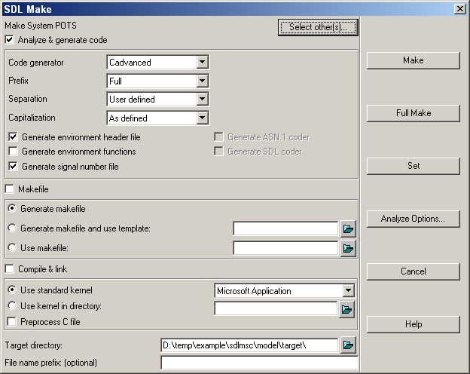
Figure 46. SDLMSC example

- Smart Template

This section describes Smart Template functionality.
  - Overview
Smart Template has been developed in order to generate target code from ATS file. Smart Template represents Tcl script, which implements procedures from ATS file.
  - Types of code generation templates
In the chain of TAT work the use of code generation template is viewed after ATSGEN work and ATS getting. Thus ATS is the input to CGTC. ATS is the set of data - list or set of commands – functions’ calls in TCL. ATS contains full information on input data from test suite and its work process.
The most evident approach, when developing CGTC, is direct procedures realization. Procedures are called in ATS, using necessary set of data in TCL. The order of procedures calls in ATS has linear structure. Each call answers for a certain event, described on MSC diagram. All events’ parameters are transferred to ATS as procedures parameters. Thus code generation process represents consistent unload of target code blocks, corresponding to concrete event, to output files. Each function is responsible for defined block of target code unloading. Generally, blocks have fixed structure, and outer parameters modification is realized concerning input parameters of called procedure in ATS.
There are two fundamentally different types of code generation templates.
- Specialized CGTC (dedicated code generation template)
- Universal CGTC (MPCGT)
DCGT (Figure 47) is projected and realized due to concrete use, project, or system. Here is the need in exact knowledge of tested system interfaces, types and obtaining data formats.

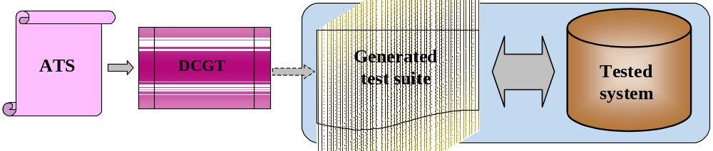
Figure 47. Use of DCGT
In this case interfaces and system data structures are used directly, when generating. There could be no necessity in writing wrapper, or such program creation complexity is simplified to minimum. In the considered approach high indices of compactness and optimum characteristics can be reached for generated code.
The following approach is applied in DCGT realization. Each event on MSC diagram is presented as a block of code in target language. It uses concrete interconnection interfaces with system.
Essential lack of DCGT use is its opportunity to be used just for testing of one concrete project or system. The template couldn’t be tuned, it is tightly specialized. It’s secondary use even in parallel development areas is rather complex.
MPCGT (Figure 48) allows decisions creation for the whole class of projects. Usability area is rather wide, it can count several types of systems. In this case template has enough number of tunes for concrete system. Generated code is rather flexible. Its data structure and functional organization do not depend on the entire tested environment. All system dependent operations are realized in wrapper. In contrast to DCGT more essential load is put to wrapper.

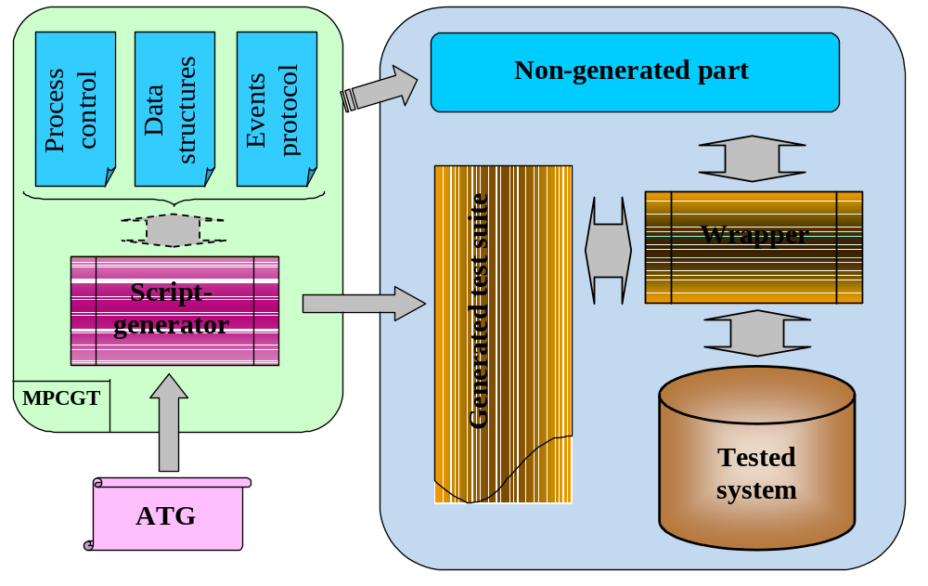
Figure 48. Use of MPCGT
Volume increase and decrease of optimum characteristics of generated code can be marked as lacks of MPCGT. The lacks decrease productivity, when executing test suites. Projecting and development time of CGTC increases, but there is also increased essential reuse opportunity.
Further main recommendations on MPCGT realization are presented. If it is necessary to create DCGT this method is quite useful, as DCGT is a private case of MPCGT.
  - Development of non-generating part
To describe approaches to MPCGT creation notion of kernel is entered. The notion means separate program module, realized in target language, which doesn’t participate in generation process and which is switched to system in case of direct assembling.
    - Inside data structures
It is recommended to develop types of inside data structures, which describe system conditions in the concrete moment of time. The types of data structures are presented below:
- Data structures, responsible for variable or constant properties during test system work. Data set in such structure is to be belonged to the test environment description as a hole. Structure can keep in itself pointers to all functions, necessary for system work, pointers to all structure arrays of direct data got from ATS for all test suites and each test particularly. Such structure can be used for process of test suites work process control.
- Data structure, which can store information about any event, described on MSC diagram. Such structure stores event’s type, all event’s parameters (time, name, direct data). The structure might be used for data exchange between test environment modules about each step event.
- Internal queue of tests system. Queues realization can differ. For example, it can represent some structures’ array (with recommended type of structure pointed above), describing events on MSC diagram, and also in data fields, necessary for work with the array (different pointers on queue’s size).
Given set of structures allows unifying data exchange between internal functions of tests’ system. Also each function will have full information on the system, if it has minimum of parameters. The system’s data types description is to be put to kernel.
    - Controlling functionality
There is an opportunity of functionality underlining, which is responsible for calls processes and test suites’ work control. It is recommended to give user the opportunity to run test suites’ in different variants: the whole suite, partial suit, set of scenarios suite. For example, as some interface functions, available for user.
Also it is possible to include functionality connected with data structures’ initialization. This functionality is also to be carried out to interface for giving user more flexible tunings.
    - Getting system responses functionality
It is necessary to project mechanism of messages getting from tested system in response to given inputs. Direct check of different parameters of message due to correspondence with specification is realized by generated code. However, generally process of messages getting to internal queue is recommended to outline as interface function. The function is to get data, describing any message from tested system and described on MSC diagram. Converting and formats type reduction are organized by user in messages’ positioning to internal queue of tests’ environment for its further obtaining. Pointers on data structures, described in 16.3.1. are recommended to use as function’s parameters. The queue is recommended to create dynamically to have an opportunity to set its size by user.
    - Time support
It is necessary to provide events’ time parameters obtaining and work with time in system. For different types of ATS (behavioral tree – active engaging or transition system, time transition system – passive engaging) such obtaining is allowed:
- For active engaging it is necessary to develop functionality, which allows sending clocking signals to the tested system. In this case test environment is presented as active entity, from the point of view of work with time.
- For passive engaging it is necessary to develop functionality, which allows getting information about current system time. In this case system test environment is presented as passive entity, from the point of view of work with time. Some external synchronic clock is assumed in system.
    - Start process and finish of test suites execution
It is recommended to provide functionality, allowing user conducting data, when starting; and in case of each test scenarios execution finishing and also finishing of all test suites execution (for example, make initialization and repeat it when starting, allocate memory, and when finishing analyze execution result and set memory free). Such approach can be realized, if there is an opportunity for user to set pointers to the appropriate functions, when initializing internal data structures of tested system (16.3.1). Then template’s task is to check functions existence and call them with pointers in appropriate moments of test suites work.
    - Impact delivery to tested system
It is recommended to let user to organize obtaining messages sending to the tested system functionality. This functionality launching to tested system is made with the function, pointer on which is to be delivered to internal data structure of tested system (16.3.1), when initializing. The function’s realization is assumed in wrapper. This approach allows structuring impacts methods on the tested system from test environment. All given methods might be organized as DLL and could be launched directly, when system is launched.
    - Test suites process execution recordation (log)
On the stage of MPCGT projecting it is necessary to develop method of process execution recordation. It is recommended to outline the mechanism to the separate module, realized in target language, which could be launched to the system launching process with test system interfaces. Standard interface of data transmission on happened event at the current moment for each event on MSC diagram. This interface could be presented with pointers to data structures, described in 16.3.1. The approach gives user the opportunity to use not just modules of recordation, realized when creating MPCGT, but to the limit small period of personal modules’ creation. In this case the problem of log-file format (for test system work, format could have enough strict demands for each project of the system) appears.
  - Wrapper development
Wrapper is MPCGT module, which provides direct generation process of test suites in target language from abstract suite (ATS). ATS represents consistency of procedures’ calls in script language TCL. The module’s creation contains functional calls’ realization, generated in ATS.
    - Defining minuteness of formal description
One of the main advantages of automation testing approach on the base of formal specifications is the ability of parallel system and test environment development. When system is designed it is necessary to set minuteness’ power of system’s description on MSC diagram. This factor influences directly value of work on development of DCGT. On Figure 49 possible levels of minuteness description are shown. On the left diagram the stage of system initialization is described in details, and on the right diagram the stage is taken down to one message.
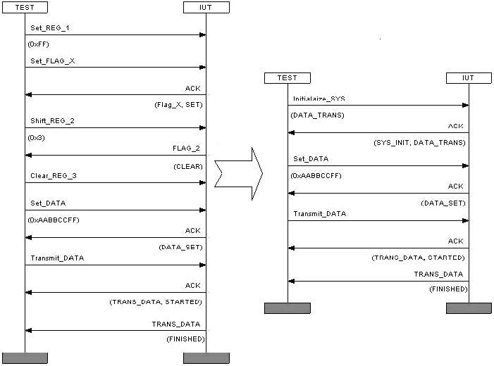
Figure 49. Description minuteness level
When minuteness is deep, generation process becomes trivial, but it is necessary to obtain majority of separate events in template. From the other side, if description is too general, the number of events on MSC diagram is few, but each of them contains the set of lower level events. In this case the problem is raised of qualitative coupling of such blocks, if there are different variants of looking through events. Evidently, there is the need to come to harmonious balance.
    - Input data description (ATS – Time Transition Form) and aspects, connected with constructions of generated code
Universal, abstract presentation of test suites is the result of ATSGEN work. On the output of ATSGEN user gets file in TCL language, which is abstract test suites (ATS). ATS is input to generation template. Due to its structural core ATS is represented with set of data structures and some parameterized sequence of procedures calls. Number, type and purpose of the procedures are strictly fixed. The task of direct generation module realization is realization of called procedures in ATS. Data structures in ATS deliver full set and description of parameters, set on MSC diagrams and in XML configuration files. The sequence of functions is description of test work process in according to MSC scenarios. Each procedure, called in ATS is briefly described below, but procedure “State”, which is described separately. Purpose and type of parameters of these procedures are pointed in Appendix B.
StartTestSuite – this procedure is called at the beginning of all test suite description. Its task is in elements generation, which are common for all test suite. For example: global variables, memory allotment functions and etc.
EndTestSuite – this procedure is called at the end of all test suite description. Its main task is in execution of elements’ generation, which is common for test suite, which stored up information during whole generation process.
StartTestCase - this procedure is called at the beginning of each test description. Its main task is to execute elements’ generation, which are common for the test. For example: global variables, memory allotment functions and etc. There is the need to execute data structures’ generation, which are responsible for such test parameters as: variables, time labels and list of names and identifiers. Structures fields are filed in with data, got from input parameters.
FinishTestCase - this procedure is called at the end of test description. Its main task is to produce generation of elements, which are common for test suite, which stored up information during whole test generation process.
    - “State” procedure
In correspondence to ATS design the procedure is to form and generate target code, which is responsible for some event realization, described in MSC. Parameters of the procedure contain full set of information to generate such code. It is necessary to realize all rules of MSC constructions conversion exactly in this procedure; also it is necessary to pay special attention to generation of linear and nonlinear areas of execution. In the case of linear execution procedure’s parameter is current moment event description. It is also important to provide dynamic realization of statically generated code. The remark responds to alternative sets of events. MSC constructions allow describing system behavior, where one from the set of possible events is realized. In this case parameters of the procedure contain list of all possible events on the current moment. Description and system execution conditions are generated statically, the choice of concrete event due to the defined conditions is realized dynamically when system is working.
If in the current state it was possible to realize some alternative events, then the procedure would contain the list of all possible conditions.
Due to the parameters value, describing number of events of different types, serious obtaining of list of events is realized. Events from the list are sorted in correspondence with priority. Priority gradations are the following: logical events, timer events, passive events, and active events.
Examples of events obtaining in ANSI C language follows. However, structural realization of the given examples of code could be realized in other test suites generation target languages.
Timer events and logical events are obtaining first. They include events of standard terms (IF, WHILE, ASSERT).
- “IF” term is specific for MSC of “ALT” type. It allows choosing any alternative of system behavior. If the term is executed corresponding alternative branch is chosen and the following actions from the branch are executed. Generated code is presented on Figure 50.
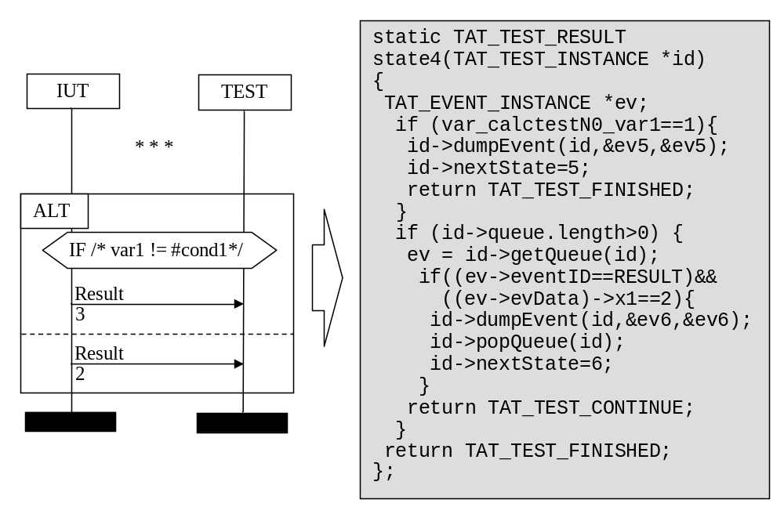
Figure 50. Generation of “IF” term
- “WHILE” term is specific for MSC construction of “LOOP” type. This term allows realization of cycle on MSC diagram in very close to major of target languages notation. Connection becomes evident, when using MSC variables with cycle terms. Generated code can be viewed on Figure 51.
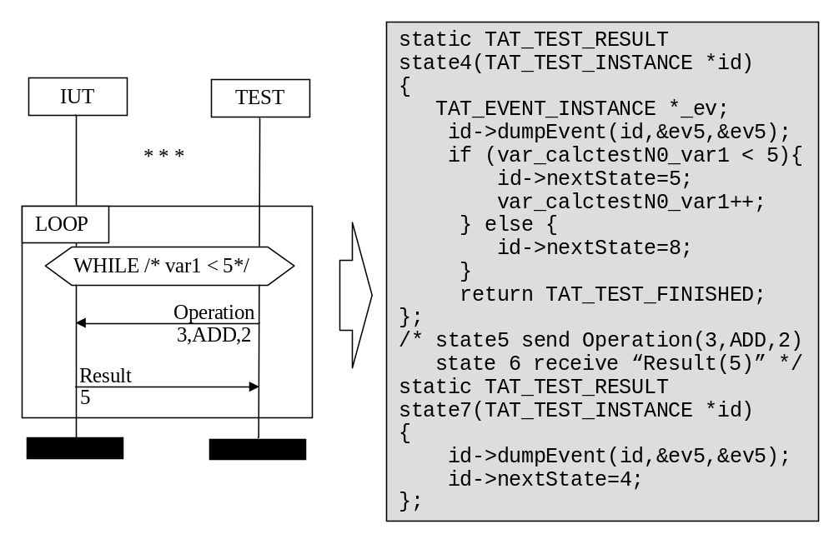
Figure 51. Generation of “WHILE” term
- “ASSERT” term can be applied in every construction. However it has no outlined similarity with target language. The MSC term provides test of term in target language. In case of its execution system work goes on, else it would be interrupted, and test would be finished with error. Generated code can be viewed on Figure 52.
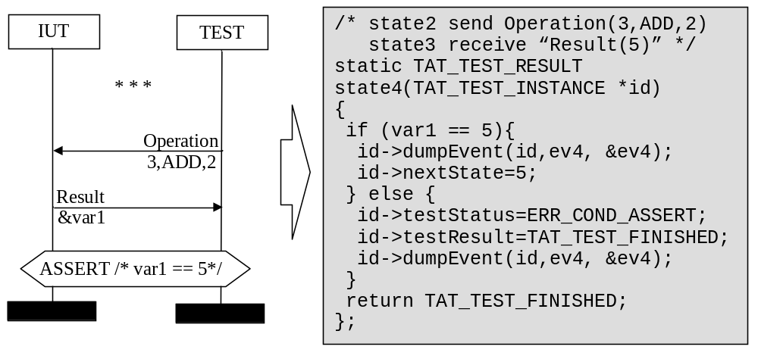
Figure 52. Generation of “ASSERT” term

Further passive events obtaining is realized. Passive events are those messages (signals), which are got from tested system. Thus, generated code accomplishes dynamic check of system work results and input data transformation. Here waiting of message appearance in the internal queue of current system is realized. If message is absent, when it is queried, then thread of execution is transmitted to the tested system. After control returning to the tested environment, message test is resumpted. If it is found in the queue, it is read and all event’s parameters (time, when the even occurred, its name and direct parameters) are checked. If all necessary terms are fulfilled, then next event is obtained, or:
- for linear case control delivery to tested system is realized immediately and event’s waiting is renewed
- for non-linear case delivery to testing of terms (considering to another alternative of behavior) is realized, after looking through all possible alternatives, delivery of control to the tested system is realized and waiting of event renews.
On the expiry of set number of waiting cycles (set timeout) system work is finished and error message is given out. Generated code can be viewed on Figure 53.
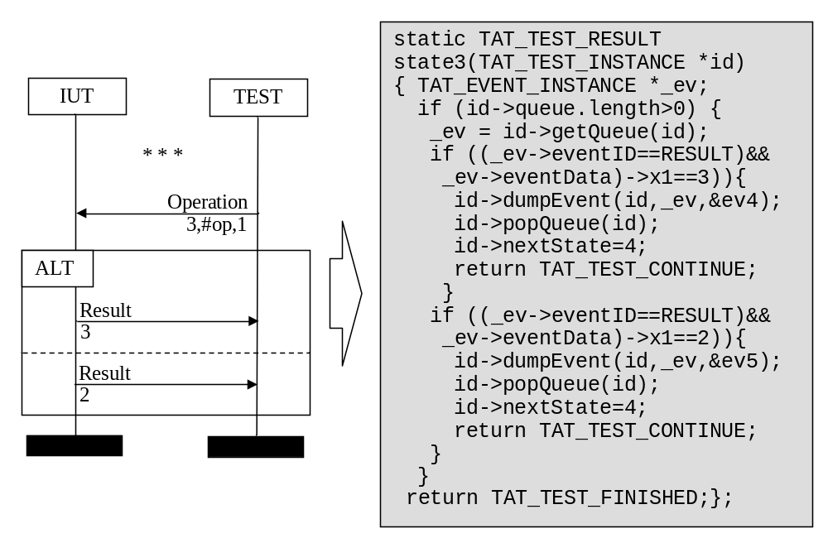
Figure 53. Generation of passive alternative
At the end, active events are obtained. These are events of signals (impacts) sending to the tested system and MSC constructions of “ACTION” type (direct writing of target code on MSC diagram). For events of “ACTION” type always direct representation to target code takes place. Generated code can be viewed on Figure 54.
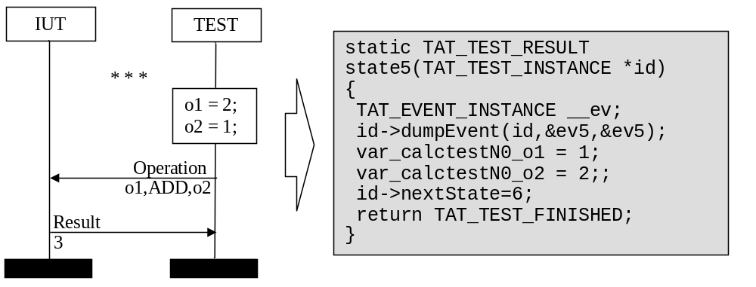
Figure 54. Generation of “ACTION” construction
When obtaining events of sending impacts to the tested system, code is generated, which provides the check of allowed time term for event in dynamic work of system. If time of event has not come yet, then control is transmitted to the tested system for time counter incrimination. If current time later, then time of event, then systems work is interrupted and error message is given out. When time term is executed, function, which impacts the system, is called. Similar with passive events, here can be variant of alternative ways to active events existence. In this case forced iterative look through of such variants is realized (test has passed through several phases). Generated code can be viewed on Figure 55.
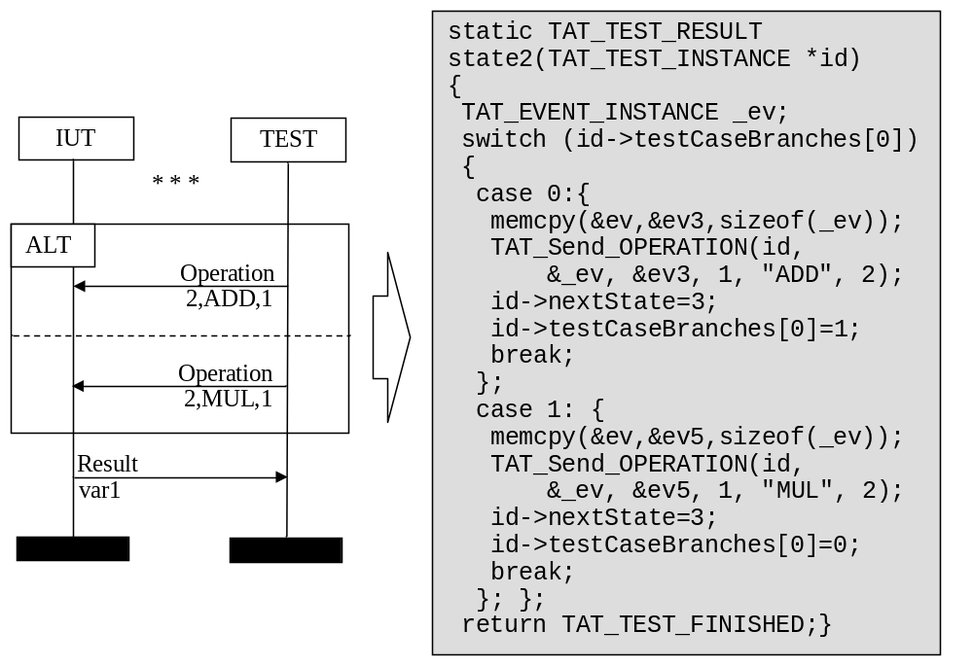
Figure 55. Generation of active alternative
It is necessary to note, that for non-linear variant the situation is possible, when at the concrete moment in system there is an opportunity of realization passive as well as active event. This alternative of behavior is called mixed. It obtaining is separated in two parts, corresponding to the event’s type (active or passive). Each part is obtained due to the rules, described above. Two blocks are interconnected in according with priority like follows. First of all queue is checked and system’s answers (if they are existing) are obtained. In case got messages are absent, then the ability of sending impacts to system is checked. If sending terms are executed, then it is realized without any waiting for system’s response. Either, control transfer and checks resumption cycle is repeated due to the set scope, in similar to above description. Generated code can be viewed on Figure 56.
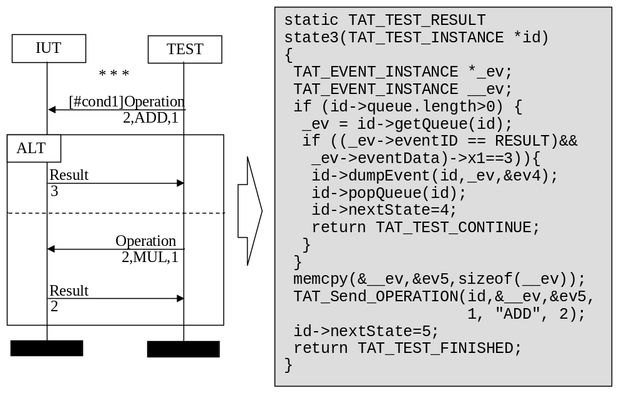
Figure 56. Generation of mixed alternative
From all functionality description of the procedure, it is evidently seen, that is has main sense load of code generation. That is why whole functionality is realized in the set of different internal procedures calling each other and interconnected with this procedure.
  - Command Line
Smart Template can be launched from the command line via standard Tcl shell interpreter:
- tclsh cgtc.tcl -ats <ATS file> [options]
If no argument is given to Smart Templates then the help on options usage will be outputted.
Smart Template have accepted the same set of options. This section explains each of these options, along with any considerations, which must be taken into account when executing the templates.
Table 20 outlines options of Smart Templates.
Table 20: Command line options of Smart Templates
ID | Option/Switch | Description
1 | [-ats <ATS file>]  : input ATS files | This option allows you to specify ATS file to be processed.
2 | [-break] : break test case execution | If this option is specified then test case execution shall be interrupted after the first error detection
4 | [-inst]  : instance support | This option is used to enable instance check functionality
5 | [-log]  : log of generation | If this option is specified then log file of generation process shall be created
6 | [-multi] | If this option is specified then each test case shall be generated in a file
7 | [-nomain]  : no main function | If this option is specified then shall not be ‘main’ function in the generated target code
8 | [-o <output_path>]  : output path | This option causes Smart Template to generate code into directory specified by <output_path>.  If this option is not specified all generated files shall be created in the current directory.
9 | [-qcheck] | This option is used to check the queue for unprocessed messages
10 | [-time]  : time support | This option is used to enable time support functionality
12 | [-spcomm] | This option is used to output signal`s parameters comments
13 | [-wrap <file name>]  : generate wrapper | This option causes Smart Template to generate wrapper source and header files with name specified by <file name>. Default name for wrapper files is ‘wrapper’.
14 | [-iwrap <files name>] | This option is used to include files with specified names to wrapper prototype. This option works only with option –wrap.
15 | [-sdl <version>] | This option is used for integration with Telelogic Tau SDL Suite and Telelogic Tau G2. Version equals to 1 or 2, default is 1.
16 | [-reset <signal>] | When -sdl and -wrap options are specified, this option specifies the signal to be transmitted to SDL system to reset it to initial state. Otherwise this option has no effect.
17 | [-env <instance>] | When -sdl and -wrap options are specified, this option is used to specify default environment instance. Otherwise this option has no effect.
18 | [-model <instance>] | When -sdl and -wrap options are specified, this option is used to specify default model instance. Otherwise this option has no effect.

  - API in code generated by CGTC
    - Creating Test Instance
TAT_TEST_INSTANCE* TAT_CreateTestInstance(size_t qsize, size_t logsize, size_t timelimit, TAT_SYSTEM_INIT, TAT_SEND_CALL, TAT_CLOCK_FUNC, TAT_TEST_STARTED, TAT_TEST_FINISH );
Parameters:
logsize - maximal number of dumping modules
qsize - maximal size of queue for messages (must be greater than zero)
timelimit - timeout specification
TAT_SYSTEM_INIT - function with following prototype:
typedef TAT_TEST_RESULT (*TAT_SYSTEM_INIT) (TAT_TEST_INSTANCE*);
This function is to be called every time test case starts and shall reset state of IUT.

TAT_SEND_CALL - function with following prototype:
typedef TAT_TEST_RESULT (*TAT_SEND_CALL) (TAT_TEST_INSTANCE*, TAT_EVENT_INSTANCE*);
This function is called each time test cases sends message to IUT. TAT_EVENT_INSTANCE contains SEND message which shall be passed to IUT.

TAT_CLOCK_FUNC - function with following prototype
typedef TAT_TIME_TYPE (*TAT_CLOCK_FUNC) (TAT_TEST_INSTANCE*);
This function is called every time test cases retrieves current time.

TAT_TEST_STARTED - function with following prototype
typedef TAT_TEST_RESULT (*TAT_TEST_STARTED) (TAT_TEST_INSTANCE*);
This function is called each time test cases started after resetting IUT. Use NULL, if not specified.

TAT_TEST_FINISH - function with following prototype
typedef TAT_TEST_RESULT (*TAT_TEST_FINISH) (TAT_TEST_INSTANCE*);
This function is called every time test cases finishes, including successful and unsuccessful verdict. Use NULL, if not specified.
    - Closing Test Instance
int TAT_FreeTestInstance(TAT_TEST_INSTANCE*);
    - Registering dump module
TAT_TEST_RESULT TAT_RegisterLogFunc(TAT_TEST_INSTANCE*,
TAT_TEST_OPEN_LOG, TAT_TEST_LOG, TAT_TEST_CLOSE_LOG);
Use this function after creating test instance to register specific dumping functions associated with it. Each dump function shall have following prototype:

typedef TAT_TEST_RESULT (* TAT_TEST_OPEN_LOG) (TAT_TEST_INSTANCE*);
TAT_TEST_OPEN_LOG function is called each time test case starts, including each iteration of test case.

typedef TAT_TEST_RESULT (* TAT_TEST_LOG) (TAT_TEST_INSTANCE*, TAT_EVENT_INSTANCE*, TAT_EVENT_INSTANCE*);
TAT_TEST_LOG function is called to dump each event in test cases. First event is actual event, second one is original. If actual event is set to NULL, it shall be treated as error case and appropriate record shall appear in dump file.

typedef TAT_TEST_RESULT (* TAT_TEST_CLOSE_LOG) (TAT_TEST_INSTANCE*);
TAT_TEST_CLOSE_LOG function is called each time test case iteration finished. The purpose of this function is to close dump file.
    - Test Instance Message receiving function
TAT_TEST_RESULT TAT_ReceiveMessage(TAT_TEST_INSTANCE*, TAT_EVENT_INSTANCE*);
IUT shall call this function each time new message to environment occurs.

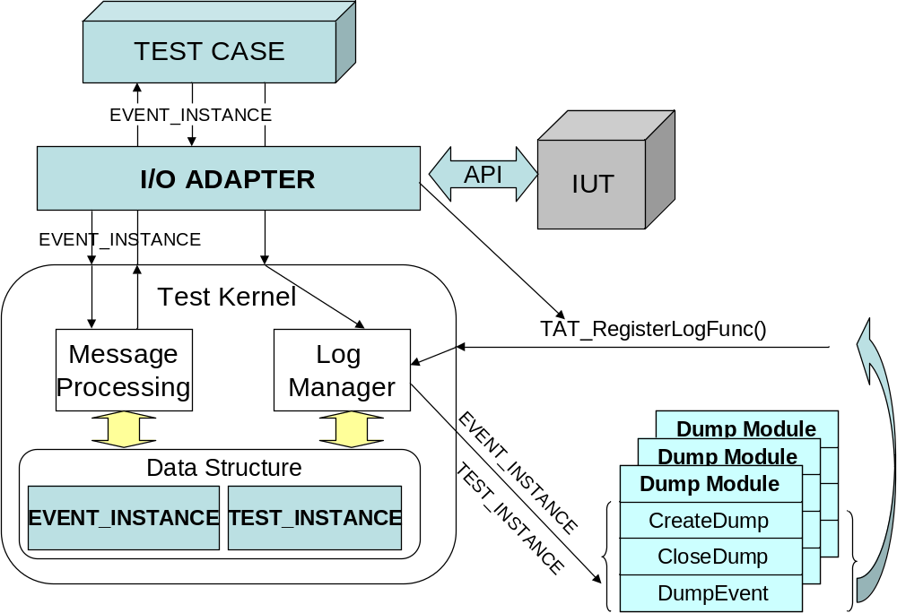
Figure 57. Structure of generated code
    - Control over Test Cases execution
TAT_TEST_RESULT TAT_StartSuite(TAT_TEST_INSTANCE*, TAT_SUITE_INIT );
This function shall be called to initialize specific Test Suite, fill TEST_INSTANCE fields to suite specific values (signals, instances definitions, test table etc.). Call to this functions doesn’t leads to immediate test case execution. It just prepares required data structures.

TAT_TEST_RESULT TAT_ContinueSuite(TAT_TEST_INSTANCE*);
Call to this function leads to continuation of test case. It starts new test case if no one is started, switches between test cases and test iterations automatically.

TAT_TEST_RESULT TAT_StartTest(TAT_TEST_INSTANCE*, size_t id);
Call to this function leads preparation to start specific test case.

TAT_TEST_RESULT TAT_ContinueTest(TAT_TEST_INSTANCE*);
Call to this functions leads execution of test case prepared by TAT_StartTest function.

TAT_TEST_RESULT TAT_StartNextTrace(TAT_TEST_INSTANCE*);
Call to this functions prepare TEST_INSTANCE to start of next iteration of initialized test case.

TAT_TEST_RESULT TAT_ContinueTrace(TAT_TEST_INSTANCE*);
Call to this functions leads to execution of current iteration of initialized test case.
  - User defined data types support
TAT allows a user to define both scalar and complex data types. For each user-defined data type the following functions are generated (replace datatype with actual data type name):
    - Dump function
int TAT_Dump_datatype (void * data, char * dest)
This function converts data to datatype* and appends its string representation to dest. It is used in logging modules.
    - Free function
int TAT_Free_datatype (datatype * x)
This function is used to free all dynamic memory allocated for x. It is called when the data structure is no longer needed.
    - Copy function
datatype TAT_Copy_datatype (datatype src)
This function is used to create a copy of a data structure src.
    - Compare function
int TAT_Compare_datatype (datatype x1, datatype x2)
This function compares x1 and x2 and returns 0 if equal, 1 otherwise.

All these functions are located in test suite common code file. The test suite header file contains declaration for all user defined data types. The following data types are supported:
Type | Definition in XML configuration file | Usage in MSC message parameter
Synonym | name=“new_type” type=”old_ name” | Value
Structure | name=”new_type” type=”struct” | (. Value1, Value2, … .)
Array | name=”new_type” type=”element_type” dimension=”dimension” | (: Value1, Value2, … :)
Dynamic array | name=”new_type” type=”element_type” dimension=”var” | (: Value1, Value2, … :)
Linked list | name=”new_type” type=”element_type” dimension=”list” | (: Value1, Value2, … :)
String (SDL only) | name=”new_type” type=”element_type” dimension=”string” | (: Value1, Value2, … :)
  - Tau SDL Integration
CGTC supports a simplified way to test SDL systems designed with Telelogic Tau SDL Suite or Telelogic Tau G2. It allows using SDL data types in TAT without conversion in wrapper. CGTC also provides automatic generation of a wrapper for SDL system.
    - SDL data type support
CGTC must be invoked with -sdl command line switch. All user-defined data types must be defined in XML configuration file. The paramstype attribute of these data types must be “SDL”. This prevents CGTC from generating declarations of these data types since they are already declared in SDL model source files. Note that SDL model header files must be included with -incl command line swith in ATSGEN. However there is no need to include standart Telelogic Tau header file scttypes.h which is included automatically if -sdl command line switch is present.
    - Wrapper generation
If both -sdl and -wrap command line switches are present, a special wrapper is generated. It is much similar to a generic wrapper prototype generated for non-SDL systems (see Section 18) but there are some differences. This wrapper contains implementations of SDL system environment functions xInitEnv, xCloseEnv, xOutEnv, xInEnv, xGlobalNodeNumber and SDL_Clock. This wrapper is a passive wrapper containing no main() function. However it contains the following functions:
- WrapInit() – called by xInitEnv() to initialize test environment.
- WrapClose() – called to xCloseEnv() to close test environment.
- WrapRun() – continues test execution to get response to model’s actions.
The SDL wrapper provides the following features:
- Transmitting messages from test to IUT and from IUT to test.
- Synchronizing SDL and test clock and advancing model time.
- Using multiple instances in environment and addressing them.
In most cases this wrapper can be used “as is”.

- Developing Wrappers for SiC Generated Code

This section provides information on how to develop wrappers for SiC generated code.
  - What is wrapper?
Wrapper is a module developed in the target language which binds the generated test environment with IUT interfaces Figure 58. Wrapper structurally represents separate programming module realized in target language. Its direct task includes providing of “binding together” tested system and test environment. All aspects of interconnection, questions of coupling are solved in wrapper. Test environment, generated on the base of MSC diagrams, sends impacts to system and receives system response to the impact by means of this program module. Also all additional functionality, necessary for user is realized there.
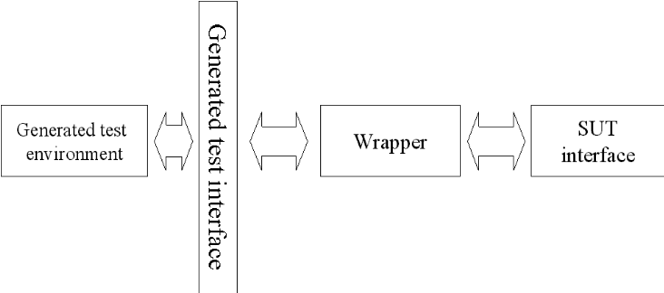
Figure 58. Developing wrappers - general scheme
Wrapper shall utilize the exported/imported functions of the generated code interface.
Design of code template reflects directly on projecting of wrapper. When DCGT developing, try to avoid necessity of wrapper creation or minimize its functionality. For DCGT this approach is quite suitable, as there is the ability of target code generation, directly in interface’s notation in the tested system. For MPCGT wrapper creation is necessary. When developing MPCGT, choose one project area, where template use is planned. So, there is no concrete information about system interfaces or data structures with which system is working. In this case, code generation is built the way to provide user with some universal interface from the side of test environment. Such interface contains all data plenitude, entered on MSC diagrams. Here user is to execute coupling of data stream and control stream among tested system (known in the concrete project) and generated test environment (universal for all projects).
Main task of wrapper is to couple interfaces of generated test set and generated system. MPCGT realization allows letting user some standard interface from the side of generated set. Using such an interface user’s task is to develop functionality of transformation of test environment calls to the tested system function calls.
Advanced structure of wrapper is not imperative. Users may change prototype, add it or create it due to another approach, fulfilling just one required term – to support standard interface of generated test environment.
Data exchange, and information on test environment condition receiving, is realized with delivery and applying to data structures of TAT_TEST_INSTANCE and TAT_EVENT_INSTANCE types.
To support standard interface in TAT_TEST_INSTANCE structure it is necessary to initialize set of pointers to appropriate functions. These functions are to be realized in wrapper. Procedure of pointers initializing is realized by means of TAT_CreateTestInstance (17.1.1). Evidently, functions, used in further description are not principal.
    - TAT_TEST_INSTANCE data structure
This data structure contains the set of fields of different types, including other structures. Main functional structure’s load is to keep current system state pointers to data structure, obtaining when generation, and pointers to functions. The function is unique for each test set and is the example of all main functions of test environment and of wrapper. The approach is rather comfortable, as it allows each function get full access to data and all system functionality by means of one parameter. Purpose of structure’s elements is described in Table 21:Elements of data structure TAT_TEST_INSTANCE.
Table 21:Elements of data structure TAT_TEST_INSTANCE
Name | Type | Description
instanceID | size_t | Unique identifier
resetSystem | TAT_SYSTEM_INIT | Pointer to user’s function for system reset when running
testCaseCall | TAT_TEST_FUNC | Pointer to generated function of test scenarios
testCaseStart | TAT_TEST_STARTED | Pointer to user’s function, called when each test from test suite starts execution
testCaseFinish | TAT_TEST_FINISH | Pointer to user’s function, called when, each test from test suit finishes execution
sendMessage | TAT_SEND_CALL | Pointer to user’s function, transmitting impact from environment to tested system
internalClock | TAT_CLOCK_FUNC | Pointer to user’s function, defining current time
clock | TAT_TIME_TYPE | Field, containing system current time value
timeoutCounter | size_t | Field, containing current value of counter of waiting times
timeoutLimit | size_t | Field, containing current value of limit of counter of waiting
runned | unsigned int | Field-flag, set when element of test suite is run
queue | TAT_QUEUE | Field-structure of internal queue of storage of tested system answers
logMethods | TAT_LOG_FUNC_STRUCT* | Field-pointer to the array of pointers to recordation functions
logMethodsNumber | size_t | Field, containing current number of recordation modules
logMethodsLimit | size_t | Field, containing limit number of recordation modules
getQueue | TAT_GET_QUEUE | Pointer to function of element internal queue reading
popQueue | TAT_POP_QUEUE | Pointer on function of element deleting from internal queue
openLog | TAT_TEST_OPEN_LOG | Pointer on internal function of starting work with recordation modules
dumpEvent | TAT_TEST_LOG | Pointer on internal function of recordation modules, when test suite is executed
closeLog | TAT_TEST_CLOSE_LOG | Pointer on internal function of work finishing with recordation modules
signalCount | size_t | Number of signals in test suite
signalDef | TAT_SIGNAL_DEF* | Pointer to the array of test suite structures description
instanceCount | size_t | Number of test instances on MSC
instanceDef | TAT_INSTANCE_DEF* | Pointer on array of test suite structures description
testStatus | TAT_TEST_ERROR | Field of current status of test suite execution
testResult | TAT_TEST_RESULT | Field of current result of test suite execution
currSuiteName | char* | Указатель на строку, содержащую имя данного тестового набора
testCount | size_t | Number of tests in test suite
testTable | TAT_TEST_TABLE* | Pointer on array of structures of test suite tests’ description
currCaseName | char* | Pointer on the string, containing name of the given test from test suite
currCaseID | size_t | Field containing identifier of current test from the table of tests
initedCaseID | size_t | Field, containing identifier of initialized test from the table of tests
currCaseIteration | size_t | Field, containing value of current iteration of given test
nextState | int | Field, containing next condition, when test execution
branchCount | size_t | Number of active alternatives for current test
repeatCount | size_t | Number of repetitions for current test
timerCount | size_t | Number of timers for current test
loopCount | size_t | Number of cycles for current test
testCaseBranches | size_t* | Pointer on array of variables, which are responsible for current state of each alternative in test
testCaseTimers | size_t* | Pointer on array of variables, which are responsible for current state of each timer in test
testCaseLoops | size_t* | Pointer on array of variables, which are responsible for current state of each cycle in test
timeLabelCount | size_t | Number of time labels for current test
timeLabels | TAT_TIME_LABEL_DEF* | Pointer on array of variables, which are responsible for time labels description in test
timeLV | TAT_TIME_TYPE* | Pointer on array of variables, which are responsible for current state of time labels in test
varCount | size_t | Number of variables for current test
varDefs | TAT_VARIABLE_DEF* | Pointer on array of variables, which are responsible for variable description from MSC diagram in test
vars | void** | Pointer on array of pointers, which are responsible for current state of variables from MSC diagram in test
srcFilesCount | size_t | Number of initial MPR files
srcFiles | TAT_SRC_FILE_DEF* | Pointer on array of descriptions of initial MPR files
    - TAT_EVENT_INSTANCE data structure
This structure contains full set of fields of different types, including other structures. Main functional load of this structure is to keep all parameters of any event, which could be described in MSC. Variables of this structure’s type are created statically, when generating test suite and they are describing events for each test from test suite. All functions, which somehow work with current event in system, receive all data on event by means of parameter transmission – pointer of the described structure’s type. This approach allows function to get full access to all obtained event parameters by means of one parameter. Purpose of the structure’s elements is described in Table 22.
Table 22: Elements of data structure TAT_EVENT_INSTANCE
Name | Type | Description
eventType | TAT_EVENT_TYPE | Type of the given event from the array of possible events
eventID | TAT_EVENT_ID | Identifier of current event number (actual just for events of “signal” type)
eventData | void* | Pointer to event’s data
eventTime | TAT_TIME_STRUCT | Pointer to structure, which describes time of event’s execution
eventInstanceSize | size_t | Number of test instances from MSC diagram, on whish event was executed
eventInstance | TAT_INSTANCE_ID* | Pointer to array of identifiers of test instances from MSC diagram, on which event was executed
eventComment | char* | Pointer to the string, containing comment to event, pointed on MSC diagram
srcRefInfLen | size_t | Number of references to initial MPR files
srcRefInf | TAT_SRC_REF_STRUCT* | Pointer to the array of references of initial MPR files (file number, string number)
eventTimeLabel | int | Number of time label of current state in array of labels for given test
eventInitialText | char** | Pointer to array of strings, describing event and parameters in text view
    - Function resetSys
This function provides initialization of the tested system, when running each test. Function has the following parameters, described in Table 23.
Table 23: Parameter description of resetSys function
Name | Type | Description
Id | TAT_TEST_INSTANCE* | Pointer to typical structure of current test instance
Returned value has TAT_TEST_RESULT type. In case of error’s origin in system, during initialization process, function is to return TAT_TEST_CRITICAL. Then test execution is interrupted and error message is given out. If all action, defined in the function have no errors, then to continue test execution it is necessary to return value TAT_TEST_CONTINUE. Code example is presented below:
TAT_TEST_RESULT resetSys(TAT_TEST_INSTANCE *id)
{
if (!id) return TAT_TEST_CRITICAL;
/*TODO: implement system reset and initialization*/
return TAT_TEST_CONTINUE;
}
This function realization is obligatory.
    - Function sendMess
This function is called with pointer from TAT_TEST_INSTANCE structure, if there is the need to send some impact to tested system. In other words, all active signals on MSC diagram are translated to this function’s calls. Active signal, as all others on the diagram, has description of TAT_EVENT_INSTANCE type in generated code. The function has the following input parameters, described in Table 24.
Table 24: sendMess function description of parameters
Name | Type | Description
id | TAT_TEST_INSTANCE* | Pointer to typical structure of current test instance
event | TAT_EVENT_INSTANCE * | Pointer to data structure, describing event

Parameters are to be significant. Returned value is of TAT_TEST_RESULT type. If parameter id or event has NULL significance, function is to return TAT_TEST_CRITICAL value and test execution is interrupted due to critical error. Further by means of identifier (field eventID structure of TAT_EVENT_INSTACE type) concrete event is defined (that is impact), which is to be transmitted to system. If error occurs, when transmitting impact, then returned value is to be equal to TAT_TEST_FINISHED, field testStatus of TAT_TEST_INSTANCE structure has to have significance of the error. Test execution is interrupted and error message is given out. If all actions, defined in the function have no errors, then to continue test execution it is necessary to return TAT_TEST_CONTINUE value. Code example is presenter below:
TAT_TEST_RESULT sendMess(TAT_TEST_INSTANCE *id, TAT_EVENT_INSTANCE *event)
{
if (!id || !event)
{
return TAT_TEST_CRITICAL;
}
/* handle only SEND events */
if (event->eventType == TAT_SEND_EV)
{
switch (event->eventID)
{
case TAT_S_POWER_ON_ID: /* POWER_ON message */
{
/*TODO: implement system handle and check return*/
break;
}
case TAT_S_MULTI_OPERATION_ID: /* MULTI OPERATION message */
{
/*TODO: implement system handle and check return*/
break;
}
}
}
return TAT_TEST_CONTINUE;
}
This function realization is obligatory.
    - Function clockF
By means of this function test environment gets information on system current time. Clocking module itself can be a part of the tested system or some external module. Function has the following input parameters, described in Table 25.
Table 25: clockF function parameters description
Name | Type | Description
Id | TAT_TEST_INSTANCE* | Pointer to typical structure of current test instance
Parameter is to be significant. Returned value has TAT_TIME_TYPE type. Code example is presented below:
TAT_TIME_TYPE clockF (TAT_TEST_INSTANCE *id)
{
/*TODO: implement timer handler*/
return SystemClock;
}
This function realization in wrapper is obligatory.
    - Functions startCase and finishCase
These functions are called at the beginning and at the end of each test execution correspondingly. Sense load of the functions is not standardized, it is left to user’s discretion. Usually, these functions are used for memory allotment and cleaning, closing and opening of files and etc. Function has the following input parameters, described in Table 26.
Table 26: startCase and finishCase functions parameter description
Name | Type | Description
Id | TAT_TEST_INSTANCE* | Pointer to typical structure of current test instance
Returned value has TAT_TEST_RESULT type. If error occurs in system, when initializing, functions are to return value TAT_TEST_CRITICAL. In this case test execution is interrupted and error message is given out. If all actions, defined in the functions have no errors, then to continue test execution it is necessary to return TAT_TEST_CONTINUE value.
This functions realization in wrapper is not obligatory.
    - Function TAT_ReceiveMessage
This function is external interface function to be used in wrapper. By means of this function test environment gets system response to the sent input impact. Function has the following input parameters, described in Table 27.
Table 27: TAT_ReceiveMessage function parameter description
Name | Type | Description
id | TAT_TEST_INSTANCE* | Pointer to typical structure of current test instance
evInst | TAT_EVENT_INSTANCE* | Pointer to typical structure, describing happened event of system response
To input second parameter to function, it is possible to create such structure beforehand in the form of global variable of TAT_EVENT_INSTANCE type in wrapper for each possible response from tested system. In this case it is necessary to fill with notion just the following fields of TAT_EVENT_INSTANCE structure (<SIG_NAME> is the name of response signal in the highest register):
Name | Type | Description
eventType | TAT_EVENT_TYPE | TAT_RECV_EV
eventID | TAT_EVENT_ID | TAT_S_<SIG_NAME>_ID
eventData | void* | &sig_<SIG_NAME>, if signal has no parameters here, it is necessary to NULL
eventInstanceSize | size_t | 2
eventInstance | TAT_INSTANCE_ID* | &inst_<SIG_NAME>
It is necessary to assume significations by default to other fields. Due to the table there is the need to set beforehand:
- Data structure to transmit parameters of response signal. It is set by notification of a global variable of TAT_SIG_<SIG_NAME> type in wrapper with direct initialization.
- Input and output instances for given response signal. Setting is realized by notification of 2-dimention array of global variables of TAT_INSTANCE_ID type with direct initialization.
TAT_INSTANCE_ID inst_ALLSIG[]={TAT_I_CALC_MODEL_ID,TAT_I_MAN_ENV_ID};

TAT_EVENT_INSTANCE ev_ACK = {TAT_RECV_EV, TAT_S_ACK_ID, NULL,{{0,0},{0,0},""},
2, inst_ALLSIG, NULL, 0, NULL, TAT_VERDICT_PASS,
-1, NULL};

ТAT_SIG_RESULT sig_RESULT = {"",0,"",0,"","",0};
TAT_EVENT_INSTANCE ev_Result={TAT_RECV_EV,TAT_S_FULL_DEBUG_RESULT_ID,
&sigFullDebugResult, {{0,0}, {0,0}, ""},
2, inst_ALLSIG, NULL, 0, NULL, TAT_VERDICT_PASS,
-1, NULL};
When this function is called as system output handler, event’s description (got by means of standard parameter) is placed to internal queue of test description. If test suit is already run, then function is exited. If on the previous step, exit from test suite was realized, and control transformation to the tested system to get output was realized, then from the function entrance to the test suite (to continue executing) is fulfilled. The example of tested system output return is depicted below (output without parameters and with set of parameters):
* * *
TAT_ReceiveMessage(TI_ID, &ev_ACK);
* * *
sig_RESULT.x1=res1;
sig_RESULT.x2=res2;
sig_RESULT.x3=res3;
TAT_ReceiveMessage(TI_ID, &ev_RESULT);
* * *
Returned value has TAT _TEST_RESULT type. If it is impossible to place it to queue, the returned value is TAT_TEST_CRITICAL, and test executing is interrupted due to critical error. In case of successful placing in queue the returned value is TAT_TEST_CONTINUE and test execution goes on.
    - Function main
This function is the standard entrance point of ANSI C language. Test suite is executed using this function.
On the first step test instance creation is realized. In wrapper global variable of pointer to TAT_TEST_INSTANCE structure type is defined. Interface function TAT_CreateTestInstance returns pointer to initialized structure value. This function is called with the next parameters:
- Queue size
- Number of dumping modules
- Timeout size
- Pointer to resetSys function
- Pointer to sendMess function
- Pointer to clockF function
- Pointer to startCase function
- Pointer to finishCase function
Further it is necessary to register dumping modules. To do it, call interface function TAT_RegisterLogFunc for each module with the next parameters (in correspondance with fixed launching interface):
- Pointer to created structure of test instance
- Pointer to initialization (opening) of data format function
- Pointer to direct event dumping function
- Pointer to closing dump format function
On the next step interface function TAT_StartSuite for additional initialization of test instance structure is called. The function’s input parameters are: pointer to created structure of test instance, and pointer to generated function of additional initialization (generation of additional function is realized to “<test_suite_name>data.c” file).
Further to execute tests suite interface function TAT_ContinueSuite is called. The function’s parameter is transmitted to the function pointer to created structure of test instance. Exit from the function is possible in two cases: if test suit is executed, or if expected from tested system to given input impact reply is absent. The second variant needs organization of a cycle for repeat entrance to test execution, and also to provide control transmission to tested system to obtain it in such a situation.
Finishing there is the need to call TAT_FreeTestInstance interface function with pointer to created structure of test instance as the parameter of cleaning allocated memory. Code example is presented below:
int main(int argc, char *argv[])
{
TAT_TEST_RESULT res;
TI_ID = TAT_CreateTestInstance(128, 3, 4096,
resetSys,
sendMess,
clockF,
startCase,
finishCase);
if (!TI_ID)
{
printf("ERROR: can't initialize test instance\n");
return 1;
}
TAT_RegisterLogFunc(TI_ID,
TAT_OpenLogMPR,
TAT_LogFuncMPR,
TAT_CloseLogMPR);
TAT_RegisterLogFunc(TI_ID,
TAT_OpenLogTXT,
TAT_LogFuncTXT,
TAT_CloseLogTXT);
res = TAT_StartSuite(TI_ID, TAT_Init_calctest);
while (res == TAT_TEST_CONTINUE)
{
res = TAT_ContinueSuite(TI_ID);
/*TODO Optional: IUT request */
}
if (res == TAT_TEST_CRITICAL)
{
printf("ERROR: critical error during execution\n");
}
TAT_FreeTestInstance(TI_ID);
return (res==TAT_TEST_CRITICAL);
}
User is free to add or widen functionality inside the function as far as in the prototype.

  - Example wrapper
The framework for developing wrappers to support SiC can be found in example/wrapper directory of the SiC installation.
The following sections show basic routines for using CGTC generated code interface.
    - Transmitting messages to IUT
For each message to be transmitted to IUT TAT_SEND_CALL function specified with test instance creation is called. The purpose of this function is to analyse sent signal and make appropriate actions like passing message to IUT or immediate processing and sending back result.
The following code illustrates TAT_SEND_CALL function with immediate processing of messages:
TAT_TEST_RESULT mpctest_sendMess(TAT_TEST_INSTANCE *id, TAT_EVENT_INSTANCE *event)
{
if (!id || !event)
{
return TAT_TEST_CRITICAL;
}
/* handle only SEND events */
if (event->eventType == TAT_SEND_EV)
{
switch (event->eventID)
{
case TAT_S_OPERATION_ID: /* OPERATION message */
{
puts("OPERATION");
if (strcmp(((TAT_SIG_OPERATION *)event->eventData)->x2, "ADD")==0)
{
sigResult.x1=(((TAT_SIG_OPERATION *)event->eventData)->x1)+(((TAT_SIG_OPERATION *)event->eventData)->x3);
} else
if (strcmp(((TAT_SIG_OPERATION *)event->eventData)->x2, "SUB")==0)
{
sigResult.x1=(((TAT_SIG_OPERATION *)event->eventData)->x1) - (((TAT_SIG_OPERATION *)event->eventData)->x3);
} else
if (strcmp(((TAT_SIG_OPERATION *)event->eventData)->x2, "MUL")==0)
{
sigResult.x1=(((TAT_SIG_OPERATION *)event->eventData)->x1)* (((TAT_SIG_OPERATION *)event->eventData)->x3);
}

TAT_ReceiveMessage(id, &ev_Result);
break;
}
case TAT_S_POWER_OFF_ID: /* POWER_OFF message */
{
puts("POWER_OFF");
/* TAT_ReceiveMessage(id, &ev_ACK); */
break;
}
case TAT_S_POWER_ON_ID: /* POWER_ON message */
{
puts("POWER_ON");
TAT_ReceiveMessage(id, &ev_ACK);
break;
}
case TAT_S_RESET_MEMORY_ID: /* RESET_MEMORY message */
{
puts("RESET_MEMORY");
sigResult.x1 = 0;
TAT_ReceiveMessage(id, &ev_Result);
break;
}
}
}
return TAT_TEST_CONTINUE;
}

    - Transmitting messages from IUT
For each message to be passed to the generated test environment the TAT_ReceiveMessage function shall be invoked, e.g:
TAT_TEST_INSTANCE * id;
TAT_SIG_RESULT sigResult = {0};
TAT_EVENT_INSTANCE ev_Result = {TAT_RECV_EV, TAT_S_RESULT_ID, &sigResult, {{0,0}, {0,0}, ""}, 0, NULL, NULL, 0, NULL, TAT_VERDICT_PASS, -1, NULL};
TAT_ReceiveMessage(id, &ev_Result);
    - Launching tests and sending clocks to the generated test environment
The following bit of code is taken straight from the example of SiC (exported functions are in bold):
TAT_TEST_INSTANCE * id;
TAT_TEST_RESULT res;

id = TAT_CreateTestInstance(128, 3, 4096, mpctest_resetSys, mpctest_sendMess, mpctest_clockF, NULL, NULL);
if (!id)
{
printf("ERROR: can't initialize test instance\n");
return 1;
}
res = TAT_StartSuite(id, TAT_Init_mpctest);

while (res == TAT_TEST_CONTINUE)
{
res = TAT_ContinueSuite(id);
IUT_Control(); /* pass control to IUT */
Increment_Time(); /* increment time */
}
if (res == TAT_TEST_CRITICAL)
{
printf("ERROR: critical error during execution\n");
}

TAT_FreeTestInstance(id);

- Extended MSC Syntax Declarations Used in SiC
  - General lexical rules
Lexical rules define lexical units. Lexical units are the terminal symbols of the Concrete textual syntax.
<LETTER> ::= A - Z | a - z ;
<DECIMAL DIGIT> ::=0 – 9 ;
<LBRACK> ::= [ ;
<RBRACK> ::= ] ;
<LBRASE> ::= { ;
<RBRASE> ::= } ;
<LPAREN> ::= ( ;
<RPAREN> ::= ) ;
<OR> ::= | ;
<SEMI> ::= ; ;
<COLON> ::= : ;
<COMPL> ::= ~ ;
<EXOR> ::= ^ ;
<DOT> ::= . ;
<UNDERSCORE> ::= _ ;
<QUOTE> ::= ' ;
<AT> ::= @ ;
<PLUS> ::= + ;
<GRATE> ::= # ;
<DOLLAR> ::= $ ;
<SLASH> ::= / ;
<COMMA> ::= , ;
<QUOT_MARK> ::= “ ;
<EQUAL> ::= = ;
<AMPERSAND> ::= & ;
<MINUS> ::= - ;
<EXCLAM> ::= ! ;
<ASTERISK> ::= *;
<LESS> ::= < ;
<GREAT> ::= > ;
<BACKSLASH> ::= \ ;
<EQEQ> ::= ==;
<PERCENT> ::= % ;
<START_COMMENT> ::= /* ;
<END_COMMENT> ::= */;

<DELIM> ::= <EXCLAM> | <QUOT_MARK> | <GRATE> | <DOLLAR> | <PERCENT> | <AMPERSAND> | <QUOTE> | <LPAREN> | <RPAREN> | <ASTERISK> | <PLUS> | <COMMA> | - | <DOT> | <SLASH> | <COLON> | <SEMI> | <LESS> | <EQUAL> | <GREAT> | ? | <AT> | <LBRACK> | <BACKSLASH> | <RBRACK> | <EXOR> | <UNDERSCORE> | <LBRASE> | <OR> | <RBRASE> | <COMPL>;

<alphanumeric> ::= <LETTER> | <DECIMAL DIGIT> | <UNDERSCORE>;
<integer number> ::= <DECIMAL DIGIT>+ ;
<text literal> ::= <LETTER> | <DECIMAL DIGIT> | <DELIM> ;
<float number> ::= <integer number>[<DOT><integer number>] ;

<keyword> ::= action |
all |
alt |
as |
assert |
begin |
comment |
concurrent |
condition |
create |
def |
end |
endconcurrent |
endinstance |
endmsc |
exc |
found |
from |
if |
in |
inf |
instance |
instancehead |
loop |
lost |
msc |
mscdocument |
opt |
out |
otherwise |
par |
params |
reference |
reset |
SDTMSCPAR |
set |
shared |
stop |
text |
timeout |
to |
while ;

<MSC_END_LINE> ::= <SEMI>{ NEWLINE | (<START_COMMENT><text><END_COMMENT>)};
<IDENTIFICATOR> ::= <LETTER> { <alphanumeric>} ;
<MACRO_IDENT> ::= (<LETTER> | <macro substitution>) {<alphanumeric> | <macro substitution>} ;
  - Text definition
<text> ::= <text literal>+;
While common definition of <text> allows any characters, in real case the set of characters is restricted with used delimiters, which may be different for various applications. For example, in <msc comment> definition, <text> shall not be started with <AT> symbols and shall not use <QUOTE> character inside. Same rules applicable for all other usages of <text> term.
  - Macro substitutions
<macro substitution> ::= <macro constant>[<LPAREN> <parameter list> <RPAREN>] ;
<macro constant> ::= <GRATE> <macro name> ;
<macro name> ::= <IDENTIFICATOR> ;
<parameter list> ::=<parameter> { <COMMA> <parameter> };
<parameter> ::= <macro substitution> | <text> ;
  - Message Sequence Chart document
The Message Sequence Chart document header contains the document name.
<msc document> ::= <msc document head> <message sequence chart> ;
<msc document head> ::= mscdocument <IDENTIFICATOR> <MSC_END_LINE> ;
  - Message Sequence Chart
<message sequence chart> ::= msc <msc head> { <msc statement> } endmsc <MSC_END_LINE> ;
<msc head> ::= <IDENTIFICATOR>[<msc_source_reference>] <MSC_END_LINE> ;
<msc_source_reference>::= <START_COMMENT>{<file_reference>}<END_COMMENT>;
<file_reference> ::= <LBRACK><filename><COMMA><level_ID>
<COMMA><start_line><COMMA><end_line> <RBRACK> ;
<filename>::= <QUOT_MARK><text><QUOT_MARK> ;
<level_ID> ::= <integer number> ;
<start_line> ::= <integer number> ;
<end_line> ::= <integer number> ;

<msc statement> ::= (<unorderable event> | <orderable event> )<MSC_END_LINE> ;
<orderable event> ::= <single instance event> | <multi instance event> ;
<unorderable event> ::= <text definition> ;
<single instance event> ::= <instance name> <COLON> <single instance event decl> ;
<instance name> ::= <MACRO_IDENT> ;
<instance name list> ::= <instance name> | all {<COMMA> (<instance name> | all ) } ;
<multi instance event>::= <instance name list> <COLON> <multi instance event decl>;
<single instance event decl> ::= <instance_start> | <instance_end> | <action> | <stop> | <create> | <timer statement> | <message event> | <coregion start> | <coregion end>;

<multi instance event decl> ::=<condition> | <msc reference> | <inline expr> ;
<instance_start> ::= instance [<LBRASE> <float number> <RBRASE>] ;
<instance_end> ::= endinstance ;
  - Event’s comment
<msc comment> ::= comment <QUOTE> [<time label>][<text>] <QUOTE> ;
<time label> ::= <AT> <label name> ;
<label name> ::= <IDENTIFICATOR> ;
<event source ref> ::= <START_COMMENT>{<event line ref>}<END_COMMENT> ;
<event line ref> ::= <LBRACK> <link_index><COMMA><line_number><RBRACK> ;
<link_index> ::= <integer number> ;
<line number> ::= <integer number> ;
  - Text Statement
<text definition> ::= text <QUOTE> (<text> | <variable declaration> | <parameter declaration>) <QUOTE> ;
<variable declaration> ::= def <declaration> ;
<parameter declaration> ::= params <declaration> ;
<declaration> ::= <data type> <variable name> {<COMMA> [<data type>] <variable name>} [<SEMI>];
<data type> ::= <IDENTIFICATOR> ;
<variable name> ::= <IDENTIFICATOR> ;
  - Extended Event Specification
- <timer duration> ::= <START_COMMENT> <telelogic timer> <END_COMMENT>;
<telelogic timer> ::= <GRATE>SDTMSCPAR <LPAREN> <float number> <RPAREN> ;
- <event extension> ::= <START_COMMENT>[<COMPL>]
[<time declaration>][<predicate>]<END_COMMENT> ;
- <time declaration> ::= <LBRASE> [<AT>[<label name> <PLUS>]]
[<time interval>] <RBRASE> ;
<time interval> ::= (<time stamp>) [<DOT><DOT> <time stamp>] ;
- <predicate> ::= <LBRACK> <text> <RBRACK> ;
- <time stamp> ::= <float number> | <macro substitution> ;
- <time duration> ::= <START_COMMENT> [<single time interval>] <END_COMMENT> ;
- <single time interval> ::= <LBRASE> <time interval> <RBRASE> ;
- <condition parameter> ::= <START_COMMENT> [<text>] <END_COMMENT>;
- <reference parameter>::= <START_COMMENT> [<reference subst >] <END_COMMENT> ;
<reference subst> ::= <macro assign>{ <COMMA> <macro assign> } ;
<macro assign> ::= <macro constant> <EQUAL> ( <macro substitution> | <text> ) ;
  - Message
A message exchanged between two instances can be split into two events: the message input and the message output. The loss of a message, i.e. the case where a message is sent but not consumed, may be indicated by the keyword lost in the textual representation. Symmetrically, a spontaneously found message, i.e. a message which appears from nowhere, can be defined by the keyword found.
<message event> ::= ( <message output> | <message input> ) [<msc comment>] [<event source ref>];
<message output> ::=out <msg identification> to <input address> ;
<message input> ::=in <msg identification> from <output address> ;
<input address> ::= <instance name> | lost ;
<output address> ::= <instance name> | found ;

<msg identification> ::= [<event extension> ] <message name> [<time duration>] <COMMA> <message_label> [ <LPAREN> <msg parameter list> <LPAREN> ] ;
<message name> ::= <MACRO_IDENT> ;
<msg parameter list> ::=[<msg parameter>] { <COMMA> [<msg parameter>] };
<msg parameter> ::= <variable expression> | {<text> | <macro substitution>};
<variable expression> ::= <variable reference> [<EQEQ> <value list>] ;
<variable reference> ::= <AMPERSAND> <IDENTIFICATOR> ;
<value list> ::= <single value> | <multiple value> ;
<single value> ::= <text> ;
<multiple value> ::= <LBRASE><single value> {<OR><single value>} <RBRASE>;
  - Condition
In the textual representation the condition has to be defined for each instance to which it is attached using the keyword condition together with the condition name. Condition name started with ‘_’ is internal and shall not be used manually.
<condition> ::= condition [<event extension>] <condition name>[<condition parameter>] [<shared>] [<msc comment>] [<event source ref>];
<condition name> ::= ( if | assert | while | otherwise | when ) | [<UNDERSCORE>]<IDENTIFICATOR>;
<shared> ::= shared <instance name list> ;
  - Timer
<timer statement> ::= <timer_set> | <timer_reset> | <timer_timeout> [<msc comment>] [<event source ref>];
<timer_set> ::= set <timer name>, <timer identifier> [ <timer duration> ] ;
<timer_reset> ::= reset <timer name>, <timer identifier>;
<timer_timeout> ::= timeout <timer name>, <timer identifier>;
<timer name> ::= <IDENTIFICATOR> | <single time interval> ;
<timer identifier> ::= [Tmr ] <integer number> ;
  - Action
<action> ::= action <QUOTE>[<text>]<QUOTE> [<msc comment>] [<event source ref>];
  - Instance creation
<create> ::= create <instance name> [ <parameter list> ] [<msc comment>] [<event source ref>];
To each <create> there must be a corresponding instance with the specified name. An instance can be created only once, i.e. within one simple MSC, two or more <create>s with the same name must not appear, however they are syntactically supported.
  - Instance stop
The instance stop in a sense is the counterpart to the instance creation.
<stop> ::= stop [<msc comment>] [<event source ref>];
  - Coregion
<coregion start> ::= concurrent [<msc comment>] [<event source ref>];
<coregion end> ::= endconcurrent [<msc comment>] [<event source ref>];
  - Inline expression
The <inline expression area> refers to all instances in the MSC (TAU editor restriction).
<inline expr> ::= <loop expr> | <opt expr> | <alt expr> | <par expr> | <exc expr> ;
<loop expr> ::= loop [<event extension>] [ <loop boundary> ] begin <MSC_END_LINE>
{<msc statement>} loop end ;
<opt expr> ::= opt [<event extension>] begin <MSC_END_LINE>
{<msc statement>} opt end ;
<exc expr> ::= exc [<event extension>] begin <MSC_END_LINE>
{<msc statement>} exc end ;
<alt expr> ::= alt[<event extension>] begin <MSC_END_LINE>
{<msc statement>}
{ alt <MSC_END_LINE> {<msc statement>} }
alt end ;
<par expr> ::= par[<event extension>] begin <MSC_END_LINE>
{<msc statement>}
{ par <MSC_END_LINE> {<msc statement>} }
par end ;
<loop boundary> ::= <LESS> <loop spec> <GREAT>;
<loop spec> ::= <counter loop> | <number loop> ;
<counter loop> ::= <DOLLAR><IDENTIFICATOR><COMMA><inf natural> ;
<number loop> ::= <inf natural>[<COMMA><inf natural>] ;
<inf natural> ::= inf | <integer number> | <macro substitution> ;
  - MSC reference event
<msc reference> ::= reference [<event extension>] <msc reference name> [ <reference parameter>] [<msc comment>] [<event source ref>] ;
<msc reference name> ::= <MACRO_IDENT> ;

- Grammar for SiC Abstract Test Suite
  - ATS
ATS-Tcl grammar is based on Tcl language grammar.
3 forms of ATS shall be available:
- Timed transition system (TTS) (invoked by –state switch)
- Behavior tree (BHT)
- MSC-direct form (invoked by –flat switch)
  - Common definitions
Lexical rules define lexical units. Lexical units are the terminal symbols of the Concrete textual syntax.
General lexical units are defined in Appendix A.
  - ATS Definition
<ats-tcl> ::= <ats_header> {<ats_body>} <ats_end> ;
<ats_body> ::= <test case start> {<test case body>} <test case end>;
<test case body> ::= <tts command> | <bht command>| <flat command>;
Commands in list shall be ordered according their priority (logical, timer, passive, active).
  - Command granule
<command>::=list <LBRASE> <keyword> <RBRASE> <time> <cond> <instances_applied> <line> <source_reference> <comment> <label>[<data>] ;

<keyword>::=
empty | /* no event, no other parameters exist */
cond | /* condition event */
send | /* send signal event */
recv | /* receive signal event */
chck | /* check existing of signal event */
inpt | /* input signal event */
outp | /* output signal event */
actn | /* action event */
break | /* test case break event */
refr | /* reference event */
create | /* create object event */
stop | /* stop object event */
save_time | /* save current time event */
timer_set | /* set timer event */
reset_time | /* reset time event */
timer_reset | /* reset timer event */
check_time | /* check time interval event */
timer_timeout | /* timer timeout event */
concurrent_start | /* coregion start event */
concurrent_end | /* coregion end event */
code | /* code event */
alt | /* inline expression, available in MSC-direct ATS only*/
opt | /* inline expression, available in MSC-direct ATS only*/
exc | /* inline expression, available in MSC-direct ATS only*/
par | /* inline expression, available in MSC-direct ATS only*/
end_alt | /* inline expression, available in MSC-direct ATS only*/
end_opt | /* inline expression, available in MSC-direct ATS only*/
end_exc | /* inline expression, available in MSC-direct ATS only*/
end_par | /* inline expression, available in MSC-direct ATS only*/
start_loop | /* start loop event */
end_loop ; /* end loop event */

<time>::= <LBRACK> list <timespec> <start_time> <finish_time> [<label>] <RBRACK>;
<timespec> ::= RELATIVE | ABSOLUTE | LABELED ;
<start_time> ::= <float number> | <text> ;
<finish_time> ::= <float number> | <text> ;
<label>::= <IDENTIFICATOR> ;
<cond>::= <QUOTE> <text> <QUOTE> ;
<line>::= <integer number> ;
<comment>::=<QUOTE><text><QUOTE> ;
<source_reference>::= <LBRACK>list {<source_ref_link>} <RBRACK> ;
<source_ref_link> ::= <LBRACK>list <link_index> <line_number> <RBRACK> ;

<data> ::= <LBRACK> list ( <condition data> | <message data> | <action data> | <reference data> | <create data> | <code data> | <savetime data> | <resettime data> | <checktime data> | <startloop data> | <endloop data> | <timer data> ) <RBRACK>;

<condition data> ::= <QUOTE><text><QUOTE><QUOTE><text><QUOTE>;
<message data> ::= <signal name> <LBRACK> list <param list> <RBRACK><text_ID> <duration>;
<signal name> ::= <IDENTIFICATOR> ;

<text_ID> ::= <integer number> ;
<text_ID> specify index in <signal logging> table.

<param list> ::= { <QUOTE><text><QUOTE> } ;
<duration> ::= <LBRACK> list RELATIVE <start_time> <finish_time> <RBRACK> ;

<action data> ::= <QUOTE><text><QUOTE>;
<code data> ::= <QUOTE><text><QUOTE>;
<create data> ::= <instance name> <LBRACK> list <param list> <RBRACK>;

<instances_applied> ::= <LBRACK> list {<integer number>} <RBRACK> ;
<instances_applied> specifies indexes in INSTANCES array.

<instance name> ::= <IDENTIFICATOR> ;
<pct command> ::= <LBRACK> <command> <branch_ID> <next state><RBRACK> ;
<act command> ::= <LBRACK> <command> <case number> <RBRACK> ;
<next state> ::= <integer number> | -1;
<case number> ::= <integer number>;
  - ATS Header
<ats header>::= <instance def><signal def><testcases><types def><include def>
<conf def><ATS_command_params><decl def><start suite>;

<conf def> ::= set CONFIGURATION <LBRASE><text><RBRASE> ;
<ATS_command_params> ::=
set ATS_EVENT_TYPE 0
set ATS_EVENT_TIME 1
set ATS_EVENT_COND 2
set ATS_EVENT_INST 3
set ATS_EVENT_LINE 4
set ATS_EVENT_SREF 5
set ATS_EVENT_COMMENT 6
set ATS_EVENT_LABEL 7
set ATS_EVENT_DATA 8 ;
<instance def>::= <instance record size>set INSTANCES <LBRACK> list { <inst def>} <RBRACK> ;
<inst def> ::= <instance name> <instance type> <signal attr> <signal param type><target signal param type> <signal params name> <param_type><var_arg> <priority>;
<instance type> ::= env | model | monitor | vmodel | ignore | undef ;
<inst param> ::= <QUOTE> <text> <QUOTE> ;
<param_type> ::= <QUOTE> <text> <QUOTE> ;
<param_type> specifies an attribute for attributes. For example, it may specify language.
<var_arg> ::= 0 | 1 ;
<var_arg> is set to 1, if additional parameters are available. (Like ‘…’ in C language).

<priority> ::= <integer number>;
<instance record size>::=
set INSTANCE_NAME 0
set INSTANCE_TYPE 1
set INSTANCE_ATTR 2
set INSTANCE_PARAMS 3
set INSTANCE_STYPES 4
set INSTANCE_FIELDS 5
set INSTANCE_PARAMTYPE 6
set INSTANCE_VARARG 7
set INSTANCE_PRIORITY 8
set INSTANCE_RECORD_SIZE 9 ;

/* <signal def> defines all signals and their attributes */
<signal def>::= <signal record size> set SIGNALS <LBRACK>list {<signal spec>} <RBRACK> ;
<signal record size>::=
set SIGNAL_NAME 0
set SIGNAL_TYPE 1
set SIGNAL_ATTR 2
set SIGNAL_PARAMS 3
set SIGNAL_STYPES 4
set SIGNAL_FIELDS 5
set SIGNAL_PARAMTYPE 6
set SIGNAL_VARARG 7
set SIGNAL_PRIORITY 8
set SIGNAL_RECORD_SIZE 9 ;

<signal spec> ::= <signal name> <signal type> <signal attr> <signal param type><target signal param type> <signal params name><param_type><var_arg> <priority> ;

<signal type> ::= in | out | in_out ;
<signal attr> ::= <LBRACK> list <param list> <RBRACK> ;
<signal param type> ::= <LBRACK> list <param list> <RBRACK> ;
<target signal param type> ::= <LBRACK> list <param list> <RBRACK> ;
<signal params name> ::= <LBRACK> list <param list> <RBRACK> ;

<target signal param type> specify indexes in DATATYPE definition list (-1 if data type is not specified ) and used for generating message format strings.

<testcases> ::= set TEST_CASES <LBRACK> list <param list> <RBRACK> ;
<include def> ::= set INCLUDES <LBRACK> list <param list> <RBRACK> ;

<types def> ::= <types def size> set DATATYPE <LBRACK>list { <type decl>} <RBRACK>;
<types def size>::=
set DATATYPE_NAME 0
set DATATYPE_ATTR 1
set DATATYPE_ENUM 2
set DATATYPE_PARAMTYPE 3
set DATATYPE_RECORD_SIZE 4 ;

<type decl> ::= <type name> <LBRACK> list <param list> <RBRACK> ;
<type name>::= <QUOTE> <text> <QUOTE>;

<decl def> ::=
global ATS_EVENT_TYPE ATS_EVENT_TIME ATS_EVENT_COND ATS_EVENT_INST ATS_EVENT_LINE ATS_EVENT_SREF\
ATS_EVENT_COMMENT ATS_EVENT_LABEL ATS_EVENT_DATA SIGNAL_PARAMTYPE SIGNAL_VARARG\
SIGNALS INSTANCES TEST_CASES INCLUDES DATATYPE CONFIGURATION DATATYPE_NAME DATATYPE_ATTR DATATYPE_RECORD_SIZE\
SIGNAL_NAME SIGNAL_TYPE SIGNAL_ATTR SIGNAL_PARAMS SIGNAL_FIELDS SIGNAL_STYPES SIGNAL_RECORD_SIZE\
INSTANCE_PARAMS INSTANCE_STYPES INSTANCE_FIELDS INSTANCE_PARAMTYPE INSTANCE_VARARG DATATYPE_ENUM DATATYPE_PARAMTYPE\
INSTANCE_NAME INSTANCE_TYPE INSTANCE_ATTR INSTANCE_RECORD_SIZE INSTANCE_PRIORITY SIGNAL_PRIORITY

export_data ATS_EVENT_TYPE ATS_EVENT_TIME ATS_EVENT_COND ATS_EVENT_INST ATS_EVENT_LINE ATS_EVENT_SREF\
ATS_EVENT_COMMENT ATS_EVENT_LABEL ATS_EVENT_DATA SIGNAL_PARAMTYPE SIGNAL_VARARG\
SIGNALS INSTANCES TEST_CASES INCLUDES DATATYPE CONFIGURATION DATATYPE_NAME DATATYPE_ATTR DATATYPE_RECORD_SIZE\
SIGNAL_NAME SIGNAL_TYPE SIGNAL_ATTR SIGNAL_PARAMS SIGNAL_FIELDS SIGNAL_STYPES SIGNAL_RECORD_SIZE\
INSTANCE_PARAMS INSTANCE_STYPES INSTANCE_FIELDS INSTANCE_PARAMTYPE INSTANCE_VARARG DATATYPE_ENUM DATATYPE_PARAMTYPE\
INSTANCE_NAME INSTANCE_TYPE INSTANCE_ATTR INSTANCE_RECORD_SIZE INSTANCE_PRIORITY SIGNAL_PRIORITY ;

<start suite>::= Start_Test_Suite <test suite name>[<global signal table>];
<test suite name>::= <QUOTE> <text> <QUOTE> ;

<global signal table>::= Signal_Table <signal logging> ;

If <global signal table> is specified, then <signal logging> for each test case shall be empty, and indexes in message definitions (<text_ID>) shall refer to <global signal table>;
  - ATS termination
<ats end> ::= End_Test_Suite <test suite name>;
  - Test Case Wrapper
<test case start> ::= <test case open> <time labels> <text def> <timers def> <branches decl> <signal logging><variables decl><source decl> ;

<test case open> ::= Start_Test_Case<test case name><repetition number><test parameters>;
<test case name> ::= <QUOTE> <text> <QUOTE> ;
<repetition number> ::= <integer number> ;
<test parameters> ::= <LBRACK> list { <param decl> } <RBRACK>;
<param decl> ::= <LBRACK> list <type name><varname> <RBRACK> ;
<varname>::= <QUOTE> <text> <QUOTE> ;
<time labels> ::= <LBRACK> list <param list> <RBRACK>;
<test case end> ::= Finish_Test_Case <test case name> ;

/* declaration of text statements */
<text def> ::= <LBRACK> list <param list> <RBRACK> ;
/* reservation for storage area for timers */
<timers def> ::= <integer number>;
/* reservation for memory to store active branches for further research on input actions */
<branches decl> ::= <integer number>;
/* <signal logging> defines messages and their parameters as they specified in MSC. message related commands have a pointer to elements from this list */
<signal logging> ::= <LBRACK> list <param list> <RBRACK> ;
/* declaration of internal test case variables */
<variables decl> ::= <LBRACK> list { <param decl> } <RBRACK>;
<source decl> ::= <LBRACK> list { <source spec> } <RBRACK>;
<source spec> ::= <LBRACK> list <filename><level_ID><start_line><end_line> <RBRACK>;
  - TTS Specific commands
<tts command> ::= state <state_ID> <logical_count> <timer count> <passive count> <active count> <branch count> <LBRACK> list {<pct command>} <RBRACK> ;
<state_ID> ::= <integer number>; /* unique state identifier started from 0*/
<logical_count> ::= <integer number> ; /* number of conditions with expression*/
<timer count> ::= <integer number> ; /* number of timer checking */
<passive count> ::= <integer number>; /* number of passive events */
<active count> ::= <integer number> ; /* number of active events */
<branch count>::=<integer number> ; /* number of branch if <active count> >1 */
Example:
state 6 0 0 1 1 0
[list
[list recv [ list RELATIVE 0 INF ] "" [list Calc_Model Man_Env] 8 "" [list Result [ list "3" ] 21] 0 7]
[list send [ list RELATIVE 0 INF ] "" [list Man_Env Calc_Env] 10 "" [list Operation [ list "ADD" ] 20] 0 17]
]
<branch_ID> is used in case of <active count> is greater than 1. <branch_ID> specify the ordered number of this branch for further research for all active alternatives of behavior.
  - BHT Specific commands
<bht command> ::= <multiple switch> | <check tag> ;
<multiple switch> ::= EventTree <event tree>;
<event tree>::= <logical_count> <timer count> <passive count> <active count> <branch count><LBRACK> list {<eventlist>} <RBRACK>;
<event list> ::= {<event number> <event tree>} ;
<check tag> ::= IfTag <tag number>
{<bht command>}
EndTag <tag number>;
  - MSC-direct form commands
<flat command> ::= generate (<act command> | <alt command>| <par command>) ;
<case number> shall be always equal to 0.
<alt command> ::= generate <act command>
{<alt frame>}
generate <act command> ;
<par command> ::= generate <act command>
{<par frame>}
generate <act command> ;
<alt frame> ::= generate_Start_Case <integer number>
{<flat command>}
generate_Finish_Case <integer number> ;
<par frame> ::= generate_Start_Thread <integer number>
{<flat command>}
generate_Finish_ Thread <integer number> ;

- Document Type Definition for SiC XML configuration
Explanation for DTD fields provided in comments.
<!—- XML version and encoding type -->
<?xml version="1.0" encoding="UTF-8"?>

<!—- The structure of TATPREOJECT – incorporates all other tags -->
<!ELEMENT TATPROJECT (CONFIG+, MSCFILES?, TOOLS?, PIPES?)>

<!—- TATPROJECT fields:
“name” – project name
“info” – project-specific information
“title” – project title
“user” – current project user
“leader” – project leader -->
<!ATTLIST TATPROJECT name NMTOKEN #REQUIRED
info CDATA #IMPLIED
title CDATA #IMPLIED
user CDATA #IMPLIED
leader CDATA #IMPLIED>

<!—- A project configuration consists of instance, signal, datatype and macro definitions. A project typically has one, and may have more than one configuration
-->
<!ELEMENT CONFIG (INSTANCES?, SIGNALS?, DATATYPE?, MACROS?, AXIOMS?, INITIAL?)>
<!—- Fields:
“name” – configuration name
“base” – configuration base - another configuration from the current project (TATPROJECT) which serves as the basis for the current configuration, i.e. the current one extends or redefines instances, signals, datatypes or macros definitions. Leave this field empty to define a standalone configuration.
“comment” – user’s comment -->
<!ATTLIST CONFIG name CDATA #REQUIRED
base CDATA #REQUIRED
comment CDATA #IMPLIED>

<!—- The block of Instances for the current configuration. May have 0 or more instances declared. -->
<!ELEMENT INSTANCES (INSTANCE*)>
<!—- Each instance might have parameters and attributes, i.e. parameterized, for example, during an instance creation on the MSC, or given attributes to be dumped for further code-generation template imnplementation. -->
<!ELEMENT INSTANCE (PARAMETER*, ATTRIBUTE*)>

<!—- Instance fields:
“name” – instance name,
“type” – an instance type (environment or model)
“comment” – user’s comment
“annotation” – user’s annotation
“priority” – priority for evaluating message traces. Leave 100 for default. -->
<!ATTLIST INSTANCE name NMTOKEN #REQUIRED
type (mod|env) #REQUIRED
comment CDATA #IMPLIED
annotation CDATA #IMPLIED
priority CDATA #REQUIRED>

<!—- The declaration of the Signals definition block. May consist of zero or more signals in scope of the current configuration. -->
<!ELEMENT SIGNALS (SIGNAL*)>
<!—- Each signal may be parameterized and given additional attributes for the code generation purposes. Please refer to User’s Manual for details. -->
<!ELEMENT SIGNAL (PARAMETER*, ATTRIBUTE*)>

<!—- Fields:
“name” – signal name
“type” – signal type
“comment” – user’s comment to the definition
“annotation” – user’s annotation
“priority” – priority for evaluating the order of message traces. Leave 100 for default.
“paramstype” – the type of signal parameters -->
<!ATTLIST SIGNAL name NMTOKEN #REQUIRED
type (in|out|inout) #REQUIRED
comment CDATA #IMPLIED
annotation CDATA #IMPLIED
priority CDATA #IMPLIED
paramstype CDATA "C">

<!—- Signal parameter fields:
“field” – parameter name
“type” – parameter type
“comment” – user’s comment to parameter definition -->
<!ATTLIST PARAMETER field CDATA #IMPLIED
type CDATA #REQUIRED
comment CDATA #IMPLIED>
<!—- The beginning of the DATATYPE declaration block. May consist of zero or more datatype definitions (TYPEDEFs) -->
<!ELEMENT DATATYPE (TYPEDEF*)>
<!—- Parameters, attributes and members may give an addition description to TYPEDEF definition. Please refere to the appropriate section of SiC User’s Manual. -->
<!ELEMENT TYPEDEF (PARAMETER*, ATTRIBUTE*, MEMBER*)>
<!ATTLIST TYPEDEF name NMTOKEN #REQUIRED
type CDATA #REQUIRED
dimension CDATA #IMPLIED
comment CDATA #IMPLIED
annotation CDATA #IMPLIED
paramstype CDATA #IMPLIED
prefix CDATA #IMPLIED
dataclass CDATA #IMPLIED>

<!ATTLIST MEMBER name NMTOKEN #REQUIRED
type CDATA #REQUIRED
dimension CDATA #IMPLIED
comment CDATA #IMPLIED>

<!—- The beginning of macros declaration block. May consist of zero or more definitions of MACRO -->
<!ELEMENT MACROS (MACRO*)>
<!—- Each macro should have at list one list of values ot be substituted. -->
<!ELEMENT MACRO (VALUELIST+)>
<!—- Fields:
“type” – of the macro types supported by SiC,
“replace” – rule for macro re-definition in case the current configuration has a parent (see “base” field of CONFIG),
“datatype” – one of the macro datatypes supported by SiC
“comment” – user’s comment
“annotation” – custom annotation to macro definition
“priority” – priority assigned to the current macro to be used for evaluating the order of macro substitution. Leave 100 for default.
“vector” – for complex macro defintions, used for describing vectors of dependent macro definitions. Please refer to the appropriate section of SiC User’s Manual
“research” – a custom macro research rule,
“priolist” – macro priority list. Please refer to the macros desctipions section of SiC User’s Manual -->
<!ATTLIST MACRO name NMTOKEN #REQUIRED
type (list|derive|function|abort|index) #REQUIRED
replace (replace|subset|extend|remove) #IMPLIED
datatype (string|number|id|undefined) #IMPLIED
comment CDATA #IMPLIED
annotation CDATA #IMPLIED
priority ID #IMPLIED
vector CDATA #IMPLIED
research CDATA #IMPLIED
priolist CDATA #IMPIED>

<!—- This tag outlines a list of values to be substituted for the current macro. Shall have at list one. -->
<!ELEMENT VALUELIST (VALUE+)>
<!—- VALUELIST specifies:
“condition” – condition for value substitution. In case a condition is not true, the values shall not be substituted.
“comment” – user’s comment
“annotation” – custom annotation -->
<!ATTLIST VALUELIST condition CDATA #REQUIRED
comment CDATA #IMPLIED
annotation CDATA #IMPLIED>

<!—- VALUE has the only field “value” which shouls specify a macro value as to appear after substitution -->
<!ATTLIST VALUE value CDATA #REQUIRED>
<!ATTLIST ATTRIBUTE value CDATA #REQUIRED comment CDATA #IMPLIED>
<!—- AXIOM provides an axiom definition for the VRS tool in scope of the current configuration -->
<!ELEMENT AXIOMS (AXIOM*)>
<!—- The initial logical state of the axiom -->
<!ATTLIST AXIOMS initialstate CDATA #REQUIRED>

<!—- Basic axiom definition (VRS tool)-->
<!ATTLIST AXIOM name CDATA #REQUIRED
axiom CDATA #REQUIRED
check CDATA #REQUIRED>

<!—- Checks the axiom for consistency (VRS tool)-->
<!—- The initial state for the annotation checker (VRS tool) -->
<!ATTLIST INITIAL initial CDATA #REQUIRED>

<!—- Files used in scope of the current project. The file structure of the project consists of multiple files arranged into “sets” (SETs) -->
<!ELEMENT SPECFILES (SET+)>

<!—- Set name and type (optional) -->
<!ATTLIST SET name CDATA "default"
type #IMPLIED>

<!ELEMENT SET (FILE+)>
<!—- A single file path -->
<!ATTLIST FILE path CDATA>

<!—- This blocks declares tools that shall be used in scope of the the project. May consist of zero or more tool definitions. -->
<!ELEMENT TOOLS (TOOL*)>
<!—- Tool’s inputs and outputs, configurations and the execution part (in case a tool is defined as being a pipe – see the “ispipe” field in the TOOL definition) -->
<!ELEMENT TOOL (INPUT*, OUTPUT*, TOOLCONFIG*, EXEC*)>
<!—- tools’ inputs -->
<!ATTLIST INPUT name CDATA #REQUIRED
type CDATA #REQUIRED>
<!—- tool’s outputs -->
<!ATTLIST OUTPUT name CDATA #REQUIRED
type CDATA #REQUIRED>
<!—- Fields:
“name” – tool name,
“path” – path to the tool executable,
“configscript – path to the tool configuration script,
“ispipe” – 1 – tool is defined as being a pipe, i.e. is a sequence of other tools with closed inouts/outputs in scope of the project. Pipes can be used inside of pipes also. 0 – a tool is not a pipe. -->
<!ATTLIST TOOL name CDATA #REQUIRED
path CDATA #REQUIRED
configscript CDATA #REQUIRED
ispipe (0|1) #REQUIRED>

<!—- Tool configuration (options, command line switches, etc.), passed to the configuration script (see the “configscript” field in the TOOL description -->
<!ELEMENT TOOLCONFIG (ATTRIBUTE*)>
<!—- Fields:
“name” – unique toolconfiguration name
“options” – string of tools options -->
<!ATTLIST TOOLCONFIG name CDATA "default"
options CDATA #IMPLIED>
<!—- Applies to pipes only. A link to the tool to be executed along with its configuration. -->
<!ELEMENT EXEC (ATTACHIN*, ATTACHOUT*)>
<!ATTLIST EXEC name CDATA #REQUIRED
toolconfig CDATA "default">
<!—- Redirection of tool inputs inside a pipe -->
<!ATTLIST ATTACHIN from CDATA #REQUIRED
to CDATA #REQUIRED
value CDATA #IMPLIED>
<!—- Redirection of tool outputs inside a pipe -->
<!ATTLIST ATTACHOUT from CDATA #REQUIRED
to CDATA #REQUIRED
value CDATA #IMPLIED>
<!—- Pipes can be packed into testcases, which are arranged into a testsuite (TESTSUITE)-->
<!ELEMENT TESTSUITE (TESTCASE*)>
<!ATTLIST TESTCASE name CDATA #REQUIRED>
<!—- The list of pipes. In terms of SiC GUI, a pipe can be executable, i.e. be executed upon “Run” command, and “non-executable”, that is, executed only upon “Build” command, which implies building (linking) of the test execution environment. -->
<!ELEMENT TESTCASE (PIPE*)>
<!ATTLIST PIPE name CDATA #REQUIRED
isexec (0|1) #IMPLIED>
<!—- Inputs (e.g. files) given to a pipe. A user can also optionally provide desired values for the outputs. -->
<!ELEMENT PIPE (DATAIN+, DATAOUT+)>
<!ATTLIST DATAIN name CDATA #REQUIRED value CDATA #REQUIRED>
<!ATTLIST DATAOUT name CDATA #REQUIRED value CDATA #REQUIRED>

Last words
Thank you for choosing Silver Cartridge, the toolset and technology, which provide you with the best solutions for testing automation!
Our friendly technical support will help you with any questions you might have. Please refer to
Motorola ZAO - St. Petersburg Branch Office, Russia
Europa House, 1 Artilleriyskaya Street,
St.Petersburg, 191104, Russia

Phones: +7 (812) 329-1942
Fax: +7 (812) 329-1912

E-mail: R36959@motorola.com
Web: http://atech.spb.mot.com/Integration/index.html

