High Level Design
for
TATplus
Issue 1.0.0.0
M
Global Software Group - Russia

The Management team listed agrees to supply the necessary capital and engineering resources to support the project described in this document
Printed Name | Signature | Sign-off Date
GSG-Russia Sr. Operations Manager - Andrei Pitko
GSG-Russia Chief Architect - Sergey Baranov
Project Leader - Vsevolod Kotlyarov
Project SQA Engineer - Yelena Belyayeva
Project Test Leader - Lina Kotlyarova

Distribution List:
Evgeny Shakuro – stakeholder
  - Maxim Tchervinsky – stakeholder
  - Vladimir Belov – stakeholder
  - Mikhail Chernorutsky – stakeholder
  - Timofey Mokhnatkin – stakeholder
  - Petr Panteleyev – stakeholder
  - Yelena Belyayeva
  - Vadim Sukhomlinov
  - Alexander Tikhomirov
  - Vadim Rumyantsev
  - Evgenia Savelieva
  - Andrey Karpov
Change History
Issue | Description | Date | Author
1.0.0.0 | First version | 22-Mar-2002 | Vadim Sukhomlinov
- Introduction
  - Purpose
This document describes the software architecture of the “TAT⁺” product. The document is primarily intended for use by the software engineering team designing this product.
TAT⁺ - is the next version of Test Automation Toolset (TAT), which is intended for testing automation of embedded applications based on various platforms. In the new version:
- Extended language capabilities for test description – SDL notation is added to the enhanced notation of MSCs.
- Having the XML structured language as it’s basis, the description of test data and configuration are unified and become simpler.
- The customization of SMART Templates for generating standalone tests becomes easier and is fully based on Customer specification.
- The test generation handle are become simpler and prevented test explosion effect.
- The license procedure is introduced for user’s deliverables.

TAT⁺ answers the purpose of developing a software product of RP quality, which would be able to compete in the market of tools of testing automation of embedded applications.
This documented covers interaction of TAT⁺ product’s subsystems:
- User’s Interfaces
  - Graphical User Interface
  - Testing environment API
  - Command line interface
- Kernel tools
- Smart code generation templates
  - Definitions and Acronyms
The following definitions are in addition to those terms defined in the GSG-Russia Software Engineering Handbook glossary.
ATS Abstract Test Suite
API……………………………Application Program Interface
GUI Graphical User Interface
IUT Implementation Under Test
MSC Message Sequence Chart
MSC-PR MSC Phrasal Representation
SDL Specification Description Language
TAT Test Automation Toolset
TCL……………………………Tool Command Language
XML…………………………..Extensible Markup Language
  - References
Motorola, GSG-Russia Software Engineering Handbook, issue 20.01.0.1
  - Motorola, Test Automation Toolset SPSD RP Software, version 1.0
  - Project Ticket for TATplus, 28-Feb-02
  - Project Requirements Book for TATplus, issue 1.0.0.0
- High-Level Design
  - General Architecture
The goal of this project is to develop a toolset - Test Automation Toolset (TAT⁺) - for testing automation of embedded applications customizable to different target environments. This document describe differences from TAT HLD [2] .
The TAT⁺ product consists of a number of modules, utilities and templates, described in 2.2.
  - Block Diagram
The TAT⁺ product consists of the following modules:
GUI
  - Execution Manager
  - Kernel Tools
  - Smart Template
The purpose of the GUI module is to provide an interface and interaction with a user. The GUI shall allow a user to input and modify configuration data files and execute tests. The configuration file for TAT⁺ encompasses the description of test description data is stored in the XML format. The GUI shall have an ability to run in terminal mode for automated execution of test scenarios.
The purpose of Execution Manager is to handle TAT⁺ tool execution, provide logs and handle error codes for the result of the execution.
Kernel tools process MSC specifications, verify their correctness in terms of behavior generation, conducts semantic analysis by modeling specification and output possible scenarios, generates ATS in 3 forms: behavior-tree, transition system and msc-direct.
Smart templates processes generated ATSs and produce target system code. Smart templates include number of customization features to adapt generated code to target system specific.
TAT⁺ contains the following additional modules: MSC Linker, MSC Converter, MSC Verifier, SDL/MSC wrapper. Whole TAT⁺ structure is shown in Figure 1.
Kernel tools (MSC Linker, MSC Converter, MSC Verifier, Trace Generator, Abstract Test Generator, Macro processor) were implemented in TAT. In TAT⁺ they are reused and enhanced. Information below is intended for description of enhanced functionality.
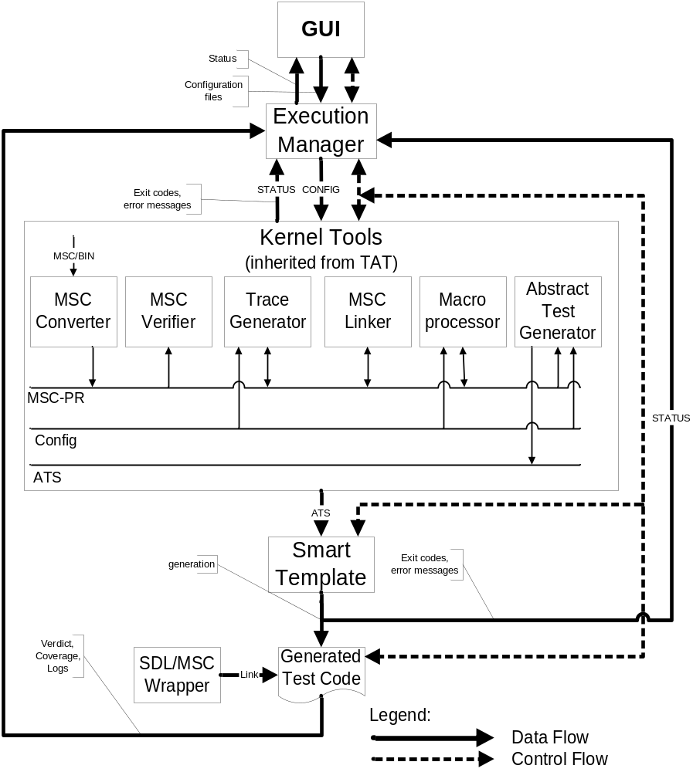
Figure 1. Decomposition of TAT⁺
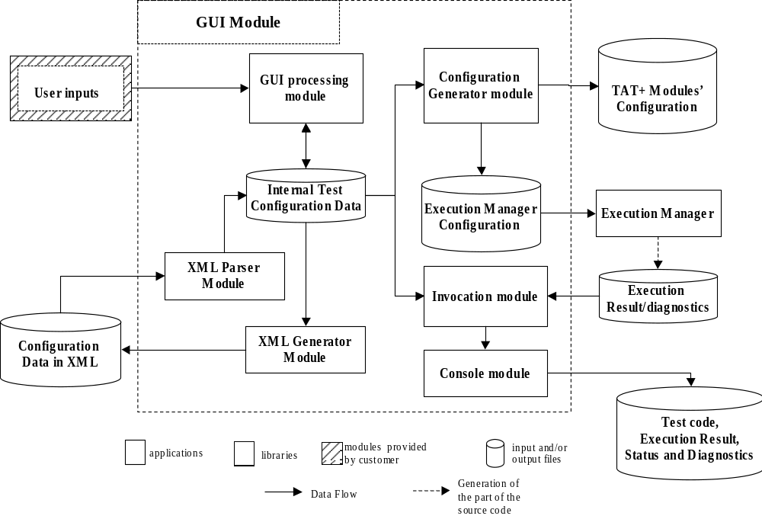
Figure 2. Dataflow diagram for the GUI module

  - Subsystems
    - User’s Interface
TAT⁺ provides GUI for creating, loading, saving and modifying its configuration described in XML structured language (detailed in FS). TAT⁺ GUI provides dialog panes for specifying processing stages, invocation of tools and specifying their options, along with the help for these options. The GUI module also provides an ability to edit configuration-related files with an external editor.
The GUI module also provides the capability to be executed in the terminal mode in the command prompt.
The dataflow diagram for the GUI module is illustrated in Figure 2.
    - Execution Manager
      - TAT⁺ shall provide ability to run tests in terminal mode without GUI. This ability shall conform to special grammar fixed in FS.
      - TAT⁺ shall provide ability to gather coverage statistics if target compiler allows and user specified script.
      - TAT⁺ shall provide ability to split full set of tests by several parts with restricted size for loading on embedded systems.
    - Kernel Tools
Kernel tools are based on kernel library, where general blocks are implemented. Kernel tools implements license related activities.
      - Macro processor
The purpose of Macro processor is to generate a set of MSC’s from parameterized template. Macro processor is organized in 2 stages: building generator with user-defined rules in C and its execution. Internal structure of Macro processor is shown in Figure 3.

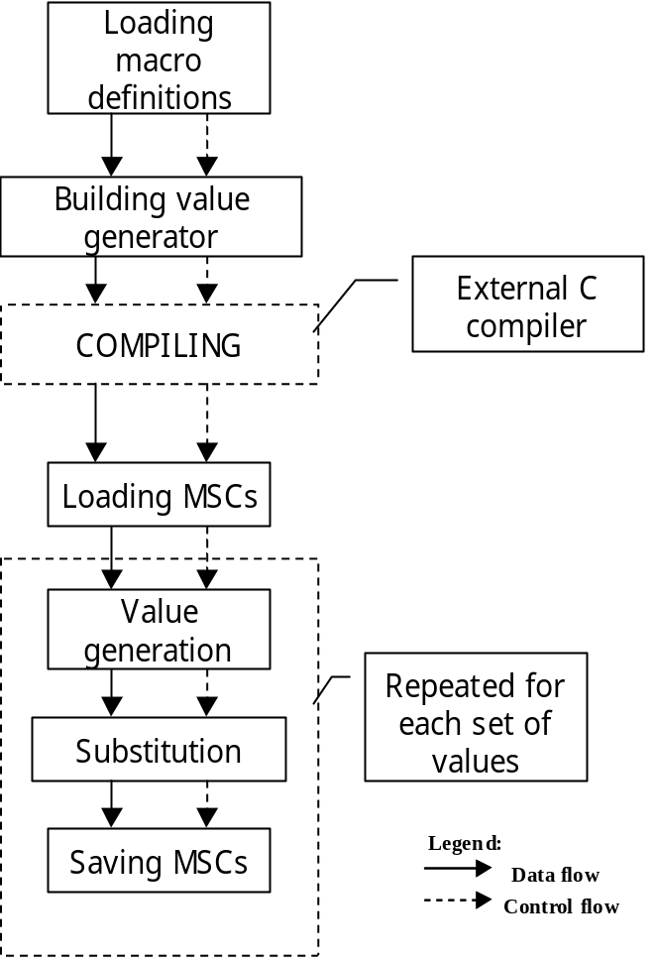
Figure 3. Structure of Macro processor

        - Macro processor shall receive parameters from command-line and configuration files with grammar, detailed in FS.
- Macro processor shall support following types of macro definitions with grammar, detailed in FS:
- lists
- conditional lists
- user’s functions
- exception rules
        - Macro processor shall allow to calculate number of possible permutations in following ways:
- Exactly. This process is just a simulating of values generation without actual substituting.
- Approximately: This means that upper-bound of permutations is to be estimated. The estimation is based on following rules: all independent values shall be calculated as number of different values. All conditional lists shall be calculated as maximal length of list. All user’s functions shall be calculated as 1. The result is calculated by multiplication of these values.
      - Trace Generator
The purpose of Trace Generator is to research for possible traces by using user-defined rules and generate MSC files. Structure of Trace generator is shown in Figure 4.
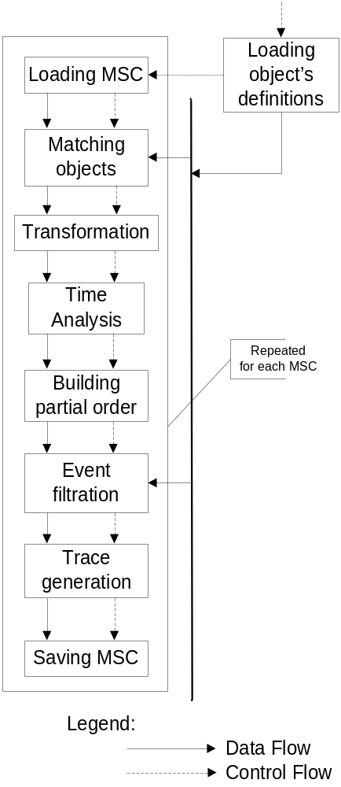
Figure 4. Structure of Trace Generator
        - Trace Generator shall receive parameters from command-line and configuration files with grammar, detailed in FS.
        - Trace Generator shall allow to generate possible traces in MSC-PR format with grammar, detailed in FS.
        - Trace Generator shall support user-defined rules for trace generation loaded from shared library with interface, detailed in FS.
        - Trace Generator shall allow to count number of possible traces with user-defined rules.
        - MSC loading block
MSC loading block contains functionality for parsing and error checking of MSC-PR files.
        - MSC saving block
MSC saving block contains functionality for generation MSC-PR files from internal representation.
        - Time Analysis block
This block is intended for computing relative timings into absolute one. It also checks MSC for time correctness (time is growing from top to bottom).
        - Transformation block
Functionality of this block consists of loop processing (unrolling, values substituting) and different kinds of synchronization (including ‘condition’ events before/after specified events).
        - Objects definitions loading block
This block is invoked when information about instance’s kind is loaded by TAT⁺. The input for this block is files in Instance definition file format, defined in FS.
        - Building partial order block
This block is intended to split complex MSC to linear parts (parts, where each trace contains the same set of events).The purpose of partial order generator module is to split original MSC into linear parts (parts where number of events is fixed and all possible paths will consists of same events). This functionality is invoked before event filtration, trace generation, test tree generation.
        - Event filtration block
This blocks removes events which are not sensitive to IUT.
        - Trace generation block
The input of trace generation is specification of partial order which is generated from linear parts of MSC in partial order generation block. First step is generation of transitive closing for partial order. It is not necessary, but it improves speed significantly.
        - Matching objects block
This block shall map instances definitions to instances in MSC.
      - Abstract Test Generator
The purpose of Abstract Test Generator [Figure 5] is to generate ATS.
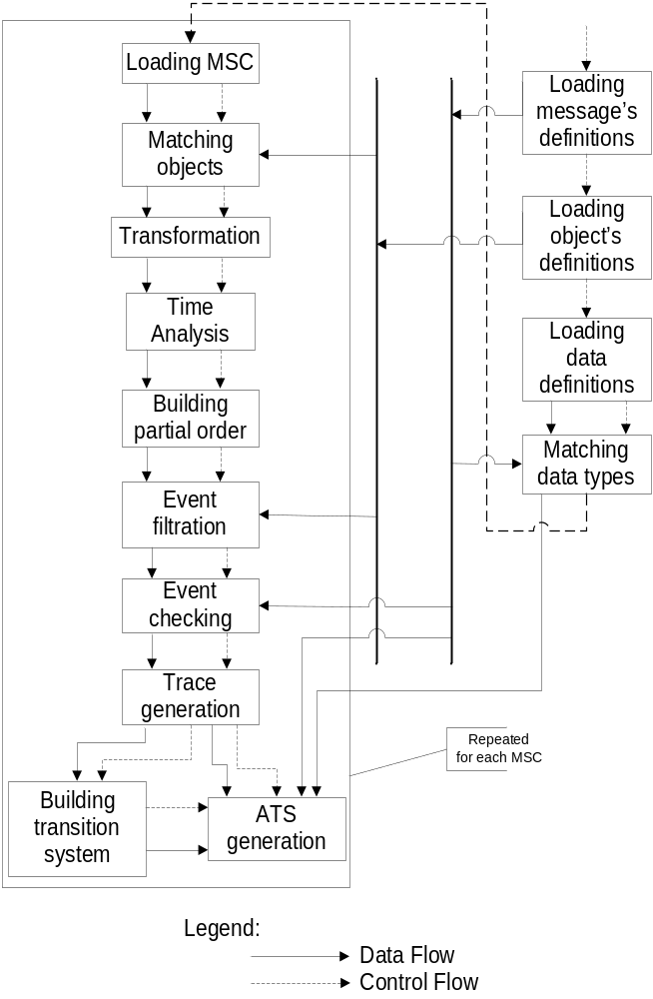
Figure 5. Structure of Abstract Test Generator
        - Abstract Test Generator (Figure 5) shall generate ATS in 3 forms: behavior-tree, transition system and msc-direct with grammar, detailed in FS.
        - Abstract Test Generator shall receive parameters from command-line and configuration files with grammar, detailed in FS.
        - Trace generator shall support user-defined rules for trace generation loaded from shared library with interface, detailed in FS.
        - MSC loading block
MSC loading block contains functionality for parsing and error checking of MSC-PR files.
        - ATS generation block
ATS generation block contains functionality for ATS generation in 3 forms, defined in FS.
        - Time Analysis block
This block is intended for computing relative timings into absolute one. It also checks MSC for time correctness (time is growing from top to bottom).
        - Transformation block
Functionality of this block consists of loop processing (unrolling, values substituting) and different kinds of synchronization (including ‘condition’ events before/after specified events).
        - Objects definitions loading block
This block is invoked when information about instance’s kind is loaded by TAT⁺. The input for this block is files in Instance definition file format, defined in FS.
        - Message definitions loading block
This block is invoked when information about message types is loaded by TAT⁺. The input for this block is files in Message definition file format, defined in FS.
        - Data definitions loading block
This block is invoked when information about data types is loaded by TAT⁺. The input for this block is files in Data type definition file format, defined in FS.
        - Matching data types block
This block is invoked for matching data types in MSC with target data types, specified by user.
        - Events checking block
This block is invoked for verification of messages in MSC to be consistent with definitions provided by User.
        - Partial order generation block
This block is intended to split complex MSC to linear parts (parts, where each trace contains the same set of events).The purpose of partial order generator module is to split original MSC into linear parts (parts where number of events is fixed and all possible paths will consists of same events). This functionality is invoked before event filtration, trace generation, test tree generation.
        - Event filtration block
This blocks removes events which are not sensitive to IUT.
        - Trace generation block
The input of trace generation is specification of partial order which is generated from linear parts of MSC in partial order generation block. First step is generation of transitive closing for partial order. It is not necessary, but it improves speed significantly.
        - Matching objects block
This block shall map instances definitions to instances in MSC.
        - Transition system building block
This block is invoked for generation and further optimization of transition system generated from execution tree, generated in Trace generation block.
      - MSC Linker
The purpose of MSC Linker is concatenation of several MSC diagrams into single one. MSC Linker can be used when series of tests shall be run under one configuration.
        - MSC Linker shall receive parameters from command-line and configuration files with grammar, detailed in FS.
      - MSC Converter
The purpose of MSC Converter is to call Telelogic’s library for converting MSC stored in internal Telelogic’s format to MSC-PR format.
        - MSC Converter shall receive parameters from command-line and configuration files with grammar, detailed in FS.
        - MSC Converter shall allow to process MSC’s recursively.
      - MSC Verifier
The purpose of MSC Verifier is to convert files between MSC-PR and FG formats, detailed in FS, check syntax of MSC-PR and FG files.
        - MSC Verifier shall receive parameters from command-line and configuration files with grammar, detailed in FS.
    - Smart Templates
The purpose of Smart templates is generation of target code from ATS.
      - TAT⁺ shall contain Smart Template for C code generation from ATS in behavior-tree form.
      - TAT⁺ shall contain Smart Template for C code generation from ATS in transition system form.
      - TAT⁺ Smart Templates for C code generation from ATS shall have following switches for customization purposes:
        - time support
        - dynamic/static memory allocation
        - one test per one source file or combination of several test in single source file
        - break/continue test case execution after errors
        - support instances in message parameters
        - support for Telelogic MSC-Trace
        - generate test suite header files / whole test suite / test suite w/o header files
        - check/uncheck input queue before any action
        - generate general startup function
        - generate wrapper’s template
        - specification of user’s function for message receiving.
      - TAT⁺ Smart Templates for C code generation shall output verdict in format, defined in FS.
      - TAT⁺ Smart Templates for C code generation shall receive parameters from command-line.

    - SDL/MSC wrapper
The purpose of SDL/MSC wrapper [Figure 6] is to connect SDL and MSC descriptions. Messages described in MSC will be routed to SDL model and vice versa.
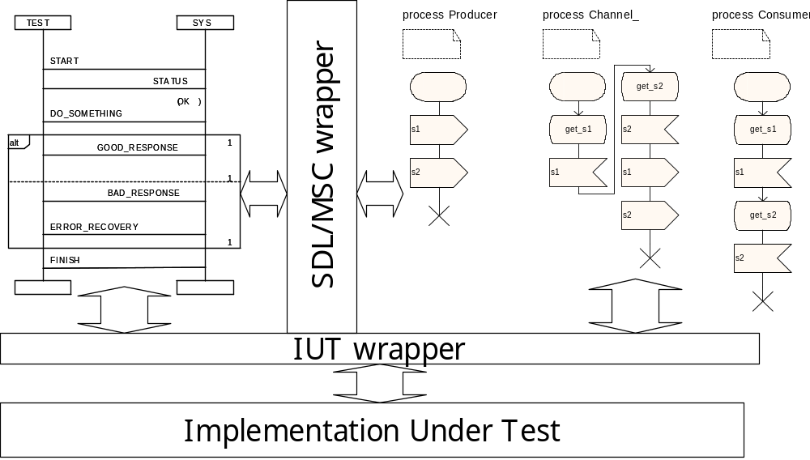
Figure 6. MSC/SDL integration

  - Interface Description
    - TAT+ shall generate ATS files in 3 forms, with grammar detailed in FS:
      - Behavior-tree form
      - Timed transition system form
      - Msc-direct form
    - TAT⁺ shall support input files generated by Telelogic Tau MSC Editor 4.3 in MSC-PR format.
    - MSC-PR files generated by TAT+ shall be supported by Telelogic MSC-Editor 4.3.
    - TAT⁺ shall support input files generated by Telelogic Tau SDL to C compiler(CAdvanced) 4.3.
    - TAT⁺ shall support input files with signal description, macros declaration, data types specification with grammar detailed in FS.
  - Dependency Descriptions
No special dependencies.

