TAT IDE

This document describes the main features of TAT Integrated Development Environment.

Important note: Currently TAT IDE can be used for configuration editing only, test suite creation and execution is not implemented yet.

Main window
TAT IDE main window contains two resizable panes – the project tree browser (left pane) and the properties window (right pane). The tree is used to navigate through the entire project while the properties pane allows the user to edit the attributes of a selected tree node, to add child nodes, delete or reorder the selected node.
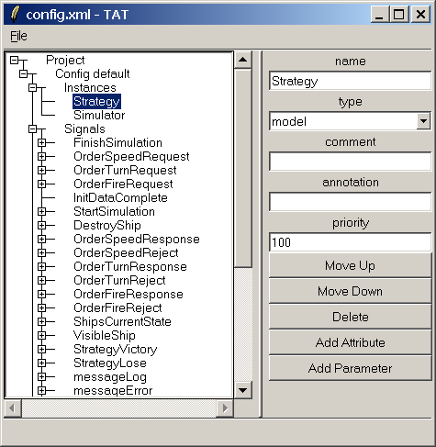
Figure 1. TAT IDE window.

Main menu
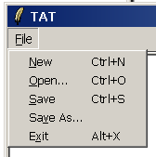
Figure 2. TAT main menu
File – file operations
New – create new project
Open – open existing project
Save – save opened project
Save As – save opened project to new file
Exit – close TAT IDE

Attribute editing
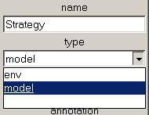
Figure 3. Attribute editing
When a project tree node is selected, the right pane shows its attributes. In Fig. 3 instance “Strategy” is selected and its attributes (name, type, comment, annotation and priority) are available for editing. Each attribute is represented either with a text entry field or with a combo box allowing the user to choose from a set of predefined values. In Fig. 3 the “type” attribute is a combo box with two possible values – “env” and “model”. Some nodes have no attributes at all (INSTANCES, SIGNALS and other container nodes)

Adding child nodes
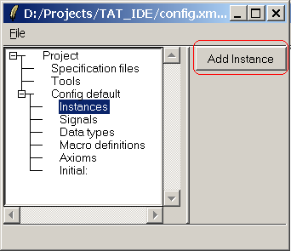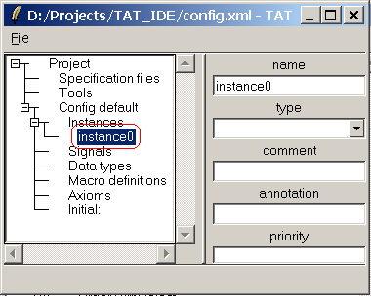
Figure 4. Adding child nodes
Some nodes in TAT XML can have child nodes (see TAT XML DTD in [1] Appendix C for XML node hierarchy). Each child node type is represented by a button “Add <type>” in the properties window. Fig. 4 shows an example of adding an instance. Clicking the “add Instance” button causes a new instance to appear at the bottom of the instance list. The newly created instance is assigned a unique name (“instance0” in this case)

Reordering nodes
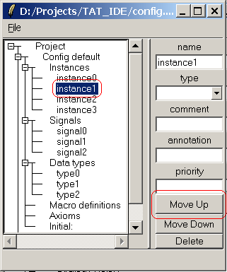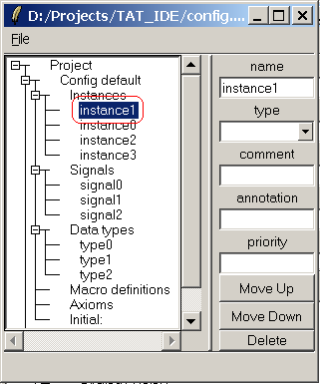
Figure 5. Reordering nodes
Some nodes may be reordered. These nodes have two buttons in the properties window – “Move Up” and “Move Down”. Clicking them causes the node to switch positions with previous or next node respectively. If a node is on the top of its parent node’s child list, clicking the “Move Up” button will have no effect. If a node is on the bottom of its parent node’s child list, clicking the “Move Down” button will have no effect. Fig. 5 shows an example of reordering instances – instance1 is moved one position up.

Deleting nodes
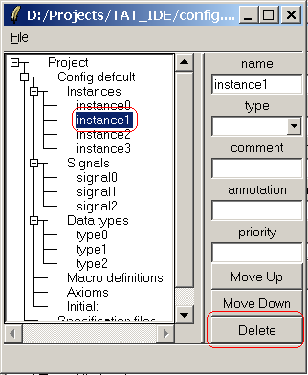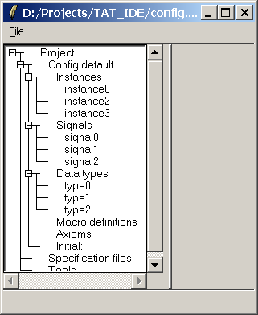
Figure 6. Deleting nodes
If a node can be deleted, the “Delete” button is shown in the properties window. Clicking this button causes the selected node to be deleted. Fig. 6 shows an example of deleting an instance – instance1 is deleted.

Loading projects from command line
Type “ide.tcl filename” or “wish ide.tcl filename” to load a project file at start-up.

Requirements
TAT IDE is a Tk window application and requires the following Tcl libraries:
BWidget (any version)
TclDOM (version 2.6 and above)

References
[1]. TAT User’s Manual

