

ePaper Guidebook

[ FOR AUTHORS ]



UGM Annual Scientific Conferences

CONTENTS

|  |  |
| --- | --- |
| Account Registration | 3 |
| Abstract Submission | 6 |
| Payment Procedure | 13 |
| Payment confirmation tutorial | 14 |
|  |  |

# ACCOUNT REGISTRATION

This section will guide you through the registration of your ePaper Management account.

1. Go to the [ePaper Management](http://epaper.uasc.ugm.ac.id) site.

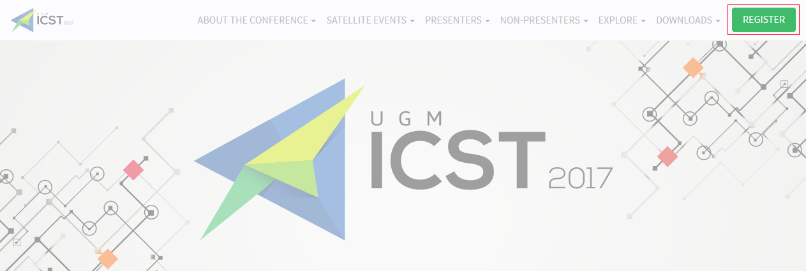Alternatively, you can simply click the Register button on the respective UASC website, which will redirect you to the ePaper Management site.

1. 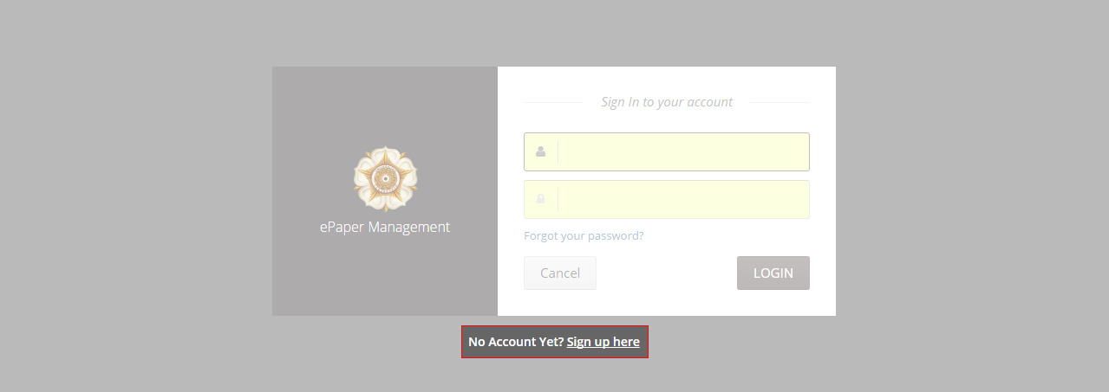Below the login form, click Sign up here.
2. 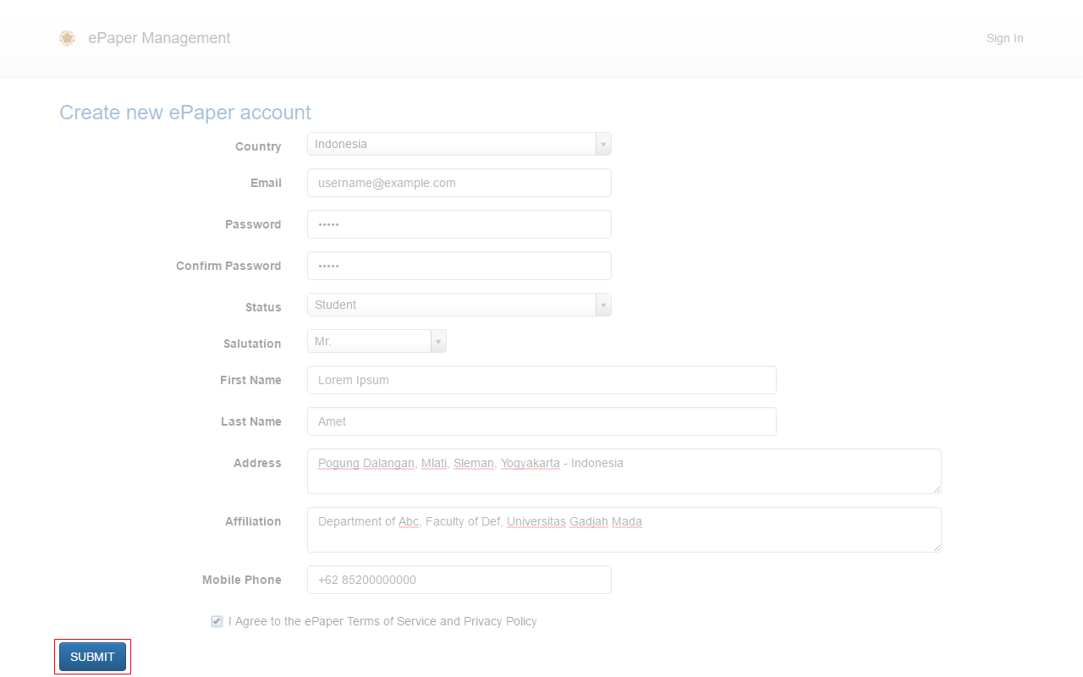Enter your details and click Submit to create your account.

Notes:

- Add your country’s phone code (e.g. **+62** for Indonesia)

- Enter **only** **one** active email address

- You can change these details later (except for your email)

1. Your account has been created. Your user ID and password will be sent to your email.

# Further steps for participants (non-presenters)

## Conference participants who will not be presenting a paper or poster should continue with the following steps.

1. 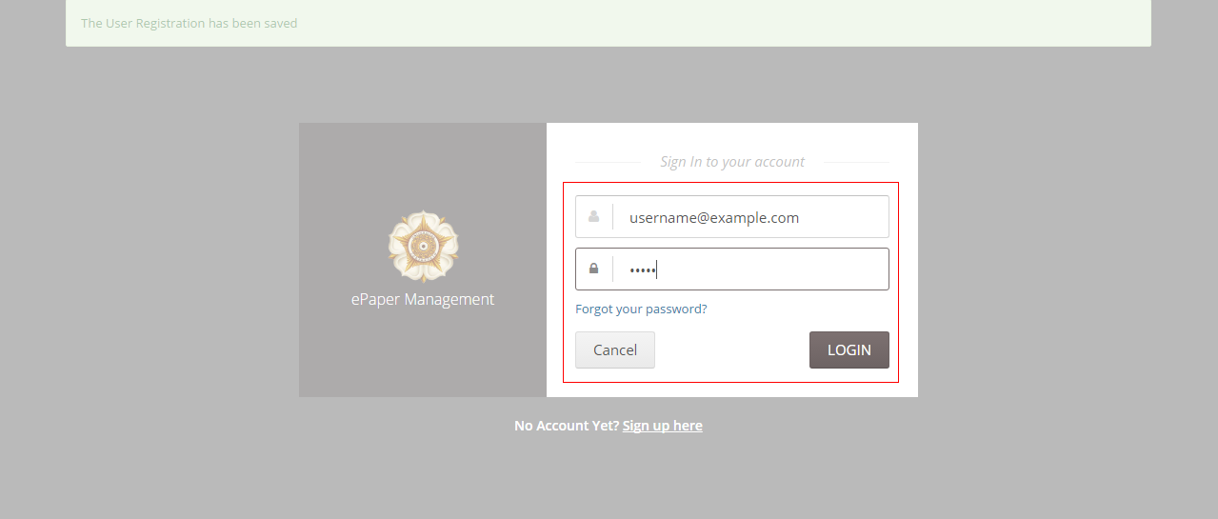Once you have received your user ID and password, log into your account.
2. 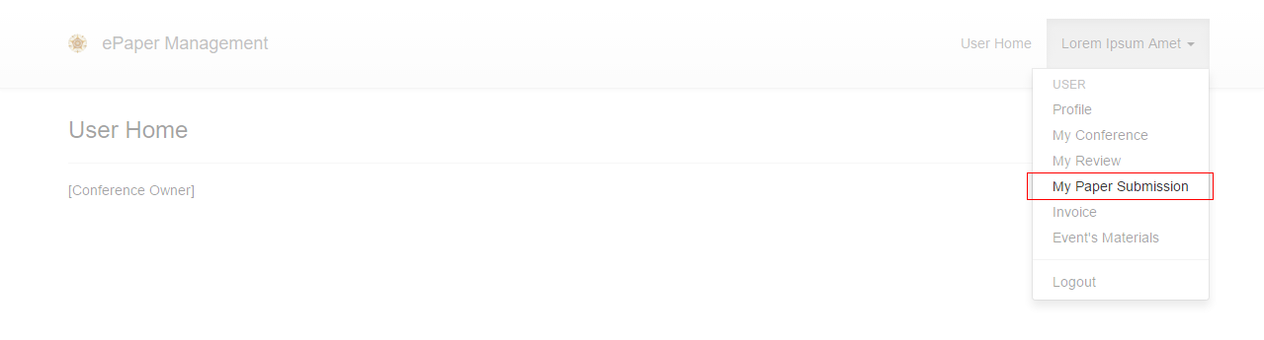Click on your name in the top-right corner of the page and select My Paper Submission.
3. Click the Submission button.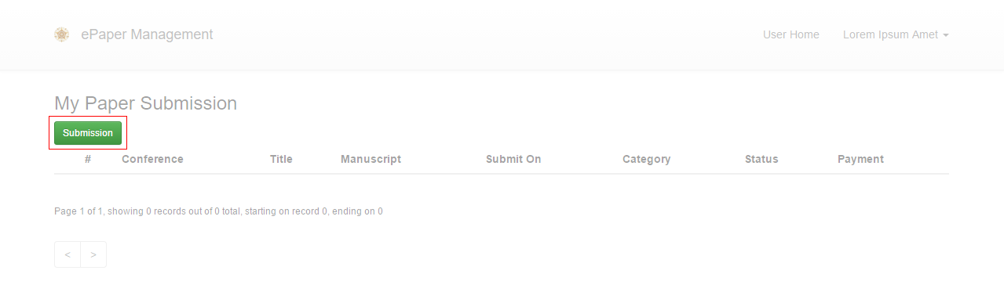
4. 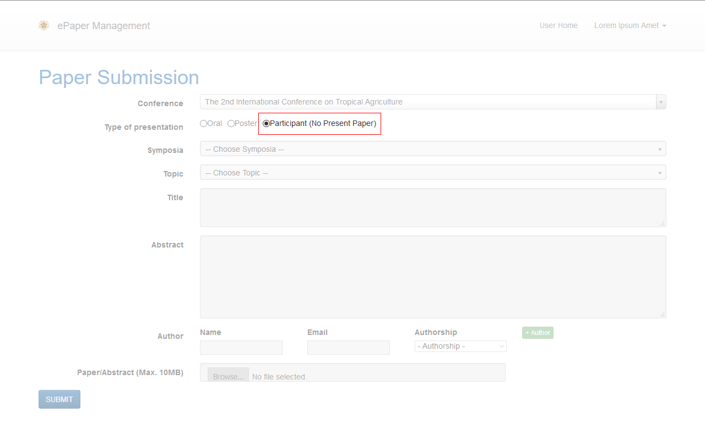Select Participant under Type of presentation and then click Submit.

If you require further assistance, please email the conference’s contact person.

# ABSTRACT SUBMISSION

## Once your ePaper Management account has been created, you will be able to use this account to submit your abstract. This section will guide you through your abstract submission.

Please ensure that you are using the correct account to submit your manuscript, as an invoice will be generated for this account.

1. Sign in to your account.
2. Once you are logged in, click on your name in the top-right and select My Paper Submission.
3. Click the Submission button.
4. 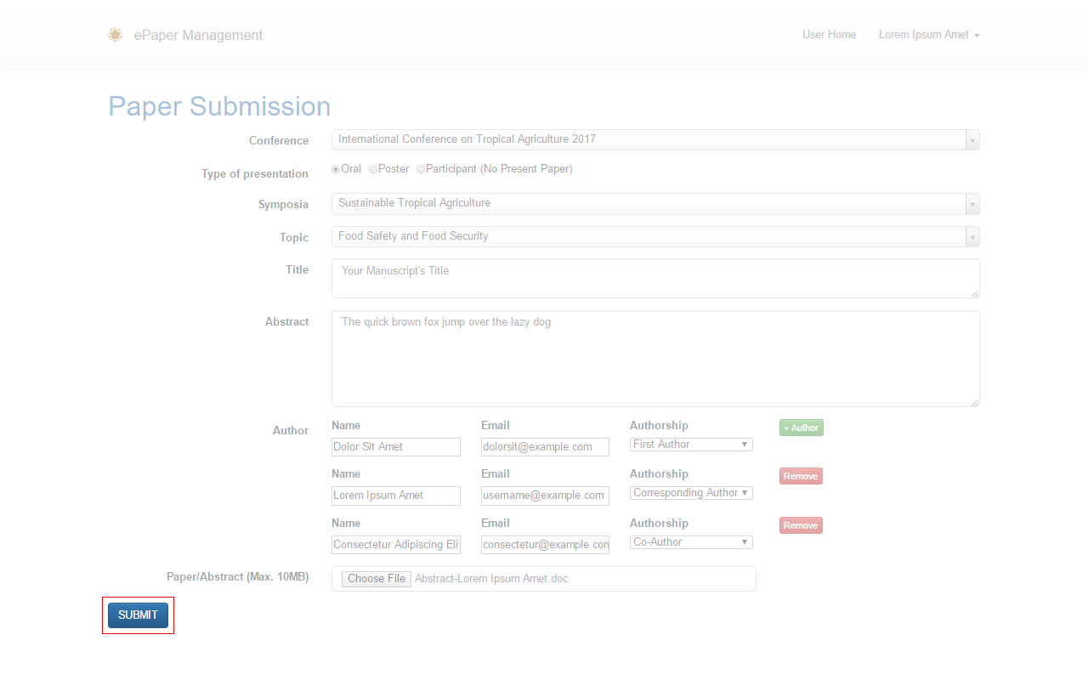Fill in the form and then click Submit to send your abstract.

Notes when selecting authorship:

- Select **First Author** for first author

- If the corresponding author is not a first author, select **Corresponding Author**

- Select **Co-Author** for another author

1. 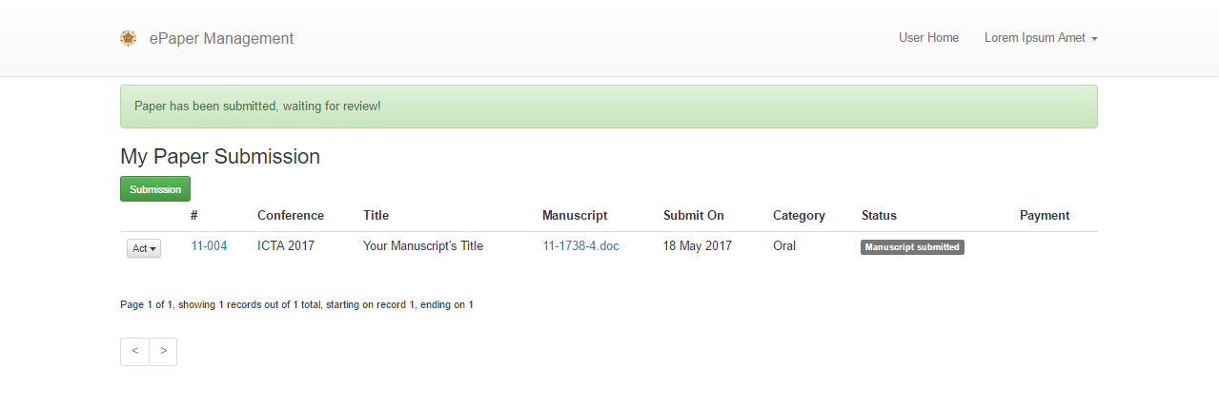Your abstract has successfully been submitted. You will now be able to view your abstract in the My Paper Submission and Active Paper pages.

If you require further assistance with submitting your abstract, please email the conference’s contact person.

# FULL PAPER SUBMISSION

## If your abstract is accepted, you will be able to submit your full paper. Follow these steps to do so.

1. 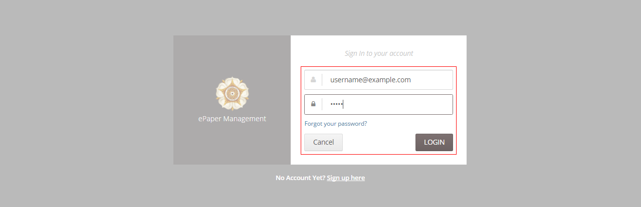Sign in to your account.
2. 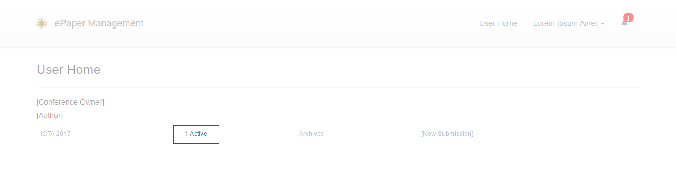In the User Home page, click your Active paper.

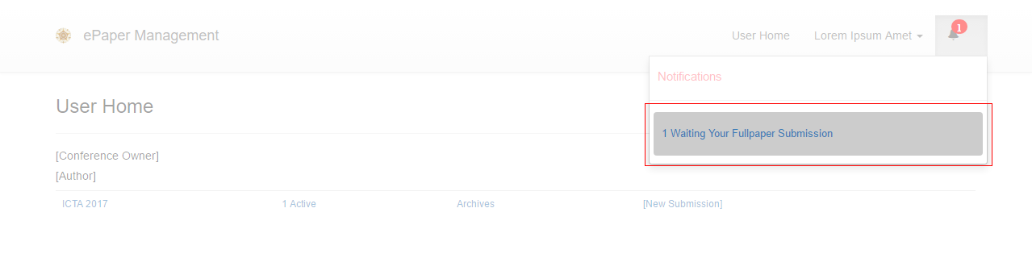Alternatively, you can click the notification in the top-right of the page.

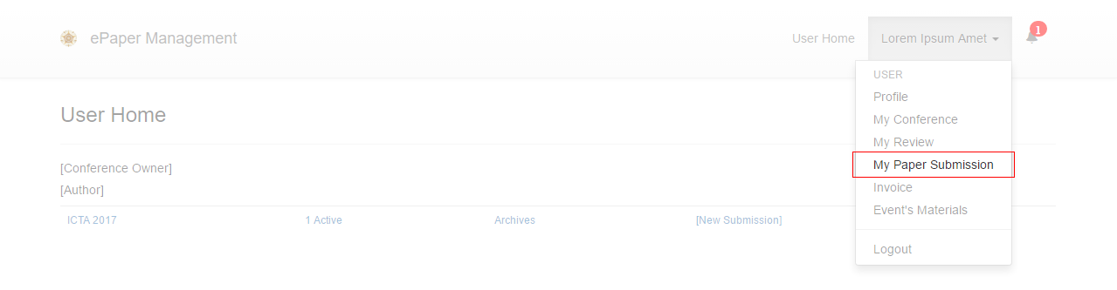You can also access your paper by clicking your name in the top-right of the page and then selecting My Paper Submission.

1. 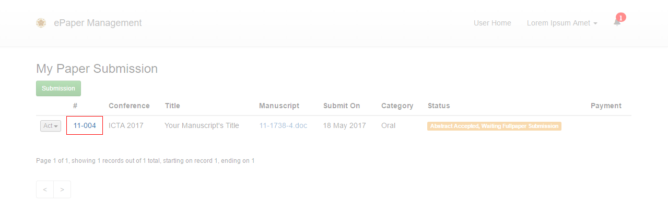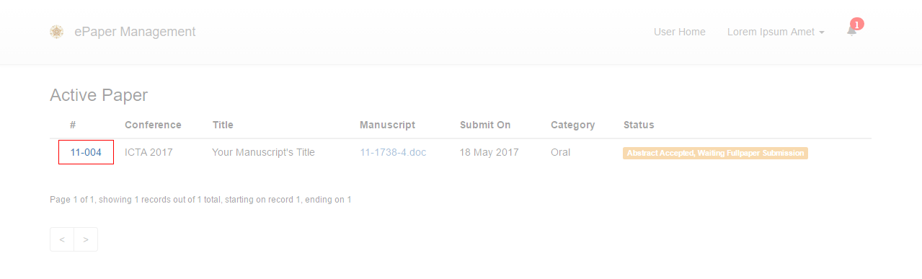Click your paper’s ID.
2. Your paper’s summary will appear. Click the Upload File button.

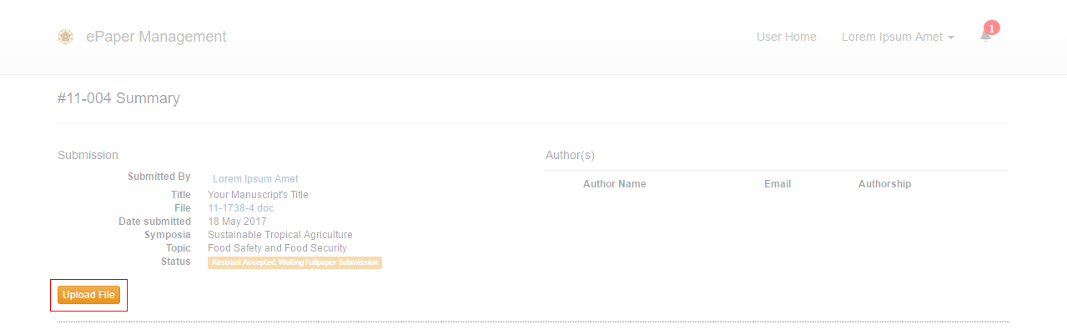

1. 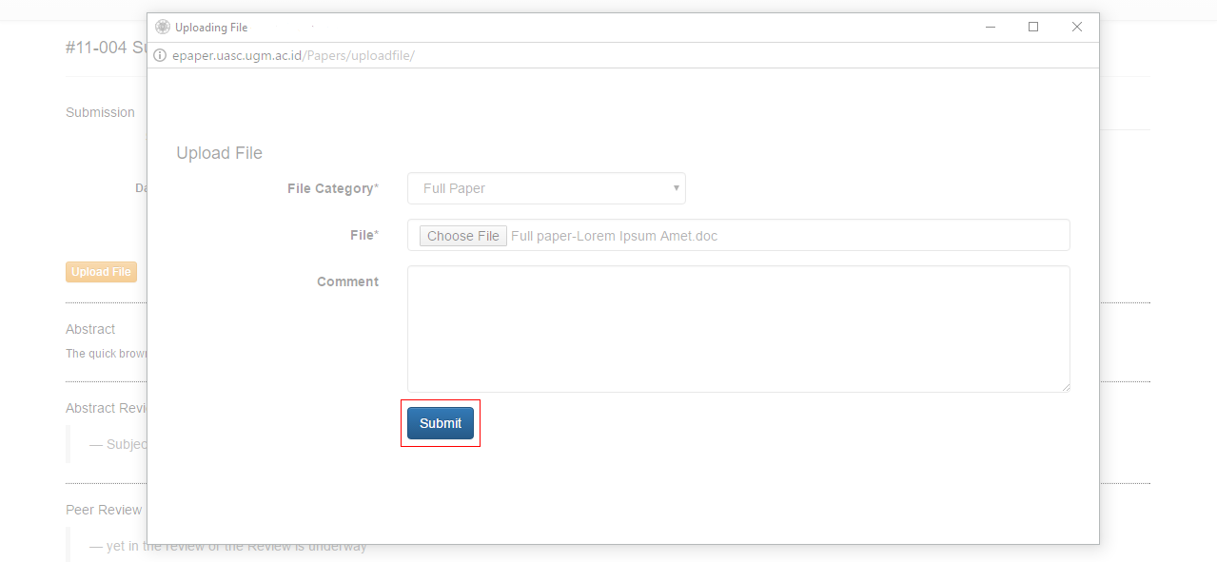A new window will appear, through which you can upload your full paper. Once you have selected the File Category and attached your full paper, click Submit.

Notes:

- Select **Full Paper** for a new full paper

- If you submit a revised full paper, select **Revised Full Paper**

- If your paper has supplementary files, select **Supplementary File**

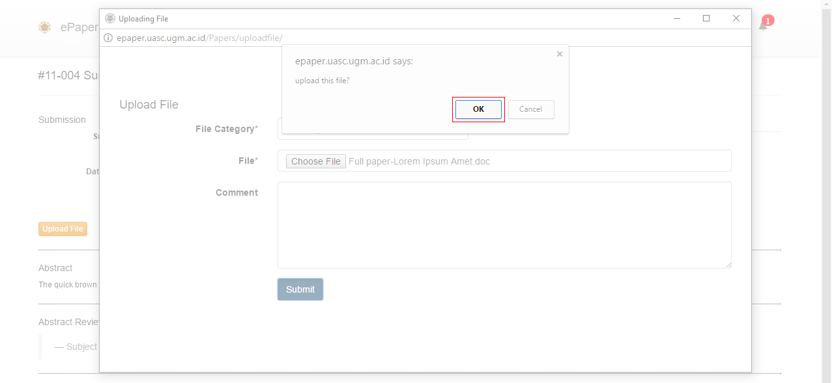A confirmation dialogue will appear. Click OK to confirm your submission.

1. Your full paper has been submitted.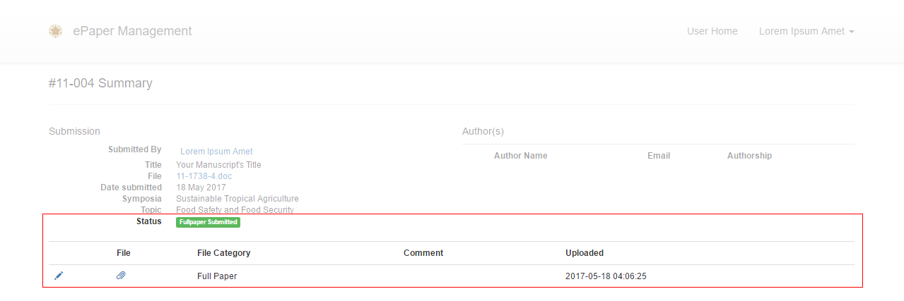

If you require further assistance with submitting your full paper, please email the conference’s contact person.

# PAYMENT PROCEDURE





Make the payment via ATM/Teller/eBanking. The exact amount stated on the invoice should be paid.

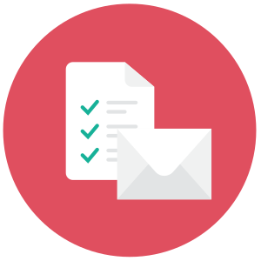



An invoice will be emailed to you after your paper has been accepted or (if you are not presenting) after you have registered.





We will verify your payment within 1–2 business days.





Log into your ePaper Management account, fill in the payment confirmation form, and upload your payment receipt. Alternatively, you can email us the confirmation receipt.

# PAYMENT CONFIRMATION TUTORIAL

## This tutorial covers the confirmation of your payment through the ePaper Management site. If you have any difficulties with this method, you can also email the receipt to us.

1. Sign In to your account.



1. Once you are logged in, click on your name in the top-right and select Invoice.

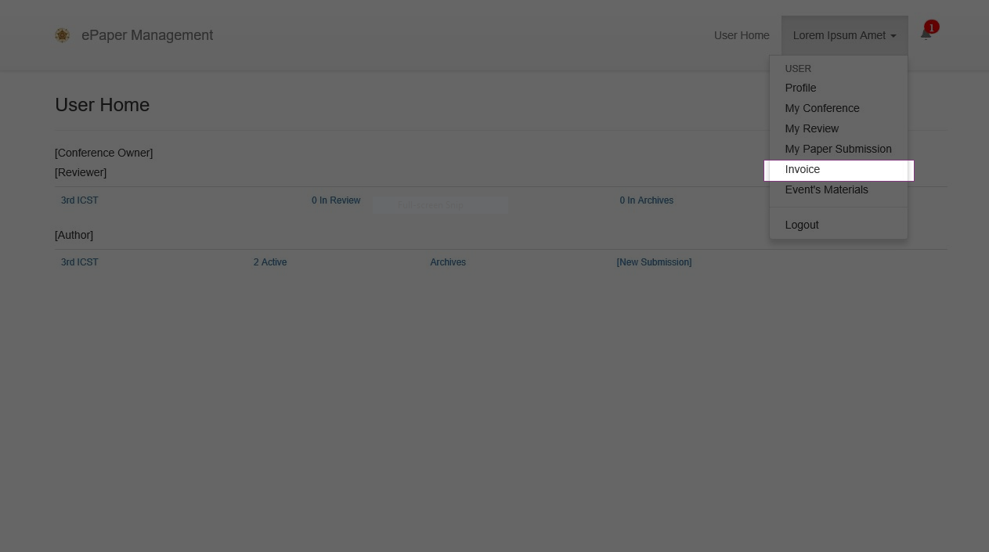

Alternatively, you can click the Notification button in the top-right of the page.

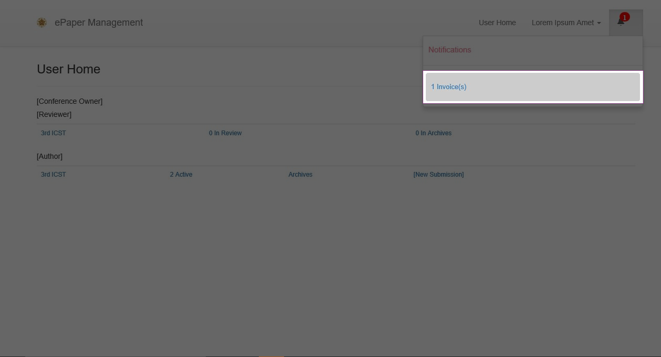

1. Click the Payment Confirmation button.

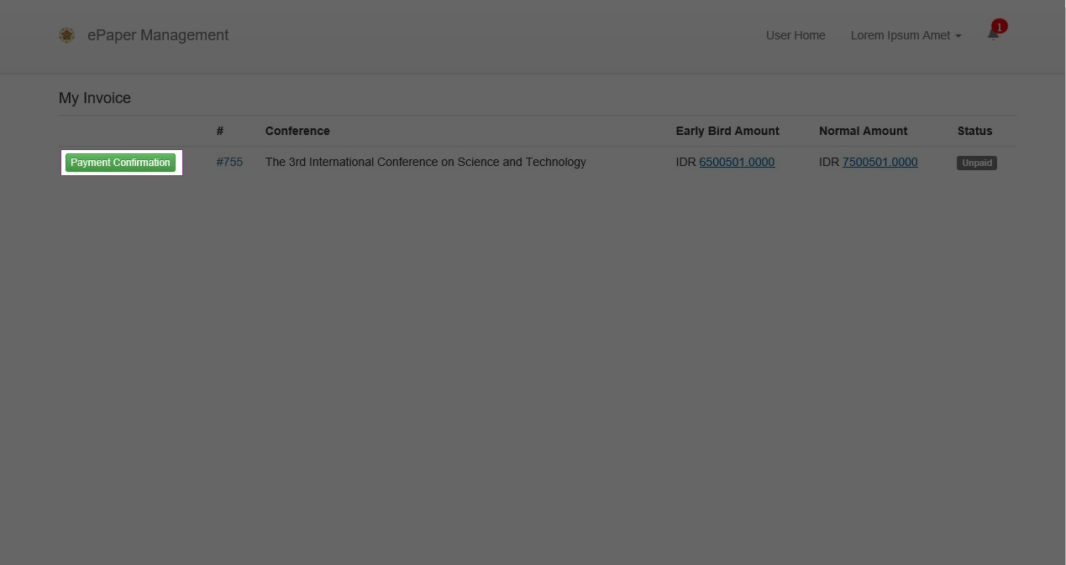

1. Fill in the form and then click Confirm to confirm your payment.

Do not use any punctuation in the **Nominal** field, or your form will be invalid.

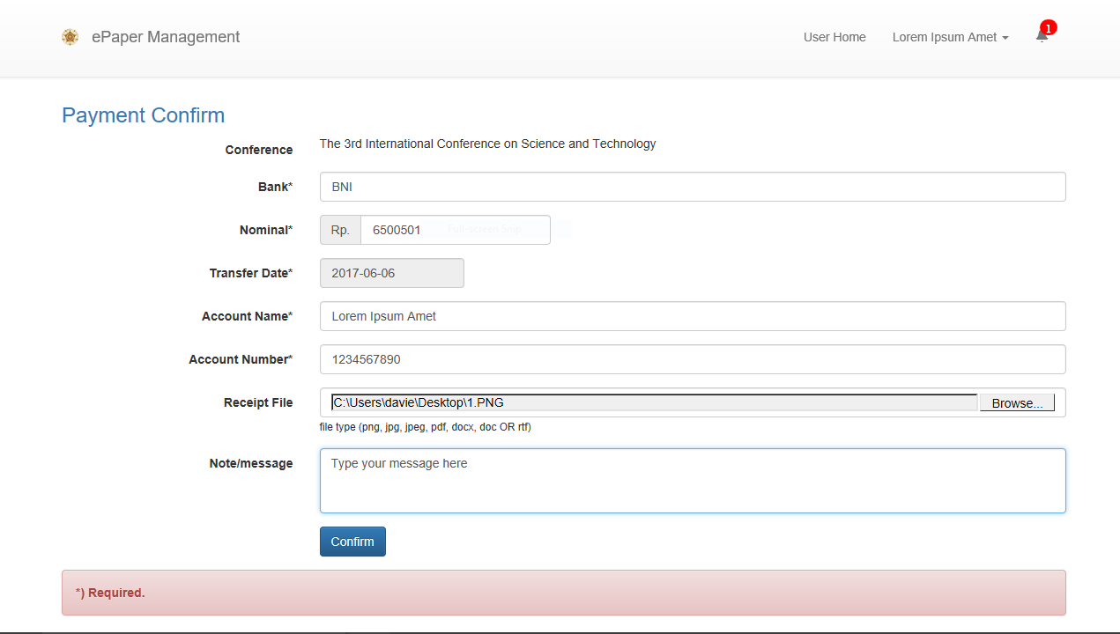

1. Your payment confirmation has successfully been submitted. We will verify your payment within 1–2 business days.

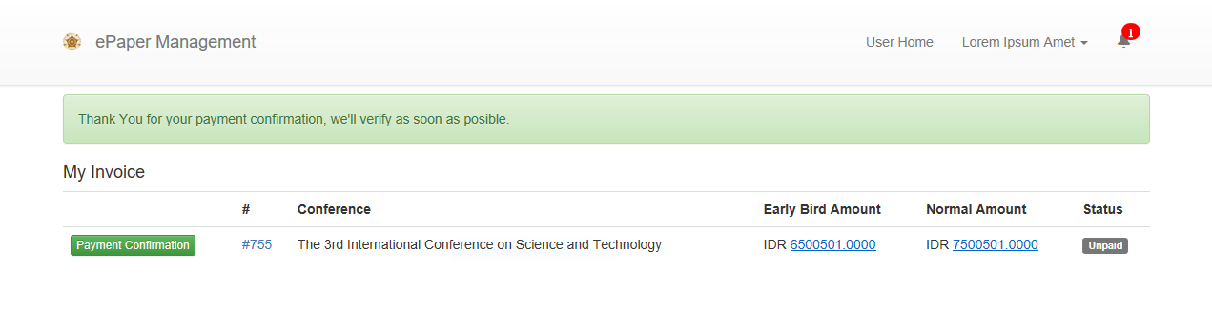

If you require further assistance with confirming your payment, please feel free to contact us. You can also email your confirmation receipt.



BADAN PENERBIT DAN PUBLIKASI

UNIVERSITAS GADJAH MADA

UGM Main Office Building, 3rd Floor, Room B3-05

Bulaksumur, Yogyakarta, Indonesia 55281

Phone (+62) 274-6491-963

Whatsapp (+62) 811-2576-950